QUALITY MANAGEMENT ADVISORY
COMMITTEE (QMAC) NEWSLETTER

Ending the Epidemic Update
Data Subcommittee
The Data Subcommittee is focusing on connecting agencies who use the same data systems. The Data Subcommittee continues to discuss the migration to RedCap for state-reported data and the new CAREWare 6 update. Agencies represented on the Data Subcommittee are sharing migration plans and tips with other agencies amidst these system changes. Please contact either Brooke Williams (BAW8CP@hscmail.mcc.
virginia.edu) or Tim Agar (tagar@novaregion.org) with any questions.

Quality Improvement (QI) Subcommittee
The QI Subcommittee recently began conducting interviews with agencies to determine best practices for Quality Improvement. To date, the QI Subcommittee has interviewed UVA, NovaSalud, and Northern Virginia Family Service. The QI Subcommittee will develop an
E-booklet of the results. For questions, contact either Allison Collazo (acollazo@nvfs.org) or Dr. Virginia Walker Sherrod (firstlightgroup@cox.net).
In the State of the Union Address on February 5, 2019, the current administration announced their goal to end the HIV epidemic in the United States within 10 years. To achieve this goal and address the ongoing public health crisis of HIV, the proposed Ending the HIV Epidemic: A Plan for America will leverage the powerful data and tools now available to reduce new HIV infections in the United States by 75 percent in five years and by 90 percent by 2030.

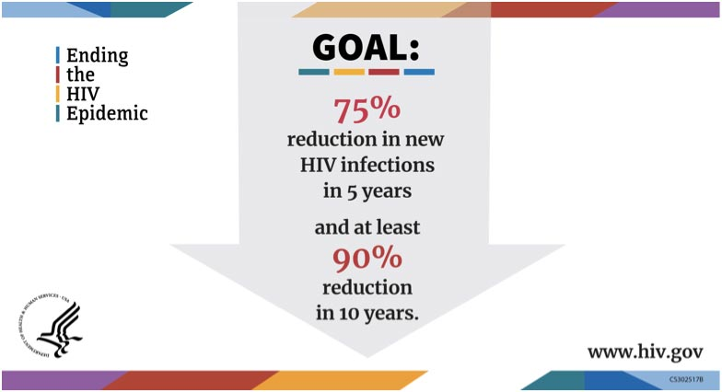
The Plan's major areas of action include:
- Increasing investments in geographic hotspots through existing, effective programs, such as the Ryan White HIV/AIDS Program, as well as expanding access to PrEP.
- Using data to identify where HIV is spreading most rapidly and guide decision-making to address prevention, care, and treatment needs at the local level.
- Supporting the jurisdictions to establish local teams
committed to the success of the Initiative and expand HIV prevention and treatment services.

The efforts will focus on four key strategies that together can end the HIV epidemic in the United States.: Diagnose, Treat, Prevent, and Respond.
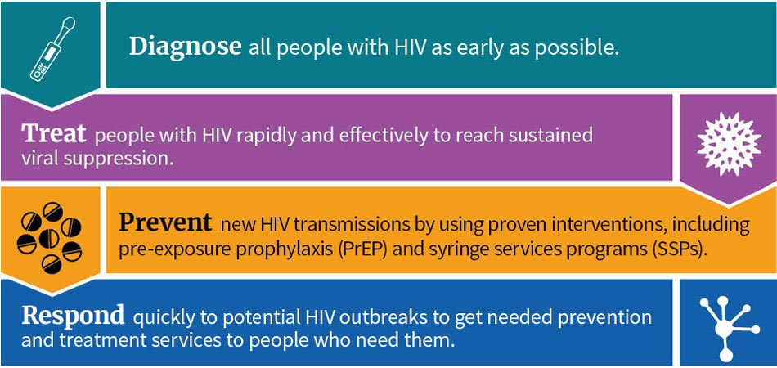
Ending the Epidemic Update Continued
(from page 1)

Capacity Building Subcommittee
The committee is recruiting for new QMAC mentors to provide guidance for new incoming members. These mentors would provide guidance for new incoming QMAC members. More details on the roles and responsibilities of the mentor are in the QMAC Orientation Manual. Please contact Beverly Franklin (FranklBS@evms.edu) or
Ashley Yocum (Ashley.Yocum@vdh.virginia.gov) with any questions.

Virginia Quality of Care Consumer Advisory Committee (VACAC) Subcommittee
Twenty one people living with HIV (PLWH) and members of the VACAC attended the Virginia Department of Health funded Building Leaders of Color (BLOC) program from January 21-24, 2020 in Charlottesville, Virginia.
The VACAC began planning for the 2020 Regional Consumer trainings. Trainings will include consumer-based webinars and teleconferences throughout Grant Year (GY) 20. VACAC brainstormed training topics that were most relevant and needed in the regions. Each region worked on proposals for additional regional trainings that are being reviewed by VDH QM Staff. Contact co-chairs Sylvester Askins at djw0314@hotmail.com or
Mark Baker at mbaker@totalhealthcare.org.

Efforts for Phase I will be focused on 48 counties and seven rural states plus Washington, DC, and San Juan, Puerto Rico. Together, these so-called HIV hot spots have contributed to more than 50 percent of new diagnoses in recent years. In Phase II, efforts will be even more widely disseminated across the nation to reduce new infections by 90 percent by 2030. In Phase III, intensive case management will be implemented to maintain the number of new infections at fewer than 3,000 per year.
For more information and updates, please visit: https://www.hiv.gov/federal-response/ending-the-hiv-epidemic/overview
Quality Improvement Agency of the Month
Our “Agency of the Month” for November 2019 is Northern Virginia Family Service (NVFS). Located in Manassas, Virginia, NVFS provides care to over 100 HIV+ individuals in the northern region of Virginia. The following services are provided through their Ryan White Part B Program: Housing Services, Non-Medical Case Management, Medical Transportation, Emergency Financial Assistance, and Non-Medical Case Management. NVFS also provides Permanent Housing Placement (PHP) and Short-Term Rent, Mortgage, and Utility (STRMU) services through HOPWA.

NVFS’ Quality Improvement Project for GY 2019 is to retain 100% of clients in care through the provision of Non-Medical Case Management, Medical Transportation, and Emergency Financial Assistance. As of October 31, 2019, fifty four clients have been served through Ryan White Part B. One hundred percent of clients served in the first quarter were linked or retained in care. In the second quarter, ninety-six percent of clients served were linked or retained in care.
NVFS actively seeks consumer involvement and feedback. Clients who receive a service through Ryan White or HOPWA are asked to complete a client satisfaction survey to better inform services.
For more information, please visit www.Nvfs.org or contact Allison Collazo at 571-748-2885 or acollazo@nvfs.org.
___________________________________________________________
Our “Agency of the Month” for December 2019 is NovaSalud. Located in Falls Church, Virginia, NovaSalud provides care to over 50 HIV+ individuals in the northern region of Virginia. The following services are provided through their Ryan White Part B Program: Outreach Services, Health Education and Risk Reduction Counseling, Early Intervention Services, Mental Health, Access and Linkage to HIV Care and Treatment, Medical Transportation, Food Vouchers and Referrals Services to Other Social Support Services.

Glasscubes
Glasscubes is the online repository for our QMAC provided by the Center for Quality Improvement & Innovation (CQII). Information related to the QMAC is electronically stored, including presentations, action plans, minutes, etc. To join Glasscubes, please email VDH Quality Management Specialist Jonathan Albright.

VDH QM Staff Contact Info

Safere Diawara
Quality Management Coordinator
Safere.Diawara@vdh.virginia.gov
(804) 864-8021

Jonathan Albright
Quality Management Specialist
Jonathan.Albright@vdh.virginia.gov
(804) 864-7951
Ashley Yocum
HIV Planner
Ashley.Yocum@vdh.virginia.gov
(804) 864-7621

Quality Improvement Agency of the Month Continued (from page 2)

Consumer involvement is fundamental in every process at NovaSalud. After reviewing internal processes with the client, NovaSalud provides individualized and group support to strengthen the patient’s emotional well-being.
Their structured programs provide a series of activities that enhance client’s participation helping them overcome doubts, concerns and other barriers. The focal point is to assist clients with situations that may impact their ability to manage their health status, giving priority to viral load suppression.

NovaSalud tries to include the client’s partner, friends and family to provide a customized service that make patients feel comfortable in seeking help any time they need. For more information, please visit www.Novasaludinc.org or contact Lazaro Pesina at
703-827-3199 or lpesina@novasaludinc.org.

NMAC’s Building Leaders of Color 2020 VACAC Training

Twenty one people living with HIV (PLWH) and members of the statewide Virginia Quality in Care Consumer Advisory Committee (VACAC) attended the Virginia Department of Health funded Building Leaders of Color (BLOC) program from January 21-24, 2020 in Charlottesville, Virginia.
The BLOC program, facilitated by NMAC (formerly the National Minority AIDS Council), builds the capacity of consumers to engage in planning, implementation, and evaluation of HIV-related services at different levels of service delivery.
This training uplifts and enhances the voices of those communities that are over represented in the number of new cases of HIV, but under-represented in current leadership and/or decision-making processes.
The core components of the BLOC program are: defining traits and characteristics of leaders; developing leadership skills in community-level advocacy; data analysis; and performance measurement. The constituents’ participation is focused on ensuring persons of color and allies living with HIV are active participants in supporting the planning and decision-making processes that impacts the quality of life and health outcomes for persons of color living with HIV.

Within sixty (60) days of completion of the three-day training, participants are requested to engage in Virginia’s planning processes of local community groups serving PLWH, such as VACAC, Ryan White Planning Councils, Community HIV Planning Group, Prevention and

NMAC’s Building Leaders of Color 2020 VACAC Training Continued (from page 3)

Care Integrated Planning, Quality Management Advisory Committee and their subcommittees, Quality Improvement Teams or Consumer Advisory Boards.
Consumer Inspiration/Spotlight

A client that had been incarcerated for over 30 years has recently made great strides in becoming independent since his release. He recently attended a local Community Services Board (CSB) for recreation and mental health development services to reintegrate into society. He states he will return to the CSB in May for additional services. Currently, the client receives Case Management Services, HIV medications, Medical Transportation, Dental Care, and Health Education through the Ryan White Part B program, which have helped the client remain adherant with his medications. Recently the client received assistance with housing and has made arrangements to into his own place, as he previously lived with his elderly parents. Currently, the client is compliant with his medications, doctor visits, and is focused on maintaining a healthy and productive perspective.

