2017 Fredericksburg City Local Public Health System Assessment

Your organization was identified as a critical part of the Fredericksburg City Local Public Health System (see diagram below). Your insights and input will assure the success of the Public Health System Assessment (LPHSA). Thank you for your participation.

What is LPHSA?

The LPHSA measures the capacity of the local public health system to conduct essential public health services by bringing together community organizations to discuss and evaluate how Fredericksburg City public health system measures against national performance standards developed by the Centers for Disease Control and Prevention (CDC).

Below are the three public health core functions and the ten essential public health services. Under each essential services are few questions that will help us assess how well our public health system is doing. Please review before the meeting to help you provoke your thinking.

Assessment, the first core function, has two essential services:

ES 1: Monitor health status to identify community health problems
- What is going on in our community?
- How healthy are we?
ES 2: Diagnose and investigate health problems and health hazards in the community
- Are we ready to respond to the health problems in our community?

Policy Development, the second core function, has three essential services:

ES 3: Inform, educate, and empower people about health issues
- Are we ready to respond to the health problems in our community?
ES 4: Mobilize community partnerships to identify and solve health problems
- How well do we get our community engaged in local health issues?
ES 5: Develop policies and plans that support individual and community health efforts
- What policies in government and private sector – nonprofit and for profit – promote health in our community?
- How effective are we in setting health policies?

Assurance, the third core function, has four (4) essential services:

ES 6: Enforce laws and regulations that protect health and ensure safety
- When we as a system enforce laws and regulation, are we technically competent, fair, and effective?

ES 7: Link people to needed personal health services
- Are people in our community receiving the health care they need?
ES 8: Assure a competent public health and personal health care workforce
- Do we have a competent public health system staff?
- How can we be sure that our staff is current?
ES 9: Evaluate effectiveness, accessibility, and quality of personal and population health services
- Are we doing any good?
- Are we doing this right?
- Are we doing the right things?

The tenth essential service – Research – crosses all three core functions and the other nine services:

ES 10: Research for new insights and innovative solutions
- Are we discovering and using new ways to get the job done?

Core Public Health Functions and Essential Services

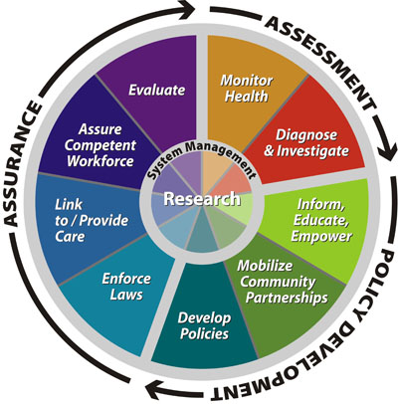

Local Public Health System

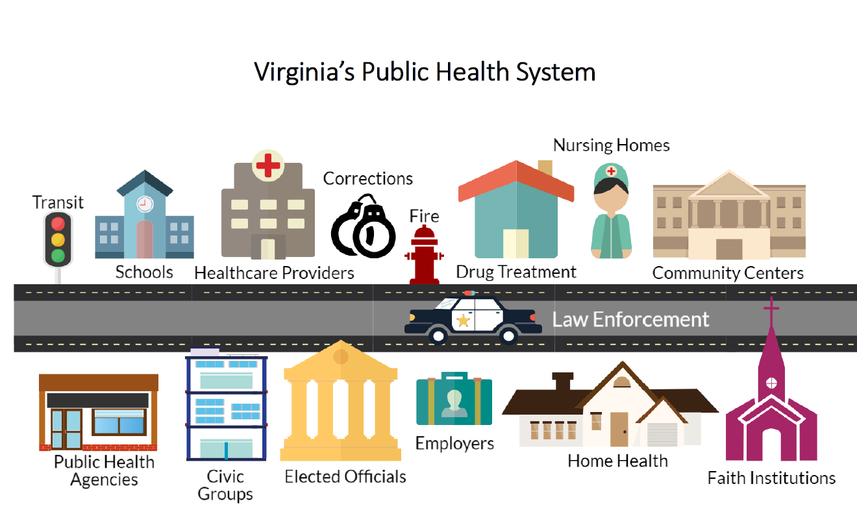

For more information about the 2017 Fredericksburg City Community Health Assessment please click here.

