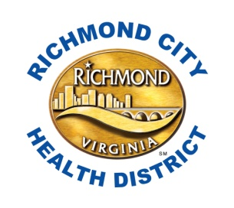
PRESS RELEASE

For immediate release: March 27, 2015

Media contact:
George Jones, Richmond Health District Public Information
804-205-3735
Amy Vincent, Richmond Health District Tobacco Intervention Project Coordinator
804-205-3737
Cletisha Lovelace
Richmond Public Schools Interim Communications Officer
804-780-7100

Richmond Public Schools and Richmond City Health District join forces
to promote tobacco-free communities

Richmond, VA - The Richmond City Health District congratulates Richmond Public Schools on their designation as a Tobacco-Free School Zone. The Richmond City School system is acknowledged by the Virginia Foundation for Healthy Youth for adopting a 100% tobacco free-policy that restricts smoking and the use of any tobacco or smoking products by anyone on school property, school grounds, and at school-sponsored events.

“School faculty and staff are role models for students, and this policy presents a positive example for students, as well as providing protection to our youth and others from unhealthy second-hand smoke,” said Dr. Dana T. Bedden, Richmond Public Schools Superintendent.

“Richmond City Health District is proud to partner with Richmond Public Schools to provide supporting classroom education that helps students learn about the dangers of tobacco use and hopefully will equip them to make good decisions and resist temptation to start smoking or using tobacco,” said Dr. Danny Avula, Richmond City Health District Deputy Director.
Each day, more than 3,200 people under age 18 smoke their first cigarette, and approximately 2,100 youth and young adults become daily smokers. In the general population, an estimated 88 million non-smoking Americans, including 54% of children aged 3 to 11 years, are exposed to second-hand smoke. In addition to other harmful effects, second-hand smoke can trigger asthma attacks or aggravate other breathing problems. More than 11% of high school students in the United States have asthma, and studies suggest that youth who smoke are more likely to develop asthma.
Richmond Public Schools Tobacco Free Policy is an important intervention. Comprehensive tobacco-free policies will reduce exposure to harmful effects of tobacco and prevent youth from starting use of tobacco. Parents and members of the public are encouraged to support our schools in this effort to protect the health of our youth and make our community healthier. For more information about tobacco-free schools, visit www.vfhy.org.
###

