Boating Infrastructure Grant (BIG) Training Manual
2018
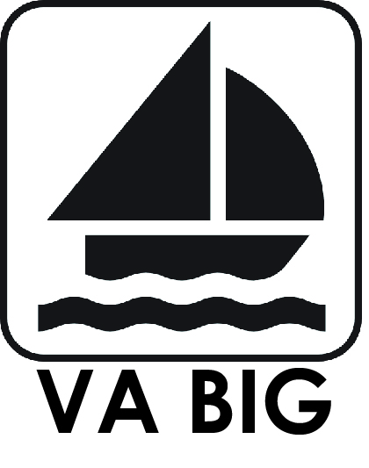
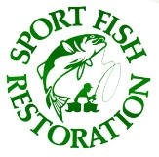
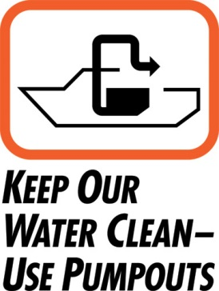
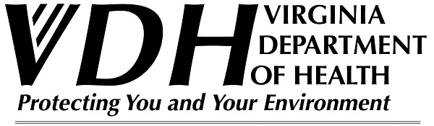

Table of Contents
Program Contacts……………………………………………………………………………3
Purpose of the BIG Program………………………………………………………………...4
Need for the BIG Program…………………………………………………………………..4
BIG Program Funding and Administration……………………………………………….....5
BIG Grant Types…………………………………………………………………………......6
Eligible Grantees, Infrastructures, and Pre-Award Costs……………………………………7
Mandates……………………………………………………………………………………..9
Application Timeline………………………………………………………………………...10
Award to Completion Timeline……………………………………………………………...10
Post-Award Process………………………………………………………………………….11
Post-Obligation Process……………………………………………………………………...11
Post-Construction Process…………………………………………………………………...12
Program Income, User Fees, and Important Points………………………………………….12
Proposal………………………………………………………………………………………13
Need………………………………………………………………………………….13
Purpose/ Objective……………………………………………………………………14
Expected Results or Benefits…………………………………………………………14
Approach……………………………………………………………………………..14
Relationship With Other Grants……………………………………………………...14
Budget Form………………………………………………………………………….15
Budget Narrative……………………………………………………………………...15
Equipment……………………………………………………………………………..15
Useful Life…………………………………………………………………………….16
Indirect Cost Statement………………………………………………………………..16
Assurances Form………………………………………………………………………16
Ranking Criteria………………………………………………………………………………..16
Checklist………………………………………………………………………………………..21

Program Contacts

Preston Smith – VDH BIG Program Coordinator
Phone: 804-864-7468
Email: preston.smith@vdh.virginia.gov

Scott Vogel – BIG/CVA Grants Coordinator
Phone: 804-864-7467
Email: scottm.vogel@vdh.virginia.gov

Purpose of the BIG Program
The Boating Infrastructure Grant provides funding for the construction, renovation, and maintenance of boating infrastructure tie-up facilities for transient, nontrailerable, recreational vessels.
Facilities under the BIG Program should:
  - Limit use of overnight docks and moorings to eligible boats that are 26 feet or more in length staying no more than 15 consecutive days
  - Serve its intended purpose for its useful life- grantee must submit an estimated useful life in years of each capital improvement for the proposed project
  - Offer security, safety, and service for eligible users and vessels
  - Be open/accessible to eligible vessels on navigable waters that are at least 6 feet deep at the lowest tide or fluctuation, UNLESS you can show that the facility will still serve its intended purpose for typical eligible users that visit that location;
  - Provide sanitary waste pump-out if you allow overnight stays
  - Provide public access to shore
  - Be recreational: operated primarily for pleasure; or leased, rented, or chartered to another person for the latter’s pleasure.

Need for the BIG Program
There are approximately 12 million registered boats in the U.S. of this total an estimated 560,000 are 26 feet or more in length and are considered non-trailerable. Manufacturers are responding to the public demands and are building larger (wider) boats. Marinas and other facilities that provide docking amenities are not designed or adequate to accommodate larger boats. Boats of this size are more likely to have holding tanks and therefore need docking facilities to access pump-out and sanitary services.

BIG Program Funding and Administration
The Boating Infrastructure Grant was established with the Sportfishing and Boating Safety Act of 1998 (Public Law 105-178). It is funded through the Sport Fish Restoration and Boating Trust Fund which is derived from excise taxes on fishing equipment, motorboat and small engine fuels, import duties, and interest on the fund. BIG is administered nationally by USFWS (Bill Perry) and statewide by VDH (Preston Smith).
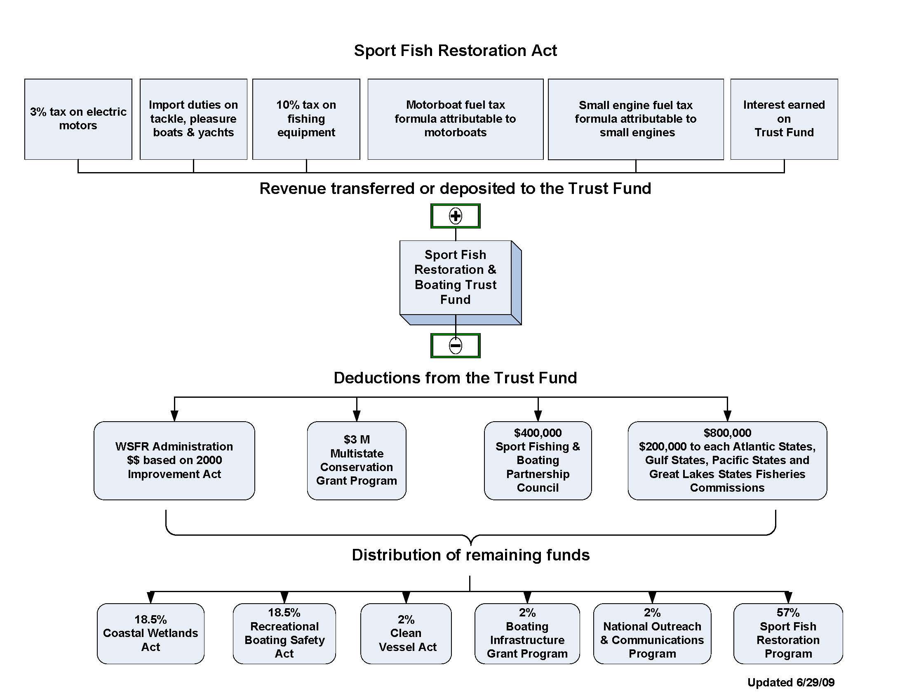

BIG Grant Types
  - Tier I- State
  - Projects cannot exceed $200,000 in federal funding.
  - Compete against other VA projects.
  - One or more may be selected pending number of requests and amount of Federal share
  - Can submit more than one as long as the projects are not dependent on completion of the other. Must stand alone.
  - Tier II- National
  - USFWS expects to award approx. $10-14 million/funding cycle.
  - $1.5 million (federal) funding limits on projects.
  - Compete against all other projects nationwide.
  - Can submit more than one as long as the projects are not dependent on completion of the other. Must stand alone.

Eligible Grantees, Infrastructures, and Pre-Award Costs
  - Grantees
Both public (state, county, cities, or towns) and private (any facility not associated with government) marina facilities located in Virginia are eligible for funding. Grantees must meet all Federal Regulations as detailed in USFWS 50 CFR Part 86. They also must comply with VA Procurement Requirements:
  - Minimum three (3) bids
  - Signed “Standard Contract”
  - Licensed tradesman, etc.
Grantees must complete an entity registration in SAM – http://www.sam.gov/. In terms of cost sharing or matching, the maximum Federal award under BIG Tier I is $200,000 and Tier II is $1.5 million. Maximum Federal Match up to 75% is equal to 0 points.
Cost share/match may be met through contributions from a third party. A third party is any individual/organization other than the State applicant. As the primary State grantee, you are responsible for the full amount of the non-Federal match including any amount provided by one or more third parties. This means that if your third party contribution falls through you, are responsible for the shortfall.
You must describe the nature of all proposed partnerships in the project narrative to allow reviewers to evaluate the proposed project against the criteria. You may request BIG funds for facility maintenance only if you will complete the maintenance action during the period of performance and only if it directly benefits eligible users and is directly related to the proposed BIG project. All user fees collected for use of BIG funded facility shall be applied to the maintenance of the facility. If you use BIG funds for maintenance at a facility that has received a BIG grant in the past, you must extend the useful life of each affected capital improvement.
Dredging that is needed to fulfill the purpose and objectives of the proposed project can qualify as an eligible action only if dredging-related actions do not exceed $200,000 in Federal funds, and you have allocated the dredging costs between the expected use by eligible and ineligible vessels. You must maintain the dredged area at the approved width and depth for the useful life of the BIG-funded facility, unless you are awarded BIG funds in the future that provide for maintenance dredging. You must record the Federal Interest in real property that includes a BIG-funded capital improvement.
  - Infrastructures

- Mooring buoys
- Day-docks
- Navigational aids
- Transient slips
- Safe Harbors
- Floating docks and fixed piers
- Floating and fixed breakwaters
- Dinghy docks
- Restrooms and showers
- Retaining walls, living shorelines
- Bulkheads
- Dockside utilities
- Pump-out stations
- Recycling and trash receptacles
- Debris deflection structures
- Marine fueling stations
- One-time dredging

  - Pre-award Costs
Only eligible for reimbursement if project is obligated and completed!
1. Conducting appraisals
2. Administering environmental reviews and permitting
- Conducting technical feasibility studies
4. Carrying out site surveys and engaging in site planning
5. Preparing cost estimates
- Preparing working drawings, construction plans, and specifications
*Must submit request to Regional Office (USFWS) for pre-award costs approval regarding eligible actions. USFWS will only reimburse pre-award costs if approved and if you receive a grant. The grantee incurs pre-award costs at their own risk.

Mandates
  - Facilities must:

- Be designed for temporary (less than 15 day visit) use by non-trailerable (greater than or equal to 26 feet), transient, recreational vessels (operated primarily for pleasure).
- Facility must be located on navigable waters.
- Transient slips or tie-up must have water depth greater than or equal to 6 feet at low tide.
- Allow reasonable public access to all recreational vessels.
- Charge equitable fees.
- Open for reasonable periods.
- Provide security, safety, and service (including a pump-out station for transient facilities).
- Designed to last at least 20 years, as determined through a capital improvement Useful Life Determination.
  - Built to Americans with Disabilities Act (ADA) compliance standards.
- All projects that receive federal funds under the BIG program must operate for at least 20 years in accordance with the Notice of Grant Agreement and program regulations.
- Place signage informing boaters that the project was funded through the Sport Fish Restoration and Boating Trust Fund and is restricted to transient boater usage only. (VDH provides signage)
- Allow reasonable access to all recreational vessels.
- Provide matching funds of 25% or more. Non-federal funds only.
- Place a Notice of Grant Agreement on the property deed declaring there is a federal interest on the property.
- Program income must be used for operation and maintenance of the funded infrastructure.
- The State is required to comply with FATA (Federal Funding Accountability and Transparency Act – sub-award reporting system criteria.

Application Timeline (FY 2017)
- February/March 2017 – CVA/BIG/Clean Marina Workshop(s)
- April – July 2017: Assist applicants in developing proposals
Expect USFWS 2016 BIG Request for Proposals (RFP)
- August 1, 2017: (first Monday): Applications/proposals due to VDH
- August 15, 2017: (tentative) Meeting of the BIG review/scoring committee
- September 2017: VDH proposals due to USFWS
- March 2018: USFWS/VDH announces awards
- FUNDS AWARDED
  - 2-year maximum to obligate funds after award date
  - 5-year maximum to complete the project after award date

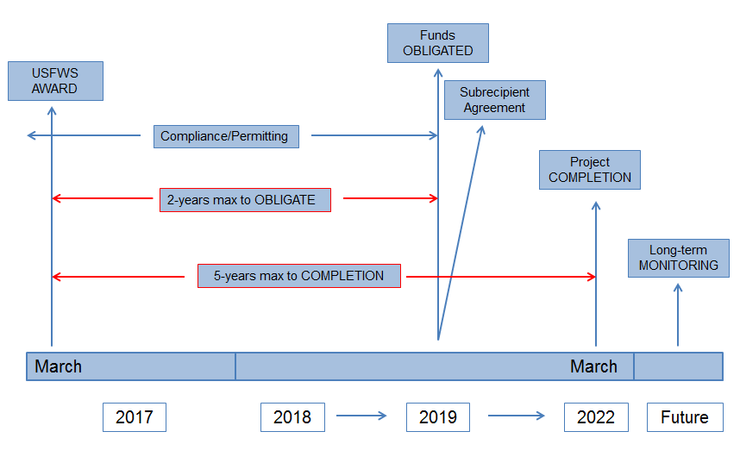
Award to Completion Timeline

Post Award Process
- Grantee provides documentation to VDH that required permits/approvals have been obtained (VMRC/USACE/Local Government) for the awarded project.
- VDH completes the required compliance analysis:
  - State Historic Preservation Office comments pursuant to Section 106 of the National Historic Preservation Act.
  - US Fish & Wildlife Service comments pursuant to Section 7 of the Endangered Species Act.
  - National Environmental Policy Act (NEPA) compliance checklist.
  - Boating facility must be in compliance with the Commonwealth of VA Sanitary Regulations for Marinas and Boat Moorings (12 VAC5-570-10) et seq.
- FUNDS OBLIGATED
  - Project must be completed within 5-years from AWARD date.

Post Obligation Process
- Sub recipient Agreement between VDH and the Sub grantee (Marina) detailing:

  - Scope of Services
  - Time of Performance
  - Compensation
  - Method of Payment
  - Terms and Conditions
  - Reporting Requirements
  - Federal Award Information
  - Whistleblower Protections

- Construction begins and is completed within the Sub recipient Agreement timeframe, unless extension requested for and granted.
- Start taking pictures for documentation.

Post Construction Process
- Upon construction completion, Sub grantee submits request for reimbursement with corresponding paid invoices.
  - Contact VDH to schedule a final inspection (scope of work)
  - All receipts stamped Paid in full
  - Federal Identification Number
  - Federal Interest Statement
  - Pictures taken for final report (before – during – after)
- VDH compliance monitoring for 20-years (useable life of the project construction). Constructed infrastructure must continue to:
  - Be used for transient vessels only.
  - Allow public access to shore and basic features including fuel and restrooms.
  - Comply with Americans with Disabilities Act requirements.

Program Income, User Fees, and Important Points
  - Program Income
This is income received by the subgrantee that is directly generated by a grant supported activity, or earned only as a result of the grant agreement during the grant period. “During the grant period” is the time between the start and ending of the Subrecipient Agreement. This is the construction phase. Any income generated during this period must be used for operation and maintenance of the funded infrastructure, as verifiable with receipts. Income generated from funded improvements after the "grant period" are considered User Fees.
  - User Fees
User Fees are fees charged to transient boaters for the use of the funded infrastructure, after construction is complete and the Subrecipient Agreement has ended. Fees charged must be comparable to those charged regionally. The collected fees should be used for operation and maintenance of the funded infrastructure for its useable life.
  - Important Points
- Funding may not be available year-to-year.
- This is a reimbursement program. Project must be completed and inspected by this office, using the scope of work, before reimbursement is made.
- Upfront costs (pre-agreement) associated with engineering, permit acquisition, etc., are activities eligible for reimbursement only if the project is awarded, funds obligated, project completed and APPROVED BY USFWS.
- Pre-agreement cost must first be approved by the USFWS- therefore; build it into the grant proposal

Proposal
You must submit the proposal (digital copies only) to VDH by August 1st, 2017 no later than 4:30 PM. Follow the USFWS published “Request For Applications” guidelines and provide detailed, digital color photos/maps as indicated. You must utilize the provided Scoring Criteria and Sample Proposals to maximize project competitiveness. Do not forget to PRORATE!
General guidelines:
- Formatted to fit on 8.5″ x 11″ paper
- 1″ margins
- 12 point Arial or Times New Roman font
- Project Statement should not be any longer than 10 pages.
  - Need
Explain why the project necessary/how it fulfills the purpose of BIG.
- Describe existing facilities available for transient vessel use.
- Describe how the proposed project fills a need or offers a benefit not offered by existing facilities.
- Provide information to support the number of transient boats expected to use the facility and demonstrate why existing facilities are insufficient to meet demand;

  - Purpose
State the ultimate purpose for the proposed project and link the purpose to the demonstrated need.
  - Objectives
Identify specific, measurable, attainable, relevant, and time-bound (SMART) objectives to be accomplished during the project period.
  - Expected Results or Benefits
Describe the expected results or benefits from accomplishing the objectives.
- Describe each capital improvement, service or other product that will result from the project.
- Describe how the structures, service, or other products will address the need(s) and benefits for eligible users.
  - Approach
Describe the approach to be used in meeting the objectives.
- Describe the methods, designs, and/or procedures to be used to achieve the objectives, providing enough information on the status of required permits or other compliance requirements (Section 7, 106, and NEPA).
- Identify the project officer who has or will have detailed knowledge of the project, are they the Federal Aid Coordinator for the State agency, provide contact information, and state whether they have signatory authority for committing the grantee to a course of action.
- Give name, contact information, qualifications, and role of each known concessioner or sub grantee.
- Explain how you will exercise control to ensure the BIG-funded facility continues to achieve its authorized purpose during the useful life of the facility.
- Provide timeline of activities.
  - Relationship With Other Grants
Describe any relationship between the proposed project and other related work funded by Federal grants that is planned, anticipated, or underway.

  - Budget Form
Complete the Budget Information for Construction Programs (SF 424C) or provide a budge spreadsheet that provides a similar or greater level of budget detail.
  - Budget Narrative
Explain and justify all requested budget items/costs. Demonstrate a clear connection between costs and the proposed project activities.
- Match and other partner contributions: Identify the cash/in-kind contributions that you, a partner, or entity contributes to the project. Describe how the contribution (s) will directly benefit the project.
- Contingency Costs: are permissible but must be separately identified in your budget, comply with federal cost principles, necessary/reasonable, and why they are necessary to improve the precision of your budget estimates
- Proration: Costs for facilities that will benefit operators of boats other than transient recreational vessels at least 26 feet long must be prorated. Examples – fuel docks, restrooms, showers, retaining walls, bulkheads, breakwaters, dredging and other features that may benefit ineligible users.
The basis or method you used to allocate costs between eligible and ineligible users;
Your reasoning and evidence supporting use of this method;
Why prorating is not necessary? 100% transient usage
- Program Income: VERY IMPORTANT – is gross income earned by you or your subgrantee that is directly generated by a grant-supported activity, or earned as result of the grant, during the grant period. Meaning; if the BIG project has not been completed and your earning revenue from the project in which you are seeking reimbursement then that money will be deducted from the Federal reimbursement – i.e. do not collect revenue on any part of the project until it has been completed, reimbursement has been issued, and the grant closed out! If not we must request approval for the additive method.
  - Equipment
Provide a list of equipment to be purchased with BIG fund, if any. The equipment listed must have a useful life of more than one year and an acquisition cost of $5,000 or more.

Useful Life
Estimate the useful life in years of each capital improvement for the proposed project. A capital improvement (structure) that cost at least $25,000 to build, repair, or renovate must have an estimated Useful life determination. You must reference a generally accepted method of how you determined the useful life.
  - Indirect Cost Statement
VDH Marina Program staff will add the required statement into your proposal.
  - Assurances “form”
Must be signed and submitted with the grant proposal. VDH- Marina Program staff will provide the form.

Ranking Criteria (BIG Scoring Criteria)
Maximum of 12 pages, total of 36 points
Criteria | Points
Need, Access, and Cost Efficiency (Sections 86.52, 86.53, & 86.54) | 20 total possible points
Will the proposed boating infrastructure meet a need for more or improved facilities? (Section 86.52)  - Construct new boating infrastructure in an area that lacks these facilities, but where eligible vessels now travel or would travel if the project were completed;  - Renovate a facility to:  - Improve its physical condition:  - Follow local building codes: (ADA requirements)  - Improve generally accepted safety standards; or  - Adapt it to a new purpose for which there is a demonstrated need;  - Create accessibility for eligible vessels by reducing wave action, increasing depth, or making other physical improvements;  - Expand an existing marina or mooring site that is unable to accommodate current or projected demand by eligible vessels; or  - Make other improvements to accommodate a demonstrated eligible need.  FOR EXAMPLE: REPURPOSE AN EXISTING BOATING FACILITY TO ACCOMMODATE TRANSIENT VESSELS IN AN AREA THAT HAD PREVIOUSLY LACKED TRANSIENT BERTHS OR MOORINGS. | 0-10
Will eligible users receive benefits from the proposed boating infrastructure that justify the cost of the project? (Section 86.53)  - Total cost of the project:  - Total benefits available to eligible users upon completion of the project; and  - Reliability of the data and information used to decide the benefits relative to costs.  - You must support the benefits available to eligible users by clearly listing and discussing in the project statement how they relate to Need  - Consideration of the cost relevant to all the benefits to eligible users supported in the application. The availability of existing structures and amenities may be considered. Please refer to the example provided near the end of Section 86.53 (Page: 23227)  STRONG EMPHASIS ON NEED! A PROJECT THAT IS ALREADY LOCATED IN AN AREA THAT HAS AN ABOUNDANCE OF TRANSIENT ACCOMMODATIONS WILL NOT BE AS STRONG A CANIDATE AS A PROJECT THAT PROVIDES TRASIENT AMENITIES IN AN AREA THAT LACKS SUCH. | 0-7
Will the proposed boating infrastructure accommodate boater access to significant destinations and services that support transient boater travel? (Section 86.54)  - The degree of access that the BIG-funded facility will give;  - The activity, event, or landmark that makes the BIG-funded facility a destination, how well known the attraction is, how long is it available, and how likely it is to attract boaters to the facility; and  - The availability of services near the BIG-funded facility, how easily boaters can access them, and how well they serve the needs of eligible users.  THIS COULD ALSO INCLUDE POTENTIAL FUNDING FOR A TEMPORARY TRANSIENT TIE-UP FACILITY VERSUS A FACIILTY THAT ALLOWS OVERNIGHT MOORING. THE TEMPORARY FACILITY WILL HAVE ESTABLISHED HOURS RESTRICTING THE LENGTH OF TIME A TRANSIENT BOATER CAN MOOR. | 0-3
Match and Partnerships: Section(s) 86.56 & 86.57 | 10 possible points
Partnerships – (Section 86.57)  - A non-Federal entity, including a sub-grantee  - A Federal agency (NATIVE AMERICAN TRIBE) other than the Service  - The partner must commit to a financial contribution, an in-kind contribution, or to take a voluntary action during the grant period.  - In-kind contributions or action must contribute directly and substantively to the completion of the project. You must explain in the grant application how it is necessary to complete the project. | 0-3
Match- (Section 86.56)  - Minimum match 25%  - The contribution may be from a State, a single source, or any combination of sources.  - Will award points as follows:  Percent cash match(Grantee) Points  0-25 0  26-29 1  30-39 2  40-49 3  50-59 4  60-69 5  70-79 6  80 or higher 7  Will the proposed project include private, local, or State funds greater than the required minimum match? | 0-7
Innovation- (Section 86.58, 86.59, & 86.60) | 6 total possible points
Will the proposed project include physical components, technology, or techniques that improve eligible-user access?  - Will the project increase the availability of the BIG-funded facility for eligible users or improve eligible users or improve eligible boater access to the facility by:  - Using a new technology or technique; or  - Applying a new use of an existing technology or technique.  - Must describe in the grant application the current standard and how you will exceed the standard  THE BIG ADVISORY COMMITTEE WILL NEED TO DISCUSS THIS IN GREATER DETAIL. I MAY BE INCORRECT IN MY ASSUMPTIONS BUT I WOULD THINK THAT IF THE BOATING FACILITY IS REPLACING FIXED DOCKS WITH FLOATING DOCKS, PARTICULARILY IN AN AREA THAT EXPERIENCES EXCESSIVE TIDAL FLUCUATIONS, THEN THIS ACTION WOULD IMPROVE ELIGIBLE-USER ACCESS. THIS WOULD ALSO INCLUDE ADA ACCESS. | 0-3
Will the proposed project include innovative physical components, technology, or techniques that improve the BIG-funded project?  - Newly available; or  - Repurposed in a unique way  - Examples of the type of innovations we will consider are components, technology, or techniques that:  - Extend the useful life of the BIG-funded project;  - Designed to allow the operator to save costs, decrease maintenance, or improve operation;  - To improve BIG eligible services or amenities;  - During construction, are used specifically to reduce negative environmental impacts; or  - Reduce the carbon footprint of the BIG funded facility.  WHEN EXTENDING THE USEFULL LIFE OF A FACILITY IT MEANS USING MATERIALS THAT REDUCE TIME ALLOCATED FOR MAINTENANCE. THIS COULD INCLUDE USING TREX DECKING AND OTHER MATIERALS THAT CAN ENDURE THE HARSH ENVIRONMENTS ASSOCIATED WITH BOATING FACILITIES. IN REGARDS TO REDUCING CARBON FOOTPRINT WE COULD POSSIBILITY LOOK AT ALTERNATIVE ENERGY SOURCES. | 0-2
Has the facility where the project is located demonstrated commitment to environmental compliance, sustainability, and stewardship and been officially recognized by an agency or organization?  - Has the BIG-funded project received official recognition for its voluntary commitment to environmental compliance, sustainability, and stewardship by exceeding regulatory requirements? (Documents must be provided supporting this recognition)  - The official recognition must be part of a voluntary, established program administered by a Federal or State agency, local government agency, Sea Grant or equivalent entity, or a State or Regional marina organization.  - The established program must require the facility to use management and operational techniques and practices that will ensure it will continue to meet the high standards of the program and must contain a component that requires periodic review.  - The facility must have met the criteria required by the established program and receive official recognition as the time of the application. | 0-1
TOTAL POSSIBLE POINTS | 36

Criteria Points
BI meets a need for more/improved facilities 0-10
Eligible users’ rec. benefits that justify cost 0-7
Boater access to destinations and services 0-3
Private, local, or state funds > minimum 0-7
Contributions by private or public partners 0-3
Include physical, technological, or techniques 0-3 (improve user access)
Innovative physical, technological or techniques 0-2
Commitment to environmental Compliance (award) 0-1
Total Possible Points 36

Checklist
  - Research the BIG program on VDH and USFWS websites.
  - Read the RFA’s and Federal Register.
  - Consult your marina peers who have completed past projects
  - Attend VDH BIG Workshop
  - Maintain email communication throughout
  - Do you have match funds?
  - Minimum 25%, typically closer to 50% for Tier II.
- Contact VDH (Preston Smith) for assistance

