In the winter months EMS providers often focus on treating patients suffering from the results of cold exposure, but often we forget to think about our own exposure. Cold weather can cause significant health issues. We must understand and recognize the signs and symptoms of cold exposure injuries in ourselves so we can take steps to limit the impact.
Hypothermia
Definition: A condition in which body uses up its stored energy and can no longer produce heat.
Early Symptoms: shivering, fatigue, loss of coordination, confusion/disorientation
Late Symptoms: no shivering, blue skin, dilated pupils, slowed pulse &respirations, unconscious
Treatment: Move to warm area; Warm center of your body; if conscious drink warm beverage; stay dry and wrapped in multiple layers
Frost Bite
Definition: Injury to the body caused by freezing, most often affecting nose, ears, cheeks, chin, fingers, or toes
Symptoms: Reduced blood flow to hands and feet, numbness, aching, tingling or stinging, bluish or pale, waxy skin
Treatment: Get into warm room, do not walk on frostbitten feet (if possible), immerse area in warm water or warm with body heat; do not massage frostbitten areas!

Protect Yourself!
Monitor your condition
Wear appropriate clothing – Layer for insulation
Protect ears, face, hands, and feet – Boots should be waterproof; wear a hat!
Move to warm locations during breaks
Carry extra socks, gloves, hats, jackets, blankets, and a change of clothes
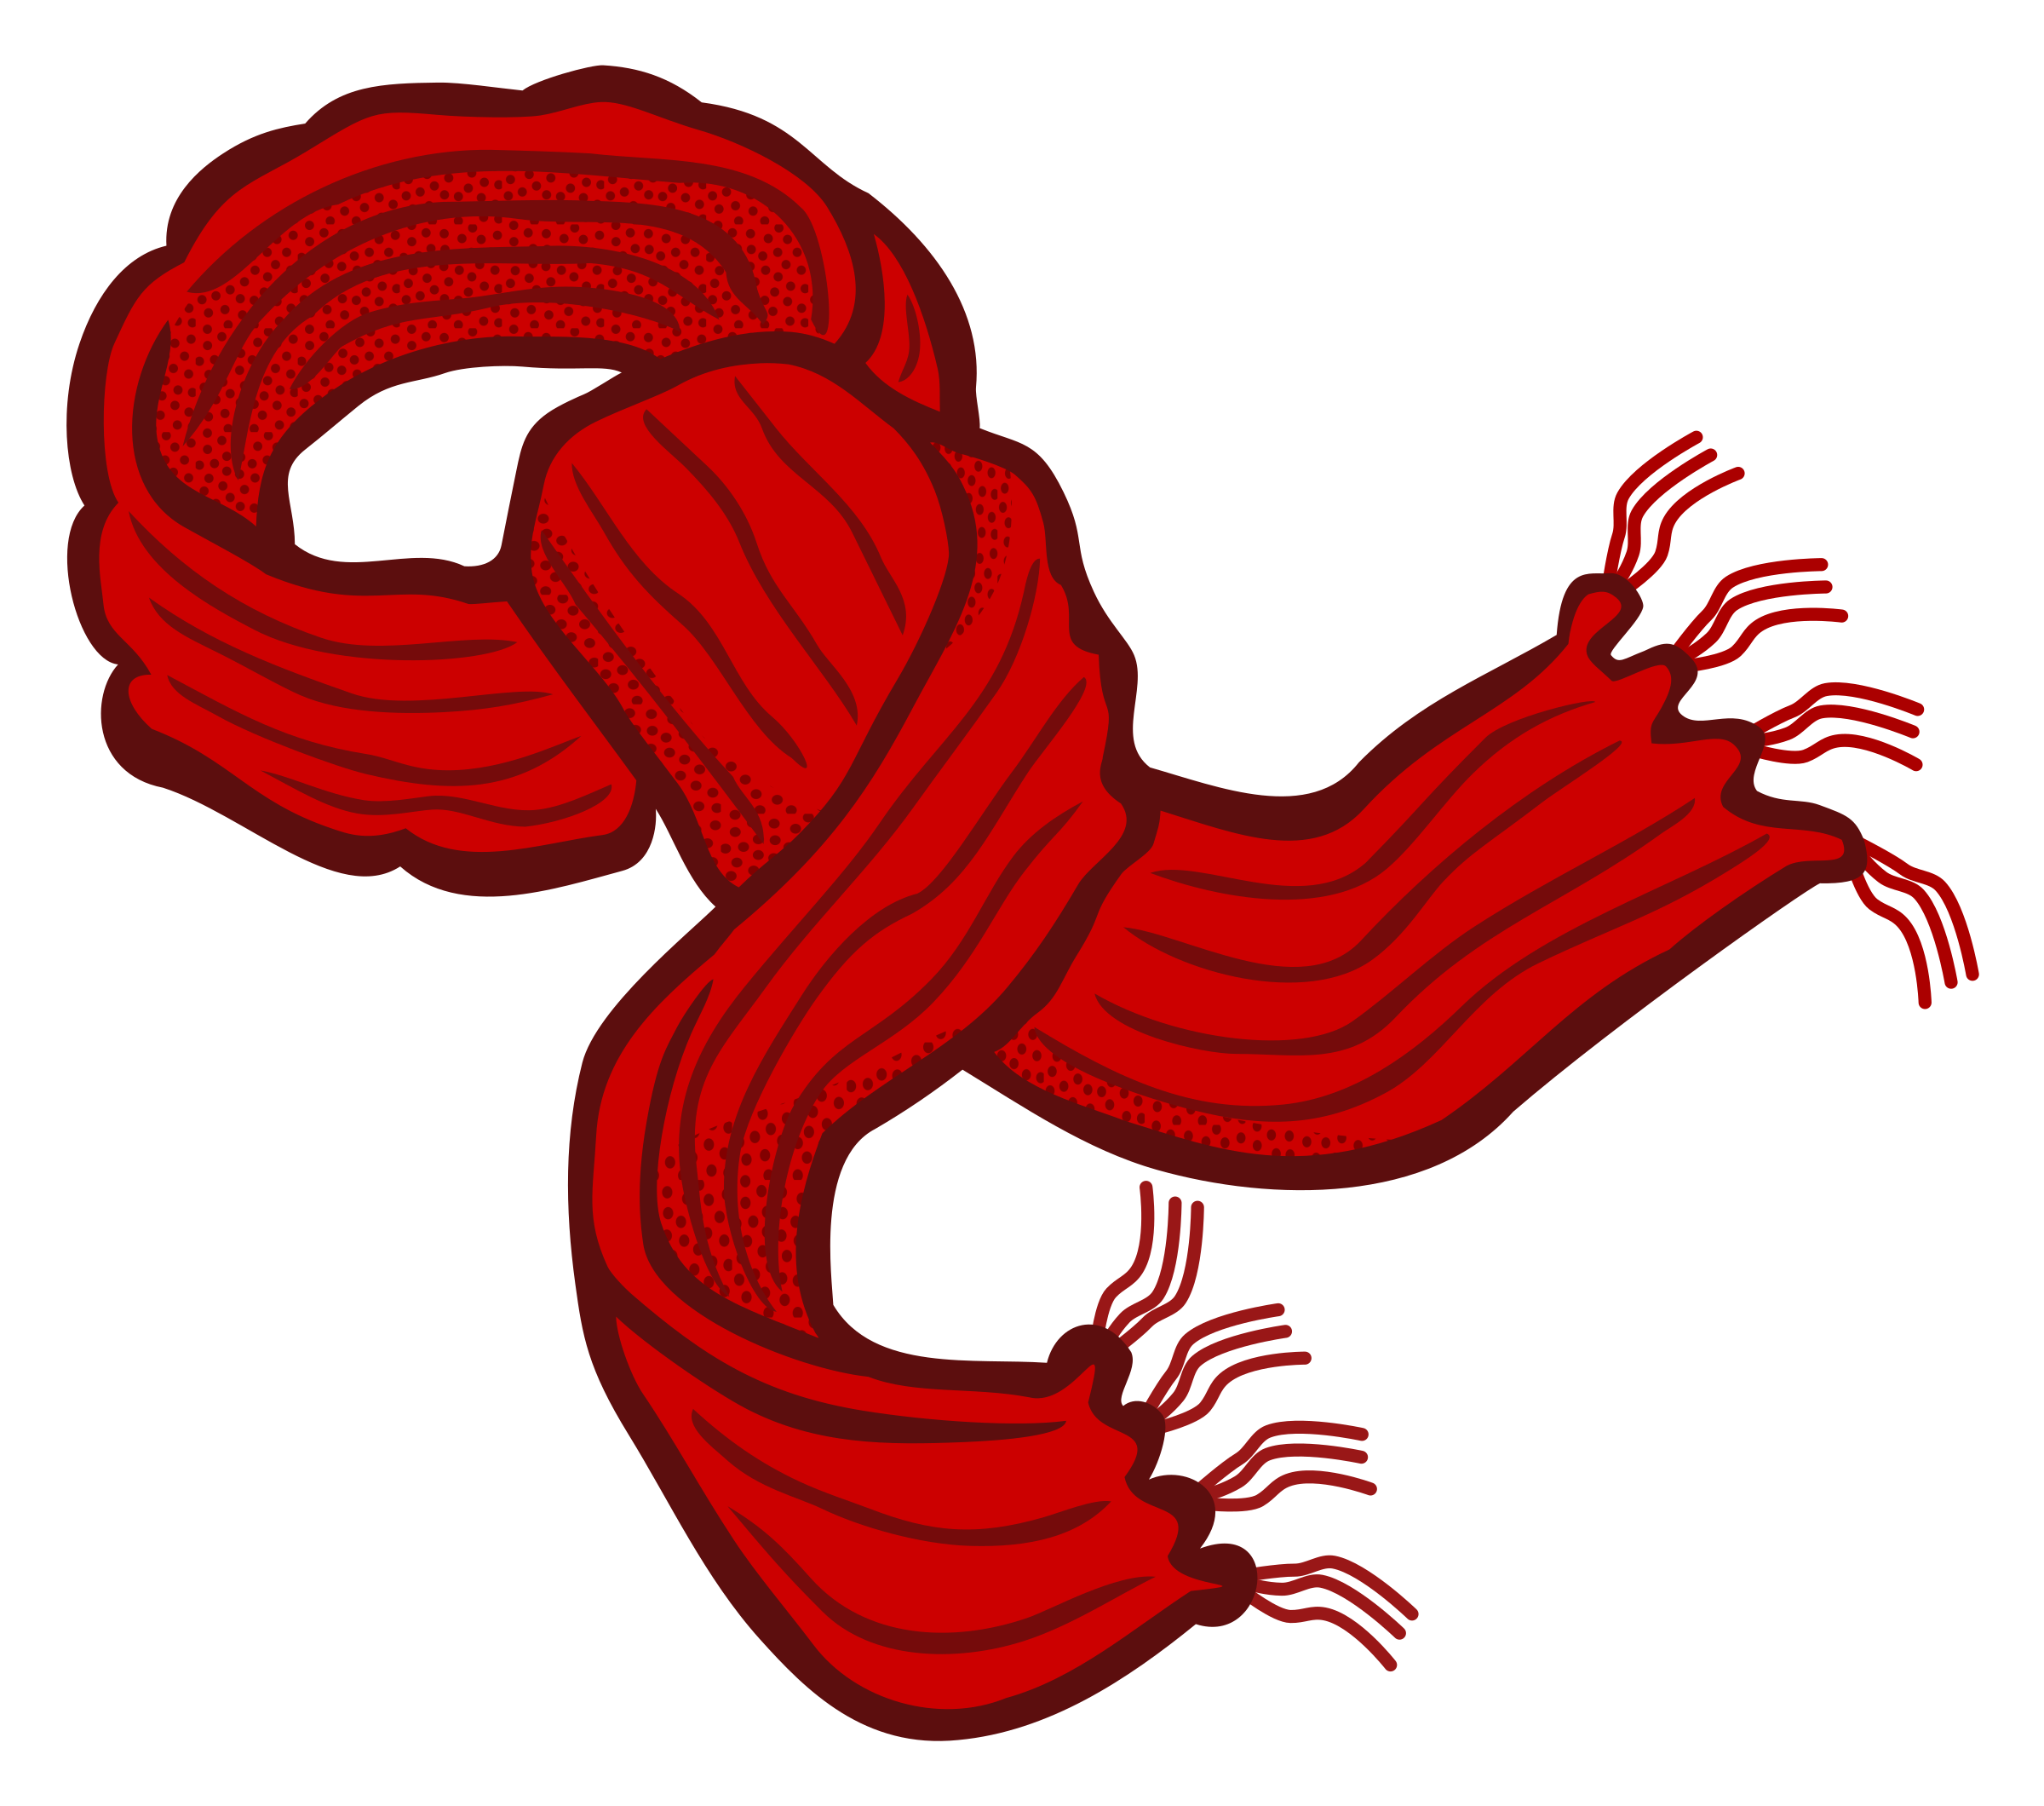

Remember – you can’t help others if you become a patient yourself!

