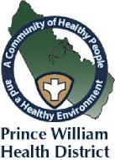 | The Prince William Health District is dedicated to  promoting optimum wellness, preventing illness,  responding to emergencies and protecting the  environment and health of our residents.

What is Public Health in the Prince William Health District?

Public Health is the science of protecting and improving the health of entire populations through promotion of healthy lifestyles, disease and injury prevention and detection and control of infectious diseases.

Our population includes Prince William County, Manassas City and Manassas Park, and it is our vision that this will be a community of healthy people and a healthy environment.

Public Health Focus: Prevention

Unlike clinical professionals, who focus primarily on treating individuals after they become sick or injured, as public health professionals we try to prevent problems from happening or recurring by implementing educational programs, recommending policies, administering services and conducting research. We work with local, regional and national partners to limit health disparities and promote healthcare equity, quality and accessibility.

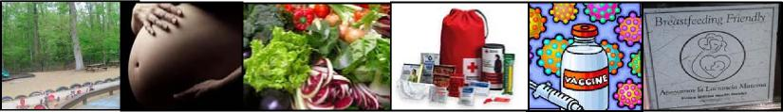

How does the Prince William Health District promote public health?

- We monitor the health status of the community. This includes tracking trends in health indicators such as vaccination rates among children.

- We detect, investigate and appropriately address reportable communicable diseases in the community. Examples include foodborne and other gastrointestinal diseases, respiratory illnesses and sexually transmitted infections.

- We offer immunizations and health screenings, making referrals to other systems, programs and clinics when necessary. We work with local health providers and social service departments to ensure that patients receive coordinated care.

- We ensure food and water safety. We ensure compliance with regulations or laws by inspecting restaurants, hotels and care facilities.

The Prince William Health District is dedicated to
promoting optimum wellness, preventing illness,
responding to emergencies and protecting the
environment and health of our residents.
How does the Prince William Health District promote public health?

- We foster safe and healthful physical environments. Activities include inspecting onsite sewage, ground water, encouraging Chesapeake Bay protection and more.

- We limit, prevent, and alleviate environmental hazards. This includes assisting in the repair of failing septic systems, handling chemical spills and promoting preparedness.

- We provide nutrition education, healthy foods and breastfeeding support for Women, Infants & Children. The WIC program encourages healthy pregnancy outcomes, healthy eating and general better health.

- We train for and plan responses to a wide range of health threats and emergencies. Recent examples include our response to Zika and Ebola and natural disasters.

- We implement evidence-based health prevention strategies. We promote initiatives including worksite wellness and breastfeeding programs, among others.

- We promote healthy behaviors through education and counseling. This encompasses anything from hand-washing practices to preconception health education for better birth outcomes.

- We provide leadership and instruction on emerging health issues. Spearheading efforts in the community to address issues ranging from the flu to childhood obesity.

- We conduct primary and secondary research on various public health issues. Research ranges from community-wide health assessments to studies on specific topics like breast cancer awareness.

- We partner with community organizations to support systemic solutions to health concerns. We co-lead the Live Well! Coalition, a variety of organizations and agencies dedicated to preventing chronic disease.

- For more information about the Prince William Health District, visit www.vdh.virginia.gov/Prince-William.
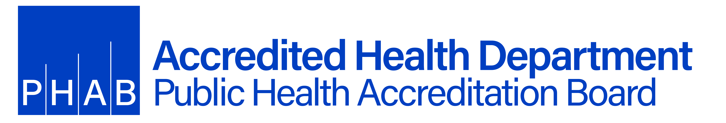

8/4/2017

