Efforts to improve primary care for children in the U.S. have focused on the development and implementation of practice models and payment reforms to create delivery models to effectively coordinate clinical and social services that children may require; the practice supports the core functions of primary care and the management of chronic disease conditions. In addition to payment reforms, add-ons to primary care delivery include care coordination outside the context of an office visit, adoption of health information technology, and interactions with patients and families by phone or email.
Medical Home
The medical home is best described as a model or philosophy of primary care that is patient-centered, comprehensive, team-based, coordinated, accessible, and focused on quality and safety. It has become a widely accepted model for how primary care should be organized and delivered throughout the health care system, and is a philosophy of health care delivery that encourages providers and care teams to meet patients and families where they are, from the simplest to the most complex conditions. It is a place where patients are treated with respect, dignity, and compassion, and enable strong and trusting relationships with providers and staff. Above all, the medical home is not a final destination. Instead, it is a model for achieving primary care excellence so that care is received in the right place, at the right time, and in the manner that best suits a patient’s and family’s needs.
Efforts to strengthen medical home models are based on communication, payment, and broader community acceptance and support (see Table).
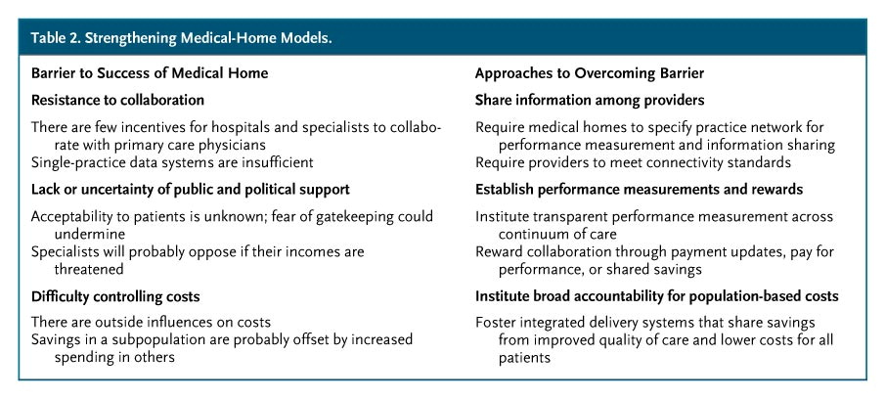

The medical home model has great potential to improve the provision of primary care and the financial stability of primary care practice. To effectively implement a medical home model in concert towards the improvement of patient care, it needs a hospitable and high-performing medical neighborhood.

Medical Neighborhood
The medical neighborhood is defined by the Patient-Centered Primary Care Collaborative as a clinical-community partnership that includes the medical and social supports necessary to enhance health, with the medical home serving as the patient’s primary “hub” and coordinator of health care delivery. The goals of a high-functioning medical home include collaborating with various medical neighbors to encourage the flow of information across and between clinicians and patients, to include specialists, hospitals, home health, long term care, and other clinical providers. In addition, non-clinical partners like community centers, faith-based organizations, schools, employers, public health agencies, YMCAs, and even Meals on Wheels. Together these partners can actively promote care coordination, fitness, healthy behaviors, proper nutrition, as well as healthy environments and workplaces (see model below). The Agency for Healthcare Research and Quality (AHRQ) articulates that a successful medical neighborhood will “focus on meeting the needs of the individual patient, but also incorporate aspects of population health and overall community health needs."
