​​​ TEXT4BABY- text4baby.org
Text4baby is a free app for pregnant and new mothers. Text4baby sends FREE text messages with health information and helpful tips during pregnancy and until your baby turns 1. You can also use Text4baby to send yourself FREE appointment reminders.
Text message topics include:
- What to Expect for Labor
- Mom and Baby’s Doctor visits and appointment reminders
- Healthy Eating for mom and Baby
- Safe Sleep and Travel
- Urgent News
- Health Insurance Information
- Resources Hotlines and Websites
It’s easy to sign up! Text BABY to 511411. Envia BEBE al 511411 and visit text4baby.org for more information.

What Is SIDS?

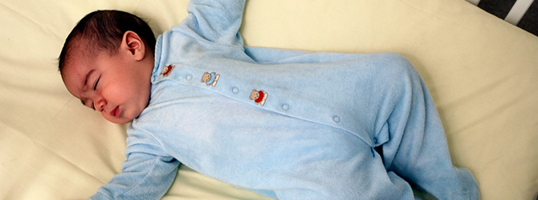
Sudden Infant Death Syndrome (SIDS) is the sudden, unexplained death of a baby younger than 1 year of age that doesn’t have a known cause even after a complete investigation. This investigation includes performing a complete autopsy, examining the death scene, and reviewing the clinical history.
When a baby dies, health care providers, law enforcement personnel, and communities try to find out why. They ask questions, examine the baby, gather information, and run tests. If they can’t find a cause for the death, and if the baby was younger than 1 year old, the medical examiner or coroner will call the death SIDS.
If there is still some uncertainty as to the cause after it is determined to be fully unexplained, then the medical examiner or corner might leave the cause of death as “unknown”.

What Does a Safe Sleep Environment Look Like?
You can reduce your baby’s risk of SIDS and other sleep-related causes of infant death in the following ways.
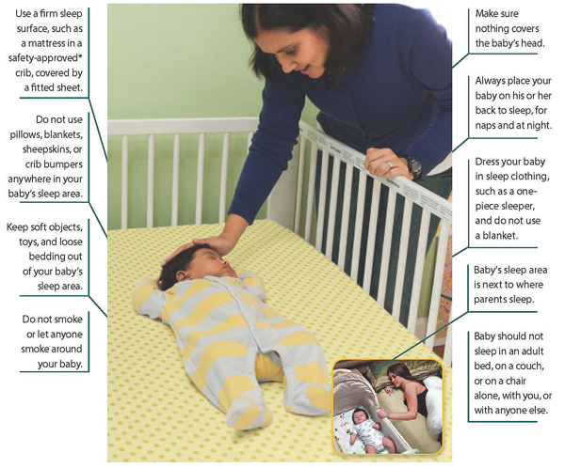
Printable versions of this safe sleep environment information are available below:
- What does a safe sleep environment look like? Reduce the risk of SIDS and Other Sleep-Related Causes of Infant Death
- ¿Cuál es la apariencia de un ambiente seguro para dormir? Reduzca el riesgo del síndrome de muerte súbita del bebé y de otras causas de muerte relacionadas con el sueño
*Visit the U.S. Consumer Product Safety Commission website for more information about crib safety: http://www.cpsc.gov/en/Safety-Education/Safety-Guides/Kids-and-Babies/Cribs/.
Please visit https://www.nichd.nih.gov/sts/about/environment/Pages/look.aspx for more information on SIDS and Infant Safe Sleep Practices.

