HAMPTON HEALTH DEPARTMENT
1320 LaSalle Ave., Hampton VA 23669 Phone (757) 727-2570 (Fax (757) 727-1227)
Worksheet for permitted Temporary Food Vendors visiting Hampton
The person named below is currently permitted to operate a temporary food establishment issued by the local health district of the Virginia Department of Health other than Hampton Health Department. Please submit this worksheet at least five (5) business days prior to the event for review and approval to ensure your operation does not exceed the conditions of your permit. Please use the attached checklist as food safety guidance when setting up and operating your booth.
Name of Permit Holder _____________________________________________ Phone (H) ____________________
Home Address__________________________________________________ Phone (W)_____________________
City __________________________ State __________ Zip Code _________ Phone (C)_____________________
E-mail address________________________________________________________________________________
Name of Organization/Business __________________________________________________________________
Event Associated with Sale _____________________________________ Date (s) of Sale ___________________
Location of Event ___________________________________________ Time (Hours) of Sale _________________

FOODS TO BE SOLD OR DISTRIBUTED
The sale of any home prepared or canned foods is prohibited. Home baked goods such as cakes, cookies, brownies, etc. may be allowed
FOOD SOURCE (Where purchased) PREPARATION (where & how)
1 ____________________________ _____________________________ _____________________________
2 ____________________________ _____________________________ _____________________________
3 ____________________________ _____________________________ _____________________________
4 ____________________________ _____________________________ _____________________________
5 ____________________________ _____________________________ _____________________________
6 ____________________________ _____________________________ _____________________________
You May Attach Additional Menu items to this worksheet
Water supplied by (e.g. city, bottled):

Wastewater disposal provided by (e.g. event, portable toilets):

The following items are also required and must be provided and/or used during the event:
- Plastic Gloves | - Handled ice scoop
- Sneeze Shields | - Hair restraints
- Food thermometer | - Food grade water hose
- Complete Hand washing station | - Hot and cold holding equipment
- Three-tub set-up | - Overhead protection
- Chlorine/Quaternary ammonia test strips | - Sanitizer buckets and wiping cloths

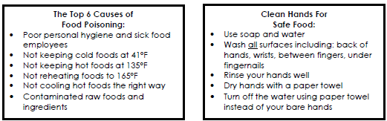

By signing this application, I do hereby agree to comply with the rules and regulations as outlined in 12 VAC 5-421 of the Virginia Food Regulations.
Signed ___________________________________________________ Date _________________________
Reviewed by ___________________________________ Date __________________________

