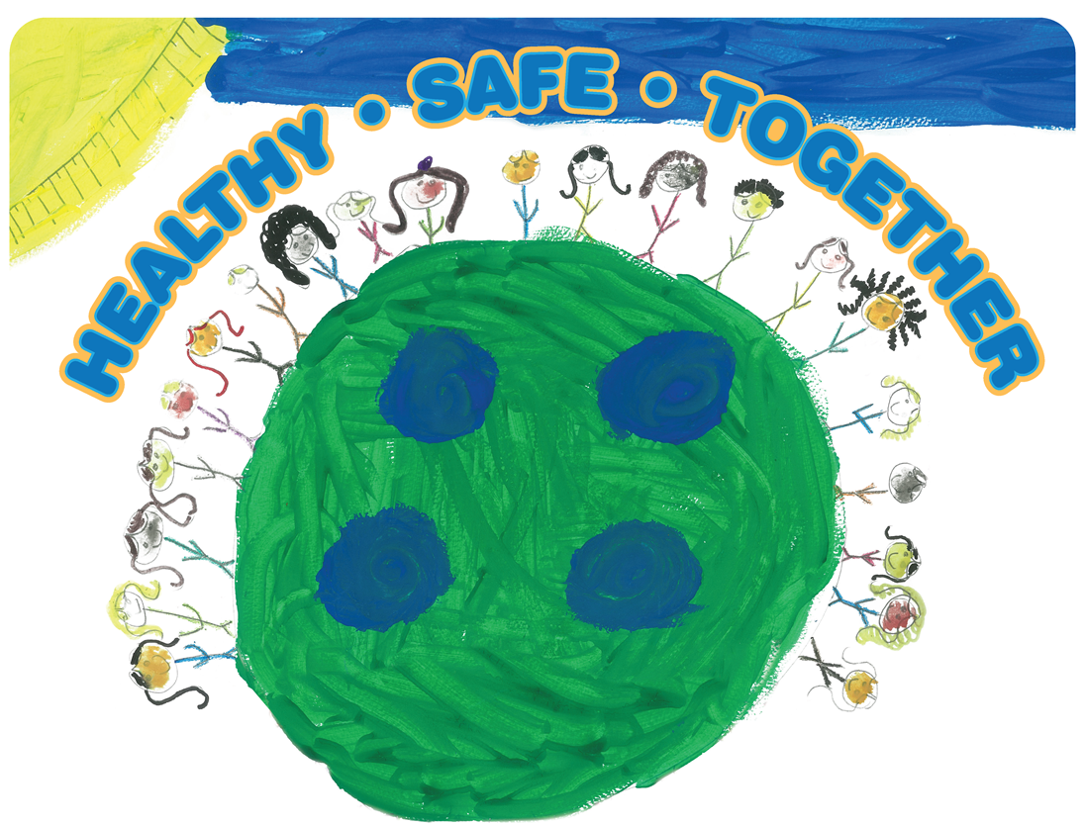Mobilizing for Action through Planning and Partnerships

Leadership Council Agenda

City Space
100 5th St NE
Charlottesville, VA 22902
August 17, 2016

Our Vision:
Together we support equitable access to resources for a healthy, safe community.

Our Values:

Accountability | Respect
Inclusivity | Teamwork

8:30 AM Introductions & Welcome – Aaron Pannone

8:40 AM Community Health Assessment Data Review – Elizabeth Beasley

9:30 AM Break

9:40 AM Community Themes & Strengths Assessment Results – April Carman

10:15 AM September – December Plan – Jackie Martin

10:30 AM Adjourn

Next Meeting: September 21, 2016, 8:30 – 10:30 AM

