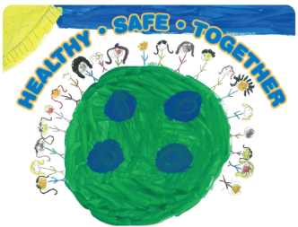
2019 MAPP2Health

Charlottesville/Albemarle MAPP Council Agenda

Tuesday, December 4, 2018, 8:30–10:00 am

Charlottesville/Albemarle Health Department, Entrance #3, 1138 Rose Hill Drive, Charlottesville, VA 22903

Our MAPP Vision:
Together we support equitable access to resources for a healthy, safe community.

Our MAPP Values:
Accountability | Respect
Inclusivity | Teamwork

8:30 AM Introductions & Welcome – Ruth Gaare Bernheim and Rebecca Schmidt

8:40 AM 2019 MAPP2Health Overview – Putnam Ivey de Cortez

9:05 AM Unnatural Causes Documentary Clips – Putnam Ivey de Cortez

9:20 AM Unnatural Causes & Equity Discussion – Elizabeth Beasley & Jackie Martin

9:55 AM Next Steps – Putnam Ivey de Cortez

10:00 AM Adjourn

Next meeting:
Tuesday, February 12, 2019
8:30–10:00 AM
Charlottesville/Albemarle Health Department, Entrance #3
1138 Rose Hill Drive, Charlottesville, VA 2290

