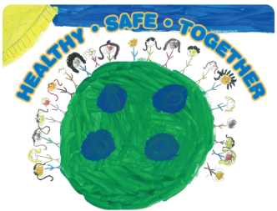
2019 MAPP2Health

Nelson Interagency Council (IAC) Agenda

Monday, January 14, 2019, 2:00–3:30 Pm
The Nelson Center, 8445 Thomas Nelson Highway Lovingston, VA 22949

Our MAPP Vision:
Together we support equitable access to resources for a healthy, safe community.

Our MAPP Values:
Accountability | Respect
Inclusivity | Teamwork

2:00 PM Introductions & Welcome – Randy Pirtle

2:05 PM 2019 MAPP2Health Overview – Putnam Ivey de Cortez

2:20 PM Unnatural Causes Documentary Clips – Putnam Ivey de Cortez

2:35 PM Unnatural Causes Equity Discussion – MAPP Core Group

2:55 PM Photovoice Project Selection – Jackie Martin and Diana Webb

3:10 PM Agency Updates – All

3:30 PM Adjourn

Next meeting:
Monday, March 18, 2019
2:00–3:30 PM
The Nelson Center
8445 Thomas Nelson Highway, Lovingston, VA 22949

