2019 MAPP2Health

Greene Agencies Coming Together (ACT) Meeting Minutes

Monday, January 28, 2019, 10:00 AM–12:00 PM

Region 10 Conference Room, 9963 Spotswood Trail, Stanardsville, VA 22973

Our MAPP Vision:
Together we support equitable access to resources for a healthy, safe community.

Our MAPP Values:
Accountability | Respect
Inclusivity | Teamwork

Introduction & Welcome – James Howard, Director of Greene Social Services

2019 MAPP2Health Overview
- See the attached presentation for further details and an overview of the process.
- Infographic from the CDC’s Community Health Improvement Navigator is a succinct way of explaining and understanding the idea of assessing and improving health and well-being for all (e.g. MAPP2Health).
  - See also the attached handout: “Who, What, Where, How of Improving Community Health” from the CDC’s Community Health Improvement Navigator. Also available here: https://www.cdc.gov/chinav/index.html.
- Since 2007, our district has used the MAPP framework. Mobilizing for Action through Planning and Partnerships (MAPP) is a strategic framework to engage community stakeholders, key organizations, and citizens to come together to review health indicators and determine community health priorities for focus and improvement. In the 2016 MAPP process, 105 community partners and 10 community coalitions reviewed and discussed quantitative and qualitative data and 2,885 community members provided feedback on strengths and areas for improvement. These discussions led to the adoption of four priorities, described in the 2016 MAPP2Health Report:
  - Promote Healthy Eating and Active Living
  - Address Mental Health and Substance Use
  - Reduce Health Disparities and Improve Access to Care
  - Foster a Healthy and Connected Community for All Ages
- The 2019 MAPP2Health process will build on the work of the 2016 process by diving deeper into each of the priorities through the lens of health equity.
  - Have you seen these depictions of health equity before?
    - Baseball
    - Apple tree
    - Bicycle
  - See the attached handout for further details on the 2019 MAPP process: “Join the Greene ACT for MAPP2Health.”
  - MAPP Core Group is Thomas Jefferson Health District (TJHD), Sentara Martha Jefferson Hospital (SMJH), UVA Health System (UVA HS), and UVA Department of Public Health Sciences (UVA DPHS). Group meets regularly for planning, logistics, and coordination.
  - The Core Group is partnering with the MAPP Leadership Council (district-wide organizations and community coalitions), Charlottesville/Albemarle MAPP Council, Fluvanna Interagency Council, Greene Agencies Coming Together, Louisa Interagency Council, and Nelson Interagency Council for a series of three MAPP meetings.
    - See the attached flyer “Join the Greene ACT for MAPP2Health” for Greene meeting dates, times, and locations. Feel free to share with others that might be interested!
  - There are also two new groups: the MAPP Data & Evaluation Committee and the MAPP Best Practices Work Group. If you are interested in learning more or joining, please contact Putnam Ivey de Cortez at putnam.ivey@vdh.virginia.gov.
  - Community engagement builds on the 2016 process that included input from almost 3,000 residents on areas of strength and areas in need of improvement to help with prioritization. For 2019 process, looking for more in-depth information on areas of strength and community + cultural assets through Photovoice projects.
  - There will also be MAPP funding available to each locality, including Greene, to move forward selected strategies around the MAPP priorities. Come to the third meeting to find out more.

Unnatural Causes Documentary Clips
Played selected clips from the four-hour Unnatural Causes documentary.
- Trailer
- Unemployment Affects Family
- Kim Anderson’s Story

Unnatural Causes Discussion
- See the attached Unnatural Causes handout, “10 Things to Know about Health.” Also available at: https://www.unnaturalcauses.org/handouts.php.
- To learn more about racial and socioeconomic inequities in health, visit https://www.unnaturalcauses.org/. The website contains descriptions of each episode, discussion guides as well as other tools and handouts, resources, and an action center.

Discussion:
- Health behavior affects health status
- Access to care affects health status
- Regarding the clip “Kim Anderson’s Story,” discussed the effects of racism and chronic stress on health (see the Unnatural Causes handout: #3 Racism imposes an added health burden and #6 Chronic stress can be toxic). Impact of trauma, chronic stress, and race compounded by intergenerational trauma changes health outcomes. Adverse childhood experiences (ACEs) can also impact health.
- Question posed: What can we do?
  - Changing policies, systems, and environments currently in place
    - School meals example:
      - Food that you get at school is defined by the school district that you are in. Are there policies in place to ensure meals are healthy? Change ordering and prep systems to include more fresh fruits and veggies, less processed.
    - Food banks
      - Less expensive options are canned and processed foods (now) but in the long run it will be more costly because of health outcomes
  - Changing health behaviors is important but difficult. How can you change health behavior?
    - Education: If you don’t know how, do you know to do better?
    - Takes time
    - In addition to working with individuals on health behaviors (how can we better educate, counsel, coach, and engage?), also important to consider things that are ingrained in the way that we offer services that don’t make healthy options the default. Also, how can we examine the structures that we currently have in place to provide more equitable care? What are we doing to put up barriers to the people we serve?
- Clients are often worrying about things other than health including: unemployment (don’t have insurance), a place to live, violence (Unnatural Causes handout #4: the choices we make are reflected by the choices we have)
- Demographics of Greene County are 90% white; need to work on creating a sense of trust for minority communities and addressing barriers that may exist (like language barriers)
- Other things that affect health include criminal record, race/ethnicity, legal status, etc.
Photovoice Project Selection
- See the attached flyer for an overview of Photovoice.
- Watch a video of the first Photovoice project: https://bcove.video/2PCQVLW.
- What is a group in Greene that may experience health disparities and could participate in Photovoice?
  - Move2Health Coalition will reach out to Greene Care Clinic to follow up about a Photovoice project with the uninsured population.
Greene County Data Profile
- See presentation, draft Greene County Data Profile handout, and TJHD Community Survey handout for data and additional information.
- MAPP priority indicators and other data: https://public.tableau.com/profile/thomas.jefferson.health.district#!/
- Before hearing the presentation, meeting attendees walked around to review several data posters and highlight the following. Pictures of the started posters are below.
  - Blue = What stands out to you?
    - Opioids (by locality)
    - Adult obesity (Greene County)
    - Child obesity (Greene County)
    - Total Low Birth Weight
    - Percent Uninsured
    - Percent of Smokers (sticker on this side) and Poor Mental Health Days
  - Green = Do you see any differences in the data (better/worse outcomes) by geography, race, age, gender, etc.?
    - On-Time Graduation Rates
    - Access to Exercise Opportunities (Greene)
    - Life expectancy estimates
    - Child obesity (Greene County)
    - Families below Federal Poverty Level
  - Yellow = Is there a topic where you’d like to see more data or have more discussion?
    - On-Time Graduation Rates
    - Free and Reduced Lunch
    - Opioids (by locality)
    - Black Low Birth Weight
    - Families below Federal Poverty Level
    - Percent Uninsured
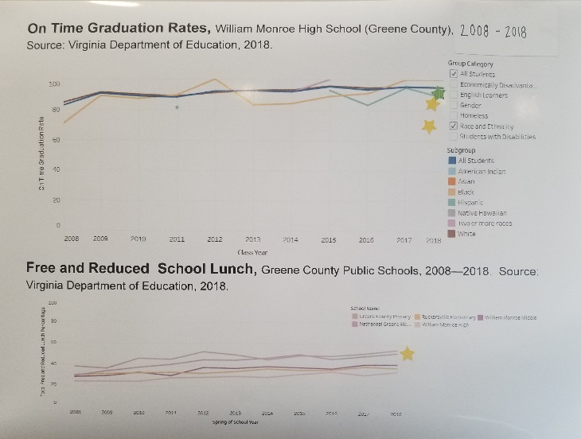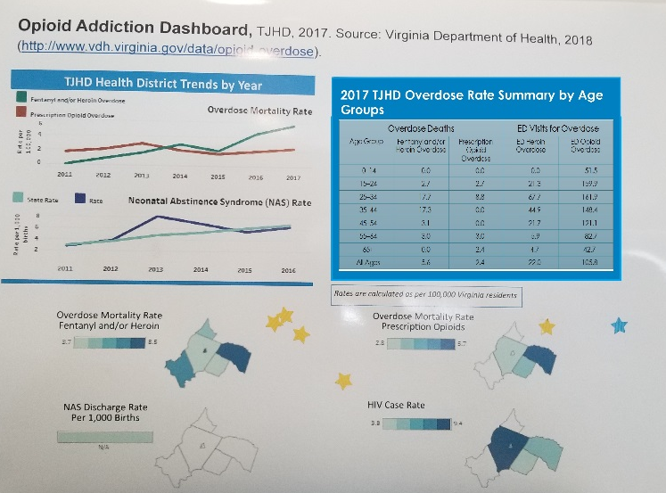
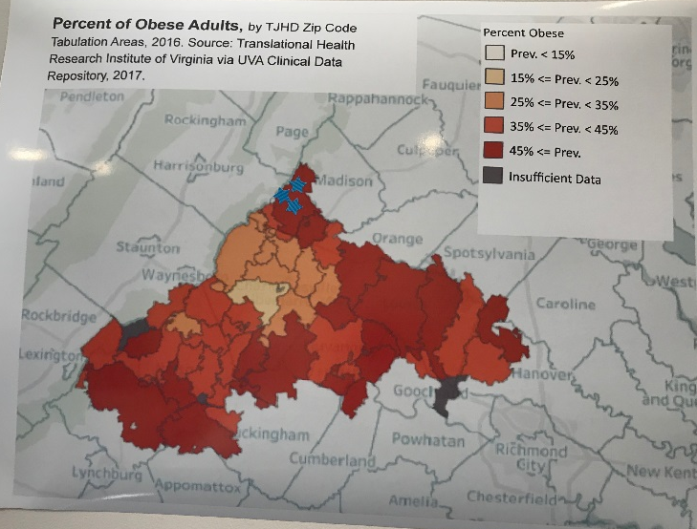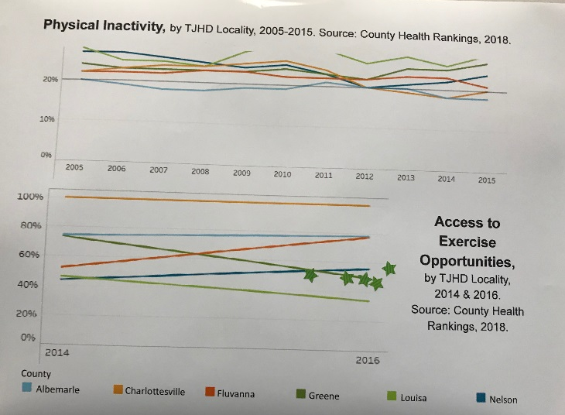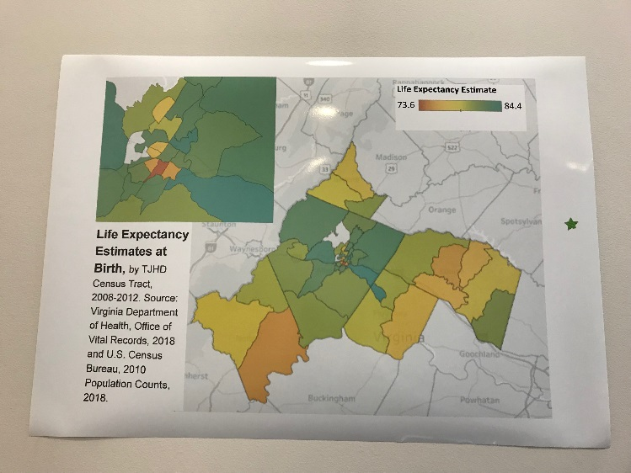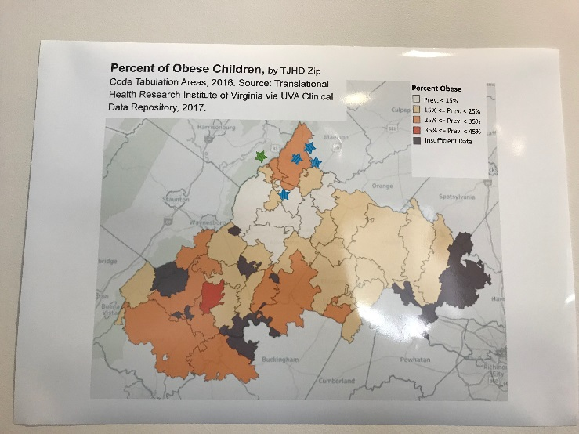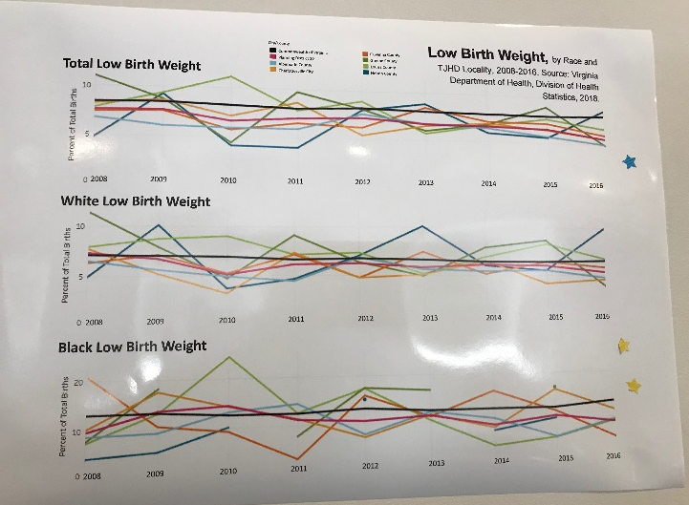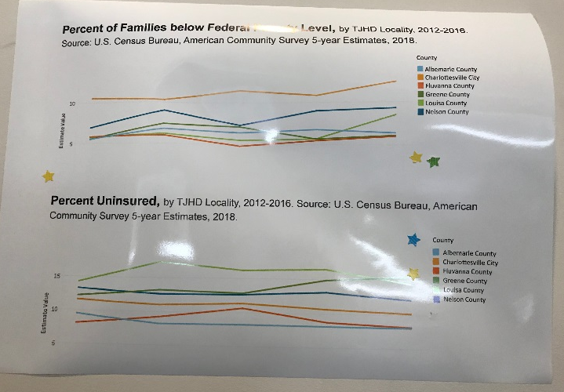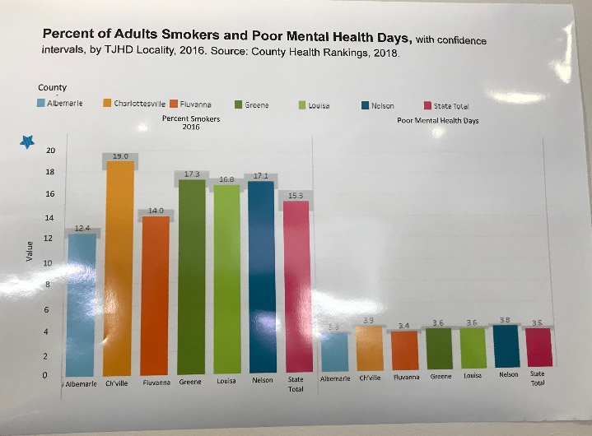
Data & Equity Discussion
- What stands out to you?
  - Mental health slide is interesting
    - City living vs country living and the effect on number of poor mental health days
  - Asset Limited, Income Constrained, Employed (ALICE) is a cost of living estimate produced by the United Way (national)
    - The amount of money to take care of a family with children in pre-school is high
  - Access to exercise opportunity decrease in Greene county is likely because of a park/gym/community center closing between 2014 and 2016
- Health disparities are differences in health status (different than health equity)
  - Disparities could be by income, race, ethnicity, gender, education, age, employment status, sexual identity, homeownership and housing status, immigration status, etc.
  - Do you see any differences in health outcomes?
  - Place matters. Our zip code is a strong indicator of our health. Do you see any geographic differences in the data?

Next meeting:
Monday, April 29, 2019
10:00–11:30 AM
Region 10 Conference Room
9963 Spotswood Trail, Stanardsville, VA 22973

