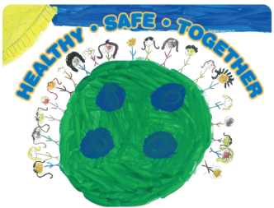
2019 MAPP2Health

MAPP Data and Evaluation Committee Meeting Minutes

Friday, February 8, 2019, 9:00–10:30am
CitySpace, 100 5th St NE, Charlottesville, VA 22903

Introduction and Welcome – Aaron Pannone
- Aaron Pannone welcomed and the group introduced themselves

Unnatural Causes – Putnam Ivey de Cortez
- The group watched three clips from a PBS documentary series entitled Unnatural Causes including the trailer for the documentary, Kim Anderson, and Living in Disadvantaged Neighborhoods is Bad for Your Health
- Putnam noted that the health department had a couple of copies of the documentary available to lend if any local groups wanted to view in its entirety
- A discussion about the clips followed

Data Discussion
- Graham Dillon will follow-up via email and phone

HUMAINS Presentation – Titus Castens
- HUMAINS is a holistic view of breaking down barriers, working to resolve issues, and limiting threats faced by our residents—the whole purpose is prevention
- The goal of HUMAINS is trying to ensure the patient receives the right care, by the right provider, at the right time, at the right place, at the right cost
- Lots of barriers in the system prevent patients from using a clinic
  - Clinic hours, ERs are always open, can see a provider more quickly
  - The group discussed working together on this issue
- See attached presentation for more information

Next meeting:
Friday, March 8, 2019
9:00-10:30am
City Space on the Downtown Mall
100 5th Street NE, Charlottesville, VA 22902

