Health Equity Strategy Brainstorm
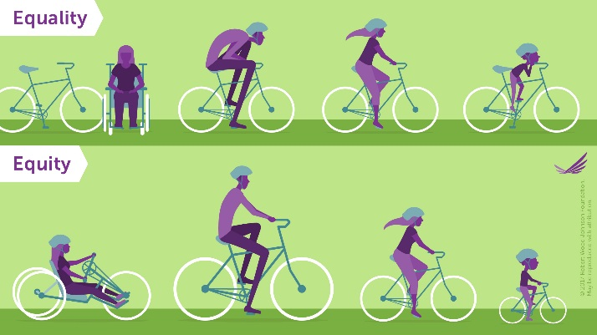

Health Equity
“Everyone has the opportunity to attain their highest level of health.”
– American Public Health Association (APHA)

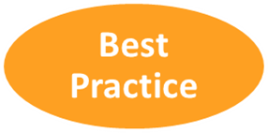 _________________________________________________________________________________________________________
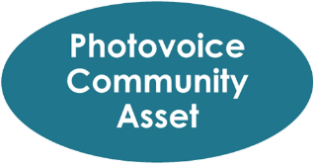 _______________________________________________________________________________________________________
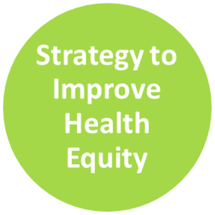 _________________________________________________________________________________________________________

Questions:
- How does your identified strategy fill a community need (expressed through community conversations, surveys, data, the MAPP report, etc.)?
- Additionally, how would your identified strategy focus on an area/community* of greatest need and make an impact (*a specific geographic area with need and/or a population that is historically underserved, underrepresented, experiences health disparities, etc.)?
- Who else needs to be included? What other organizations could you partner with or reach out to move forward this strategy? Which community members/groups should be part of the development and implementation of your strategy? Have you reached out to them?

