WIC- West Piedmont Health District Community Resources

Local Social Services Offices:
Social Services: Temporary Assistance to Needy Families (TANF), SNAP, Medicaid,
Energy assistance, Child Care, Medical Assistance etc… Apply for services on line at: www.commonhelp.virginia.gov
Henry-Martinsville Department of Social Services 20 Progress Drive, Martinsville 24115 P.O. Box 832, Martinsville, VA 24114  ph. 276-656-4300  Toll Free 855-635-4370 | Franklin County Department of Social Services  120 E Court St, Rocky Mount, VA 24151  Phone #: (540) 483-9247  Fax (540) 483-1933 | Patrick County Department of Social Services  106 Rucker St., Suite 128 Stuart, VA 24171  Phone: ( 276) 694-3328  Fax: (276) 694-8210
For after-hours CPS and APS concerns please contact the hotlines: for CPS is 1-800-552-7096 and for APS is 1-888-832-3858. You may apply for benefits online at CommonHelp, by phone at 1-855-635-4370, or for Medical Assistance only at 1-855-242-8282 (TDD: 1-888-221-1590).
Insurance: FAMIS (Family Access to Medical Insurance Security Plan)1-866-873-2647 (www.famis.org) FAMIS Outreach worker: Ann Walker 276-732-0509
Drug and Alcohol:

Piedmont Community Services:
- Martinsville: 24 Clay Street, Martinsville, VA 24112, ph. 276-632-7128
- Patrick: 22280 Jeb Stuart Highway, Stuart, VA 24171, phone 276-694-4361,
- Franklin County: 30 Technology Dr, Rocky Mount, VA 24151
Phone: (540) 483-0582
www.FindTreatment.gov You can also call: 1-800-662HELP (4357)

Dental Providers:
- Smiles For Children (SFC) is Virginia's Medicaid and FAMIS dental program
for adults and children. The SFC program is managed by DentaQuest.

- Connect Health + Wellness Dental: 276-638-0787
Smoking Cessation:
1-800-QUIT-NOW is the national portal to a network of state quitlines. Quit lines offer evidence-based support—like counseling, referrals to local programs, and free medication—to people who want to quit tobacco. The American Lung Association’s Freedom From Smoking® 1-800-LUNGUSA
Need a ride? Transportation services are available to Medicaid members
for their dentist appointments. Visit the Virginia Medicaid website
or contact your health plan for contact information to make a reservation.

Local Links: You will find more links on the left here to community resources. https://www.vdh.virginia.gov/west-piedmont/resources/



- Find Help- www.findhelp.org/ (Food, Housing, Goods, Transit,
Health, Money Care, Education, Work and Legal)

- 2.1.1 Virginia is a free service that can help you find local
resources that you need. Including Food Banks,
Utility Assistance and more
Local Resources:
Pregnancy Care Center-314 Fairy Street Suite E, Martinsville, VA 24112
276-634-5433 www.pregcc.com
Healthy Families: Healthy Families home visitors are living, breathing how-to manuals, supporting parents as they establish nurturing parent-child relationships, develop positive parenting skills, provide safe homes, and learn to support healthy child development. Phone: 276-656-0425 ext. 102
VDH Community Health Workers: Get the support you need every step of the way. Our caring team is here to help you reach your goals by providing encouragement, free baby care items, and helpful information. To learn more, contact Autumn at 273-403-8389
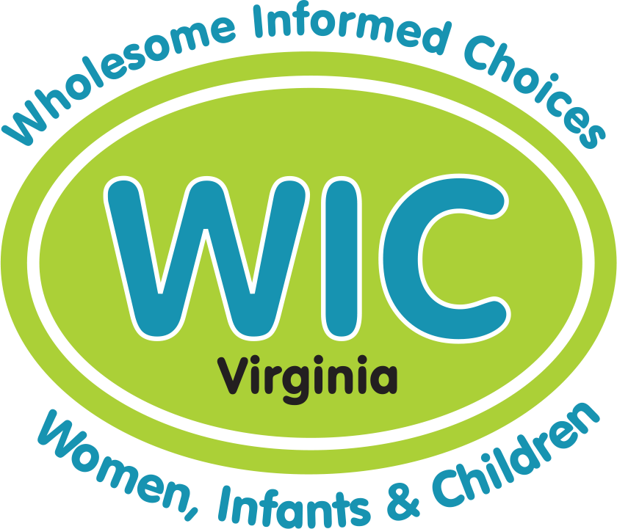

WIC Website:

Comments Questions or Concerns call TELL WIC at 1-877-295-5942, email: TellWIC@vdh.virginia.gov
The contents of this list are options and not all inclusive, nor are they endorsed by the WIC Program
In accordance with Federal law and U.S. Department of Agriculture (USDA) policy, this institution is prohibited from discriminating on the basis of race, color, national origin, sex, age, disability or retaliation. To file a complaint 1-866-632-9992 USDA is an equal opportunity provider and employer

