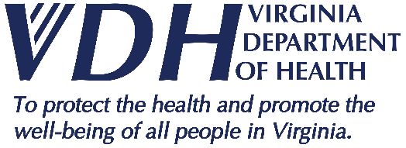 | Rappahannock Area Health District  News Release
109 Governor Street, Richmond, Virginia 23219 ● www.vdh.virginia.gov

FOR IMMEDIATE RELEASE November 3, 2021
Media Contact: Mary Chamberlin: mary.chamberlin@vdh.virginia.gov

Rappahannock Area Health District Offering Pfizer-BioNTech COVID-19 Vaccine for Children Ages 5-11
Fredericksburg, Va. — Beginning Thursday, November 4, 2021, the Rappahannock Health District (RAHD) will offer the Pfizer-BioNTech COVID-19 vaccine for children ages 5 to 11, following guidance from the Centers for Disease Control and Prevention and the Food and Drug Administration.

Because the Virginia Department of Health (VDH) has been planning for the expansion of vaccine eligibility and availability, families will have many options for where to get their children the Pfizer-BioNTech COVID-19 vaccine. Vaccination sites may include:

- Pediatric offices
- Family practice offices
- Community Vaccination Centers (CVC)
- Retail pharmacies

Those wishing to get their children vaccinated at the CVC in Central Park, located at 1877 Carl D. Silver Pkwy, Fredericksburg, can make appointments beginning Wednesday, November 3, 2021 for available openings at https://vase.vdh.virginia.gov, using the zip code “22401.” The CVC currently operates Tuesday-Sunday from 10 a.m. to 7:30 p.m.

Parents may sign up at for other locations at vaccinate.virginia.gov or call 877-VAX-IN-VA (877-829-4682). TTY users can call 711. Assistance is available in English, Spanish, and more than 100 other languages. Appointments are required at this time and children must be accompanied by a parent or guardian. Walk-ins will not be accepted.

Everyone 5 years and older is eligible to be vaccinated against COVID-19, and the Rappahannock Area Health District encourages all Virginians to get their vaccination if they haven’t already done so. For more information on COVID-19 in Virginia, visit vdh.virginia.gov/coronavirus.

###

NOTE: Members of the media are not permitted inside the CVCs when patients are present.

