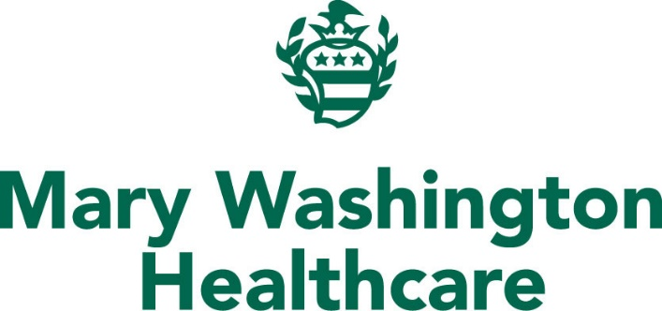
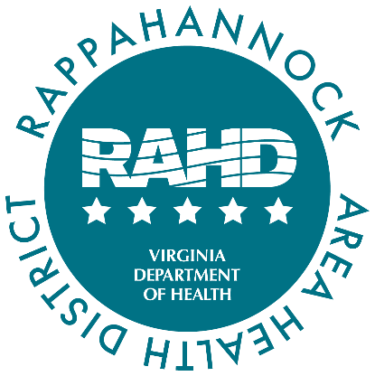

For Immediate Release August 5, 2025
RAHD Media Contact: Erin Perkins, Erin.Perkins@vdh.virginia.gov
MWHC Media Contact: Tamra Wheeler, Tamra.Wheeler@mwhc.com

Rappahannock Area Health District and Mary Washington Healthcare
Release 2025 Community Health Improvement Plan
New Plan Features 88 Strategies from 35 Organizations to Address Behavioral Health, Housing, and Healthcare Access

FREDERICKSBURG, Va. – Mary Washington Healthcare (MWHC) and the Rappahannock Area Health District (RAHD) announce the release of the 2025-2028 Community Health Improvement Plan (CHIP). The CHIP focuses on the counties of Caroline, King George, Spotsylvania, and Stafford and the City of Fredericksburg.
This comprehensive plan tackles some of the region’s most pressing health concerns:
- Behavioral Health,
- Housing, and
- Access to Healthcare.
A year-long effort, the CHIP was developed through research, collaboration and strategic planning. The CHIP is an action-oriented document based on the findings of the Community Health Assessment (CHA). Released in April, the CHA examined a variety of data sources to understand key health needs. The community then selected the top three health needs, which are addressed in the CHIP.
“We are deeply grateful to all the community members and partners who dedicated their time and expertise to this effort,” said Rappahannock Area Health District Director Olugbenga Obasanjo, M.D. “This initiative helps to modernize public health practice by ensuring collaboration of cross sector partnerships and utilizing of data to create a roadmap with the potential to drive real, lasting improvements in the health and wellbeing of our community.”
Compared to previous years, the 2025-2028 CHIP is significantly more robust. It contains 88 strategies contributed by 35 community organizations. The updated format also reflects a stronger emphasis on measurable outcomes. This new CHIP has indicators to track progress and ensure accountability.
“The Community Health Improvement Plan is the result of a truly collaborative effort, shaped by dozens of local organizations – from government agencies and healthcare providers to schools and nonprofits. This plan reflects our shared commitment to a healthier community,” said MWHC Senior Vice President and Chief Development Officer Xavier Richardson. “It is exciting to see how broadly the CHA and CHIP are used across the community to guide programs, inform policy, and spark lasting change.”
The CHIP serves as both a strategic guide and a living document. It will evolve in response to emerging needs and community feedback. The plan establishes clear priorities and cross-sector collaboration. It sets the stage for meaningful, measurable change over the coming years.
The full plan can be viewed on the RAHD website or on the MWHC website.

# # #
Rappahannock Area Health District is one of 35 health districts under the Virginia Department of Health. RAHD provides medical, environmental, and public health services to residents of the City of Fredericksburg and Caroline, King George, Spotsylvania, and Stafford counties, serving a population of more than 405,000. Its mission is to protect the community and the environment through the prevention of disease, lasting community partnerships, access to quality services, and the promotion of healthy behaviors.
Mary Washington Healthcare is a fully integrated, regional healthcare system that provides inpatient and outpatient care at over 80 facilities including Mary Washington Hospital, a 471-bed tertiary hospital, Stafford Hospital, a 100-bed community hospital, four emergency departments, and a multi-specialty graduate medical education program. Mary Washington Healthcare is a non-profit health system with a longstanding commitment to providing care regardless of ability to pay. For more information about our services and facilities, visit mwhc.com.

