APPLICATION FOR TEMPORARY FOOD PERMIT
WESTERN TIDEWATER HEALTH DISTRICT
Health Dept. Use Only
Date Rec.____________
Date Rev. ___________
Date Permitted: ______
Comments: _________
(Please Print or Type)
Important Information Please Read
This application must be submitted 10 business days prior to the event per PIM# 07-03. Failure to provide the necessary information regarding your operation may delay the processing of your application. Operators should be set up and ready for inspection by the begin time of operation shown on this application. Our inspectors may have multiple events and vendors to check so it is vitally important that you are ready for inspection when they arrive. Because the inspectors may have multiple events and vendors to inspect you may not see them before you are ready to start. You are allowed to start operating prior to their inspection. Under the discretion of the Health Department, operators who are more than 30 minutes late for inspection may not receive a permit. There is an application fee of $40 unless it has already been paid for the year. Fee receipt required.
Event Details
Name of Event_______________________________________________________________________
EventDate(s): From: ____________To __________Times of Operation___________________________
Event Location_______________________________________________________________________

Sponsor Information
Name_________________________________________ Mailing Address_________________________
Phone# ___________________

Contact Information
Event Coordinator _______________________Mailing Address____________________________
Phone# _______________________Cell#________________Email__________________________

Site Address
Building# __________Street Name ________________Unit#_________________
Zip Code______________________City______________County___________________State_____
Country_______________Directions__________________________________________________

Operator Information
Name of Business/Organization (Trade Name): ____________________________________________
Name of Owner: _________________________________________________________________
Address: ______________________________City:_______________
State/Zip: ________________
Name of Contact (if different than owner) ______________________________________________
Contact Information: Bus. #:______________Cell #: ___________ E-Mail: _______________________

- Have you paid for a temporary event permit this calendar year? Yes No If yes, please provide proof of payment. You do not have to pay again until next calendar year.

- Do you possess a permit to operate a food establishment issued by the Virginia Department of Health that is not expired? Yes No Issued by what Health District? ___________________

If yes, please provide a copy of your permit unless issued by the Western Tidewater Health District. If you have a valid permit, you will not be required to obtain a permit for this event or pay a fee, but you will need to complete this application, display a copy of your permit during your temporary event and you may be inspected by the local health department during the event.

- Is the event greater than 2 days in duration? Yes No

- Do you have a food handler’s card or a Certified Food Manager Certificate? Yes No
(If yes provide a copy)

- To the best of your knowledge, do you fall into one of the following categories? Yes No If yes, circle:
A. Church B. Fraternal Organization C. Rescue Squad D. Fire Department E. Police

F. Non-Profit Organization 501(c)(3)

If you do fall into one of these categories and you:
- Are holding a dinner or a bazaar that is held not more than one time per week and not in excess of two days duration you will not need a permit or pay an application fee.

If you do not fall into one of these categories you will:
- Need to pay an application fee unless you have a current food establishment permit or if you have already paid the temporary event permit fee of $40 for the year.
- Need a permit regardless of number of days of the event unless you have a current food establishment permit.

- Event Sponsor’s only (if applicable): Is the event totally non-profit for you and your vendors or are all of the vendors members of your organization? Yes No If your event is 2 days or less and if the answers to this and question 5 are both yes, all vendors of your event are exempt. If no, some of your vendors may require permits.

In order to better understand and assist you with your food safety processes, please help us with information about your proposed operation.
Circle the Applicable Items Noted Below:
TYPE FACILITY: Booth Self-contained Mobile Tent
WATER SOURCE: On-site Transported
SEWAGE DISPOSAL: On-site Individual Holding Tank
HAND WASHING Self-contained Water cooler with spigot
WASHING AND SANITIZING: Self-contained Individual Containers
REFRIGERATION EQUIPMENT: Mechanical Igloo Cooler Refrig. Truck
COOKING EQUIPMENT: Grill Mobile Cooker Crock Pot Oven
HOT HOLDING EQUIPMENT: Steam Table Heat Lamp Grill Crock Pot
All potentially hazardous foods (PHF's) must be prepared at the site or obtained from a permitted facility. All PHF's must be prepared daily. No such foods may be kept overnight and offered for sale the next day. All food and food equipment must be kept under overhead protection at all times.

LIST ALL FOOD ITEMS BELOW:
Name of Food Product_______________________________________________Commerical: Yes or No
Method of Preparation, Holding and Serving________________________________________________
____________________________________________________________________________________
Name of Food Product_______________________________________________Commerical: Yes or No
Method of Preparation, Holding and Serving________________________________________________
____________________________________________________________________________________
Name of Food Product_______________________________________________Commerical: Yes or No
Method of Preparation, Holding and Serving________________________________________________
____________________________________________________________________________________
Name of Food Product_______________________________________________Commerical: Yes or No
Method of Preparation, Holding and Serving________________________________________________
____________________________________________________________________________________
Name of Food Product_______________________________________________Commerical: Yes or No
Method of Preparation, Holding and Serving________________________________________________
____________________________________________________________________________________
Name of Food Product_______________________________________________Commerical: Yes or No
Method of Preparation, Holding and Serving________________________________________________
____________________________________________________________________________________
INDICATE BELOW ANY ADDITIONAL INFORMATION THAT YOU FEEL MIGHT BE NECESSARY TO FURTHER EXPLAIN YOUR OPERATION (attach an additional form if necessary)
__________________________________________________________________________________________________________________________________________________________________________
I have completed the application accurately to the best of my knowledge. I have read the attached instructions, understand them, and will comply with their requirements. I understand that failure to comply may result in a permit not being issued or permit suspension.
Print Name: _____________________________________
Signature of Applicant: _____________________________________Date: __________________
Health Department Use Only:
Health Department Signature if exempt from permit requirements: _____________________________
Suffolk Health Department---135 Hall Avenue, Suffolk, VA 23434

Temporary Food Establishment Booth Construction

Above, please provide a sketch of the basic set-up of your temporary food booth. Please include all equipment (tables, holding units, etc.), serving area, food preparation area, ware washing area, and hand washing station. Also, provide the extra information below:

Floor Construction: ______________________________________________________
Canopy Construction: ____________________________________________________
Barriers to Public: _______________________________________________________
Pest Control Measures: ___________________________________________________
Means of Hand Washing: __________________________________________________
Mechanical Refrigeration/Freezer Units (# and type):___________________________ ______________________________________________________________________
Source of Water Supply: __________________________________________________
Wastewater Disposal: _____________________________________________________

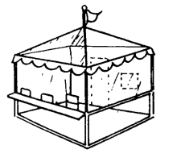
REQUIREMENTS FOR TEMPORARY FOOD ESTABLISHMENTS

The following requirements are pursuant to 12 VAC 5-421 of the Code of Virginia, pertaining to the safe preparation, handling, and protection of food in places where food is prepared and/or served to the public for consumption. Please read the requirements carefully.
1. Permit
A. Submit an application for a permit to the Western Tidewater Health District 4 business days or more prior to the starting date of the event
B. Inspection times are to be set up with the Environmental Health Specialist at each local office. Operators should be set up prior to inspection. Under the discretion of the Health Department, operators who are more than 30 minutes late for inspection may not receive a permit.
C. Permits are not transferable to another party or event, and are valid only for the period of time specified.
D. Only those food items listed on the application can be served unless changes are approved by the Health Department in advance.
E. No temporary restaurant shall open for business until a field inspection has been completed and a permit is issued.
- The permit shall be posted in public view.
The operator shall be advised that continuing or flagrant violations are grounds for suspension or revocation of the permit and immediate cessation of operations.
2. Personal Hygiene
- Persons with acute respiratory infections such as colds or flu, or communicable diseases involving organisms that can be transmitted by food or food handling are not allowed in food service and are subject to immediate exclusion if found in a food service operation.
- No person having open cuts or sores on his/her hands or arms may prepare or serve food.
- Eating, drinking, and tobacco use is prohibited in food preparation and service areas. Food handlers that use tobacco, eat, and drink must wash their hands before returning to work.
- While preparing food, food handlers may not wear jewelry on their arms or hands.
- Food handlers shall keep their fingernails trimmed, filed, and maintained so that the edges and surfaces are cleanable and not rough. While preparing food, food handlers may not wear artificial fingernails or fingernail decorations other than nail polish. If nail polish is worn, intact gloves must be worn.
- Hair restraints are required for food handlers and all other employees.
- 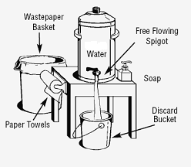Hands must be washed frequently. Water must be provided for handwashing. A waste bucket must be provided to catch the waste water and prevent ground water contamination. Liquid or bar soap and paper towels must be provided in dispensers for hand washing. Gloves are not a substitute for hand washing.

3. Food Preparation and Handling
- All potentially hazardous foods (PHF’s) prepared with meat, fish, poultry, cooked rice/noodles/pasta, milk and dairy products, eggs, etc. must be prepared onsite or obtained from a food establishment with a valid Health Department permit or license from the Virginia Department of Agriculture and Consumer Services (VDACS). If licensed by VDACS, please provide proof of license to the Health Department. All foods prepared prior to the event must be noted on the application and approved by the Health Department.
- All PHF’s must satisfy safe temperature requirements during storage, preparation, display, service, and transportation. Internal PHF cooking temperatures shall be no less than the following: poultry- 165˚F; ground beef and ground pork- 155˚F; pork- 145˚F; Reheating a PHF- rapidly to 165˚F
- All potentially hazardous food items offered for sale should be prepared on a daily basis. If food is to be kept overnight and offered for sale the next day, proper mechanical refrigeration must be provided.
- Potentially hazardous foods must be kept cold before preparation (41˚F or below) and hot after cooking (135˚F or above). Adequate equipment must be provided to maintain these temperatures. Equipment for rapid reheat of PHF to 165˚F is required (steam tables/crock pots/canned heat is prohibited for reheating).
- Thermometers are required in each refrigeration unit (to include coolers).
- A metal stem, “tip sensitive”, thermometer (2˚ increments) is required for monitoring internal product temperatures and a temperature log sheet should be used when cooking PHFs.
- PHFs cannot be stored in un-drained ice (cooler drains must be open and drip pans provided to collect wastewater).
- If foods (ex. Steaks, eggs, hamburgers) are offered “cooked to order”, in an undercooked form, or if there are any foods that may contain raw or undercooked products (ex. Homemade Caesar salad dressing), a Consumer Advisory shall be posted stating “Consuming raw or undercooked meats, poultry, seafood, shellfish, or eggs may increase your risk of foodborne illness, especially if you have certain medical conditions”.
- Vegetables must be washed prior to preparation and service. Lettuce, cabbage, sprouts, and other hard to clean vegetables should be purchased from an approved source and pre-washed.
- All food, equipment and utensils must be kept under overhead protection at all times. Any food storage, preparation, display, or cooking must be protected from contamination by the public. Keep food, ice, and single service utensils covered to protect against contamination from dust, sand, rainwater, and insects. All food supplies (including condiments) must be stored in clean containers, off the ground, and under overhead protection. This includes coolers storing food and ice, but not bottled or canned beverages.
- All condiments must be served in single use packets or individual containers. Open bowls, jars, or bottles are prohibited. In cases where individual packets are not available, food handlers must add condiments or ingredients requested by the patron.
- Foods that are contaminated, outside of the allowed temperature ranges, or adulterated in any way are subject to immediate condemnation. Foods that are contaminated by employees or consumers, unsafe or adulterated must be discarded or rendered unusable.
- All unidentified foods in containers must be labeled with product type and consume by date if the event is 2 days in duration or more.
- All toxic items, such as cleaners and sanitizers, must be labeled and stored away from food and food preparation surfaces. The use of pesticides is restricted unless otherwise approved by the Health Department in advance.
- Thawing potentially hazardous foods at room temperature or ambient air temperature is prohibited. Approved methods are:
      - Under refrigeration below 41˚F
      - In the cooking process
- All food, utensils, and single service items must be stored 6 inches or more off the ground.

4. Equipment and Utensils
- If serving potentially hazardous foods, sufficient refrigeration facilities or effective insulated facilities shall be provided and capable of holding food at proper temperatures (135˚F or above and 41˚F or below) and must have thermometers accurate to within 3 degrees. All holding equipment must have tight seals. When coolers are used, they must be drained and the waste runoff shall be caught in a catch in a catch container. Styrofoam coolers are prohibited.
- A properly plumbed three compartment sink with running water or three containers of adequate size shall be provided for washing, rinsing, and sanitizing food contact surfaces of utensils and equipment. Adequate quantities of wash water and liquid detergent must be provided onsite for equipment and utensil washing. (see picture)

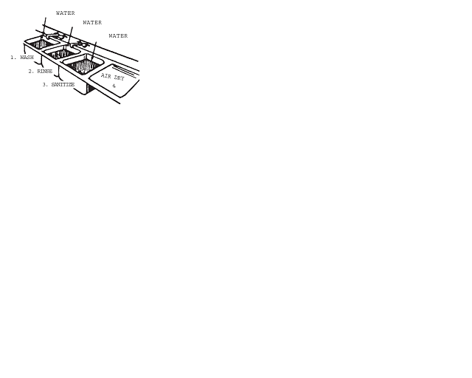
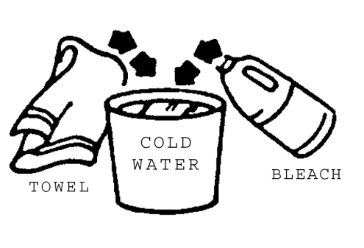

- The use of garden hoses for potable water is prohibited. Approved potable (food grade) water hoses are approvable provided that backflow prevention devises are used correctly.
- Trash and garbage shall be stored in impervious (metal or plastic) containers with tight fitting lids. Cardboard boxes are not acceptable. The use of plastic liners is encouraged, however not acceptable alone for outside storage. Trash and garbage shall be removed from the site at regular intervals.
- Equipment and utensils shall be constructed to provide for easy cleaning and kept in good repair. Equipment is to be located and stored so that it is protected from contamination.
- A plastic bucket or container containing a sanitizing solution shall be provided for wiping cloth storage. The solution must contain 50 – 200 ppm chlorine, and be checked with sanitizer test strips. Sanitizer test strips must be easily accessible. (see picture)
- In use utensils and equipment must be washed and sanitized every four hours. Food contact surfaces shall be cleaned and sanitized after each period of use or at minimum every four hours. Only equipment that can be cleaned onsite shall be used.
- A chemical sanitizer test kit shall be provided by the operator to check sanitizer strength. This kit must correspond with the appropriate sanitizer being used. If chlorine bleach is used, a chlorine test kit with a range of 10 – 200 ppm is needed. Sanitizer test strips must be easily accessible.

5. Physical Facilities

- Water is to be from an approved source.
- Wastewater is not to be disposed of on the ground. Where sanitary sewage connections are made, they shall be sanitary, non-leaking, and inaccessible to insects and rodents.
- Operators are responsible for keeping the grounds free of litter, trash and garbage, grease, and food debris.
- Overhead protection of the entire operation is required.
- If cooking or preparation is done on front line, a sneeze guard must be provided or a barrier to keep the public at least thirty (30) inches away from the food. (see picture)
- Groundcover must be provided under the entire area covered by the overhead protection when tent is placed on sand, site is dusty, or has debris on surfaces.
- Adequate lighting within the facility should be provided.

TEMPORARY FOOD ESTABLISHMENT CHECKLIST

___ 1. All foods must be obtained from a commercially approved source (no home prepared foods unless licensed from Virginia Department of Agriculture and Consumer Services-provide proof to the Health Department)
___ 2. “Tip Sensitive” Metal stem food thermometer (0-220 degrees F), not a meat roasting or glass thermometer
___ 3. If offering raw or undercooked food items, posting a Consumer Advisory statement on Menu
___ 4. Thermometer for each refrigeration unit
___ 5. Water hand washing station to include hand soap and paper towels (hand sanitizer cannot be substituted for soap)
___ 6. Chlorine bleach- unscented (or approved sanitizer)
___ 7. Three compartment utensil & dishwashing station to include liquid dish detergent, water, and washing cloths
___ 8. Sanitizer test kit (should be the kit designed for the sanitizer you use)
___ 9. Condiments provided to customers in single service packets or squeeze bottles
___ 10. Smooth and easily cleanable tables, counters and food contact surfaces
___ 11. Racks for elevating food at least 6 inches off the ground
___ 12. Ice chests with drain, ice, and pans to catch water runoff
___ 13. Extra utensils (spoons, spatulas, tongs, and ice scoop)
___ 14. Hair restraint and clean clothes
___ 15. Overhead protection for the entire operation including: all food being stored, handled, prepared, and served to the public, and both hand washing & ware washing stations
___ 16. If cooking or preparation is done on the front line, a sneeze guard must be provided, or a barrier must be provided to keep the public at least 30 inches from the food.
___ 17. Ground cover under entire operation (depending on location of set up)
___ 18. Completed Western Tidewater Health District application, with no menu changes, for a temporary food establishment and received by the local health department 10 business days or more prior to the event.

