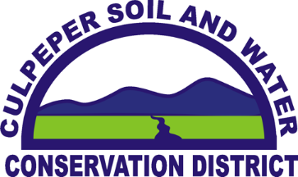

Funding Available for Septic Repairs

Residents in certain areas of Rappahannock County continue to be eligible for reimbursement of fifty percent of the expense of maintaining, repairing or replacing on-lot septic systems. All of the county that drains to the Hughes, Hazel, Thornton, Covington and Rush Rivers, including all of Battle Run is eligible. This is essentially all of the county except a small area north of Amissville and the Flint Hill and north area. Also included in the project area are the Etlan and Nethers areas of Madison County and Culpeper County west of Reva, Griffinsburg and Monumental Mills. This grant is focused on reducing any existing or potential impacts on local ground and surface water quality. E. Coli bacteria in some local streams has long been identified as being higher than expected by state water quality standards, although other pollutants can also be involved, particularly nutrients. An additional benefit to the property owner is the assurance that their system is up to standards and functioning properly. It is a win-win for both water quality and property value.

All residents are eligible for the program regardless of income level. Reimbursement payments are typically fifty percent for anyone although can go as high as eighty percent for individuals that qualify for low income status. Maximum payments to property owners at the 50% cost share level are $200 maximum towards a pumpout; $2000 maximum towards a pump out and inspection; $2,500 maximum towards a repair; $4,000 maximum towards a conventional system or $6,000 if a pump is required to move the liquids to the drain field; and $12,000 maximum towards an alternative engineered system. Maximum payments under low income situations at the 80% cost share level are $320 towards a pumpout; $3,200 maximum towards a tank pump out and system inspection; $4000 maximum towards a repair; $6,400 maximum towards a conventional system or $9,600 if a pump is required to move the liquids to the drainfield; and $19,200 maximum towards an alternative engineered system. Pump outs with an inspection extend the life of a system and prevent higher costs later on if the systems fail. If further repairs are indicated by the pump out and inspection, the owner is still eligible for the additional repair payments. Applications are required and need to be approved prior to the work being done or funding can be declined. Free assistance with initial assessments of individual system needs is available from the District. Reimbursement payments are made promptly once the work has been completed. The program is entirely voluntary and assistance from the District is free of charge.

Further information on the program is available from the District at 540-948-7531 or 540-825-8591. Funding for these projects has been secured by the Culpeper Soil and Water Conservation District from the Virginia Department of Environmental Quality, Commonwealth of Virginia.

