COMMONWEALTH OF VIRGINIA

DRINKING WATER

Water Supply Assistance Grant Fund
Program Guidelines

Updated January 1, 2019

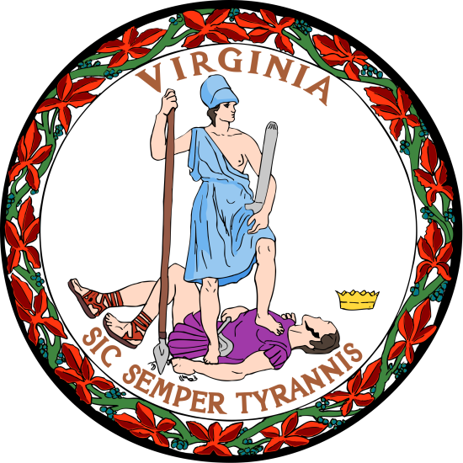

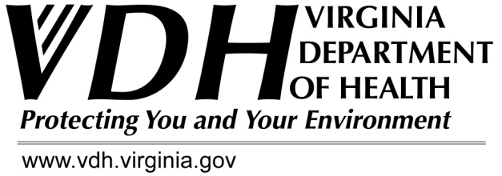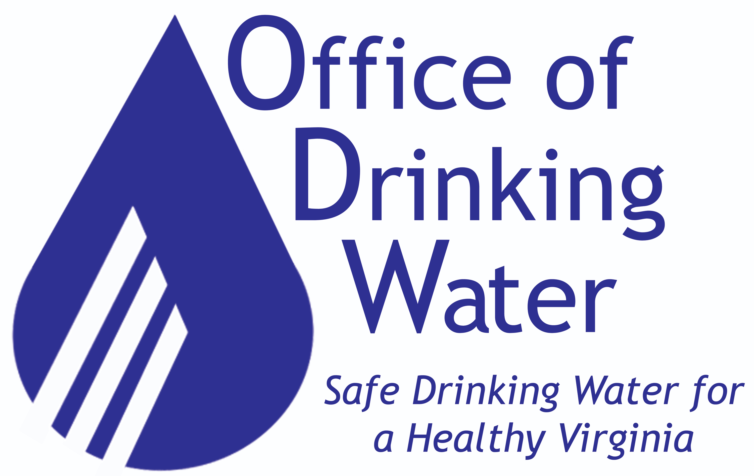

Virginia Department of Health

Office of Drinking Water
Financial and Construction Assistance Programs

109 Governor Street, 6th Floor, Richmond Virginia 23219

Voice: 804 – 864-7500
Fax: 804 – 864-7521

http://www.vdh.virginia.gov/drinking-water/financial-construction-assistance-programs/

TABLE OF CONTENTS

I. INTRODUCTION

II. GOAL

III. TYPES OF FINANCIAL ASSISTANCE

- CRITERIA FOR GRANT ELIGIBILITY

- APPLICATION

- GRANT DISTRIBUTION PRIORITIES

Planning and Design Awards
Source Water Development or Improvement Grants
Small Project Construction Grants (lead service line replacements)

- GRANT CONDITIONS

Eligible Costs
Reimbursement
Project Implementation
Other

VIII. APPENDICES

A. Excerpt from Code of Virginia
B. Source Water Development or Improvement Project Scoring
C. Application Package

PREFACE

Due to the limited availability of Water Supply Assistance Grant (WSAG) Funds –VDH does not intend to award Surface Source Water Development/Improvement Grants, Small Construction Project Grants, or WSAG Planning and Design Awards during this funding year. Instead, VDH will focus any available funding on assistance for the replacement of lead service lines.

I. INTRODUCTION

The Code of Virginia establishes a drinking water trust fund with the creation of the Water Supply Assistance Grant Fund (WSAG) in July 1999. See Appendix A.

The Virginia Department of Health (VDH) administers these state funds and coordinates such funding with other sources. VDH is the State’s Advocate for Safe Drinking Water and has been since the early 1900’s. Also, VDH has had primary enforcement responsibility (primacy) for the federal Safe Drinking Water Act since 1977.

This document establishes guidelines for the WSAG grants and the use of available dollars. An advisory committee to VDH assisted in creating the guidelines that will be reviewed annually for needed changes or additions and distributed for public comment.

Available funding under the SDWA is addressed in other program documents developed annually by the Virginia Department of Health (VDH) for the ultimate approval by the U. S. Environmental Protection Agency. Funds for the WSAG grants as provided in the Appropriations Act and are solely state dollars. Any restricted funding provided to the WSAG program designated for a specific purpose will be used for that purpose.

The Code of Virginia gives broad discretion for WSAG dollars to be used as grants to assist localities and owners of waterworks in the provision of drinking water. Therefore, these dollars (as available) may be utilized in various ways to address localities’ specific needs.

These guidelines address those needs for four categories: (1) Planning and Design Awards, (2) Source Water Development or Improvement Grants, (3) Small Project Construction Grants, and (4) Lead Service Line (LSL) Replacement Rebate Program. These categories are described in Section VI. These categories will be reviewed annually for needed changes or additions and public comment will be solicited.

Important WSAG Guideline information:

- No local match is required to obtain a grant.
- No environmental reviews are required to obtain a grant.
- No application fee or other fees are required to obtain a grant.
- No annual audit is required to obtain a grant.
- DWSRF federal requirements do not normally apply unless they are also state requirements.

II. GOAL

The goal of the WSAG Program is to assist in providing an adequate and safe drinking water supply essential to the public health and economic well-being of the citizens of the Commonwealth.

III. TYPES OF FINANCIAL ASSISTANCE

To allow the greatest flexibility to complete projects listed in Section VI, the WSAG Program allows any type of financial assistance vehicle, including but not limited to the following:

- Grants for lead service line replacements
- Grants for project planning and construction
- Grants for capacity building activities addressing regionalization or consolidation
- Refinance of debt obligations
- Guarantee or purchase of insurance for a local obligation, and
- Source of revenue or security of bonds.

IV. CRITERIA FOR GRANT ELIGIBILITY

• Any locality or owner of a community waterworks is eligible, except the state, federal, or tribal governments. Preference is given to problems at existing waterworks by points.

• Of those eligible, no assistance shall be provided if the applicant is in significant noncompliance with any requirement of the state or national drinking water regulations. However, an applicant may receive assistance if the use of the funds or other actions are agreed to that will ensure compliance.

The activity is within one of the Guideline designated project categories of (1) Planning Grants, (2) Source Water Development or Improvement Grants, (3) Small Project Construction Grants, and (4) Lead Service Line (LSL) Replacement Rebate Program. See Section VI.

V. APPLICATION

To promote coordination of assistance funding and streamline the application process, applicants that apply for DWSRF Program funding are automatically considered for the WSAG Program funding. VDH reserves the right to choose the funding program that best suits the situation and resolves the projects’ needs.

The WSAG dollars may be used in conjunction with any other funding sources.

VDH may reduce the grant amount, or reduce the scope and size of a project to ensure the greatest benefit to as many waterworks as possible. VDH reserves the right to limit funding participation to the least cost of the feasible alternatives. VDH reserves the right to require regionalization/consolidation of under-performing waterworks.

VI. GRANT DISTRIBUTION PRIORITIES

The funding of activities under the WSAG Program is contingent upon the availability of state funding. The distribution of available funds may be prioritized and designated to certain categories of assistance.

Available unrestricted funds will be distributed between project categories on a dollar or percentage of total funds available basis as follows or used to supplement DWSRF project categories. If insufficient interest is expressed in any category, funds may be shifted to another category.

Unless stated otherwise VDH will utilize the scoring and prioritization criteria that was developed for the DWSRF Program. Please refer to the most current version of the DWSRF Manual for details.

WSAG Planning and Design Awards

In ranking of applications, preference is given to those that address problems of small, rural, community waterworks with multi-jurisdictional support. The applicant submits the current VDH planning application to VDH. To promote coordination of funding and streamline the process for applicants, grants are prioritized in accordance with the rating criteria of the current DWSRF Program.

Eligible activities may include (but not be limited to): Capacity building activities addressing regionalization or consolidation, performance of source water quality and quantity studies, drilling test wells to determine source feasibility, income surveys, preliminary engineering planning, design and preparation of plans and specifications, or other similar technical assistance projects. Administrative and legal fees are not eligible costs.

Surface Source Water Development or Improvement Grants

These grants are used for community waterworks surface source water development or improvement activities. Individual applications cannot exceed $200,000.

The applicant submits the current VDH construction application to VDH. In ranking of applications, preference is given to those that address problems of small, rural, community waterworks with multi-jurisdictional support. See Appendix B for the WSAG scoring points sheet.

Eligible activities may include (but not be limited to): land purchase, options to purchase land, general site development costs, and dam upgrade and construction.

Small Project Construction Grants (lead service line replacements)

These grants are used for small community waterworks project construction that is defined as a project whose total project cost does not exceed $500,000. Eligible activities may include (but not be limited to): lead service line replacements, upgrade or construction of well or spring sources, waterlines, storage tanks, and treatment. Priority will be given to lead service line replacement projects as described below.

The applicant submits the current VDH construction application to VDH. To promote coordination of funding and streamline the process for applicants, grants are prioritized in accordance with rating criteria of the current DWSRF Program. Preference is given to community waterworks. This priority system ensures that all eligible acute or chronic health/ SDWA compliance projects are funded before any other eligible project.

Lead Service Line (LSL) Replacement Program: In an effort to accelerate the removal of lead in drinking water the SRF Program has made revisions to the priority scoring and ranking criterion. The WSAG funding will be used in support of the LSL Replacement Program as stipulated in the DWSRF Design Manual. Funding is available for the complete removal of the public and/or private portion of the LSLs. In conjunction with other available funds this program intends to provide up to $5,000 dollars as grant funds (of which up to $500 may be eligible as an admin fee) for each service line replaced on the homeowners side of the meter. The LSL includes pipe entry into the structure (up to and including a shut off valve) but excludes the premise plumbing. Please see Appendix C of the DWSRF Program Design Manual for details.

VII. GRANT CONDITIONS

All applicants for financing must comply with all applicable local ordinances, state and federal laws and regulations, or other requirements.

All Waterworks Regulations planning and design requirements, if applicable, must be satisfied prior to closing a construction grant.

An important VDH goal is to use the WSAG Program goal to assist waterworks in building long term financial sustainability and developing adequate financial capacity for necessary maintenance and infrastructure improvements. As part of the application process VDH recommends all owners use the VDH guidance information to evaluate the current financial health of their waterworks, to evaluate their ability to accept new debt, and to affect changes needed to grow revenues to support these efforts.

VDH reserves the right to require measures that build financial health and financial sustainability of the waterworks as a condition of any loan, principal forgiveness, or grant offer acceptance and in compliance with VDH’s capacity building expectations. These measures will generally follow the expectations and requirements as identified in the DWSRF Program Design Manual.

Eligible Costs

Regardless of their population size, successful applicants must comply with the Virginia Public Procurement Act, our program requirements, and procurement procedural guidelines.

Grants from the WSAG may be utilized for upgrading, rehabilitation, expansion, consolidation, regionalization or creation of a community waterworks. Planning costs are allowed. Eligible expenses incurred on an approved project PRIOR to the execution of a grant agreement can be considered for reimbursement.

All costs will be reviewed for eligibility. To be considered for reimbursement all cost items must be eligible under program guidelines, specific to the project, and necessary for the waterworks/ infrastructural improvement.

A budget with appropriate details of costs is required.

Reimbursement

The grant must be used to complete the project in accordance with the approved project completion schedule; otherwise, the recipient must repay the funds.

Funds are disbursed on a cost reimbursement basis. All requests for disbursement of funds must be substantiated by invoices and submitted attached to a requisition form shown in the grant agreement. A Certificate of the Consulting Engineer will accompany the requisition. VDH will review and approve reimbursement requests prior to the actual disbursement of funds. A Certificate of Project Completion shall be delivered to VDH when the project is completed.

An adequate record-keeping/filing system must exist or be created to ensure that required records related to the activity are maintained and accessible for at least three years after final payment. VDH, its authorized representatives, or State Auditors shall have the right of access to work sites and shall have full access to and the right to examine all books, records and other documents related to the project. A Final Project Evaluation and Final Financial Evaluation will be conducted by VDH to determine that all requirements and grant conditions have been satisfied and to ensure that financial management records are complete. Disbursement of funds will be held at the 95% level until a financial evaluation is conducted.

Project Implementation

A project completion schedule is required. It will show the items to be accomplished, when, and by whom. Use of funds must occur as soon as possible after the grant contract is signed.

The grant recipient will designate a contact person to coordinate the activities.

The applicant must obtain any permits for construction, etc, and have a field presence during construction. VDH will make a final inspection before issuance of an operating permit and disbursal of final funds. As identified in the grant agreement, the applicant will submit any required documentation to VDH.

Other

As applicable, each activity must be in compliance with the Board of Health’s Waterworks Regulations for items such as permit application - notification of intent; preliminary engineering conferences; approval of preliminary engineering reports and any required business (operating) plans; and approval of project plan design.

- VDH will give notification that a complete or partial Waterworks Business Operations Plan (WBOP) may be required.

- No annual audit is required.

- Liability insurance must be maintained for protection for claims arising from activities under the grant.

- The Virginia Conflicts of Interest Act is applicable.

- Each section of the grant agreement is severable from the entire agreement.

- VDH expects all WSAG projects to be completed in a timely manner and in accordance with the approved project schedule. The WSAG grant may be terminated if VDH determines that insufficient progress has been made on the project.

- VDH reserves the right to fund critical needs or emergency projects (as defined in the SRF Program Design Manual) subject to the availability of funds.

APPENDIX A

Excerpt from Code of Virginia

§ 32.1-171.2

Water Supply Assistance Grant Fund established

A. There is hereby created in the state treasury a special nonreverting fund to be known as the Water Supply Assistance Grant Fund, hereafter referred to as "the Fund." The Fund shall be established on the books of the Comptroller. All funds appropriated as matching funds for moneys available through the federal Safe Drinking Water Act, all penalties and charges directed to this fund by §§ 32.1-27, 32.1-175.01 and 32.1-176, and all other funds from any public or private source directed to the Fund shall be paid into the state treasury and credited to the Fund. Interest earned on moneys in the Fund shall remain in
the Fund and be credited to it. Any moneys remaining in the Fund, including interest thereon, at the end of each fiscal year shall not revert to the general fund but shall remain in the Fund. Moneys in the Fund shall be used solely for the purposes found in subsection B. Expenditures and disbursements from the Fund shall be made by the State Treasurer on warrants issued by the Comptroller upon written request signed by the Commissioner at the direction of the Board.

B. The Board shall utilize the moneys appropriated as matching funds for that purpose and, subject to other available funds, may make Water Supply Assistance Grants from the Fund to localities and the owners of waterworks to assist in the provision of drinking water. The Board shall develop guidelines establishing the (i) criteria for grant eligibility, (ii) conditions to be included in grants, and (iii) grant distribution priorities. Among the factors that shall be included in the criteria for grant eligibility and in the grant distribution priorities shall be the financial condition of the locality wherein a grant is sought.

C. The Administrative Process Act (§ 9-6.14:1 et seq.) shall not apply to the development of guidelines for the Fund. However, the process for development of the guidelines by the Board shall include (i) the use of an advisory committee composed of interested parties, (ii) a minimum sixty-day public comment period on draft guidelines followed by a public hearing, (iii) written responses to all comments received, and (iv) notice of the availability of draft guidelines and final guidelines to all who request such notice.

APPENDIX B

WSAG Source Water Development or Improvement Project Scoring

WSAGF SOURCE WATER DEVELOPMENT ITEMS CONSIDERED | Points
I. REGIONALIZATION
A. PROJECT HAS DOCUMENTED JURISDICTIONAL SUPPORT (15 points max.)
- 1 jurisdiction, e.g., county, city, town, or PSA | 5
- 2 jurisdictions | 10
- ≧3 jurisdictions, e.g., PDC endorsement | 15
B. PROJECT HAS DOCUMENTED OTHER FUNDING SUPPORT (15 points max.)
- 1 source | 5
- 2 sources | 10
- 3 sources | 15
II. PROJECT PURPOSE
A. HEALTH or SAFETY COMPLIANCE (40 points max.)
- State or federal letter declaring a hazard | 25
- Continuing VDH boil water notice | 10
- Significant Noncompliance (SNC) with Waterworks Regulations | 5
B. GROWTH - UPGRADE TO INCREASE SAFE YIELD (20 points max.)
• Upgrade a documented inadequate surface water supply source | 20
- Create new water supply source | 10
C. INTEGRATION OF EXISTING SOURCES (8 points max.)
• Promotes or consolidates sources between multiple waterworks non-complying with Waterworks Regulations. | 4
• Promotes or consolidates source of one waterworks non-complying with Waterworks Regulations | 3
• Promotes or consolidates sources of waterworks complying with Waterworks Regulations | 2
• Service to areas with individual homes having quality/quantity problems | 2
III. PROJECT AREA CHARACTERISTICS
A. SOURCE WATER PROJECT SIZE (20 points max.)
• ≧10,000 population | 0
• ≧3300 to < 10,000 population | 3
• ≧500 to <3300 population | 5
• ≧250 to <500 population | 10
• ≧100 to <250 population | 15
• <100 population | 20
B. AFFORDABILITY (Use Median Household Income – Census or latest Update Data or income survey) (20 points Max.) LSL applicants will use the scoring identified in the DWSRF Manual.
- <$37,000 | 20
- $37,001 to <$44,200 | 10
- $44,201 to <$58,900 | 5
- ≧ $58,901 | 0
IV. POINTS BASED ON COLG Composite Fiscal Stress Index (40 points max.)
V. TOTAL SCORE

APPENDIX C

Application Package

Refer to and use the existing applications of VDH’s Office of Drinking Water FCAP Program.

These applications may be obtained by mail from VDH Office of Drinking Water in Richmond or from the VDH web site http://www.vdh.virginia.gov/drinking-water/financial-construction-assistance-programs/drinking-water-funding-program-details/

