EMERGENCY RESPONSE PLAN
Virginia Department of Health

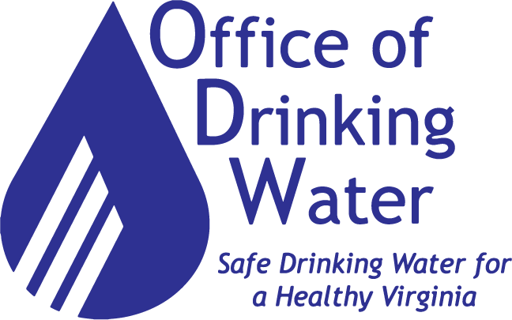

Emergency Preparedness Coordinator, VDH – ODW
June 1, 2019 – Version 1.0

PROMULGATION STATEMENT
The Virginia Department of Health – Office of Drinking Water’s (ODW) mission is to protect public health by ensuring that all people in Virginia have access to an adequate supply of clean, safe drinking water that meets federal and state drinking water standards. To accomplish this mission, ODW must ensure its operations perform with minimal disruption during all-hazards emergencies or other situations that disrupt normal operations. This document provides planning and program guidance for implementing the ODW Emergency Response Plan to ensure the agency is capable of conducting its mission essential functions (MEFs) under all threats and conditions. This emergency response plan is a companion plan to the VDH Emergency Response Plan and provides a framework to minimize potential impact and allow for rapid recovery from an incident that disrupts operations. This plan’s development was through a formal planning process and is compliant with the VDEM Planning Template as required in Executive Order #41.

Sign

Print

Director of the Office of Drinking Water

Virginia Department of Health – Office of Drinking Water

Date

This Page Intentionally Blank
Table of Contents
RECORD OF CHANGES 1
PUBLICATION AND DISSEMINATION 2
INTRODUCTION 3
Purpose 3
Scope 4
Planning Assumptions 5
SITUATION OVERVIEW 6
Incident Threat Levels 6
ROLES AND RESPONSIBILITIES 8
Central Office 8
Field Offices 9
CONCEPT OF OPERATIONS (CONOPS) 10
Initial Response 10
Transition 13
Response 13
Situation Reporting 17
Logistics 19
Public Information 19
PLAN DEVELOPMENT AND MAINTENANCE 20
Exercises 20
Maintenance 20
APPENDIX 21
ODW Emergency Notification List 21

RECORD OF CHANGES
Submit recommended changes to this document to ODW Emergency Preparedness and Security Coordinator.
Change Number | Section and/or Page Number | Description of Change | Date of Change | Posted By

PUBLICATION AND DISSEMINATION
The ODW distributes this plan to executive leadership and key personnel within ODW, VDH, and to others as deemed appropriate. Requests for additional copies of this plan or notification of updates need to go to the Director of Training, Outreach, Security, and Emergency preparedness.
Name | Title | Agency or Organization | Date Issued | Date Returned | Number of Copies

INTRODUCTION

Purpose
- The Virginia Department of Health - Office of Drinking Water (ODW) developed this Emergency Response Plan (ERP) to respond in the event of an incident affecting a public water system or systems. This plan is a Standard Operating Guidance Document to accompany the Virginia Department of Health (VDH) Emergency Operations Plan.
- This Plan is a reference guide for designated personnel in the ODW Central and Field offices.
- This Plan is for use in any incident by any ODW personnel but may require additional time and effort to understand and execute during a large-scale incident.
- Public water supply incidents may be complex and ODW may be notified through multiple agencies or people involved. Throughout an incident, there will be incoming and outgoing notifications from internal and external contacts. Effective incident communication and this Plan require tracking of those contacted; keeping them informed throughout the incident; or until they no longer require communication.
- Incidents might start as, or become part of events that trigger the activation of the agency Emergency Operations Plan. Involvement in the Emergency Operations Plan may require additional ODW personnel commitment and training especially relating to the use of the National Incident Management System - Incident Command System.
- In some cases, multiple ODW personnel may need to have direct roles in an incident including:
- An ODW representative on scene;
- An ODW representative in the local Emergency Operations Center (EOC);
- An ODW representative in the state EOC and/or VDH ECC; and/or
- One or more ODW personnel making decisions and providing support for the incident.
- ODW staff will serve in an advisory role to an affected utility, and are not to take the command role from local agencies. Although representatives may be in a field environment, ODW personnel are not first responders, and their health and safety are foremost during any incident. Therefore, ODW Staff do not enter any locations or sites that may present a health and safety hazard. Additionally, any potential intentional water contamination incident is a crime scene. Do not disturb any evidence, as this evidence is necessary to prosecute the perpetrators once apprehended by law enforcement agencies.
- This Plan provides both timely information and a list of helpful contacts to ODW staff that are assisting a public water system to respond to a variety of hazards. Therefore, this Plan provides succinct procedural information in a straightforward manner with proper documentation.
- This Plan is arranged into three parts:
- Plan Introduction and;
- Critical Plan Information;
- Appendices with additional response information and guidance.
- To use this Plan:
- Use the Critical Plan Information section located in the next section of the Plan to determine action steps to take and when;
- Use the Concept of Operations along with the other Appendices to advise the utility on what they need to do at each action step; and to determine other actions needed by the ODW, including necessary documentation.

Scope
- ODW Authority
- The VDH-ODW has the authority to regulate public drinking water systems to ensure that they provide drinking water that meets the minimum standards spelled out under federal and state laws and rules. However, the ODW’s legal authority has limitations as to what it can require of public water systems.
- The following are some of the actions the ODW has the authority to require:
- ODW can require a public water supply system to issue a public notice to their consumers. This is the primary tool for immediate public health protection. These notices alert and inform consumers of possible or known problems with the water supply, what precautions should be taken, and what is being done to resolve the problem;
- Additional monitoring and sampling;
- Compliance with regulations for monitoring, design, and construction; and
- If the ODW believes a system is continuing to serve unfit water and is not providing proper notice, the department can seek a temporary restraining order, through a court of proper jurisdiction, to require a system to cease and desist in serving water deemed unsafe.
- The ODW does NOT have the authority to require:
- Individual system users (i.e., a bar connected to a city water supply) to further notify their consumers;
- Users or individuals to boil their water or limit their water use; or
- A system to shut down (temporary restraining order can be obtained and/or see Local Health Authority).
- ODW Staff Actions
- When responding to an incident, staff should inform and consult with the Emergency Preparedness and Security Division Coordinator as to status of the event and recommendations for assistance and public notice requirements. Appropriate notification, collaboration, and communications with proper authorities and agencies will assist in making timely and informed decisions to resolve the issue as quickly as possible.
- Items that the ODW can and should discuss with the system include:
- Notifying the system that there is an issue of concern and what it is;
- Assist in providing a suitable and proper public notice;
- A recommendation that the system cease whatever action is promoting the continuation of the risk;
- Possible remedies for the problem, both short and long term;
- Advise the system that each day the system is in use without resolving the public health threat, or the system is out of compliance with a drinking water standard, may constitute a separate day of violation for purposes of calculating a penalty; and
- Assist with regulatory concerns and compliance issues.

Planning Assumptions
- This plan has been developed based on the following assumptions:
- ODW will warn appropriate personnel of the incident/event.
- The dissemination of supplemental warnings with appropriate emergency instructions and public information will be through the VDH PIO.
- A disaster may occur within the Commonwealth of Virginia with little or no warning, and may escalate faster than any single jurisdiction’s ability to respond.
- ODW will provide for its own continuity to maintain its Mission Essential Functions (MEFs).
- ODW acknowledges that its MEFs may be disrupted by: the loss of access to a facility (or portion of a facility), the loss of services due to equipment or system failure, the loss of services due to a reduction in the workforce, or any combination thereof.
- ODW will identify key personnel and alternates required for the implementation of this plan.
- ODW leadership will exercise their authority to implement the ERP in a timely manner when confronted with events that disrupt the agency’s MEFs.
- ODW will maintain communication with VDH ECC and Support operations.
- ODW will implement teleworking as an alternate work arrangement, as appropriate.
- In the event of an emergency, ODW will need to rely on services of other agencies and/or organizations for recovery, including VITA for telecommunications and information technology systems for recovery.
- When properly implemented, this ERP will reduce or prevent disaster-related losses and allow for timely recovery operations.

SITUATION OVERVIEW
The Commonwealth of Virginia has over 2700 drinking waterworks spread throughout the state. This makes drinking water infrastructure extremely susceptible to a wide range of natural, human-caused, and technological hazards. The Threat, Hazard, Identification, and Risk Assessment from VDEM allows ODW to prioritize planning requirements based on verified risk and apply human and financial resources appropriately during all phases of the emergency management process.

Incident Threat Levels
The potential exists for a number of hazards to impact ODW operations. The table below outlines the different threat levels these hazards pose to drinking water quality in the Commonwealth.
- Incident Threat Level Definitions
- Level 4: Routine Problem/ Issue
These incidents are minor disruptions to a public water system that do not substantially degrade the system’s water quality, quantity, pressure, or production capability. The anticipation is they will be repaired/resolved within 24 hours or less.
- These incidents typically utilize standard operating procedures and fixed by the system with public health precautions in place.
- If total coliform samples taken after the repair are positive, a public notification may be issued.
- ODW plays a limited role in these incidents, and may not be aware of a Level 4 incident until after the problem is resolved.
- In some instances, ODW may offer technical advice or guidance to a utility if contacted.
- A field visit is not expected, and other state agencies or organizations are rarely involved.
Examples: Minor water main breaks and mechanical problems at pumping stations.
- Level 3: Minor Emergency
These incidents are significant disruptions to a water system that have the potential to degrade the system’s water quality, quantity, pressure, or production capability. The anticipation is that they will be repaired/resolved within 72 hours or less.
- Managing and correcting these incidents may or may not be beyond the resources of the system and may require outside assistance.
- ODW will review these minor emergencies and may require a Boil Water, Do Not Drink or Do Not Use notification.
- ODW should be prepared to offer technical advice and assistance, as well as prepared for a field visit if warranted.
Examples: Major main breaks, multiple main breaks, major mechanical problems at pumping stations/treatment facility, or failure of required chemical feed systems.
- Level 2: Criminal/Terrorist Activity
These incidents involve individuals that tamper with or have intent to do harm to the public water supply or situations where the system believes that unauthorized persons accessed the system infrastructure in a method that may put consumers at risk.
- Requires immediate reporting of all possible evidence of criminal or terrorist activity, around water system infrastructure, to the appropriate local law enforcement agency.
- ODW will review these emergencies and will likely require a Do Not Drink or Do Not Use notification.
- Managing and correcting these events will generally require multiple agencies including law enforcement and other outside responders and service providers.
- ODW should be prepared to offer technical advice and assistance, as well as prepared for a field visit if warranted.
Examples: Discovery of hatch pried open, locks or equipment purposefully broken, sudden un-explained customer complaints, cyber hacking.
- Level 1: Major Emergency/ Natural Disaster
These incidents are very significant disruptions or have the potential for significant disruptions to a water system that degrade the system’s water quality, quantity, pressure, or production capability. The anticipation is they will require more than 72 hours to be repaired/resolved.
- These situations may involve a multiagency response and may be regional in nature (especially natural disasters), affecting more than one utility.
- In the case of a suspected waterborne disease outbreak, it is mandatory that the water system contact ODW within 24 hours.
- ODW will review these major emergencies and will likely require a Boil Water, Do Not Drink or Do Not Use notification.
- Handling and correcting these events could likely require outside resources and assistance.
Examples include a break in major transmission main, loss or failure of treatment facility, loss of source (e.g., dam break, water supply shortage), loss of pressure, waterborne disease outbreak or indication of widespread contamination, fecal coliform or E. coli detection, tornadoes, floods, earthquakes, volcanic eruption, or wild fires.
- Natural Disasters
- A large scale, meteorological, geological, or wild fire event, generally causes these incidents. They disrupt water systems and/or require more than one week for recovery of services. Such, events may cause structural damage to a treatment facility or contamination of a source with untreated sewage, toxic chemical or radioactive material.
Examples: Tornadoes, floods, earthquakes, hurricanes, or wild fires.

ROLES AND RESPONSIBILITIES
By the nature of most disaster situations, initial emergency response actions take place at the local level. This applies to operations of any impacted ODW Field Office. Local planning should consider Central Office and other external support to be highly dependent on the situation. This makes coordination prior to and during an incident/event paramount.

Central Office
- During an incident/event that affects drinking water infrastructure, ODW Central Office serves as:
- The control center for ODW emergency activities;
- The central allocator of ODW staff and resources;
- As the primary information resource for those engineers in the disaster area;
- The source for outside agencies of information concerning drinking water infrastructure and water quality; and
- As the central coordinator of ODW activities with the activities of other agencies.
- For incidents in which ODW Central Office receives the first notification, Central Office personnel will need to notify the appropriate field office personnel of the reported incident. Conversely, field offices notified initially should contact the Director, Deputy Director, Emergency Preparedness Coordinator and other field offices as necessary. Regardless of who receives the initial notification, all incidents require reporting to the VDH Office of Emergency Preparedness (OEP) duty officer for records management and notification purposes.
- Activities may include but are not limited to:
- Determine the potential magnitude and seriousness of the incident/event with respect to ODW’s areas of responsibility.
- Assign additional staff and resources as needed to the Field Offices within the incident/event area.
- Inform the affected Field Offices of the VDEM communication network and the location and phone numbers of Regional Coordination Centers (RCC).
- Keep the Health Commissioner and VDEM informed of developments in the areas of ODW responsibility.
- Assign additional resources, as needed, to those impacted field offices and local utilities to comply with the provisions of this plan
- Inform the affected field offices of any available external support and expected arrival times of such support.
- Expedite the handling of all administrative requests and procedures in such areas as vehicle requests, petty cash expenditures, etc. for the impacted offices.
- Provide necessary warnings on (slowly developing) hazardous events to ODW staff.
- Maintain a log of ODW expenses incurred by each office for emergency recovery.
- Maintain backup files for the five Field Offices.

Field Offices
- Field Office Director
The Field Director is the Key position in the ODW emergency response plan. He/she maintains close contact with the incident/event area, assigns allocated workers and resources to specific tasks that he/she has assigned priorities, and serves as the vital communications link between the activities in the field, Central Office, and VEOC. The Field Director becomes the administrative and operation head of all ODW emergency activities within his/her area. Activities may include but are not limited to the following:
- Report to the Central Office Twice Daily or at specified frequencies, as the situation permits. If possible, notify Central Office when the field office status changes, e.g. alternate site relocation, power loss
- Prioritize all emergency operations in accordance with guidelines from Central Office and VDH Incident Management Team.
- Assign available staff and allocated resources to specific tasks to restore basic services.
- Planner and director of field operations for administrative, transition, and austere phases.
- Disseminator of information – laterally and up and down the chain of command for all aspects of ODW emergency activities within the field unless otherwise instructed by the Director of ODW.
- Insure maintenance of a continuous log of all events and office expenditures pertaining to the emergency.
- Develop a building evacuation plan and, through posting or some other means, insure all personnel are familiar with this plan and meeting locations. Share the plan with the ODW Emergency Preparedness Coordinator.
- Determine office closures and issue event notifications in the event a closure is necessary.
- Deputy Director
Activities may include but are not limited to the following:
- The Deputy Field Director Serves as the Field Office Director, in the absence of the Field Office Director. Work shift schedules should state that either the Director or Deputy Director be in charge of office operations during an emergency.
- Develop a list of the top 10 to 15 water utilities, along with their contact information, for the field office area. Update this list by May 31 of each year. This ensures information is current and up to date prior to that year’s hurricane season (June 1 through November 30). Determine the utilities by size; population served, and field office experiences. Post the list to Y:\01-Central Office\140-Emergency Preparedness and Security\Emer Preparedness\Emergency Contact Numbers Binder\Water Utilities in the correct year folder.

- District Engineer
The District engineer also has a variety of roles during an incident/event. The District Engineer investigates reports of damage to drinking water infrastructure. The significance of the on-site inspection is two-fold. The engineer reports damage assessments to the Field Office Director so that coordination of ODW activities can occur. In addition, it is necessary during this time to make damage assessments for purposes of ultimate reporting to the Governor as a basis for declaration of a State of Emergency.
In most situations, the District Engineer is an advisor and consultant for the local authorities and must use his/her judgement and advice to expedite the provision of emergency services. Activities may include but are not limited to:
- Report all damage and other information back to the Field Director the information needed to formulate activities over a wide area. Submit reports to the Field Director twice daily.
- Consult with and advise local authorities regarding drinking water and other areas of responsibility. In particular, the engineer will be working closely with the local health director.
- Coordinate with drinking water utilities for the restoration of safe drinking water (within the priorities set by the Field Director and Central Office).
- Serve as engineer and technical advisor when no other such services are available.
- Maintain daily records of reimbursable expenditures made while in the field.

CONCEPT OF OPERATIONS (CONOPS)
The Commissioners Office and The Office of Emergency Preparedness will coordinate emergency operations within VDH with ODW controlling activities associated with drinking water quality. Under the supervision of the Deputy Commissioner of Public Health and Preparedness, the Central Office Staff, headed by the ODW Director, will be responsible for centralized control of and coordination of ODW emergency operations. The Field Directors will be responsible for day-to-day control and coordination of all field activities and ODW staff will be responsible for the execution of assigned tasks.

Initial Response
Initial Response actions are those taken to save life, avoid injury, and reduce damage to property and critical records and equipment. These actions occur before (if time is available) or after the incident/event occurs. The initial response to an emergency follows the ODW ERP and the VDH ERP. The initial response actions enable ODW staff to provide emergency technical services and allow restoration of full services for sustained periods. See Figure 1.0 – ODW ERP Activation Flow Chart on page 12.
- Notification
- During the initial response phase, notification of key personnel may be required to initiate response activities. Then follows a notification of all staff members of an impacted office with specific instructions for them to follow. Notifications require prioritization, may extend over a period, and depend on the local situation, and needs of each staff member. Notification of the ODW Central Office, VDH, or other agencies will follow previously identified communication pathways.
- Threat Level Identification
- The ODW Field Offices will work with the waterworks to determine the appropriate threat level.
- ERP Activation
- Once identification of the treat level occurs the ODW Field Office in conjunction with the ODW Director and ODW Emergency Preparedness and Security Coordinator will notify VDH leadership through the Event Notification. It will be the decision of VDH Leadership on activating the VDH ERP.
- If the VDH activates the ERP then ODW serves an advisory role to VDH while coordinating with the water utility. If there is not activation of the VDH ERP then ODW will develop a plan of action to address the threat in coordination with the waterworks.

Figure 1.0 – ODW ERP Activation Flow Chart
Notification
Chain of command used to determine Threat Level and initial action
VDH ERP Activation Needed or Required?
Incident
Yes
No
ERP Activated through chain of command.
ICS established. ODW advises VDH
Action plan developed among chain of command, staff, and Field Directors.
ODW Initial Response
Additional Needs are assessed by responders and communicated via chain of command
Response Continues or is ended
Ends
Document, Analyze, and Recover
Continues
VDH ERP Activation likely involves a major incident and ODW becomes a technical advisor. Levels of ERP activation are available to address complexity and support needs.

Transition
A Transition period may be required when impacts affect facilities and/or impact ODW staff. It may cause reduced staffing, until transportation arteries reopen, for example. It may also mean activation of the ODW Central Office or ODW Field Office Continuity Plans.

Response
ODW abides by the Commonwealth of Virginia Emergency Operations Plan and the VDH ERP that outline VDH office responsibilities.
- Operational Priorities
To meet these requirements ODW identified the following as operational priorities following a disaster.
- Safe Drinking Water
- The prime responsibility of ODW following any incident or event is to assist and advise drinking water utilities in their efforts to restore or maintain safe drinking water in affected areas. Meeting these drinking water needs may involve the use of bottled water, tanker trucks, portable pumps, generators, auxiliary sources, temporary chlorination/filtration units or any other means of providing safe drinking water to the public.
- Damage Assessment
- The District Engineer is most likely to be involved directly with damage assessment. It is important that these assessments are timely and as accurate as possible and reported to the Central Office. These assessments become the basis upon which the governor may or may not declare a state of emergency.
- Public Information
- As part of this mission essential function it is the responsibility of ODW to provide information to the public as well as the utilities. This may include information on the emergency disinfection of water, the monitoring of boil water advisories issued by water utilities, and general information regarding the safety of drinking water. Public messaging goes through the VDH Office of Emergency Preparedness (OEP) in coordination with the VDH Public Information Officer (PIO).
- Information for the water utilities and their customers is located in the ODW section of the VDH website.
- Safety
- ODW’s first responsibility is to ensure all staff members living in the affected area, their families, and property are safe.
- Threat Level Conditions and Actions
The following table outlines the threat level and necessary actions.
Threat  Level | Condition / Action
Level 4  Routine Problem | Condition: These incidents are minor disruptions to a public water system that do not substantially degrade the system’s water quality, quantity, pressure, or production capability and anticipation of repair/resolution is within 24 hours or less.  Action: ODW plays a limited role in these incidents, and may not be aware of the incident until after the problem is resolved. Typically, no field visit is expected, may offer technical advice, review situation and sampling to see if public notification is required.
Level 3  Minor Emergency | Condition: These incidents are significant disruptions to a water system that have the potential to degrade the system’s water quality, quantity, pressure, or production capability and anticipation of repair/resolution is within 72 hours or less.  Action: NOTIFY ODW Field Office, ODW Emergency Preparedness and Security Coordinator, ODW Director, and VDH OEP Duty Officer. ODW will review these minor emergencies and may require a Boil Water, Do Not Drink or Do Not Use notification. Field Offices should be prepared to offer technical advice and assistance, as well as for a field visit if warranted.
Level 2  Criminal/Terrorist Activity | Condition: These incidents involve individuals, which tamper with or have intent to do harm to the public water supply or situations where the system believes that unauthorized persons accessed the system infrastructure in a method that may put consumers at risk.  Action: NOTIFY ODW Field Office, ODW Emergency Preparedness and Security Coordinator, ODW Director, and VDH OEP Duty Officer. ODW will review these emergencies and may require a Boil Water, Do Not Drink or Do Not Use notification. Field Offices should be prepared to offer technical advice and assistance, as well as for a field visit if warranted. It will be necessary to notify the Critical Infrastructure Protection Program Coordinator for the Commonwealth and possibly the local FBI field office.
Level 1  Major Emergency/ Natural Disaster | Condition: These incidents are very significant disruptions or have the potential for significant disruptions to a water system that degrade the system’s water quality, quantity, pressure, or production capability and/or anticipation of repair/resolution is more than 72 hours.  Action: NOTIFY ODW Field Offices, ODW Emergency Preparedness and Security Coordinator, ODW Director, and VDH OEP Duty Officer. Likely involves activation of VDH Emergency Response Plan.

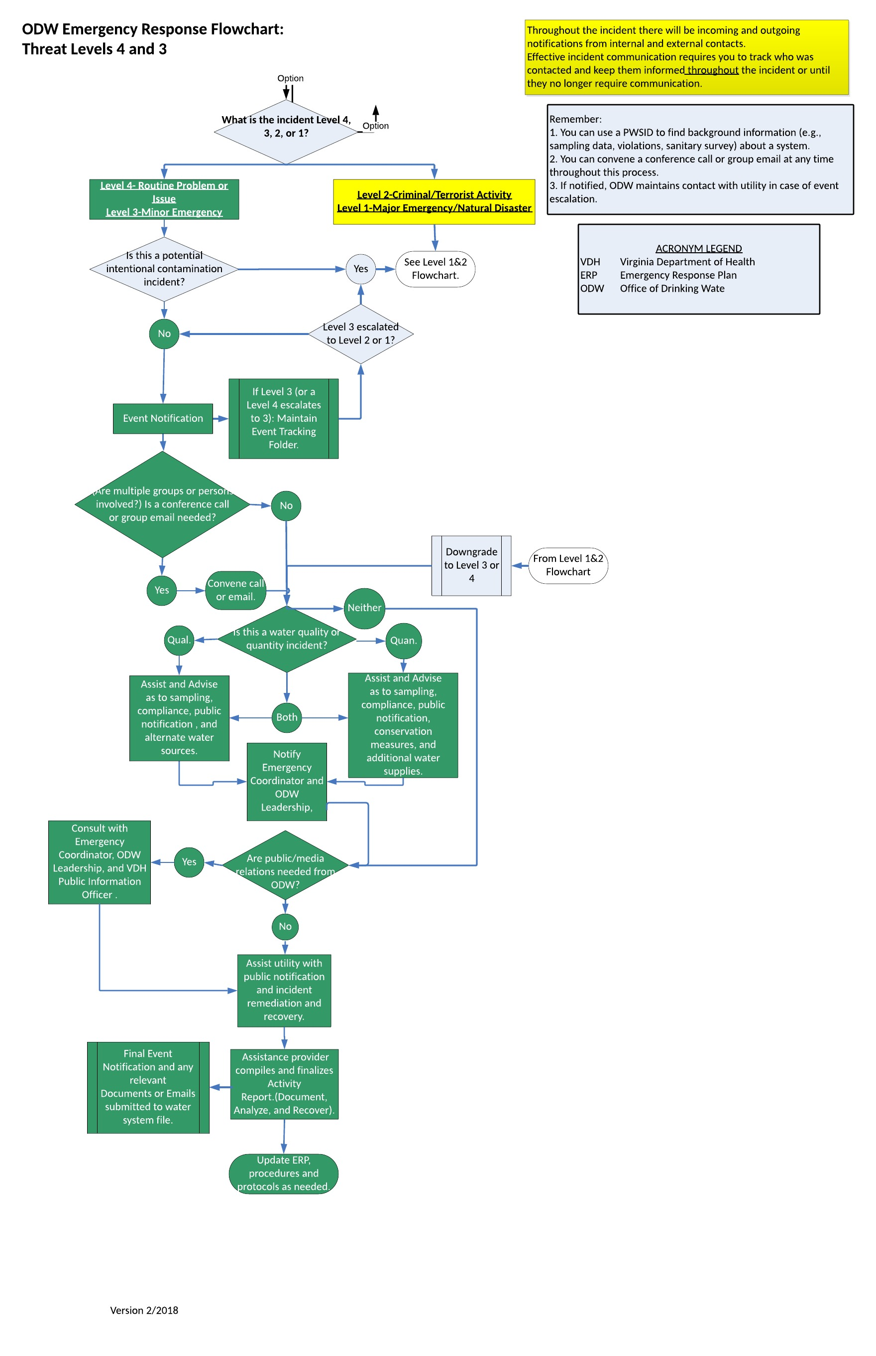

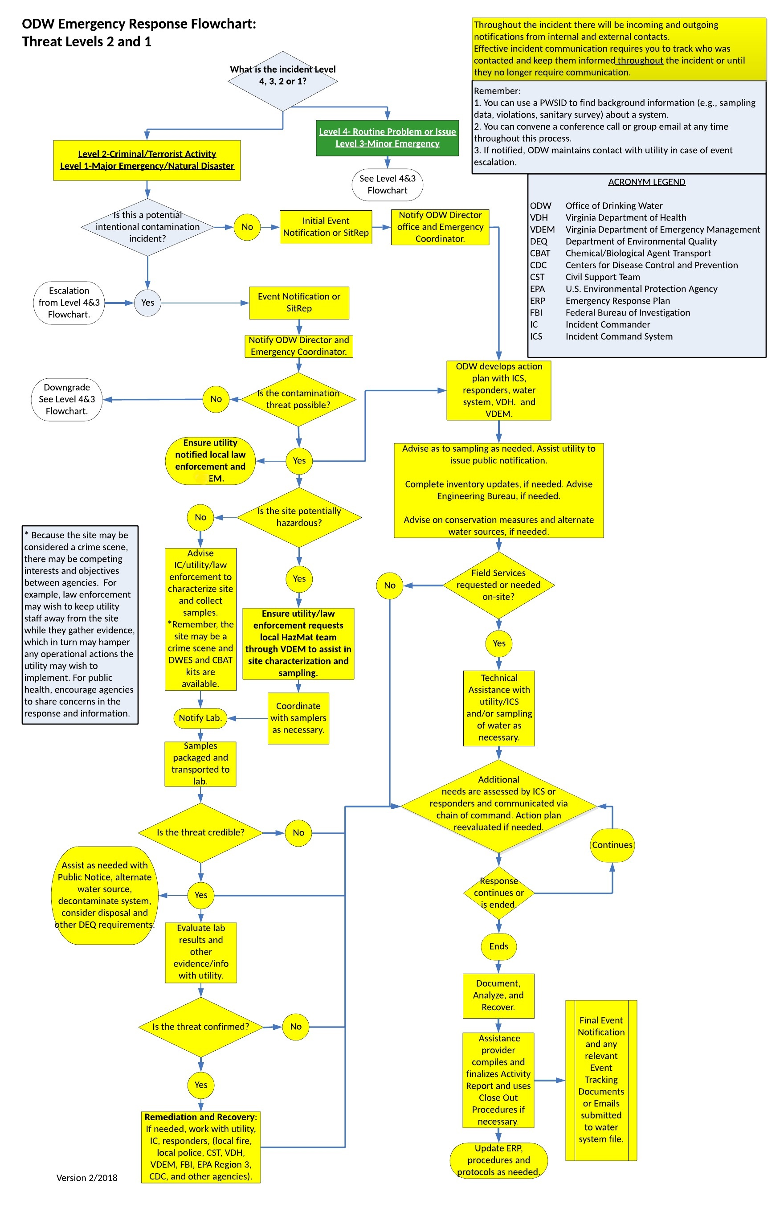

Situation Reporting
Following an incident/event ODW will issue an event notification to VDH and the Local Health Districts. Field Staff shall contact community waterworks to determine their operational status. During a hurricane, this normally occurs prior to and after the storm has subsided. Initially the status of all community waterworks in impacted areas shall be determined and reported. Afterwards, ODW will make reasonable efforts to contact all impacted waterworks daily assuming all forms of communication are available.
The Field Offices report the status of a waterworks in the Waterworks Status spreadsheet. After establishing contact with all affected waterworks or the reporting deadline arrives, the ODW Emergency Response and Security Coordinator will submit a SitRep to VDH OEP and the ODW Director and Deputy Director. This serves as an update to the earlier event notification. To avoid confusion, each Field Office will assign the duty of submitting information from their office to a single person during an event. An alternate shall also be designated and briefed. The Central Office will notify Field Offices of any reduced or increased reporting requirements and/or other changes.
These procedures apply to all of ODW during natural disasters and any other incident/event that has the potential of disrupting waterworks operations:
- Situation Assessment
- During or following an incident/event each Field Office Director (or designee) will make a determination as whether there are actual, suspected, or likely impacts to community waterworks in their districts based on local news, individual reports, or other information.
- If there are no incident related affects to any community waterworks an email to the Central Office contacts stating; “No impacts to community waterworks reported at this time” is sufficient from that Field Office. The Field Office will continue to monitor the situation but will not report to Central unless there is any change to the waterworks’ status.
- If there are actual, suspected or likely impacts to waterworks then the Field Office shall create an Event Notification and begin contacting community waterworks.
- After contacting waterworks or once the reporting deadline has arrived, the Emergency Preparedness and Security Coordinator will submit a SitRep as an update to the initial Event Notification. This will be done everyone morning by 1000 and every evening by 1900 to facilitate timely reporting to ODW Director and VEOC. Reporting times are flexible and incident driven.
- Contacting Community Waterworks
- Begin with the largest waterworks, geographic areas most likely impacted, and those that have had a history of outages due to similar incidents.
- Note the status of any BWNs or advisories for each impacted waterworks in the Water Advisories Report spreadsheet located at: ODWSHARE:\05-Incidents\501-Status Report Templates.
- Distinguish between Boil Water Advisories (BWAs) and Do Not Drink/Use Advisories in the spreadsheet. Also, note the inability to determine status of those waterworks that have not reported.
- The waterworks in impacted areas will fall into one these categories:
- Impacted by the incident/event
- Not impacted,
- No report – Utility not reached.
- Once a waterworks has reported “no impacts”, there is no need to continue to contact them unless staff become aware of new problems related to the incident (e.g. local flood days after a hurricane).
- Situation Report Submission
- Submit the SitRep twice daily to ODW Central Office, ODW Director, ODW Deputy Director, and the ODW Emergency Preparedness and Security Coordinator; by no later than 1000 and 1900 unless otherwise directed.
- Attach the waterworks status spreadsheet update to the above e-mail and submit the SitRep and status spreadsheet even if not all community waterworks are reachable or their status reported. Provide interim updates unless requested otherwise.
- Update the SitRep during the day as new information becomes available and submit to the Central Office by 1900.
- ODW Central will notify the Field office whether SitReps will be required over weekends or holidays.
- ODW Situation Report specifics:
The ODW SitReps provide an overall status report on the state of the incident/event and Community waterworks in the impacted areas. As they are incident/event specific, they should be limited to those waterworks impacted or possibly impacted by the incident/event or whose status could not be determined. SitReps are expected twice daily at the onset of an incident, and then reduced to a lesser frequency, as required by the Central Office in response to/support of VDH OEP or VEOC informational needs.
- Information shall be limited to incidents that affect the waterworks. Make note of local flooding or local road closures in the report as they may have a secondary impact to waterworks and the ability of ODW to provide resources.
- SitReps must show continuity; i.e., a clear transition from report to report must be evident. For example, if a facility is under a BWA one day, the following report should indicate the continuation or lifting of the BWA.
- Submit a separate Event Notification and SitRep when an incident occurs not apparently related to the original incident/event. For example, a BWA that issued due to a line break that is unrelated to the incident/event requires its own Event Notification and SITREP; it should not be included in the SitRep of impacted waterworks.
- Report BWAs in the Water Advisories Excel Spread Sheet as well. A separate spreadsheet will be available for regional or statewide events.
- Staffing Assignments:
The Central Office and each Field Office shall make the necessary arrangements (e.g. work schedule changes, shifts assignments, weekend assignments, prior approval for overtime, etc.) prior to an incident to ensure these reporting requirements can be met.
It is important that the Central Office and each Field Office have a primary point of contact during each work shift to reduce multiple lines of reporting and confusion. At least one alternate person should be courtesy copied on all e-mails and made aware the location of all data to ensure continuity of operations and flow of information. Designate primary and secondary contacts for each anticipated work shift pre-incident and assignments modified during the incident as needed. The staffing/shift assignments shall be shared with other offices. The Central Office and Field Offices shall assume that SitReps are necessary during weekends and holidays and shall make arrangements for the update of the SitReps during those times.
- Requests for Assistance
Any waterworks making specific requests for assistance (aside from technical assistance that ODW can provide) need to contact their local emergency manager directly. It is unlikely that ODW will know of the status (i.e. active, inactive) of all local EOCs.

Logistics
- ODW does not warehouse/stockpile disaster response materials and thus does not have resources immediately at its disposal for distribution. ODW will coordinate with VDEM for procurement of necessary resources using VDEM maintained state contracts. These contracts normally have lead times and only used when necessary support is in large volume and over an extended period. The anticipated response time in the logistical system is 25% delivery rate on day one, 50% for day 2 and 100% by day three. If a federal emergency declaration is declared, the state may also seek federal assistance to supplement needed services.
- Virginia Water and Wastewater Agency Response Network (VA WARN) is also another logistical resource that ODW can coordinate with during an event/incident. The mission of VA WARN is to provide a method whereby Virginia water and wastewater utilities that have sustained damages from natural or manmade events can obtain emergency assistance in the form of personnel, equipment, materials and other associated services as necessary from other water and wastewater utilities. The objective is to provide rapid, short-term deployment of emergency services to restore the critical operations of the impacted utility.

Public Information
During an incident/event, it is important to coordinate public information with the VDH Public Information Officer. This should be coordinated through ODW Central Office and the VDH Office of Emergency Preparedness.

PLAN DEVELOPMENT AND MAINTENANCE
To provide for consistent and uniform planning ODW will strategically manage the ERP to conform to the template produced by VDEM, and will use the resources available from VDH. Completion of the review for the ODW ERP is bi-annual, with an electronic copy sent to the VDH. The Emergency Preparedness and Security Coordinator is responsible to the Director of ODW for maintenance of the ERP.

Exercises
- VDH uses exercises to validate elements of the ERP, both individually and collectively. ODW works with VDH to ensure that during exercises individuals and business units perform the tasks expected of them in a real event. VDH conducts exercises annually in accordance with Executive Order #41 (2011). Exercises may vary in size and complexity to achieve different operational objectives. The types of exercises are described below:
- Tabletop Exercises simulate an activation of the ERP in an informal, stress-free environment. They promote constructive discussion as participants examine and resolve problems based on existing plans. There is no equipment utilization, resource deployment, or time pressure. The exercise success depends on the group identifying problem areas, and offering constructive resolution alternatives. This format exposes personnel to new or unfamiliar concepts, plans, policies, and procedures.
- Functional Exercises are interactive exercises performed in real time that test the capability of the agency to respond to simulated continuity activation. One or more functions are tested and on procedures, roles and responsibilities before, during or after an event.
- Full-Scale Exercises simulate continuity activation through field exercises designed to evaluate the execution of the plan in a highly stressful environment. This requires mobilization of agency personnel, equipment and resources.

Maintenance
- The ODW Emergency Preparedness and Security Coordinator will review this document following each Level 1 and 2 event.
- The Emergency Preparedness and Security Coordinator will review and update the document every 2 years and conduct a full rewrite every 4 years. This ensure the document captures any new ODW policy changes, new response requirements, or new VDH policy changes.

APPENDIX

ODW Emergency Notification List
James Reynolds – Field Office Director
Richmond Field Office (RFO)
804-864-7444 (office)
James.Reynolds@vdh.virginia.gov
Tony Singh – Deputy Director
Office of Drinking Water
(804) 864-7517 (office)
Tony.Singh@vdh.virginia.gov
Dwayne Roadcap - Director
Office of Drinking Water
804-864-7522 (office)
Dwayne.Roadcap@vdh.virginia.gov
Bryan Wade - Emergency Preparedness and Security Coordinator
Office of Drinking Water
804-864-7514 (office)
Bryan.Wade@vdh.virginia.gov
Dan Horne – Field Office Director
Southeast Virginia Field Office (SEVFO)
757-683-2000 (office)
Dan.Horne@vdh.virginia.gov
Jeff Wells – Field Office Director
Danville Field Office (DFO)
434-836-8416 (office)
Jeff.Wells@vdh.virginia.gov
Brian Blankenship – Field Office Director
Abingdon Field Office (AFO)
276-676-5650 (office)
Brian.Blankenship@vdh.virginia.gov
Jeremy Hull – Field Office Director
Culpeper Field Office (CFO)
540-829-7340 (office)
Jeremy.Hull@vdh.virginia.gov
Jim Moore – Field Office Director
Lexington Field Office (LFO)
540-463-7136 (office)
Jim.Moore@vdh.virginia.gov
Dr. Parham Jabari - Chief Deputy Commissioner for Public Health and Preparedness
Virginia Dept. of Health
804-864-7025 (office)
Parham.Jabari@vdh.virginia.gov
VDH
Office of Emergency Preparedness Duty Officer
DutyOfficer@vdh.virginia.gov

