Drought Monitoring Program
Prolonged periods of drought have environmental, economical and social consequences. Droughts directly affect both the quantity and quality of drinking water supplies.
The Virginia Department of Health, Office of Drinking Water (VDH-ODW) is one of 12 partners monitoring drought conditions and its effects in the Commonwealth of Virginia guided by the Virginia Drought Assessment and Response Plan. These monitoring efforts are led by the Virginia Department of Environmental Quality (DEQ) through a group called the Drought Monitoring Task Force (DMTF).
Under the DMTF, VDH-ODW is responsible for monitoring and reporting the operational status of waterworks as it relates to drought conditions.
ODW’s DMTF Latest Report
As of Jun 2021, no waterworks are implementing water use restrictions in Virginia.
VDH-ODW’s Drought Monitoring map and trend are illustrated below. The map reflects the percentage of public surface water sources operating under drought restrictions within the main river basins of Virginia. The trend shows the amount of waterworks that have been affected by drought conditions since March 2002.
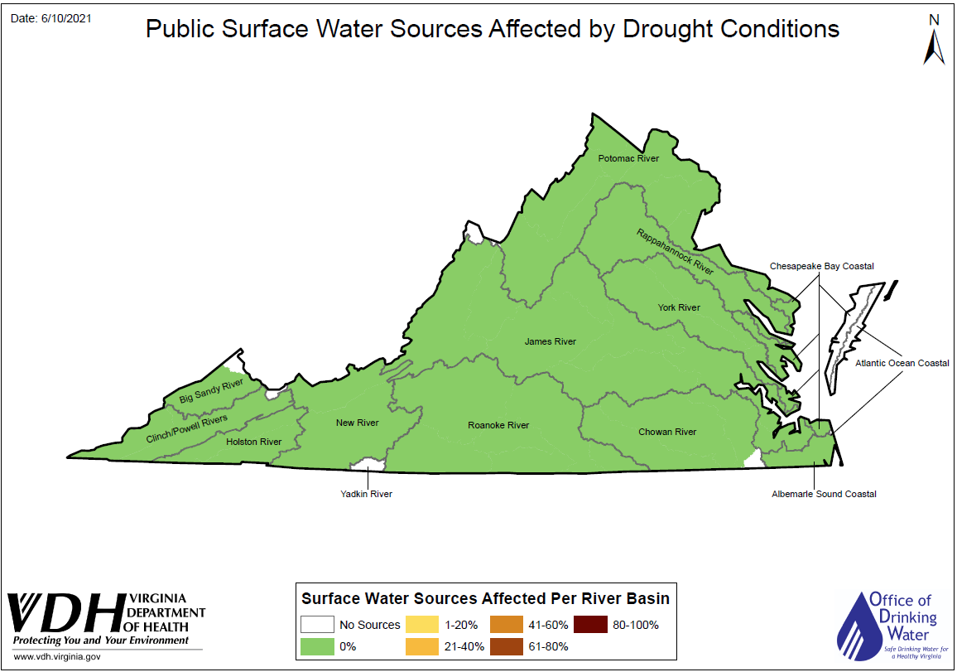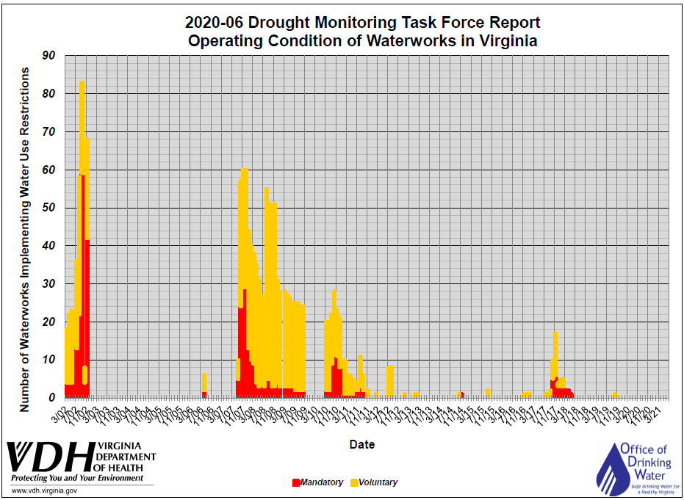
Related Links
- DEQ Drought Status, Tools, Other Resources and Full Drought Report
- EPA Tools on Drought Response and Recovery for Water Utilities
- National Drought Monitor (Virginia)
- NOAA-NWS Advanced Hydrologic Prediction Service
- NOAA-NWS Climate Prediction Center
- USGS Groundwater Watch
- USGS Surface Water real-time stream flows

