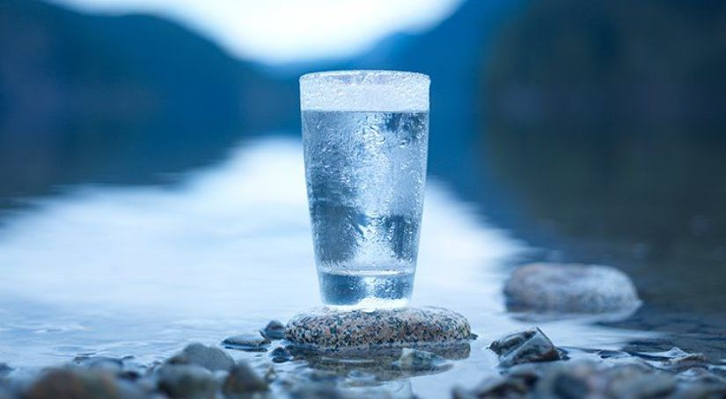

Transient Noncommunity Welcome Guide and Waterworks File

Version 1.0 – July 6, 2021

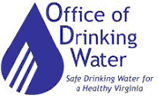
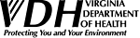

Table of Contents
Acronyms………………………………………………………………….…….……….. Page 3
Introduction………………………………………………………………………………..Page 3
Where do these requirements come from?..............................................………….Page 4
What is a public waterworks……………………………………….…………………….Page 4
This booklet is designed for TNC Waterworks……………………..………………….Page 4
What is ODW’s Responsibility…….…………………………………………………….Page 5
How do I contact ODW……..…………………………………………………………….Page 5
ODW Field Office Map and Contact Information ……………………..……………….Page 6
What are your responsibility as a public waterworks owner .………………………..Page 7
Change in ownership or treatment………………….…………………………….…….Page 8
Maintenance…………………………………………………………………………...….Page 8
Record keeping………………………………………………………………………..….Page 8
Cross Connections……………………………………………………………………….Page 8
Waterworks Business Operation Plan………………………………………………….Page 8
How do I correctly meet sampling requirements?.....................……………………..Page 9
Bacteriological..........................................................................................………….Page 9
Ground Water Under Direct Influence ….……………………….…………………….Page 9
How to take a sample……………………..……………………………………………...Page 9
Chemical Sampling…….…………………………..……………………………..…….Page 10
What happens if my sample results exceed maximum contaminant levels?.…......Page 10
Appendices………………………………………………………………………………Page 11

Acronyms
- CCCP – Cross Connection Control Program
- DCLS – Division of Consolidated Laboratory Services
- EPA – Environmental Protection Agency
- GUDI – Ground Water Under Direct Influence
- NPDWS – National Primary Drinking Water Standards
- NOAV – Notice of Alleged Violation
- ODW – Office of Drinking Water
- SDWA – Safe Drinking Water Act
- TNC – Transient Noncommunity Waterworks
- VDH – Virginia Department of Health
- WBOP – Waterworks Business Operations Plan

Introduction
Safe Drinking Water - we all need it, but we often take it for granted. That’s where you come in. As the owner or operator of a public water system, you are on the front line. You are the link between the water in the ground and the water flowing out of the tap. It is up to you to make sure the water is clean and safe for your customers.
As the legal owner of the waterworks, it is your responsibility to sample for contaminants and operate and maintain your waterworks in accordance with the Waterworks Regulations. The Virginia Department of Health - Office of Drinking Water (ODW) ensures that the construction and operations of public waterworks meet the requirements of the regulations and that public drinking water is safe for human consumption.
This handbook is designed to help you operate a Transient Noncommunity Waterworks. In it you will find information about Federal and State laws and regulations that you must follow. You will also find sources of help and answers to many of the most common questions. This handbook will become your waterworks file, your one stop shop to managing your public water system. We all have the same goal: Providing clean, safe drinking water.

Where do these requirements come from?
In 1974, The Safe Drinking Water Act (SDWA) was signed in to law by President Gerald Ford. The SDWA sets health and safety standards for public drinking water in the United States. Under the law, the United States Environmental Protection Agency (EPA) establishes the National Primary Drinking Water Standards (NPDWS) for drinking water quality. The SDWA also requires that the EPA establish and enforce water quality standards that public waterworks must adhere to. All regulated waterworks must meet these standards. Most states are given the primary enforcement responsibility for public waterworks if they establish their own regulations that meet the requirements of the SDWA.
Public waterworks in Virginia must meet both state and federal drinking water requirements. The Office of Drinking Water enforces the state and federal regulations, which are contained in the Virginia Waterworks Regulations. The Virginia Waterworks Regulations sets standards for water quality, sampling, reporting and record-keeping, and facility design, construction, and operation. The complete Virginia Waterworks Regulations can be viewed online at:
http://www.vdh.virginia.gov/drinking-water/laws-regulations/

What is a public waterworks?
Both EPA and ODW define a public water system as one that provides piped water for human consumption to least 15 service connections OR regularly serves an average of 25 persons per day for at least 60 days of the year. There are three types of public waterworks in Virginia: Community waterworks, Nontransient Noncommunity waterworks and Transient Noncommunity Waterworks.

Note: “Human consumption” includes: drinking, handwashing, bathing, showering, cooking, and dishwashing and maintaining oral hygiene.

This booklet is designed for TNC Waterworks
Transient noncommunity waterworks serve at least 25 people on average for at least 60 days per year. They do not serve the same 25 people over 6 months of the year.

Examples of TNC waterworks include, but is not limited to: restaurants, motels, parks, breweries, wineries, wedding venues, campgrounds, and marinas.

What is ODW’s responsibility?
The Virginia Department of Health Office of Drinking Water (ODW) is the state agency that ensures that all public water systems in Virginia meet state and federal requirements. ODW accomplishes this mission by:
- Performing Sanitary Surveys: A Sanitary Survey is a routine inspection of a waterworks. A trained Environmental Inspector from ODW periodically visits each public water system and conducts a complete evaluation of its infrastructure and operations. The purpose of the Sanitary Survey is to protect consumers by identifying waterworks problems and ensuring that the problems are resolved.

- Issuing Construction and Operation Permits: Proper construction of waterworks facilities is the first line of defense against water quality issues. Before a new waterworks is built, or changes made to an existing one, the owner must get a Construction Permit from ODW. ODW reviews and evaluates plans and specifications for the proposed construction to ensure that the facility design meets state requirements. ODW also inspects facilities after construction, before they are placed in service.

The Virginia Department of Health - Waterworks Operation Permit is your official permit to serve drinking water to the public. ODW is the agency that processes applications for Waterworks Operation Permits.
For more information on obtaining permits, contact the ODW Field Office for your region, or visit the ODW website at:
http://www.vdh.virginia.gov/drinking-water/permits-and-design/
- Enforcing Chemical and Bacteriological Water Quality Standards: Public water systems must comply with state and federal limits and testing requirements for chemicals and microorganisms in drinking water. ODW reviews test results to make sure that water quality standards are being met.

- Providing Technical Assistance: ODW staff includes engineers and inspectors who are available to answer your questions and offer technical assistance. They are a valuable resource to help you understand and carry out your responsibilities as a public water supply owner or operator.

How do I contact ODW for assistance?
Where your waterworks is located will dictate which ODW Field Office you will need to contact. There are six different ODW Field Offices in Virginia. The map on page 6 shows the different offices, and there is table on page 6 with contact information for each office.
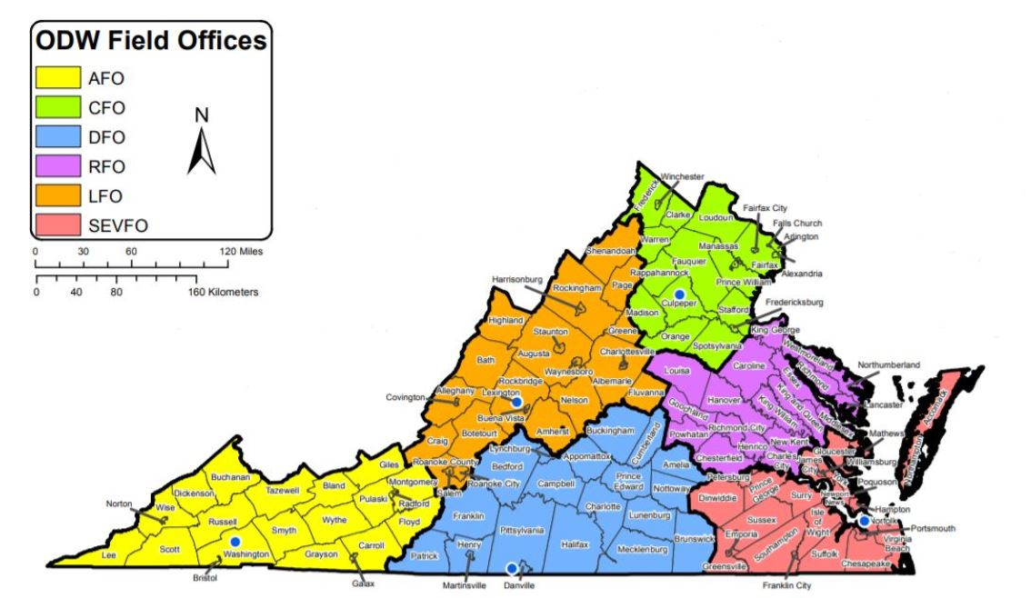

Visit this link for an interactive web map to find out the ODW staff contacts for your waterworks:

https://www.vdh.virginia.gov/drinking-water/contact-us/

 | Abingdon Field Office (AFO)  407 East Main Street  Suite 2  Abingdon, VA 24210  Phone: (276) 676-5650  Fax: (276) 676-5659 |  | Southeast Virginia Field Office (SEVFO)  830 Southampton Avenue  Room 2058  Norfolk, VA 23510  Phone: (757) 683-2000  Fax: (757) 683-2007 |  | Danville Field Office (DFO)  211 Nor Dan Drive  Suite 1040  Danville, VA 24540  Phone: (434) 836-8416  Fax: (434) 836-8424
 | Lexington Field Office (LFO)  131 Walker Street  Lexington, VA 24450  Phone: (540) 463-7136  Fax: (540) 463-3892 |  | Richmond Field Office (RFO)  109 Governor Street  6th Floor  Richmond, VA 23219  Phone: (804) 864-7409  Fax: (804) 864-7520 |  | Culpeper Field Office (CFO)  400 South Main Street  2nd Floor  Culpeper, VA 22701  Phone: (540) 829-7340  Fax: (540) 829-7337
Environmental Health Spc.: ______________________________________________________________
Email: _______________________________________________________________
Phone: _______________________________________________________________
District Engineer: _______________________________________________________________
Email: _______________________________________________________________
Phone: _______________________________________________________________

What are your responsibilities as a public waterworks owner?
You must provide water that meets state and federal drinking water standards. Information regarding drinking water standards for TNC public waterworks can be found here:
https://www.epa.gov/dwreginfo/drinking-water-regulations.
The basic requirements of owning your TNC waterworks include:
- Sampling
TNC waterworks have specific water quality testing requirements due to the nature of their interaction with the public. Drinking water contaminants fall into two categories: acute or chronic contaminants. Acute contaminants can have serious health impacts after consuming only a small amount of contaminated water. Chronic contaminants can have serious health impacts after consumption of drinking contaminated water for a long period of time. Since TNC public waterworks do not serve the same 25 people on a daily basis, risk from chronic contaminants is extremely low so they are not required to sample for that group of contaminants.

Bacteria and nitrates in drinking water, detected above certain levels, are acute contaminants. This means that they can cause illness from a single ingestion of contaminated water. There is a real risk of a customer getting sick from the water contaminated with acute contaminants, specifically bacteria and nitrate. That is why TNC public waterworks owners must monitor for both coliform bacteria and nitrates.

All TNC waterworks must, at a minimum, collect and have analyzed quarterly samples for total coliform bacteria and annual nitrate-nitrite samples. There are some TNC waterworks that must sample more frequently based on compliance history and/or water quality. All drinking water samples must be analyzed by the Virginia Division of Consolidated Laboratory Services (DCLS) or by a private laboratory that has been certified for the specific public drinking water sample(s) being analyzed. It should be noted that not all laboratories are certified for all drinking water samples. If you opt to use a private laboratory, make sure to check that they are certified by DCLS. A list of certified private labs can be found here:
https://dgs.virginia.gov/division-of-consolidated-laboratory-services/certification-accreditation/find-a-lab/
For TNC waterworks that use DCLS, the lab will send an invoice for the kit(s) to the waterworks about a month prior to the next compliance period. Once the owner has paid the invoice, DCLS will mail the kit(s) to the owner. If you do not pay the invoice, you will not receive your kit(s). For example, your second quarter invoice will arrive in late February/early March. As the owner, sampling on time is your responsibility. Detailed instructions on how to take a proper sample will be outlined on page 10 and in the appendix of this packet. ODW and DCLS are willing to assist you, but you must take the initiative to make sure you have your samples in before the end of the monitoring period. If you do not have the kits you need to take your samples, let your ODW contacts know as early as you possibly can. Failure to monitor for required contaminants will result in the issuance of a Notice of Alleged Violation (NOAV).
- Additional Seasonal Sampling
If your entire waterworks, or a portion of the waterworks, is closed for longer than one monitoring period, you may meet the definition of a seasonal waterworks. As a seasonal waterworks you are required to follow an ODW approved start-up and shut down procedure. Those procedures include special bacteriological samples that must be analyzed prior to starting up. You must also submit a seasonal start-up certification statement to ODW prior to starting up. If you do not submit the special samples and certification forms for analysis prior to starting up your system, you will receive a NOAV. If you’re required to follow seasonal start up procedures, ODW will notify the owner with a letter every year prior to start up. A copy of your approved plan should be kept in the appendix of this packet.
3. Communication with ODW about any changes
If your facility plans to change owners, modify operations that would change your waterworks classification, or makes ANY changes to the water system, let ODW know prior to making any changes. A change in ownership requires that your permit be amended and reissued to the new owner. A major operations change such as closing down for a part of the year or increasing size of the business may change your waterworks classification. ANY change to the actual water system or its components must be approved by ODW prior to instillation, failure to do so may result in the issuance of a NOAV.
4. Maintenance
Wells and pumping facilities must be kept in a safe and sanitary condition by sealing of any open conduits into the well casing, replacing any damaged vent screens, and maintaining a sanitary seal on the well head. The well lot should be maintained in good sanitary condition to provide a safe and dependable water supply.
5. Record Keeping
In accordance with 12VAC5-590-550, you must retain your sampling and assessment records. Keep copies of sampling results and inspection reports in the appendix of this packet. You’ll want these as a historical record in case you decide to sell you property or have customer questions. Lab reports can also serve as your compliance record if ODW does not receive your sample results.
6. Cross Connection Control
A cross-connection is the actual or potential pathway where contaminated water may enter the potable water system. Federal and State regulations require a cross connection control program (CCCP). Cross-connections with resulting backflow of contaminants, while a very important water quality issue, may also be a very important liability issue for a public water system of any size. Installation of backflow prevention devices will prevent cross-connection with contamination sources. Protecting the water system cannot be over-emphasized given the historical water system contamination events attributed to cross-connections. All backflow prevention devices should be inspected regularly. Caution must be exercised when a backflow prevention device is installed on a water service line. During the initial inspection of your waterworks, ODW staff will assist you in developing an appropriate CCCP. Keep your approved CCCP in the appendix of this packet.
7. Waterworks Business Operations Plan
A Waterworks Business Operations Plan (WBOP) is a written document that identifies key people, required plans, and basic finances for your waterworks. Each waterworks in Virginia, including your TNC, is required to have a WBOP. This plan demonstrates whether a waterworks has sufficient technical, managerial, and financial capacity to sustainably operate and meet all regulations. Preparing a WBOP guides you through the process of identifying responsibilities, assessing current and proposed conditions, identifying improvements, and establishing a plan to operate the waterworks using successful and sustainable methods. It is highly recommended that ODW assists you in completion of your WBOP. Keep your current WBOP in the appendix of this packet.

How do I take the required samples?

Please refer to “DCLS Sampling Guidance” in the appendix for an in depth explanation of how to collect compliance samples. There are pages detailing how to obtain sample kits, how and what the labeling means, and how to take a proper sample.

Bacteriological Sampling

All waterworks must have and follow an approved Bacteriological Sample Siting Plan (BSSP) in order for samples to be accepted by ODW for compliance. Your BSSP is your master sampling guide. It should be referenced any time you have questions about where and when to take a take a sample. If you receive notice that a routine compliance sample contains any detectable levels of total coliform or E. coli bacteria, you must reference your BSSP for follow up sampling protocol. ODW staff will help you to construct your BSSP during the initial inspection of your waterworks.

Ground Water under Direct Influence Sampling

Every ground water source in the state of Virginia must have a completed ground water under direct influence (GUDI) evaluation. New or newly found waterworks will be required to do additional sampling to determine if the source water is ground water, or if surface water (like water from a pond) is getting into the well. The GUDI evaluation typically consists of 10-20 bacteriological samples. If your TNC waterworks does not provide disinfection treatment, ODW will substitute your quarterly bacteriological samples for the GUDI evaluation. ODW staff will work with you to determine the schedule for your GUDI sampling upon their initial visit to your waterworks.

How to take a bacteriological sample

- Remove faucet attachments such as screen or splash guard.
- Clean the tap with a disinfectant wipe or alcohol based cleaning solution, making sure to get in the threads of the tap if applicable.
- Allow the tap to dry for 30 seconds to 1 minute.
- Turn the cold water fully on and flush the faucet for at least five (5) minutes.
- Adjust the flow to a slow, even stream so that the water is not aerated during collection.
  - Perform the chlorine residual test, if necessary.
- Carefully remove the bottle cap. Do not touch the inside of the cap or rim at the top of the bottle.
- Fill the bottle to about a half-inch above the 100mL line. If you do not fill to at least the 100mL line, your sample will be rejected as QNS (Quantity Not Sufficient). Leave some airspace between the cap and the sample to allow mixing in the laboratory.
- The peel-off label adheres better to a dry bottle. Dry the outside of the sample bottle and remove the completed label from the form. Place the label on the bottle vertically.

You must have a plan in place for how your samples will get to the lab in a timely manner prior to sampling. The “holding time” for bacteriological samples is only 30 hours, which means they must be analyzed at the lab within 30 hours of the sample being collected. If your samples exceed holding time, they will be rejected. If they are rejected, you will have to resample and might be issued a violation.

Chemical Sampling

All TNC waterworks in Virginia are required to perform regular tests for nitrates. Most waterworks will sample on a yearly basis, however you may be required to sample more frequently based on your water chemistry. Other chemical tests may be required in cases where contamination is suspected. Nitrates can enter water supplies from natural deposits, from fertilizers applied in the vicinity of a well, or from septic systems that are constructed too close to a well. If present in drinking water, nitrates can interfere with the body’s ability to absorb oxygen. This can be especially harmful for infants, who may suffer “blue baby syndrome” if they are fed formula that has been prepared with water that has high nitrate levels.
Follow the same sampling steps as you do for a bacteriological test. Nitrates have a longer hold time, 28 days, however it is best to get samples to the lab as soon as possible. The longer you wait, the greater the chance you forget to turn in the sample or have problems with the analysis.
What happens if my samples results exceed maximum contaminant levels?
ODW staff will contact you if you exceed the limits for bacteria or nitrate. You will usually be required to take repeat samples immediately after notification, or you may have to collect samples for analysis more frequently than before. You will also be required to advise consumers of test results by posting or hand delivering a Public Notice. Your ODW Field Office will provide a copy of a suggested notice and completion instructions.

APPENDICES

Operations permit and accompanying attachments ……………………….….. Appendix A
Monthly Operations Reporting..................................................................…….Appendix B
Approved SDWA Plans (BSSP, CCCP, WBOP) ………………………………..Appendix C
DCLS Sample Guidance……………………..………………………………..……Appendix D
Completed Sample Analyses…….………………………………………………...Appendix E
General Correspondence ……..……………………………………………………Appendix F
Miscellaneous information ……………………..…………………………………..Appendix G

APPENDIX A
Operations permit and accompanying attachments

Behind this page, please keep your Waterworks Operation Permit and any accompanying attachments (metering variance, completed permit application, etc.)

APPENDIX B
Monthly Operations Reports

Behind this page, if applicable, please keep your monthly operations report (MOR) template and copies of previously completed reports.

APPENDIX C
Safe Drinking Water Act Plans and attachments

Behind this page, please keep your approved safe drinking water act plans: BSSP, CCCP, and WBOP.

APPENDIX D

DCLS Sampling Guidance

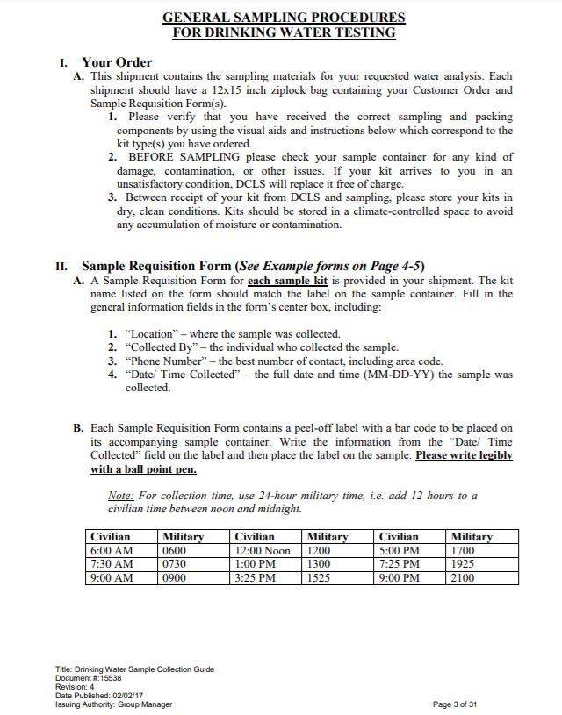
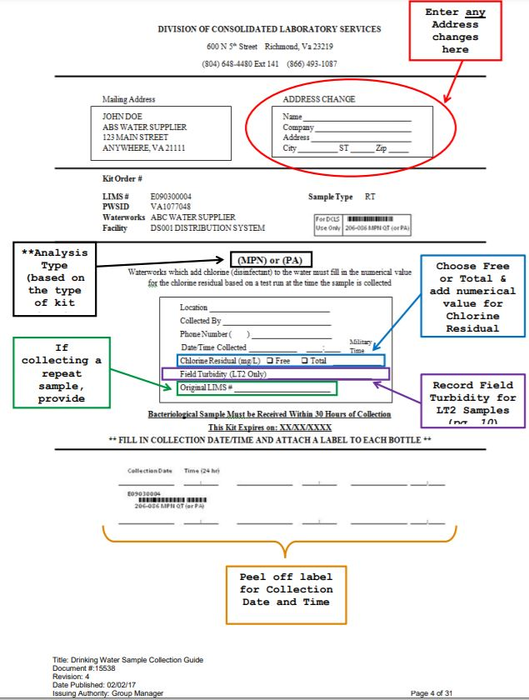
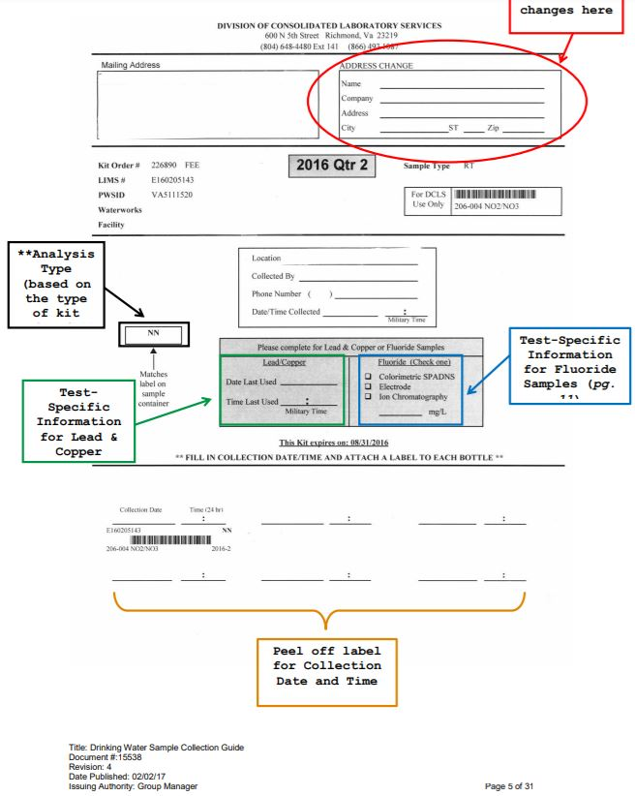
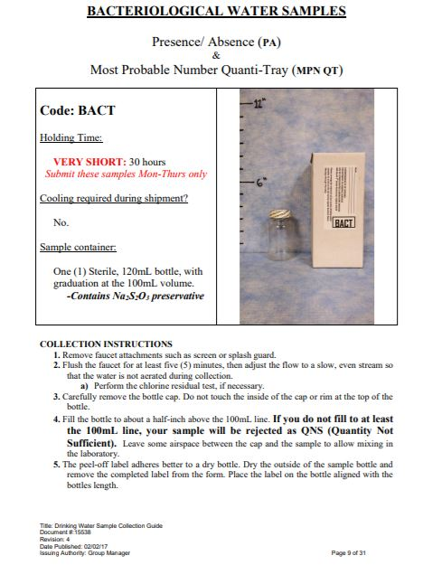
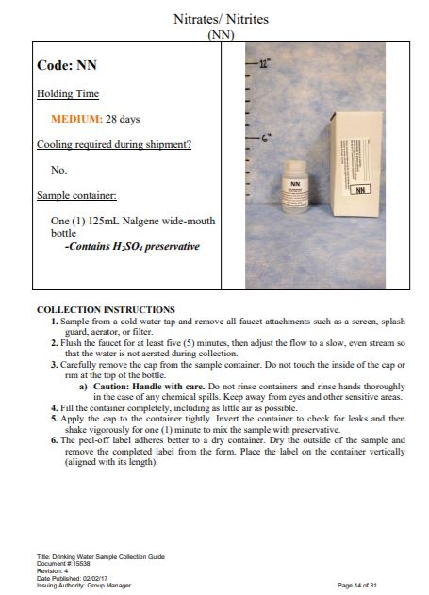

APPENDIX E
Sample Analyses

Behind this page, please keep copies of all completed bacteriological and chemical sample analyses.

APPENDIX F
Waterworks Correspondence

Behind this page, please keep all general correspondence from ODW and waterworks specific business.

APPENDIX G
Miscellaneous

Behind this page, please keep any other documents that are specific to your waterworks such as: well drillers log, yield and draw down test, plans and specifications, equipment literature, maintenance records, etc.
.

