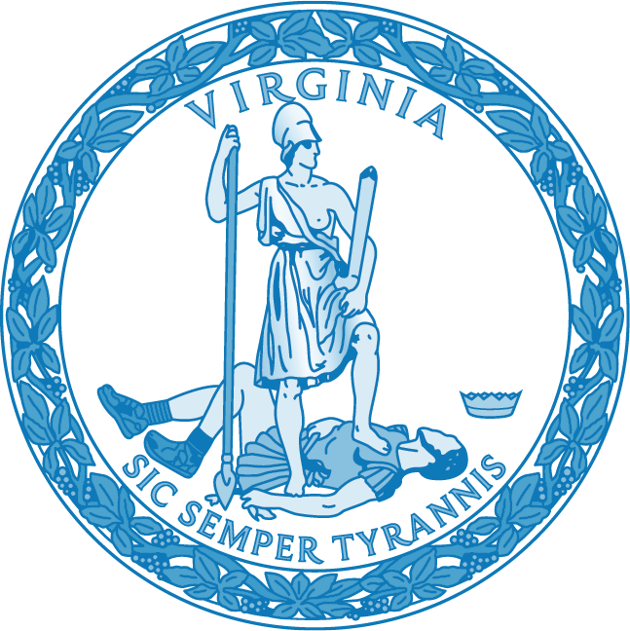

WATER MANAGEMENT PROGRAM
TO PREVENT
LEGIONELLA PNEUMOPHILA
GROWTH IN
PUBLIC SCHOOL BUILDINGS

VIRGINIA BOARD OF EDUCATION

ACKNOWLEDGEMENTs

The Virginia Department of Education (VDOE) deeply appreciates the contributions of the Virginia Department of Health - Office of Drinking Water (VDH-ODW) and all team members who helped in writing and editing the “Water Management Program to Prevent Legionella Pneumophila Growth in Public School Buildings”.

Part 1: Introduction

Each local school board must provide and maintain a healthy learning environment at school facilities under its jurisdiction. Va. Code § 22.1-138, as amended, requires public school boards to develop and maintain a water management program to prevent Legionnaires disease. The Virginia Department of Education (VDOE) must make recommendations for the establishment, maintenance, and validation of water management programs to prevent Legionella pneumophila growth in public school buildings by July 1, 2021.

The recommendations herein provide guidance and resources to school boards and their facility maintenance staff on how to establish, maintain, and validate a water management program to prevent Legionella pneumophila growth in public school buildings. As enacted by the General Assembly of Virginia in 2020: § 22.1-138 of the Code of Virginia is amended to include:

C. Each school board shall maintain a water management program for the prevention of
Legionnaires' disease at each public-school building in the local school division. Each school board shall validate each water management program on at least an annual basis to maintain the health and decency of such buildings. Each public school shall maintain files related to its water management program, including the results of all validation and remediation activities, and make such files available for review.

2. That the Department of Education shall make recommendations for the establishment, maintenance, and validation of water management programs to prevent Legionella pneumophila growth in public school buildings and shall notify each local school board of its recommendations no later than July 1, 2021.
3. That the provisions of the first enactment of this act shall become effective on July 1, 2021.This requires public schools to do three things (private schools are exempt):
- Develop and maintain a water management program for the prevention of Legionnaires' disease at each public school building in the school division;
- Validate the water management program at least annually; and,
- Maintain files related to the water management program, including the results of all validation and remediation activities, if any, and make such files available for review.
Legionella bacteria are commonly spread through airborne water droplets. Mist or vapor contaminated with the bacteria can come from whirlpool spas, team locker shower areas, cooling towers (used as air-conditioning units in large buildings), and water used for drinking and bathing, according to the Center for Disease Control (CDC). Legionnaires' disease is a form of pneumonia that is caused by inhalation or aspiration of bacteria. The organisms are consistently found in the biofilm that forms in aquatic environments, cooling towers and potable water systems.
Legionella bacteria has been found in schools’ mechanical equipment, specifically outside cooling towers. There are no current Federal laws that require the testing of Legionella bacteria or a current national protocol as to the frequency for legionella testing, or action thresholds if the bacteria is found. In the past, legionella risk assessment protocols were reviewed at least every 2 years. Current “risk assessment” should be a living document. The testing for Legionella bacteria should be part of every school division’s building preventive maintenance program.
Conditions or characteristics that can contribute to potentially hazardous conditions include, but
are not limited to: Biofilms, Stagnation, Scale, Temperature, Sediment, Flow imbalance or blockage, idling or intermittent flow without treatment and Insufficient disinfectant residual, or excess disinfectant due to overfeed.

Part 2: Resources

The Center for Disease Control and Prevention (CDC) has a toolkit for developing a water management program at this link: https://www.cdc.gov/legionella/wmp/toolkit/index.html.
The Virginia Department of Health established a specific website to help school boards better understand requirements of the legislation and to implement it. This information is found at this link: https://www.vdh.virginia.gov/drinking-water/implementing-sb-410-in-school-building-startup/.
Additional information on the American National Standards Institute (ANSI)/ American Society of Heating, Refrigerating and Air-Conditioning Engineers (ASHRAE) Standard 188-2018 can be found at Legionellosis: Risk Management for Building Water Systems.
The above resources describe the process for creating a water management program as follows:
A water management program identifies hazardous conditions and takes steps to minimize the growth and spread of Legionella and other waterborne pathogens in building water systems. Developing and maintaining a water management program is a multi-step process that requires continuous review. Seven key activities are routinely performed in a Legionella water management program:
- Establish a water management program team;
- Describe the building water systems using flow diagrams and a written description;
- Identify areas where Legionella could grow and spread;
- Decide where control measures should be applied and how to monitor them;
- Establish ways to intervene when control limits are not met;
- Make sure the program is running as designed and is effective; and
- Validate, document, and communicate all activities involving the water management program annually.
In general, the principles of effective water management program will include:
- Maintaining water temperatures outside the ideal range for Legionella growth,
- Preventing water stagnation,
- Ensuring adequate disinfection,
- Maintaining premise plumbing, equipment, and fixtures to prevent scale, corrosion, and biofilm growth, all of which provide a habitat and nutrients for Legionella.
Members of a building water management program team collaborate to:
- Identify ways to minimize growth and spread of Legionella and other waterborne pathogens,
- Conduct routine checks of control measures to keep an eye on areas at risk, and
- Take action if a problem is found.

Once established, water management programs require regular monitoring of key areas for potentially hazardous conditions. Programs should include predetermined responses to correct hazardous conditions if the team detects them.

All Virginia school boards and their school building maintenance operations (or an outside accredited Legionella testing laboratory consultant) shall comply with ANSI/ASHRAE Standard 188-2018.

ASHRAE 188 specifically mentions that the following water systems should be included in a water management plan: Potable Water Systems, Cooling Towers and Evaporative Condensers, Whirlpool Spas, Ornamental Fountains and other Water Features, Aerosol-Generating Misters, Atomizers, Air Washers, and Humidifiers.

Results of all inspections and evaluations shall be made a part of the program record.

Additional information on water management and preventative building mechanical systems maintenance measures are available on the websites of the CDC, VDH, as well as the other resources listed below.

LINKS

CDC Water Management

CDC Reopening Buildings

What is Legionella? (CDC)

CDC Surveillance and Reporting Resources

CDC Guidelines, Standards, and Laws

The Georgia Department of Public Health published a water management template dated June 2019: https://www.vdh.virginia.gov/content/uploads/sites/14/2020/09/Water-Management-Program-Template_GADoH_June2019.docx

VDH WATER MANAGEMENT PROGRAM ASSISTANCE

ReferenCes

• ANSI/ASHRAE Standard 188-2018, Legionellosis: Risk Management for Building Water Systems
• ANSI/ASHRAE Standard 180-2018, Standard Practice for Inspection and Maintenance of Commercial Building HVAC Systems • Centers for Disease Control and Prevention, Developing a Water Management program to Reduce Legionella Growth & Spread in Buildings, June 5, 2017
• Cooling Technology Institute, Legionellosis; Guideline: Best Practices for Control of Legionella, July 2008 CTI Guideline WTB-148
• OSHA eTools: Legionnaires Disease
• NSF International Protocol NSF P453-2017, Cooling Tower Water Systems – Treatment, Operation, and Maintenance to Prevent Legionellosis
• EPA 832-F-17-016c Water Efficiency Management Guide, Mechanical System

