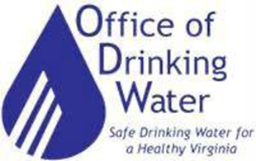
Guidance for Nontransient Noncommunity Waterworks

Initial Lead Service Line Inventory

Office of Drinking Water

Frequently Asked Questions
Do the lead service line (LSL) inventory requirements apply to noncommunity waterworks?
The service line inventory requirements apply to all nontransient noncommunity (NTNC) waterworks.
Which service line inventory template should NTNC waterworks use?
Small NTNC waterworks (i.e., NTNCs serving 5 or fewer service connections) should use the Small NTNC Service Line Template. NTNC waterworks serving 6 or more service connections should use the Community Waterworks Service Line Inventory Template. In addition, NTNC waterworks that share ownership of service lines with customers must use the Community Waterworks Service Line Inventory Template. Instructions and templates are available on ODW’s LCRR web page: https://www.vdh.virginia.gov/drinking-water/lcrr-guidance/
What has EPA said about NTNCs?
“Note that some CWSs and NTNCWSs may not have an extensive distribution system, such as those with a direct connection from a well to a single building. Systems must report the material from the well to the building inlet for their inventory. EPA intends to develop a separate guidance that is tailored to small CWSs and NTNCWSs.”
What is the definition of a “service line”?
EPA has defined service line to mean, “the pipe connecting the water main to the interior plumbing in a building.” In the context of small NTNC waterworks, the distinction between water mains and service lines may be unclear. ODW will take the “service line” to mean any buried segment of piping from the source (such as a well) to a building, excluding any premise plumbing. Some NTNC waterworks will have more than one buried segment of piping or service lines.
What is premise plumbing?
Premise plumbing is generally plumbing inside a home or building, but does not include pumping, treatment and storage that are part of a waterworks. Waterworks do not need to report premise plumbing materials in their service line inventory.
What must NTNC waterworks report in their inventory?
NTNC waterworks must identify the materials for the service lines. Refer to Figures 1 and 2 for examples of service lines.
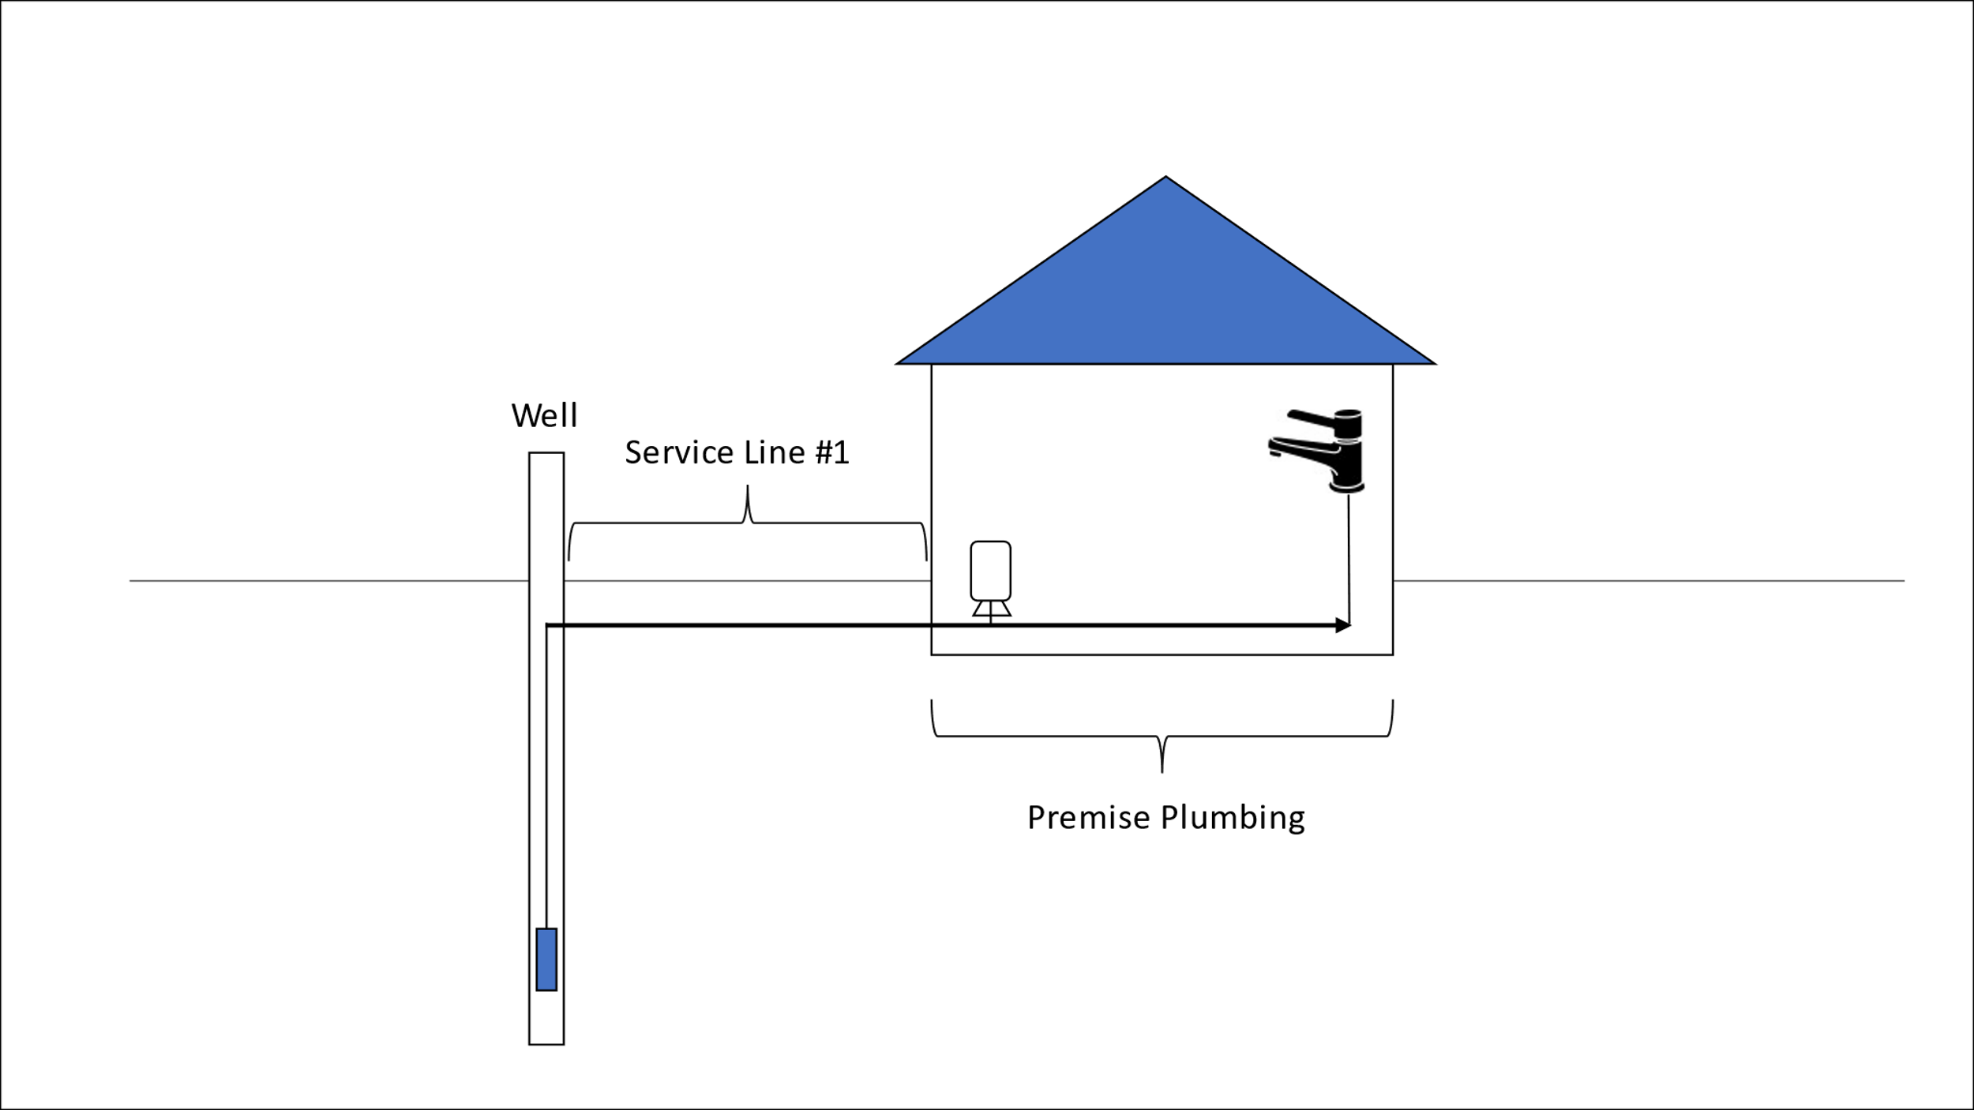
Figure 1 - One well with one building connection.
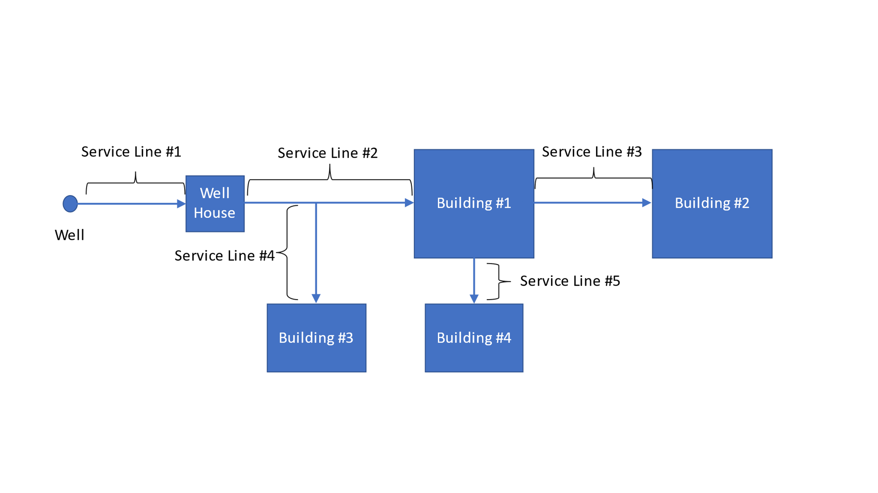
Figure 2 - One well with multiple buildings and service connections.
When must the LSL inventory be submitted?
The waterworks must submit the LSL inventory to ODW by the compliance date, October 16, 2024.
What are “unknown” service lines?
A waterworks may classify service line materials as “lead status unknown” or “unknown” where the service line material is not known to be lead, galvanized requiring replacement, or a non-lead service line, such as where there is no documented evidence supporting material classification. The LCRR does not require the LSL inventory to identify the material of every service line by the compliance date. However, the EPA has dis-incentivized having large numbers of unknown service lines by requiring annual public education and other requirements for all service connections listed as unknown. Please see 40 CFR 141.85 for more information.
What are non-lead service lines?
The EPA defines non-lead service lines as those with evidence-based record, method, or techniques that they are not lead or galvanized service lines requiring replacement. The water system may classify the actual material of the service line (i.e., plastic or copper) as an alternative to classifying it as “non-lead”.
What is a galvanized requiring replacement service line?
A galvanized service line requiring replacement is any galvanized service main that has ever been downstream of a lead service line, or of an unknown material service line. These lines are classified as galvanized requiring replacement because they have demonstrated the ability to absorb lead from a lead service line and release it in the future. Replacing these lines will reduce a source of lead to the customers.
What do I do with the LSL inventory?
All community and NTNC waterworks must submit a lead service line inventory to ODW. The LSL inventory must be submitted to ODW by the compliance date. Further information including submittal instructions will be posted on the LCRR web page: https://www.vdh.virginia.gov/drinking-water/lcrr-guidance/.
All waterworks must make their LSL inventories available to the public. In addition, all systems serving greater than 50,000 people must post their LSL inventory on the internet.

Guidance for Developing and Maintaining a Service Line Inventory (USEPA, 2022), Page 2-9.
Seventh Drinking Water Infrastructure Needs Survey and Assessment: Lead Service Line Inventory for America’s Water Infrastructure Act – State Survey Instruction (USEPA, 2021).

