Transient Noncommunity Waterworks Guidebook - January 2025
YOUR WATERWORKS BASIC INFO:
PWSID Number:
Waterworks Name:
Waterworks Contacts:
VDH-ODW Contact:
Table of Contents
INTRODUCTION 2
Contact ODW 3
WATERWORKS Personnel 3
SAMPLES FOR WATER QUALITY 4
Labs 4
Bacteria 4
Nitrate and Nitrite 5
Lead 5
SYSTEM VISITATION AND OPERATIONS 5
Repairs and maintenance 6
Cross Connection Control 7
__________________________________________ 7
A Brief Introduction to Cross Connection Control 7
What can I do to prevent it? 8
Disinfecting your water system 9
DISINFECTION TREATMENT SYSTEMS 9
Ultraviolet disinfection (UV) 9
Hypochlorination 10
Hauling water 10
public notice 11
RECORDKEEPING 11
REPORTING 11
New sources, treatment, storage, pumping, and other waterworks equipment 11
Waterworks business operations plan (WBOP) 11
unhappy Consequences 12
last thoughts 12
APPENDICES 12

INTRODUCTION
Congratulations! You are a waterworks about to embark on a journey to protect the health of your consumers!
Water systems like yours are called “waterworks” when they serve at least 25 people per day on at least 60 days out of the year. Waterworks like yours serve different people everyday, like restaurants, breweries, wineries, golf courses, campgrounds, parks, marinas, and churches, among others. Waterworks like yours are called transient noncommunity (TNC) waterworks.
Sources of drinking water include wells, springs, rivers, and lakes. Many wells have good water quality and can be drank without treatment.
Other sources have bacteria, viruses, and protozoans that can get people sick, which are called pathogens because they cause disease. Those sources are treated to kill pathogens and remove contaminants.
After the source and treatment, the water is stored in a storage tank until it is distributed to customers. The distribution system is the network of pipes and valves in the ground.
Water must be safe if it used for drinking, food preparation, dishwashing, bathing, showering, hand washing, teeth brushing, or maintaining oral hygiene.
To make sure that your water is safe, you must regularly test the water for bacteria, nitrate, and nitrite. Those are called acute contaminants because they can make people sick even after limited exposure.
The type of bacteria tested are coliform (pronounced CALL-ih-form or COAL-uh-form) bacteria, which are throughout our environment, and E. coli bacteria, which come from fecal contamination. Even though these are usually the only bacteria tested for, other pathogens can exist in drinking water, like Legionella or Giardia. Because those contaminants are difficult and expensive to test for, the presence of coliform bacteria is used as an indicator that the water system is vulnerable to contamination. E. coli presence is an indicator of fecal contamination, which indicates that contamination has occurred and that there is a health risk.
Nitrate and nitrite are chemical compounds that cause a disorder called methemoglobinemia, also called blue baby syndrome. This disorder is most acutely dangerous to infants under 6 months old where it can reduce the oxygen-carrying capacity of blood, causing a blue-grey appearance, anemia, seizures, and death. Nitrate gets into drinking water from nearby fertilizer use and nitrite gets into water from poorly-maintained or located septic systems.
During repairs and maintenance, waterworks may be contaminated so precautions must be taken before, during, and after work is done to avoid contamination.
The Virginia Department of Health, Office of Drinking Water (ODW) regulates waterworks like yours to ensure that water quality is regularly monitored and that unsatisfactory results are addressed to keep people from getting sick. These requirements and more are in the Virginia Waterworks Regulations, 12 VAC 5-590.
ODW also conducts waterworks inspections, sometimes called sanitary surveys, of water systems to meet with you and suggest improvements to better protect your water system from contamination. ODW will assign you a Public Water System Identification Number (PWSID). Your PWSID uniquely identifies your water system.

Contact ODW
If you have any questions after reading this guide, contact the Office of Drinking Water (ODW)!
ODW maintains six regional field offices. Refer to the map below for the location and contact information for each field office.
In an after-hours emergency, ODW maintains a 24/7 call center (1-866-531-3068) that will take your information and forward to the appropriate staff.
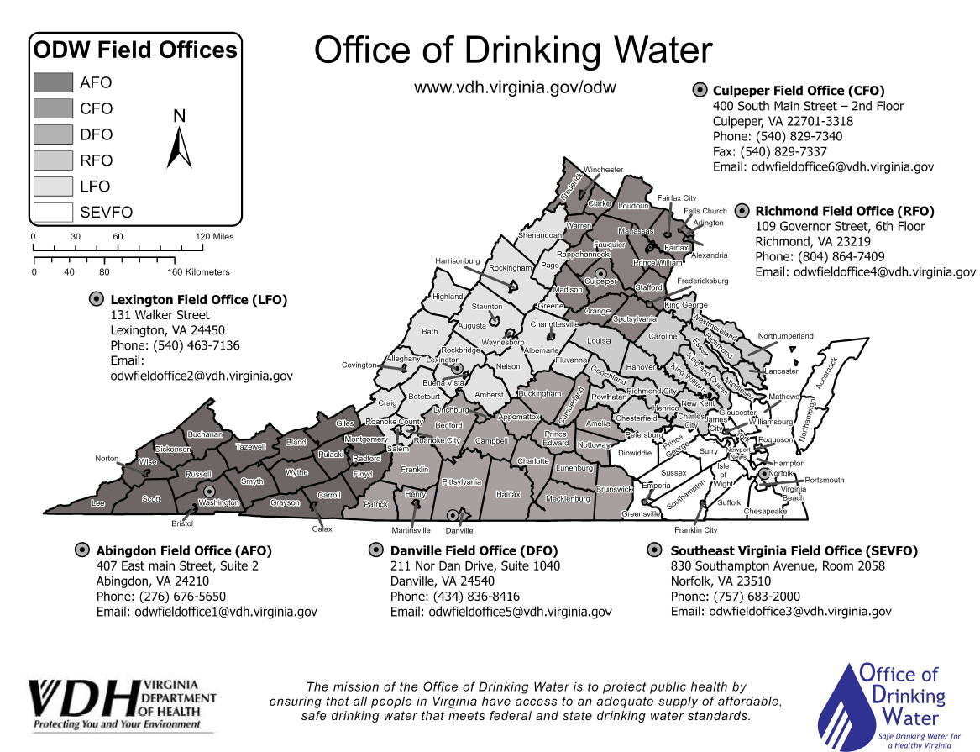

WATERWORKS Personnel
If you get sick or leave, the waterworks won’t be operated and maintained, so you need two people trained on sample collection and monitoring requirements.
Some waterworks have sophisticated water treatment systems that require oversight and operation by a licensed Waterworks Operator. You can check on the licensure status of waterworks operators with the Department of Professional and Occupational Regulation. Even if not required, hiring a waterworks operator can be worth it to ensure compliance.
When personnel change, or if your business plans to shut down for an extended period, let ODW know so that we can update our records and wish you well!

SAMPLES FOR WATER QUALITY

Labs
You must use a certified laboratory to analyze bacteria, nitrate, and nitrite samples. Labs are certified by the Virginia Division of Consolidated Laboratory Services (DCLS) to analyze water samples to ensure the lab uses reliable methods with quality control. DCLS maintains a list of certified labs on their website. You can also contact ODW for recommendations for certified labs.
You can also use DCLS’ Richmond lab for your samples. More information about DCLS, including water sample instructions and the list of courier sites, is available on their website.

Bacteria
How often and how many bacteria samples are required for your waterworks depends on your waterworks as described below:
Average number of people served, per day | Routine bacteria monitoring requirement
 | Good water quality and no samples missed | Unsatisfactory water quality or samples missed
25 to 1,000 people | 1 presence/absence (P/A) sample per calendar quarter | 1 presence/absence (P/A) sample per calendar month
1,001 to 2,500 people | 2 presence/absence (P/A) samples per calendar month | 2 presence/absence (P/A) samples per calendar month
2,501 to 3,300 people | 3 presence/absence (P/A) samples per calendar month | 3 presence/absence (P/A) samples per calendar month

Presence/Absence (P/A) samples tell you whether coliform and E. coli bacteria are in the water, or not, but they won’t tell you how much bacteria are in the water. A Most Probable Number (MPN) sample tells you how much bacteria is in the water.
Routine bacteriological samples are collected from cold water taps. A more thorough description of monitoring requirements is included in your Bacteriological Sample Site Plan (BSSP). A BSSP template is included in Appendix STUB.
Sample early in the quarter or month since you might forget or the sample may not be successfully analyzed if you wait until the end.
If bacteria are found in the water (called a present or positive sample), additional water samples are required to determine the source of contamination. These additional water samples are called repeat and triggered source water samples.
Waterworks monitoring quarterly that have a positive sample also have to collect three routine samples the month after a positive sample to make sure the contamination has not come back.
Because coliform bacteria are found throughout the environment and on you, it’s easy to accidentally contaminate the sample. This video will help you collect samples properly so you can trust the results.
It’s not unusual to find bacteria in the water after repairs and maintenance are done, but if you routinely have bacteria in the water, you may need disinfection treatment!
Waterworks with disinfection treatment, like ultraviolet disinfection (UV) or chlorination, must collect MPNs regularly to let you know if the source becomes contaminated.

Nitrate and Nitrite
Nitrate and nitrite samples are required once per calendar year.
Results for nitrate, nitrite, and other chemicals are usually in milligrams per liter (mg/L) as nitrogen. Nitrate and nitrite have maximum contaminant levels (MCLs), which are levels that you must not exceed. The MCLs for nitrate and nitrite are below:
Contaminant | Maximum Contaminant Level (MCL) (as nitrogen)
Nitrate | 10 mg/L
Nitrite | 1 mg/L
Nitrate/Nitrite (when preserved with sulfuric acid) | 10 mg/L

If a preserved sample has nitrate/nitrite over 1 mg/L, one unpreserved nitrite sample is required.
If nitrate or nitrite exceed MCLs, you will need to notify the public not to use water for making infant formula and install nitrate removal treatment. Contact ODW if you exceed any of the above MCLs!

Lead
Waterworks that serve children like preschools and summer camps may want to test for lead in drinking water. Lead exposure can cause behavior problems and reduced intelligence in children. Lead gets into drinking water when lead-containing pipe, fittings, and solder corrodes. Talk with ODW for more information if you’d like to test lead at your system.

SYSTEM VISITATION AND OPERATIONS
Your waterworks may have treatment, like disinfection, nitrate removal, softening, filtration, and corrosion control, among others.
Saltwater Surprise! – WHEN? Fauquier County
A softener malfunctioned at a Fauquier County gas station and brine waste (an extremely salty substance) was pumped into the water system. The problem wasn’t noticed until their big storage tank was already full of salty water and customers noticed.
It’s important to test treatment processes soon after the water is treated so you know immediately if there is a problem!

For treatment processes meant to keep the water safe, like chlorine or UV disinfection or nitrate removal, ODW will require you to monitor your treatment systems and report operational data like chlorine residual, UV system status, or treated water nitrate on a regular basis, and report those readings on a monthly operation report (MOR).
While some water quality problems, like the discoloration caused by iron and manganese, don’t have health effects, ODW may require you to monitor those treatment systems as well, since a malfunction of some treatment systems can contaminate the water.

Repairs and maintenance
Cat Out Of The Bag – 2017-2018 Spotsylvania County
A new water main was installed at a Spotsylvania County water utility. Water samples collected after installation were coliform-positive, even after repeated disinfection. The water main was disassembled and a cat carcass was flushed out. The cat had climbed into the pipe because contractors didn’t cover the pipe ends and didn’t swab the pipe or check it prior to installation.
Repairs and maintenance on your water system present a risk of bacterial contamination for several reasons:
- Materials and parts may be contaminated in storage, transport and installation.
- During some repairs, the water system is depressurized. When the system is depressurized, leaks may allow contamination to leak in.
- Improperly-performed work may damage waterworks components, causing contamination.

To address these risks, take the following precautions whenever work is done on the water system:
E. coli Bonanza – 2021 Madison County
Following well pump work at a Madison County utility, test results consistently showed E. coli presence. During the work, the well was damaged by the contractor, creating a direct conduit for surface runoff to enter the well, contaminating it. After the damage was discovered, repairs were made, eliminating the E. coli contamination.
- Materials and parts should be stored covered and should be swabbed or rinsed out prior to installation to minimize contamination.
- Hire qualified, competent contractors and servicemen and oversee their work to ensure work is performed well. You can check contractors and servicemen for relevant certifications, like Water Well Systems Provider with DPOR.
- Disinfect the water system using chlorine when work is done to kill any contamination.
- Collect bacteria samples after work is done to make sure the water system is not contaminated. These samples are special, not-for-compliance samples. Bacteria-positive samples indicate the need to investigate the source of contamination, resolve it, and repeat system disinfection.
- Retain invoices so that you know when the work was done, who did the work, what parts were used, and the cost.

Cross Connection Control

__________________________________________
Antifreeze On Tap – Culpeper County, 2016
A Culpeper County utility received a complaint about strange water coming from a sink. A nearby fire-suppression system had been winterized by pumping ethylene glycol, an antifreeze, into the fire-suppression system. Because insufficient backflow protection was installed on the fire-suppression system, antifreeze was also pumped into the potable water system.

A Brief Introduction to Cross Connection Control
Cross Connection? This is a phrase you probably have never heard of, but, believe me, it is all around you.

Take a look at the pictures below.

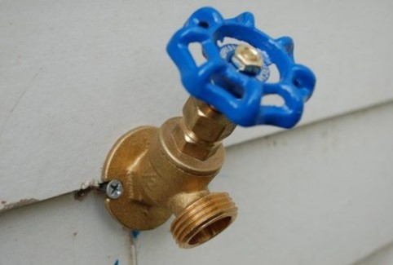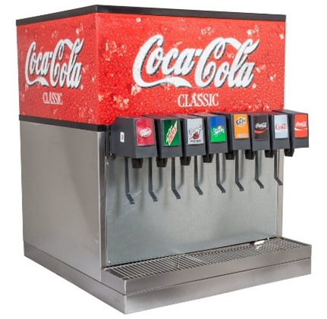 | 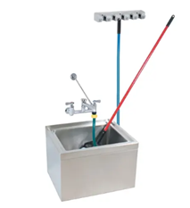 | 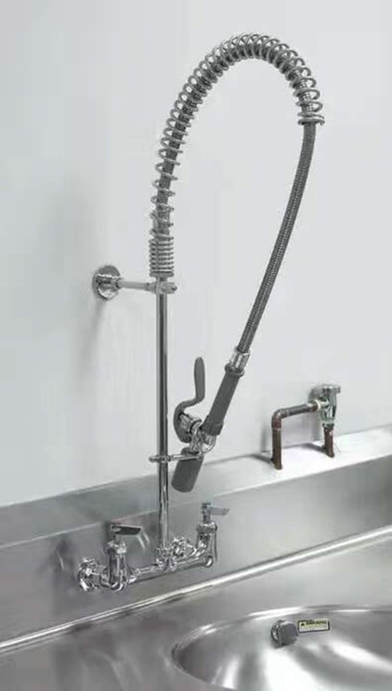
Do you recognize any of these? Do you have some of them, or something similar in your building? Then you have the potential for a cross-connection.
A cross-connection is a physical link or connection between drinking water and contaminated water. It occurs when your potable (clean) water supply comes in contact with a source of contamination, which can lead to contamination of your drinking water, illnesses, and even death.

What can I do to prevent it?
There is a lot you can do to eliminate the risk of having a cross connection contaminate your water.
1. An Active Cross Connection Control Program
The Office of Drinking Water (ODW) puts together a Cross-Connection Control Plan for every waterworks. These plans are required by state law and are used as an outline for the waterworks to follow. This will help you in creating an effective program to prevent or limit the risk of possible cross connections.
2. Continue to Re-Assess and Follow the Plan
A plan not followed is a plan that won’t work. A reassessment of potential cross connections should be done periodically. This ensures any maintenance or operational procedures aren’t coming up and cause future issues. Remember, an ounce of prevention is worth a pound of cure!
3. Keep Good Records
Maintaining good records of past assessments and plumbing repairs is crucial in assisting you of maintaining a cross-connection control program. These records of past assessments and plumbing repairs have to be kept for 10 years.
This may seem a little overwhelming at first, but with the help of your ODW representative, you will be confidently on your way to an effective Cross-Connection Control Program.
___________________________________

Water systems can be contaminated by direct connection of the water system to a source of contamination, where if the water system loses pressure, or the contamination source is pressurized, contamination may be forced into the water system.
When the water system is connected to potential sources of contamination, an appropriate backflow prevention device or other backflow elimination method is required to prevent this contamination.
You may have a boiler, soft-drink machine, swimming pool, fire-sprinkler system, all of which require backflow prevention to avoid contamination, but there are many more. The Virginia Plumbing Code and Waterworks Regulations include a complete list.
Because they protect the water system from contamination, some backflow prevention devices require annual inspection to ensure they work properly.
Connecting a water source with unknown or bad water quality is a common cross connection. Contact ODW before connecting a new or different water source to your water system!
You are required to develop a Cross Connection Control Program (CCCP) with an inventory of potential cross connections. For additional information, please reference the EPA’s Guidebook here https://www.epa.gov/sites/default/files/2015-09/documents/epa816r03002_0.pdf.

Disinfecting your water system
When you replace the pump in your well, or if the well becomes contaminated, you will need to disinfect your well. More information on well disinfection is included in APPENDIX STUB.
If you are not confident disinfecting your own water system, you should hire a licensed waterworks operator to do it for you!
Well disinfection shouldn’t be done too frequently because the harsh chemicals will damage the casing and piping. If you need to disinfect more than once a year, you should consider installing disinfection treatment.

Only use NSF/ANSI/CAN 60 certified water treatment chemicals, to reduce any risk public health.

DISINFECTION TREATMENT SYSTEMS
Most wells produce good-quality water without treatment, but some wells have bacteria from time to time and the water must be disinfected.
Common disinfection treatment for small systems like yours include hypochlorination and ultraviolet disinfection (UV).

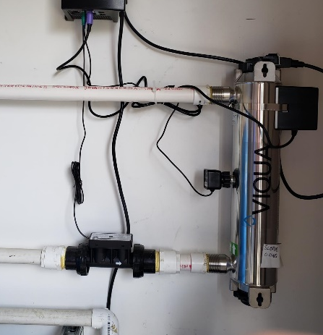
Ultraviolet disinfection (UV)
Ultraviolet (UV) disinfection uses ultraviolet “light” shining through the water to kill bacteria. UV disinfection systems are compact and don’t involve hazardous chemicals. They normally require annual servicing to replace the bulb and clean the sleeve, but in installations with discolored water, they may require more frequent maintenance unless pretreatment is provided.
In the shown installation, the water enters the bottom of the system and exits the top. This unit includes a UV sensor and meter, but that may not be necessary depending on how much bacteria is in your water.

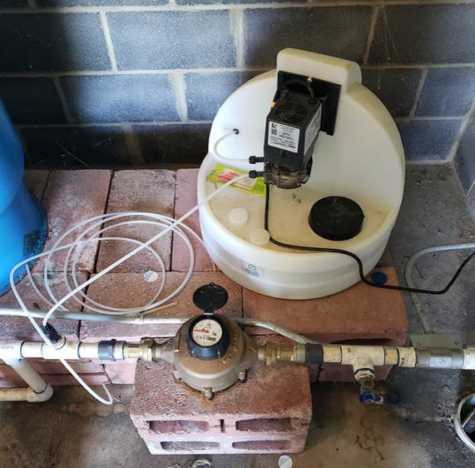
Hypochlorination
Hypochlorination treatment uses chlorine to kill bacteria. Hypochlorination systems require hazardous chemicals.
After hypochlorination, some chlorine is left in the water (called a chlorine residual) and continues to protect the system against contamination, which UV does not do. Hypochlorination is better for highly-contaminated sources than UV.
Hypochlorination will also remove sulfur odors from hydrogen sulfide.
If your water contains iron and manganese, though, staining and discoloration will be worse after hypochlorination.

Hauling water
Water systems sometimes haul supplemental water if a source has inadequate production, or a pump fails. Hauling water presents special risks of contamination.
If you need to haul water, contact ODW immediately and follow the precautions listed in Appendix STUB.
WATER SYSTEMS THAT SHUT DOWN or drain
SEASONAL Waterworks or Waterworks with Seasonal Components
Water systems that shut down and drain or winterize part or all their system, called seasonal waterworks, have to take special precautions when they start back up because contamination may leak into the system while it is depressurized. Those precautions include disinfecting the water system when appropriate, flushing, and bacteria testing to confirm the water quality is good before you start serving water.
A seasonal waterworks is one that starts up and shuts down at the beginning and ending of each operating season. A waterworks with seasonal components may operate year-round, but has some parts or components that shut down and start up at certain times of the year. If your waterworks meets these criteria, this section applies to you and you must have an approved Seasonal Start-Up Procedure. See Appendix STUB
Seasonal waterworks must monitor coliform monthly during every full or partial month the waterworks is in operations. Waterworks with seasonal components may be required to monitor coliform monthly in the months the seasonal components are in use. Additional samples may be required based on population.
Seasonal waterworks are required to complete a Seasonal Start-Up Procedure each season before serving water to the public. Waterworks with seasonal components are required to complete a Seasonal Start-Up Procedure before putting the seasonal components into operation. The Seasonal Start-Up Procedure is a documented procedure, approved by the Office of Drinking Water with step-by-step-instructions including do your own inspection of the waterworks, repair any observed sanitary defects, clean/flush storage, flush pipes, disinfect the waterworks (when appropriate), place treatment into service (where appropriate), collect two special coliform samples at least 16 hours apart and wait for “absent” results, and submit results with a completed certification form to the Office of Drinking Water.
The start-up procedure must be followed before every start-up, including collecting two special samples and wait until you get “absent” results. These special samples are not for routine compliance and do not count as your monthly coliform test result. If result of either special sample is “present,” the entire Procedure must be repeated including collecting two more special samples.
public notice
You must notify customers served by the waterworks in the following examples:
- You know the waterworks has been contaminated, based on observed contamination, like muddy water from a trench entering the water pipe. See “Do Not Drink” notice in Appendix STUB.
- The water system is contaminated, based on at least two bacteriological-positive samples, with at least one of those samples E. coli-positive. See “Boil Water” notice in Appendix STUB.
- A triggered source water sample is E. coli -positive.
- Nitrate or nitrite exceed the MCLs.
- You failed to collect all required samples.

In most cases, ODW will be in touch if a public notice is required. In other cases, like when you observe contamination, you should immediately notify consumers.

RECORDKEEPING
Keep all records associated with the water system. This includes owner’s manuals for pumps and equipment, invoices for work, construction drawings, manufacturer and model number of pumps, and materials used. Other records to keep include sample results, monthly operation reports, and correspondence from and to ODW.

REPORTING
Laboratories report results of all for-compliance tests to ODW, so you should not need to.
If you’re required to send monthly operations reports (MORs) to ODW, they are due by the 10th of the following month.
There are other reporting requirements that ODW will notify you about, like Public Notice Certification.

New sources, treatment, storage, pumping, and other waterworks equipment
The Waterworks Regulations include requirements for design and construction of waterworks equipment. Most water system design work must be done by a professional engineer (PE) to ensure that design meets the requirements, and you may need a construction permit from ODW prior to beginning work.
Whenever planning for modifications to your waterworks, talk with ODW to determine what requirements apply and whether a construction permit is required. For new wells and other sources, VDH will make a site visit to ensure that the proposed wellsite minimizes risks of contamination.

Waterworks business operations plan (WBOP)
To keep track of the cost of these requirements, so that you can anticipate future costs and budget for them, you need a Waterworks Business Operations Plan (WBOP). A WBOP template is in Appendix STUB.

unhappy Consequences
You might forget to collect a sample, or test results may not be good. If you fail to meet monitoring or water quality standards, ODW will let you know with a Notice of Alleged Violation (NOAV). The NOAV will advise you how to get back in compliance and include requirements to notify customers.
Mistakes happen. Learn from them!

last thoughts
I hope this has helped you get up to speed on the joys, obligations, and worries of owning, monitoring, and operating a waterworks. If you have any comments on this document, find any broken links, or have suggestions on how it could be clearer or information you feel is missing, please contact ROBERT.KIEFFER@VDH.VIRGINIA.GOV
Good luck!

APPENDICES

