Injectable Medication Safety
Initial Effective Date | mm/dd/yyyy
Most Recent Revision Date | mm/dd/yyyy
Authorized/Reviewed By | [Insert name of department or individual who has that authority for the policy]

Definitions
Injectable Medications: Medicines and related products (e.g., vials, syringes, intravenous tubing) commonly used in healthcare settings for the prevention, diagnosis, and treatment of various illnesses. Example forms of injectable medications include medication vials, insulin pens, intravenous (IV) fluid bags, and pre-filled syringes.
Single-dose vial: A single-dose or single-use vial is a vial of liquid medication intended for parenteral administration (injection or infusion) that is meant for use in a single patient for a single case, procedure, injection. Single-dose or single-use vials are labeled as such by the manufacturer and typically lack an antimicrobial preservative. Single-dose vials can come in any shape and size. Do not assume that a vial is single-dose based on size or volume of medication. Always check the label.
Example single-dose vial label: 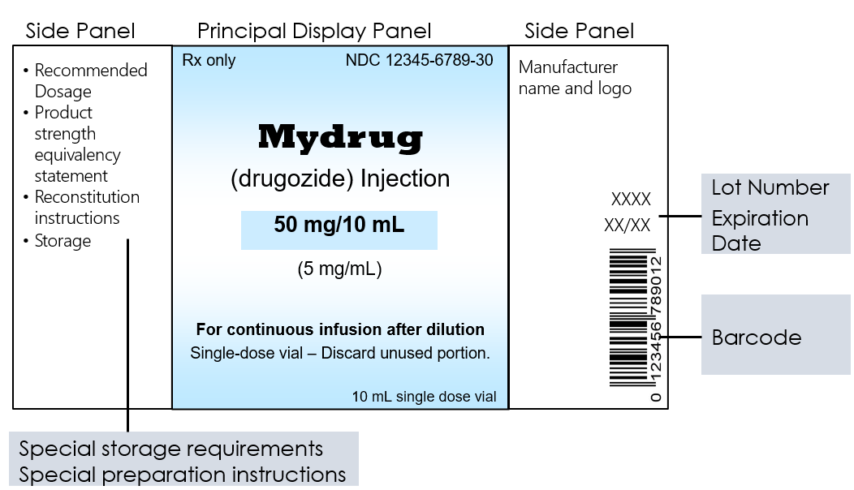
Image source: https://www.fda.gov/drugs/fdas-labeling-resources-human-prescription-drugs/carton-and-container-labeling-resources#example
Multi-dose vial: A multi-dose (or multiple dose) vial is a vial of liquid medication intended for injection or infusion that contains more than one dose of medication. Multi-dose vials are labeled as such by the manufacturer and typically contain an antimicrobial preservative to help prevent the growth of bacteria. The preservative has no effect on viruses and does not protect against contamination when healthcare personnel fail to follow safe injection practices. Multi-dose vials can come in any shape and size. Do not assume that a vial is multi-dose based on size or volume of medication. Always check the label.
Aseptic technique: Aseptic technique is the manner of handling, preparing, and storing of medications and injection equipment/supplies (e.g., syringes, needles and IV tubing) to prevent microbial contamination.

Purpose
Safely preparing and administering medical injections following Standard Precautions can reduce the risk of transmission of bloodborne and other pathogens from one individual to another. This includes between patients/residents and healthcare personnel.

Responsibility
This policy is for healthcare personnel who have had training and competency validations for preparing, handling, and administering injectable medications. This may apply to a variety of personnel, within their scope of practice, such as nurses, certified nursing assistants (CNAs), medical technicians, medical assistants, EMTs, paramedics, and/or patient care associates.

Policy
All healthcare personnel will follow current Centers for Disease Control and Prevention (CDC) guidance for the safe use of needles, syringes, injectable medications, and cannulas. Note: This policy does not apply to pharmacy settings or personnel who are to follow the Virginia Board of Pharmacy, the United States Pharmacopeia (USP), the Drug Enforcement Agency (DEA), and the Food and Drug Administration (FDA).

Preparing and Administering Injectable Medication Safely
The following procedures apply to use of all injectable medications, including the use of needles, cannulas that replace needles, and intravenous delivery systems:

General Steps for All Injectable Medication
- Store, prepare, and use all supplies (e.g., medication vials, insulin pens, needles, and syringes) as instructed by the manufacturer and to prevent contamination.
- Verify expiration dates of medication and injection supplies prior to use.
- Check patient/resident identification and medication orders according to the facility policy.
- Perform hand hygiene with alcohol-based hand rub or wash with soap and water prior to preparing and before and after administering an injectable medication.
- Wear and discard personal protective equipment (e.g., gloves) according to standard precautions.
- Prepare injections using aseptic technique in a clean area that is not adjacent to potential sources of contamination (e.g., at least three feet from sinks or other water sources; free from items that could have come in contact with blood or body fluids).
  - Examples of contaminated items that should not be placed in or near the medication preparation area include used equipment such as syringes, needles, IV tubing, blood collection tubes, or needle holders (e.g., Vacutainer® holder).
  - Clean and disinfect the medication preparation area on a regular basis and any time there is evidence of soiling. In addition, there should be ready access to necessary supplies (such as alcohol-based hand rub, needles and syringes in their sterile packaging, and alcohol wipes) to ensure that staff can adhere to aseptic technique.
- Dispose used needles and syringes in a sharps container.

Medication Vials & Pre-Filled Syringes
- Disinfect the rubber septum on a medication vial with alcohol prior to piercing.
- All needles, syringes, and cannula are sterile, single-use items that should never be used for more than one patient/resident and should be discarded after a single use. This includes manufactured prefilled syringes
- Insulin pens should be assigned to individual patients/residents and labeled appropriately. They should never be used for more than one person.
Use single-dose vials whenever possible. Single-dose or single-use medication vials or ampules solution are to be used for only one patient/resident as part of a single case, procedure, injection. Do not combine leftover contents for later use.
- Dedicate multi-dose vials to single patients/residents whenever possible.
  - If multi-dose vials must be used for multiple patients/residents, both the needle or cannula and syringe used to access the multi-dose vial must be sterile.
  - Date multi-dose vials when they are first opened and discard within 28 days unless the manufacturer specifies a different (shorter or longer) date for that opened vial.
    - Note: This is different from the expiration date printed on the vial.
  - Discard multi-dose vials if sterility is compromised or questionable
  - Store multi-dose vials according to manufacturer's instructions. These vials should be kept in a centralized medication area and never enter the patient/resident care area.
    - Note: If multi-dose vials enter the immediate patient/resident treatment area, they should be dedicated for single-patient/resident use and discarded immediately after use.

Intravenous Medications
- Use single-dose or single-use bags or bottles of intravenous solution and fluid infusion and administration sets (i.e., intravenous bags and tubing) for only one patient/resident as part of a single case, procedure, or infusion. Discard after single use.
- Do not combine leftover intravenous solution or fluid contents for later use or as a common source of supply for multiple patients/residents.

Guidelines and Resources
- Centers for Disease Control and Prevention
  - Preventing Unsafe Injection Practices: https://www.cdc.gov/injectionsafety/unsafepractices.html
  - Injection Safety Information for Providers: https://www.cdc.gov/injectionsafety/providers.html
  - Guideline for Isolation Precautions: Preventing Transmission of Infectious Agents in Healthcare Settings, 2007: https://www.cdc.gov/hicpac/pdf/isolation/Isolation2007.pdf

