*It is recommended the room remain closed until the specified time to contain and allow for airborne contaminant removal. If must be entered, follow airborne precautions and wear respiratory protection (i.e., a fit-tested N95 respirator).
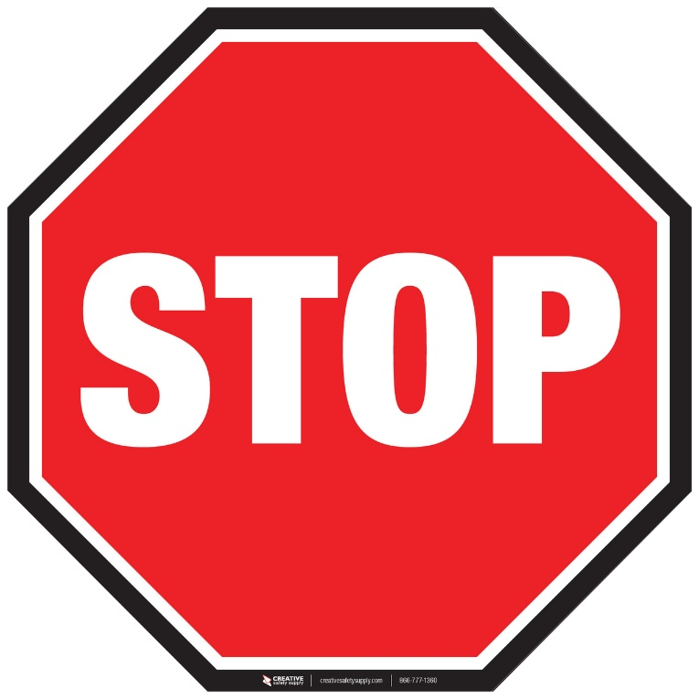
This Room Is Temporarily Closed
Please Keep the Door CLOSED and Do Not Enter Until*:

