Contact Information (Please Print)
Name _____________________________________________________________________________________________
Organization Name __________________________________________________________________________________
Mailing address _____________________________________________________________________________________
City____________________________________________________, Virginia Zip________________________________
Phone number__________________________ Email address________________________________________________
Do your services work with: Behavioral Health ____ Clinical/Medical ____ Youth ____
Business/Worksite ____ Academic ____ Other _____________________

 | YOUR QUIT JOURNEY  Brochure (200 max)  Quantity: ___  Flyer (20 max)  Quantity: ____  Poster (3 max)  Quantity: ____ | 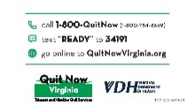 | UP IN SMOKE  Business Cards (100 max)  Quantity: ____  Flyer (10 max)  Quantity: ____  Poster (3 max)  Quantity: ____
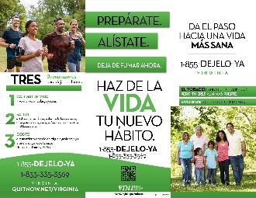 | SPANISH  Quit Now Brochure (100 max)  Quantity: _____  Poster (3 max)  Quantity: _____ |  | Quit Now Referral Note Pad (5 max)  Quantity: _____
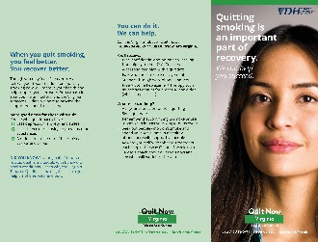 | Behavioral Health  Patient Brochure (50 max)  Quantity: _______  Provider’s Guide (5 max)  Quantity: _______ |  | Live Vape Free  Postcard (50 max)  Quantity___  Business cards (100 max)  Quantity___

May we interest you to:
⃝ Become a Quitline Referral site View our free
⃝ Become a Tobacco Free Worksite Online Provider Training
⃝ Host a Tobacco Control related presentation
⃝ Connect with a local or state tobacco coalition
⃝ Connect with your Tobacco Control Regional Coordinator

