Air/Vacuum Release Valve Placement for Drip Dispersal Systems
Correct location of the Air/Vacuum Release Valve (A/V) prevents failures. In-ground drip-dispersal systems might prematurely fail with incorrect A/V placement because a vacuum can form inside the drip tubing as it drains, aspirating soil particles into the tubing through the drip emitters.
Incorrect A/V placement is illustrated below:
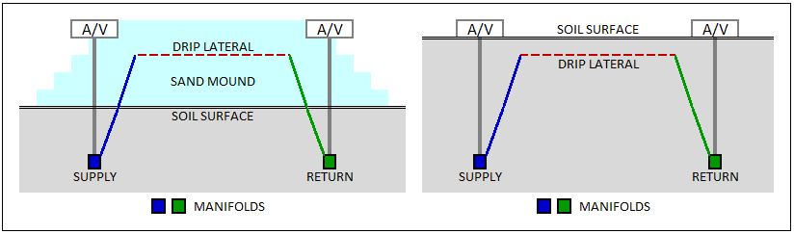
In both examples shown above, A/Vs are attached to the Supply and Return Manifolds and are located significantly below the elevation of the drip laterals. When dosing begins, the Supply Manifold A/V will adequately vent air from the Supply Manifold. However, air within the drip laterals cannot get to the Return Manifold A/V without pushing effluent ahead of it, which would likely vent through the drip emitters.
When dosing concludes and the system begins to drain, the A/Vs will release the vacuum that forms in both the Supply and Return Manifolds. However, as effluent within the drip laterals begins to drain to both the soil and the Supply/Return Manifolds, a vacuum will form in the drip tubing, potentially pulling liquefied soil particles into the emitters. Hence, A/Vs should be connected to the drip network at or above the elevation of the drip laterals, which can be accomplished by placing the Supply and Return manifolds at the same elevation as the drip laterals as shown below:

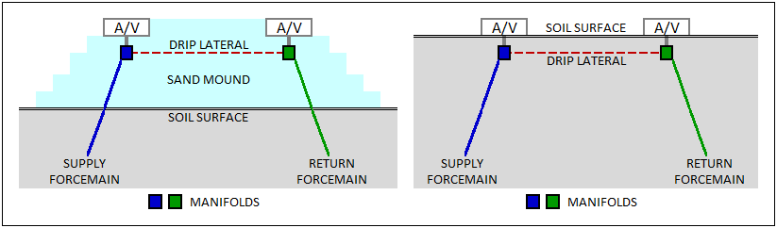
Geoflow provides the following illustration to illustrate correct A/V placement (the Return side would be similarly configured.)

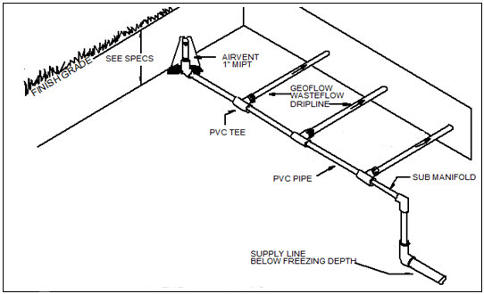
On a sloping site with an in-ground drip installation, it may be possible to place the Supply/Return Manifolds somewhat deeper than the drip laterals if those manifolds extend upslope to a sufficient distance such that the ends – to which the A/Vs are attached – are above the elevation of the highest drip lateral.

