Siting a Private Well Downslope from a Source of Contamination
12VAC5-630-380. Well Location.
B. Downslope siting of wells from potential sources of pollution. Special precaution shall be taken when locating a well within a 60 degree arc directly downslope from any part of any existing or intended onsite sewage disposal system or other known source of pollution, including, but not limited to, buildings subject to termite or vermin treatment, or used to store polluting substances or storage tanks or storage areas for petroleum products or other deleterious substances. The minimum separation distance shall be: (i) increased by 25 feet for every 5.0% of slope; or (ii) an increase shall be made to the minimum depth of grout and casing in the amount of five feet for every 5.0% of slope. [Emphasis added.]
Slope | Increase Separation | Increase Depth of casing & grout  For every 5% of slope:  - Increase separation distance 25’  OR (see note on reverse side)  2. Increase depth of casing & grout 5’
0 to <5% | None | None
5% to <10% | 25’ | 5’
10% to <15% | 50’ | 10’
15% to <20% | 75’ | 15’
20% to <25% | 100’ | 20’
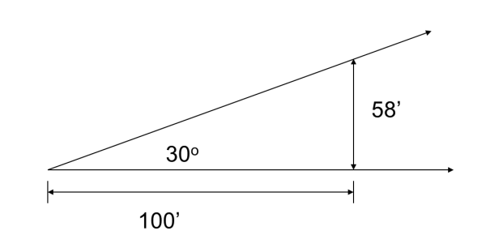
Determining a 60º arc
To determine a 60º arc, use imaginary lines running downslope, perpendicular to contour, from each side of the source of contamination. Swing a 30º arc out from each side.
The diagram to the right shows measurements to delineate a 30º arc; see the reverse side for further explanation.

Slope

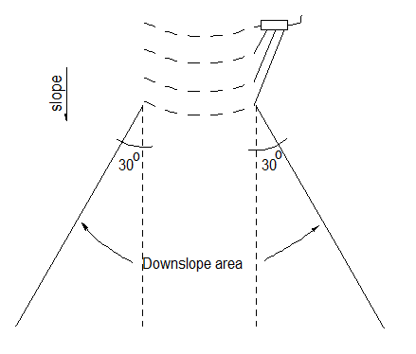
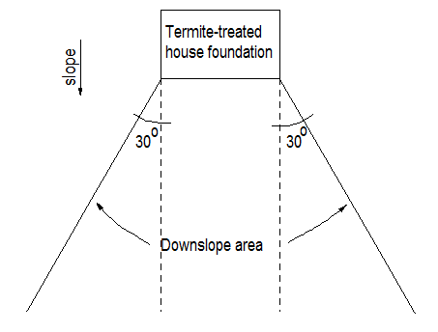

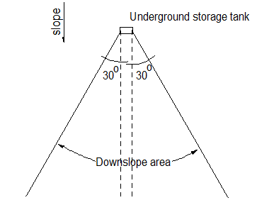

NOTES

- “OR” in the regulation is interpreted as “and/or”, allowing a combination of increased separation distance and increased depth of casing and grout to provide special protection for downslope wells. The Form, Style and Procedure Manual for Publication of Virginia Regulations discourages the use of the term “and/or” in the Virginia Administrative Code in §3.25 and 3.48 below.
§ 3.25. Use of “and/or.”
The term “and/or” should be avoided if possible. In general, the term “and” means to add something to what has already been said. The term “or” means in the alternative. In most cases, the word “or” is proper to convey the thought of “one, or the other, or any of them.” If emphasis is needed, use terms such as “any of the following,” “all of the following,” “either of the following,” or “or both.”
…
§ 3.48. Commonly used words with their plain language translations.
- Listed in this section are commonly used words and phrases. The use of the words in the right column is preferred.
AVOID | USE
and/or | “A” or “B” or both

(From the Form, Style and Procedure Manual for Publication of Virginia Regulations; http://register.dls.virginia.gov/documents/agency_resources/stylemanual.pdf )

- To derive the measurements to determine a 30º arc, use trigonometry:
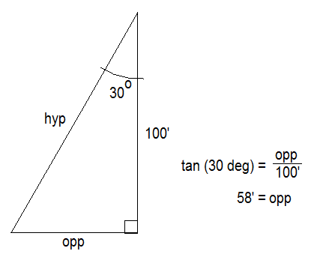
SOHCAHTOA
sin = opp
hyp

cos = adj
hyp

tan opp
adj

hyp = hypotenuse
opp = opposite side
adj = adjacent side

