Data entry requirements for VENIS – Condition Assessment Form
April 2019

The Condition Assessment form (also referred to as the Existing System Evaluation form in GMP 2017-02) will eventually replace the current Existing System Evaluation and the Malfunction Assessment forms in VENIS/EHD. However, due to the timing of the implementation of the new vendor for the state database, the modification of the forms in VENIS is delayed. This document describes how the new Condition Assessment form will be used for repairs and voluntary upgrades with regard to data input into VENIS until the database changes can be made.

For entry of a repair or voluntary upgrade request where no system information is currently in VENIS, complete all the steps below. For entry of a repair or voluntary upgrade request with current information in VENIS, skip to number 3.

- Create a physical location for the onsite sewage system. Use the same process as creating a new physical location as for a new construction permit application.

- Create a new sewage system. Enter available information for the existing onsite sewage system based on the permit on file, if available, or based on observations provided on the Condition Assessment form under ‘System File Information’.

- Create a Malfunction Report and complete as able from the Condition Assessment form based on ‘Existing System Evaluation’ section of the form. Utilize information in ‘Recommended Action’ from Condition Assessment to complete the Malfunction Report. Voluntary upgrades will not complete date of temporary abatement, date of permanent correction; and the other items related to repairs only.

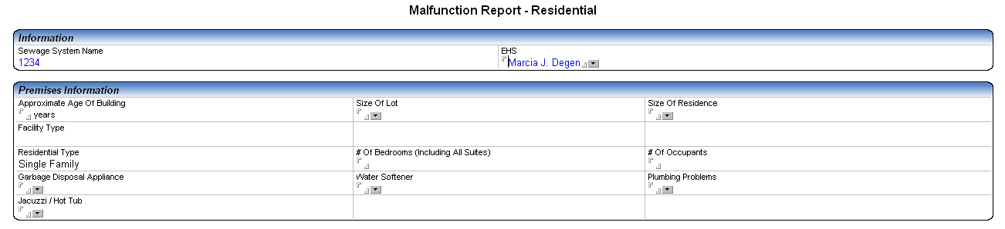

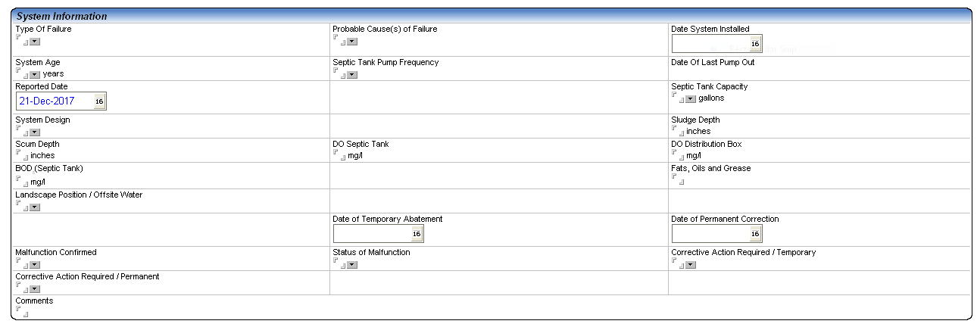
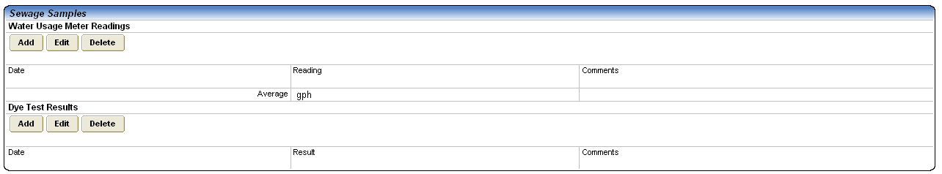

- In the comment section of the summary, describe the following:
  - For repairs, describe the temporary corrective action and the permanent corrective action reported.
  - For voluntary upgrades, describe the recommended action and the improvement associated with the voluntary upgrade. Note if the owner confirmed that the system was not failing.

