A. R. Rubin, Professor Emeritus, NCSU-BAE
205 Stanton Gable Lane
Hillsborough, NC, 27278

Dr. Marcia Degen, Ph. D, P.E.
Onsite Sewage and Water Services Division
Virginia Department of Health
109 Governor Street, 5th Floor
Richmond, VA 23219

Dear Dr. Degen; 29 April 2019

Subject: Premier Tech Report correction

Thank you for your review of the Premier Tech reports submitted in the early 2000’s to obtain approval for the peat filters. I was informed that the data in my report was listed as “CBOD” and that there was question concerning whether the values were actually CBOD or whether they should have been reported as BOD.

I have reviewed all of the monitoring reports submitted in support of the Premier Tech report and all of the values reported from both Mid Atlantic Laboratories in Port Royal, VA as well as those from Air, Water, and Soils Laboratory in Richmond, VA were reported to Premier Tech as BOD and not as CBOD.

I can provide copies of the laboratory results if you wish, but as I recall, these were provided to the Commonwealth with the Premier Tech project report. Re-Reviewing the field test data was an interesting process as it allowed me the opportunity to examine field test data again. The most interesting element of the review concerned the wide range in influent values that were treated by the Premier Tech units and the narrow range in effluent values generated by the units at the various test sites. The treatment units consistently met the treatment targets imposed through VDH.

If I may be of further assistance to you regarding this review and correction, please feel free to contact me.

Sincerely;

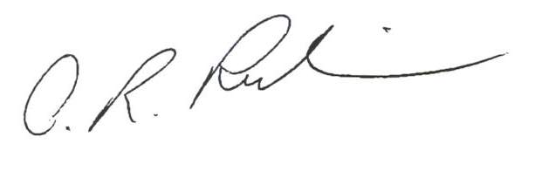

A. R. Rubin, Professor Emeritus, NCSU-BAE

CC: Marie-Christine Belanger

