Sample Measles Messages for Schools
Purpose
These sample messages are designed for schools to adapt and share with parents and guardians through school communication platforms (e.g., Blackboard, ParentSquare, Remind, school email, newsletters, or websites). Schools should tailor these messages based on local circumstances and guidance from their state, tribal, local, or territorial health department. VDH reviewed this information on August 27, 2026.
Back-to-School Reminder
Sample 1: Back-to-school reminder: as the new school year begins, make sure your child is up to date on all recommended vaccines, including the measles, mumps, and rubella (MMR) vaccine. Staying up to date on vaccinations helps protect your student and our school community.
Sample 2: Prepare for a healthy school year: as you get ready for the new school year, check that your child is up to date on all recommended vaccinations, including the measles, mumps, and rubella (MMR) vaccine. Vaccination is the best protection against measles and helps prevent illness and disruptions to learning. If you're unsure whether your child is up to date, contact your healthcare provider.
Check Your Child's Vaccinations Before Holiday or Spring Break Travel
Sample 1: Planning to travel during the upcoming break? Measles is circulating in some parts of the United States and internationally. Before you travel, make sure your family is protected with the measles, mumps, and rubella (MMR) vaccine.
Sample 2: If your family plans to travel during the upcoming holiday or spring break, now is a good time to check that everyone is protected with the measles, mumps, and rubella (MMR) vaccine. Measles can spread quickly and travelers may be exposed while away from home. If you're unsure whether your child is protected, contact your healthcare provider before your trip.

Suggested visual:
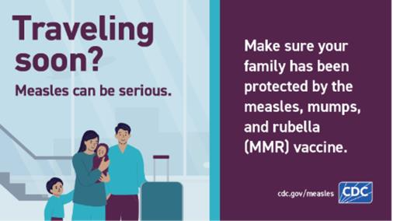
Available in 4 sizes:
- 1080x1080
- 1080x1350
- 1600x900
- 1200x675

Heightened Awareness During a Local Measles Outbreak
Sample 1: A measles outbreak has been reported in our area. Please watch your child for symptoms such as fever, cough, runny nose, red eyes, or a rash. If your child becomes sick, keep them home and contact your healthcare provider before visiting a medical facility.
Sample 2: A measles outbreak has been reported in our community. While the risk to individuals who have received measles, mumps, and rubella (MMR) vaccine remains low, we ask families to stay alert for symptoms of measles, including fever, cough, runny nose, red eyes, and a rash. If your child develops symptoms, keep them home from school and contact your healthcare provider before arriving so appropriate precautions can be taken. We are working closely with local public health officials and will continue to share updates as needed.
Communication materials (including graphics) are available in additional languages and as editable or printer-friendly versions upon request.
Prompt to Read an Important Health Notification
This message should be used in conjunction with any official school notification following a measles exposure. Schools may incorporate this content into their existing communication templates or use CDC-provided templates [measles notification template] as appropriate.
Prompt 1: Our school has distributed an important health notification regarding a possible measles exposure. Please read the notification carefully, as it contains important information about who may have been exposed, what symptoms to watch for, and any recommended actions. If you have questions about your child's risk or vaccination status, contact your healthcare provider or your local health department.

