Heat-related deaths and illnesses are preventable, yet annually many people are succumbing to extreme heat. In recent years, excessive heat has caused more deaths than all other weather events, including floods. Some of the most important things to remember are to stay as cool as possible, stay hydrated and stay informed.

Stay Cool
- Stay in air-conditioned buildings as much as possible
- Don’t rely on a fan as your primary cooling device
- Avoid direct sunlight as much as possible
- If possible, wear light-colored clothing
- Take cool showers or baths
- Check on those most at risk twice a day

Heat-Related Illnesses: (for additional information on these illnesses go to: CDC Types of Heat-related Illnesses
Heat Rash – Heat rash is a skin irritation caused by excessive sweating during hot, humid weather.
Heat Cramps – This sweating depletes the body's salt and moisture levels. Low salt levels in muscles causes painful cramps. Heat cramps may also be a symptom of heat exhaustion.
Heat Syncope (fainting) – Factors that may contribute to heat syncope include dehydration and lack of acclimatization.
Rhabdomyolysis – Rhabdomyolysis is a medical condition associated with heat stress and prolonged physical exertion, resulting in the rapid breakdown, rupture and death of muscle.
Heat Exhaustion – Heat exhaustion is the body's response to an excessive loss of the water and salt, usually through excessive sweating.
Heat Stroke – the most serious heat-related illness. Your body becomes unable to control its temperature, sweating mechanism fails, and the body is unable to cool itself.
Stay Hydrated
- Drink more water than usual
- Don’t wait until you’re thirsty to drink more fluids
- Drink two to four cups of water every hour while working outside
- Avoid alcohol or liquids containing high amounts of sugar
The main things affecting your body's ability to cool itself during extremely hot weather are:
- High humidity. When the humidity is high, sweat won't evaporate as quickly, which keeps your body from releasing heat as fast as it may need to.
- Personal factors. Age, obesity, fever, dehydration, heart disease, mental illness, poor circulation, sunburn and prescription drug and alcohol use can play a role in whether a person can cool off enough in very hot weather.

- Remind others to drink enough water

Stay Informed
- Check local news for extreme heat alerts and safety tips
- Learn and watch for the symptoms of heat illness in others and yourself

Workers who are exposed to extreme heat or work in hot environments may be at risk of heat stress. This includes EMS Workers and Firefighters.

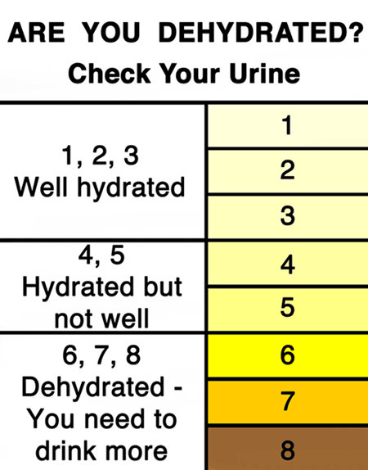
Dehydration is a major factor in heat-related illnesses. One way to check to see if you are hydrated (or dehydrated) is to check your urine color. Are you dehydrated?

References:
American Red Cross; Be Red Cross Ready, Heat Wave Safety Check List, last accessed 7/20/16; http://www.vdh.virginia.gov/content/uploads/sites/6/2016/01/m4340158_HeatWave.pdf
Center for Disease Control and Prevention; Extreme Heat and Your Health, July 2016; https://www.cdc.gov/extremeheat/
Center for Disease Control and Prevention; Keep Your Cool in Hot Weather, July 2016; https://www.cdc.gov/Features/ExtremeHeat/
Virginia Department of Health; Extreme Heat and Heat-Related Illnesses, 2016; http://www.vdh.virginia.gov/news/public-relations-contacts/severe-weather-preparedness/extreme-heat-and-heat-related-illnesses/

Check it out!

