Virginia Department of Health
Office of Emergency Medical Services
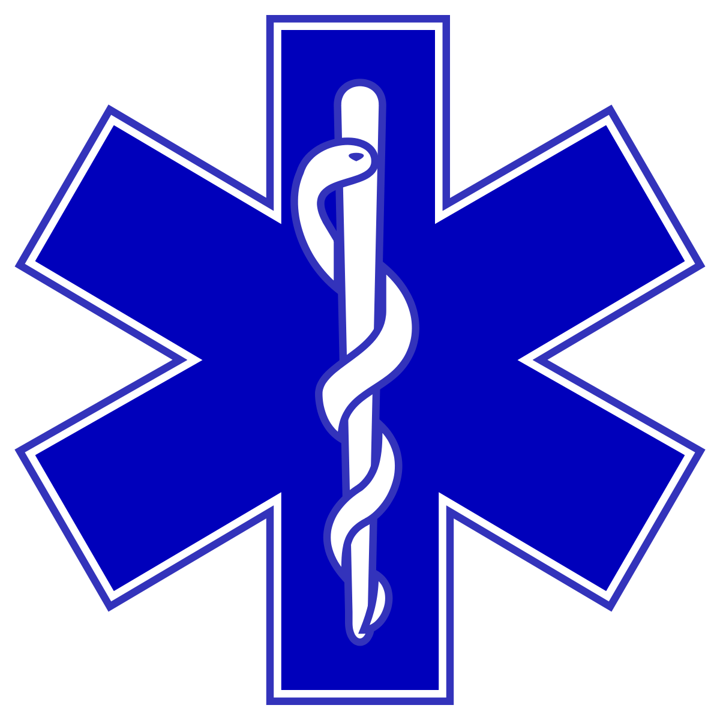

Quarterly Report to the
State EMS Advisory Board

August 5, 2022

Executive Management,
Administration & Finance

Office of Emergency Medical Services
Report to The
State EMS Advisory Board
August 5, 2022

MISSION STATEMENT:
To reduce death and disability resulting from sudden or serious injury and illness in the Commonwealth through planning and development of a comprehensive, coordinated statewide emergency medical services (EMS) system; and provision of other technical assistance and support to enable the EMS community to provide the highest quality emergency medical care possible to those in need.
I. Executive Management, Administration & Finance

- Action Items before the State EMS Advisory for August 5, 2022
At the time of finishing this report there is one (1) action item for the Board to vote on:

Action Item: Submitted by the Medical Direction Committee (MDC):

Date of MDC Meeting: 07-07-2022
Motion: The Medical Direction Committee moves to accept the changes to the Virginia EMS Scope of Practice Procedures and Formulary:

3.1.7 Through a consensus process, develop a recommendation for evidence-based patient care

Guidelines and Formulary.
4.2.2 Assure adequate and appropriate education of EMS students.

Minority Opinion:
None. There was no opposition or abstentions.

- State/Regional (Hybrid) EMS Council Reports

As previously stated, the Office of Emergency Medical Services committed to providing updates on the progress of the collaborative partnership and the transition and conversion of applicable Regional EMS Councils that have requested to be a hybrid State/Regional EMS model. The four councils include the following:
- Central Shenandoah EMS Council
- Blue Ridge EMS Council
- Rappahannock EMS Council
- Southwest Virginia EMS Council

Each Council has provided a report that is included in this Quarterly Report to the State EMS Advisory Board.

- Financial Assistance for Emergency Medical Services (FAEMS) Grant Program, known as the Rescue Squad Assistance Fund (RSAF)

The Rescue Squad Assistance Fund (RSAF) is designed to establish, expand, or enhance emergency medical services (EMS) throughout the Commonwealth of Virginia by providing matching grants to assist eligible agencies with purchasing equipment, supplies, and training. Applicants submit applications through an online application and grants management platform called the EMS Grant Information Funding Tool (E-GIFT), which is housed within the statewide EMS Portal. The applications are first reviewed by a panel of technical reviewers – regional EMS councils, field investigators, subject-matter experts, and the Transportation Committee – then the Financial Assistance Review Committee (FARC), which makes final funding recommendations to the Commissioner of Health. RSAF is divided into two grant cycles: Spring and Fall. Awards from each cycle are announced on July 1 and January 1 respectively.

This quarterly report reflects data gathered from the Spring 2022 RSAF cycle. The application period for the Spring 2022 RSAF cycle closed on March 15, 2022. The Office of EMS (OEMS) received 104 applications totaling $13,464,275.14 in funding which can be broken down to $8,625,501.87 in state and $4,838,773.27 in local matches. A total of 37 awardees were selected to receive $ 2,901,263.82 in grants. Awardees can be categorized as nonprofit licensed EMS or non-EMS agencies pursuant to § 32.1-111.12 of the Code of Virginia. 35 awardees fall into the EMS agency category, and two fall into the non-EMS agency category as shown in Figure 1.

The number of applications and total requests increased by approximately 22.3% and 0% respectively, compared to the Fall 2021 Cycle of RSAF. OEMS received applications from each of Virginia’s 11 EMS Regions. Funding from the Spring 2022 RSAF grant cycle is highest in the regions from which the most funding was requested as shown in Figure 2. The total amounts awarded by region are as follows:

- Blue Ridge – $217,391.60
- Central Shenandoah - $469,062.80
- Lord Fairfax - $109,298.13
- Northern Virginia - $0.00
- Old Dominion - $339,000.26
- Peninsulas - $132,300.00
- Rappahannock - $2,596.08
- Southwestern Virginia - $1,095,589.80
- Thomas Jefferson - $0.00
- Tidewater - $236,057.27
- Western Virginia - $299,967.40

The grants awarded this cycle represent 54 individual items and projects. Figure 3 groups these items and projects into categories to compare award and request sizes. These grants can be broken down into the following item type categories:

- Advanced and basic life support (A/BLS) equipment and supplies¹ - $55,443.40
- Cardiac monitoring, defibrillation, and chest compression² - $512,899.83
- Communications equipment³ - $36,648.90
- Cots, loading systems, and stretchers⁴ - $518,334.55
- Emergency medical dispatch (EMD) - $44,862.82
- Extrication equipment - $79,429.10
- Other⁵ – $20,304.74
- Type I ambulance - $1,749,172.00
- Type II ambulance - $92,800.00
- Type III ambulance - $250,784.00

The Fall 2022 RSAF Cycle began on August 1, 2022 and the deadline to submit an application is September 15, 2022. Please contact Michael D. Berg, OEMS Grants Program Manager, at michael.berg@vdh.virginia.gov with any questions or concerns about this report.

¹ Drug box and laryngoscopes
² Includes Automatic External Defibrillator (AED) units
³ Mobiles, pagers, and portables
⁴ Includes stair chairs
⁵ Water rescue equipment, struts, support tools, and artificial high directional (AHD) rescue equipment

- OEMS Patient Care Informatics Team

The Office of Emergency Medical Services is currently in the process of transitioning to a new data

management system for all pre-hospital and trauma registry data. During this transition, data projects

related to pre-hospital EMS data, opioid usage and Naloxone administration, and trauma incidents are

limited. This data will be included in the quarterly report once the transition has been completed. Thank

you for your understanding and patience during this transition.

Ad Hoc Reports

OEMS received 8 data requests in the second quarter of 2022. Three specific requests are discussed

below.

- A request was made for the number of traumatic brain injuries reported to the Virginia Statewide

Trauma Registry (VSTR) between October 2021 and March 2022. During this timeframe, 5,728 brain injury incidents were documented in VSTR among patients who did not expire from their injuries.

- A request was made for overdose data from the ESO prehospital system. Between January 1, 2021

and March 31, 2022, 33,741 records included an EMS provider primary impression related to

substance use (excluding records with dispositions of cancelled, assist, treated and transferred care, or standby).

- A request was made for 911 call data related to firearm and penetrating injuries occurring in

Richmond City and Petersburg from the ESO prehospital system. Between July 1 and December 31, 2021, 91 firearm injuries and 72 penetrating injuries were reported among patients who died at the scene or were treated and transported by the reporting EMS agency.

Meeting Attendance and Training Participation

During the second quarter of 2022, the OEMS Epidemiology Program Manager participated in several meetings and training opportunities, including:

- a Gun Injury and Violence Advisory Board and Collaborative Network (GIVEBACK) meeting,
- a VDH All-Epidemiology meeting,
- VDH Data Learning Collective meetings,
- ESO Insights meetings,
- an EMS System Improvement Committee meeting,
- Council for Public Health Informatics Advisory Council meetings,
- OEMS-Biospatial meetings,
- OEMS-Qlarion-ESO working sessions,
- Stroke Registry meetings,
- Tableau analytics and training sessions,
- and the ESO WAVE data conference.

Epidemiology Team Staffing Update

The Epidemiology Team welcomes a new Senior Epidemiologist to OEMS, Daisy Banta. For the last two

years, Daisy has been working with VDH’s Rappahannock-Rapidan Health District in a variety of COVID

response positions. During that time, she trained and managed a team of 10-15 COVID-19 case

investigators and contact tracers, conducted outbreak investigations, acted as a COVID-19 subject

matter expert for schools and businesses, developed and executed the strategic plan used to create a

COVID-19 mitigation team, and used her multi-lingual skills in English, Spanish, and Portuguese to

collaborate with community health workers on vaccine outreach projects and conduct case

investigations and contact tracing. Prior to her time with VDH, Daisy worked with the Brazil Fulbright

Commission as an English language and culture ambassador for a university linguistics department and

the Duke Department of Neurology, where she investigated brain connectomics in dementia and

multiple sclerosis patients using neuroimaging techniques and neurophysical evaluations. She has also

served as a Field Epidemiology Research Fellow with the Brazilian Association of Field Epidemiology

Professionals and a Laboratory Leadership Service and Epidemic Intelligence Service Intern with the

Centers for Disease Control and Prevention. As the OEMS Senior Epidemiologist, Daisy will be

responsible for responding to data requests, participating in research projects, performing quality

assurance of data, building data reports, and serving as a subject matter expert on data-related topics.

Support

For the 2nd quarter of 2022, the Informatics team addressed approximately 165 general support tickets, emails, and phone calls. The types of tickets received included things such as system access, historical records request where agencies were provided access to the old repository site, validation and documentation issues, as well as other various items.
The Informatics team took part in a Zendesk training session during this quarter. Zendesk is the ticketing support system used by the OEMS Informatics team. These sessions are designed to keep the team updated on the latest Zendesk functionality. It is also a great exercise to ensure the team is getting the most from the Zendesk system. Future sessions will be scheduled.
Informatics team members also attended the annual ESO (Wave) user conference in April. There were multiple sessions available where basic system functionally was discussed. We were also able to meet with individual staff members and go over needs for the next several months such as improvements to the data quality process that is now beginning to ramp up. Overall, it was an excellent opportunity to collaborate with other EMS agencies, EMS officials from other states, as well as some NEMSIS staff members.

Virginia Elite System/ImageTrend Elite system

As was the case in previous quarters, the Informatics team continued assisting multiple agencies with read-only access to the historical Elite (Virginia Elite System) to allow agencies to retrieve records for any legal necessity. This process is an on-going effort and will continue until all historical data has been migrated over to the ESO repository. In the ImageTrend Elite system (available via the Western regional contract), the Informatics team focus continues to be on request related to user account issues (password resets, account creation, etc.) while ImageTrend addresses general support questions.

The number of agencies using this system as their sole source for EMS documentation during the 2nd quarter now stands at 59. The number of records documented was 17,397 incidents. This accounts for just over 4.2% of the total number of records submitted (just over 402,000) to the repository for the same period. At this time, the number of agencies using this system seems to have stabilized but we will continue to monitor and report on this each quarter.

Virginia EMS (ESO) Data Repository

The Informatics team continues working with ESO on various support items. One item the team has been working with ESO on is the new reporting module called Insights. We anticipate this new reporting tool will provide a greater level of visibility into the collected data. Beyond this work, we continue to work with and advise ESO when new EMS agencies begin service as well as when new hospital facilities open.

EMS Data Submission and Data Quality

Beginning this quarter, the Informatics team was able to start providing data quality reports to the Regulation and Compliance, Enforcement Division for publication. To provide EMS agencies with previous information, data quality reports for February, March, and April 2022 were published. Along with this, OEMS working with ESO developed an FAQ to help EMS agencies understand the new report and how to use their individual ESO tenants to research data quality issues.
While these reports provides the same type of data quality information as reports created from the previous repository, there is one major difference. The reports now reflect a count of records that an EMS agency submitted yet failed to process into the repository. In the previous repository, there was no easy method for determining this other than to look at individual submission files. Since the repository received approximately 7500 submissions daily, (this includes new data submission as well as updates to previous data submissions), reviewing these one by one was not practical. Now, agencies will be able to see the number of records that fail and, using the FAQ, research those and work with their personnel or vendor to make corrections.

Data quality statistics

February 2022:
 |  | Number of Agencies
Green/Acceptable |  | 280
Yellow/Below Avg |  | 68
Red/Poor |  | 95
Failed to Submit |  | 143
Total Records Submitted | 114597
Total Records Passed | 108558
Total Records Failed | 6039

March 2022:
 | Number of Agencies
Green/Acceptable | 268
Yellow/Below Avg | 59
Red/Poor | 106
Failed to Submit | 141
Total Records Submitted | 126882
Total Records Passed | 119736
Total Records Failed | 7146
As part of our ongoing tasks, the Informatics team will be working with ESO, OEMS personnel, and EMS agencies to help everyone understand the new reports and how to address issues discovered.

ImageTrend Trauma Registry

For this quarter, the main work done in the ImageTrend registry system was to ensure the system was available for historical purposes. We also worked with ImageTrend on several system outages as well as issues with reporting to support data requested by the Epidemiology group.

Virginia (ESO) Trauma Registry (Gen6)
The feedback from the Gen6 required fields’ survey were received from the trauma program managers and registrars. This was worked on in the division to determine which fields OEMs should require for the registry data dictionary. It has been narrowed down to the new fields that will be required when submitting data to OEMS. The notification for the changes will be distributed in the upcoming weeks to the trauma centers and non-trauma centers Although we have access to Socrata (which is a system for the trauma registry data) there are still some issues when running reports. We are looking into different alternatives when it comes to pulling data reports that will be a less tedious process. The HDE and stroke registry projects has had great progress that we continue to monitor weekly.

Biospatial
We continue meeting with the Biospatial group each month to discuss issues and improvements ESO completed updates to the Gen6 platform that has helped improve agency data sent to Biospatial. We are still working on creating an export for trauma data and sending data samples to Biospatial as needed to test the export.

EMS on the National Scene

II. EMS On the National Scene

National Association of State EMS Officials (NASEMSO)
Note: The Virginia Office of EMS is an active participant in the NASEMSO and has leadership roles on the Board of Directors and in each NASEMSO Council. The National Association of State EMS Officials is the lead national organization for EMS, a respected voice for national EMS policy with comprehensive concern and commitment for the development of effective, integrated, community-based, universal and consistent EMS systems. Its members are the leaders of their state and territory EMS systems.

The National Association of State EMS Officials (NASEMSO) held their annual business meeting in Charleston, South Carolina on June 19 – 23, 2022. NASEMSO approved the following four resolutions at this meeting. Each state and territory gets one vote in all business actions and Virginia did vote in favor of each resolution.

#1 - Resolution 2022-04 Establishing EMS as an Emergency Support Function
Whereas, the nation’s emergency medical services (EMS) systems have responded to the COVID-19 pandemic since 2020 to meet the nation’s prehospital medical needs; and
Whereas, EMS continues to need to be recognized as a care provider and not just a transport service; and
Whereas, it is the request of the State EMS Directors and supported by their Health and Medical Preparedness Council that EMS be recognized by our Federal partners as a vital national service and recognize EMS as an independent emergency support function (ESF) and Community Lifeline and not simply include EMS within ESF 1, ESF 4 or ESF 8;
Now, therefore be it resolved that NASEMSO hereby requests our Federal partners to support and take the actions necessary to recognize EMS as a valuable national system of care and recognize EMS as an independent emergency support function (ESF) and Community Lifeline as soon as possible.
Signed this 23rd day of June, 2022.
Alisa Williams 2021-2023 President
Jason Rhodes 2021-2023 Secretary

#2 - Resolution 2022-01 National Registry of Emergency Medical Technicians Transparency, Collaboration, and Inclusion
Whereas, a collaboration of Emergency Medical Services (EMS) pioneers formed the National Registry of Emergency Medical Technicians (NREMT) in 1970 to establish a national standard for EMS personnel; and
Whereas, through collaboration and partnership, the NREMT gained acceptance and recognition as the Nation’s EMS Certification™; and
Whereas, the individual state and territory EMS offices have the sole responsibility and authority to license EMS personnel, and regulate EMS education and the EMS system of care within their state borders; and
Whereas, state EMS regulators and state legislators have recognized the certification provided by the NREMT as a National EMS Certification and state EMS offices have incorporated it through their legal processes as a prerequisite for state EMS licensure; and
Whereas, the NREMT is organized as an independent 501(c) (3) organization, and is therefore governed by a self-selected Board of Directors; and Whereas, it has been the tradition and practice of the Board of Directors for the NREMT to conduct meetings in privacy and without granting access to key stakeholders, including state EMS officials and nationally certified EMS personnel; and
Whereas, the resolutions, policies, and decisions taken by the Board of Directors of the NREMT frequently have a direct impact on the national EMS system, state EMS regulatory offices, state EMS stakeholders, state fiscal resources, and public policy;
Now, therefore be it resolved, the National Association of State EMS Officials (NASEMSO) urges the NREMT to increase transparency, inclusion, and collaboration with the national EMS system stakeholders, collectively with NASEMSO, and specifically with each individual state EMS office.
Be it further resolved, that NASEMSO calls upon the Board of Directors of the NREMT to provide public access to Board meetings, except for certain matters necessitating an executive session.
Be it further resolved, that NASEMSO calls upon the Board of Directors of the National Registry of Emergency Medical Technicians to engage in robust collaboration with state EMS officials prior to voting on resolutions that directly impact the principles first articulated in the EMS Agenda for the Future and reaffirmed through EMS Agenda: 2050, the construct of national EMS certification, licensure of EMS personnel, or regulatory framework of the state or national EMS system.

Signed this 23rd day of June, 2022.
Alisa Williams 2021-2023 President
Jason Rhodes 2021-2023 Secretary

#3 - Resolution 2022-02 Prioritization of Diversity Among the EMS Workforce
Whereas, emergency medical services (EMS) as an industry must prioritize inclusivity to retain and welcome all EMS clinicians and associated professionals in the workforce; and
Whereas, EMS across the United States is experiencing a significant staffing crisis for EMS clinicians and associated professionals; and
Whereas, the demographics of the EMS workforce are seemingly not analogous to the communities they serve; and
Whereas, historically marginalized populations (e.g., persons of color, LGBTQIA+, immigrants) have not been broadly engaged to participate in the EMS workforce; and
Whereas, EMS clinicians are charged with providing compassionate care for all persons without regard to their race, color, religion, gender, gender expression, age, national origin, disability, marital status, sexual orientation, political beliefs, or military status; and
Whereas, National Association of State EMS Officials (NASEMSO) members declare that EMS clinicians and associated professionals are entitled to the same compassion and respect they are charged with showing their patients;
Now, therefore be it resolved, NASEMSO challenges the EMS community as a whole to join us in exploring pathways that will encourage conversations about incorporating marginalized populations and underrepresented demographics that typically have not been engaged within the EMS workforce.
Signed this 23rd day of June, 2022.
Alisa Williams 2021-2023 President
Jason Rhodes 2021-2023 Secretary

The following communication from the National Registry of EMTs resulted in the largest and most lengthy discussion among states and territories attending the annual NASEMSO conference in Charleston. This outcome of this debate is reflected in the fourth (4th) resolution adopted by NASEMSO as well as Resolution #2:
An Open Letter to the National EMS Community from the Chairman of the Board for the National Registry of EMTs, on behalf of the Board of Directors for the National Registry of EMTs, on the Requirement of CAAHEP Accreditation as Eligibility for the Paramedic Examination

Dear Friends and Colleagues,
Since 2013, the National Registry of EMTs has required paramedic candidates seeking National Certification to graduate from a Commission on the Accreditation of Allied Health Education Programs (CAAHEP) accredited program or a program with a Letter of Review from the Committee on Accreditation of Educational Programs for the Emergency Medical Services Professions (CoAEMSP). Increasingly, over the past several years, stakeholders and State Officials have challenged the National Registry on this requirement and requested that we consider additional eligibility options. We have listened and extensively contemplated these concerns.
On June 14-15, 2022, the National Registry Board of Directors (National Registry Board) deliberated for several hours, evaluating any and all available options that might assist those states that have expressed concerns with the accreditation requirement. The Board resolutely appreciates the necessity and importance of quality education for all EMS students, which is achieved through standardized approval and accreditation processes. Furthermore, the National Registry Board of Directors acknowledges that quality EMS education is best achieved through a systems approach in which the construct of the educational process brings together multiple interconnected and interdependent domains in order to maximize the student’s learning and grasp of the educational concepts. Finally, the National Registry Board reaffirms and places great emphasis on the importance, value, and necessity of ensuring the protection of the public through the use of a scientifically sound, valid and reliable examination that evaluates the competence of EMS candidates.
To these ends, the National Registry Board of Directors drafted a resolution that, if approved following a public comment period, would direct the National Registry Executive Director to update the initial certification requirements for all levels of certification (EMR, EMT, AEMT, and Paramedic) to include successful completion of an EMS education program that meets or exceeds the National Emergency Medical Services Education Standards and:
- has been awarded CAAHEP-accreditation, or
- has been issued a CoAEMSP “Letter of Review,” or
- has received state EMS office approval
The National Registry Board recognizes that this change expands eligibility requirements, allowing states to choose the accreditation requirement for their constituents. This policy change will also address the concerns of EMS stakeholders while preserving the safety of the communities that they serve.
This resolution will be open for public comment for 60 days. The Board of Directors eagerly solicits input from its key stakeholders and the public. Public comment can be made here to this and all other resolutions approved at the June 2022 National Registry Board meeting. The National Registry Board will deliberate over any public input in August 2022 and issue a final decision at that time. The National Registry Board, leadership, and staff deeply appreciate the partnerships we have and look forward to working collaboratively with all of our stakeholders as we endeavor to improve all aspects of prehospital care.
Sincerely,
Kevin E Mackey MD, FAEMS
Chairman of the Board
National Registry of EMTs

#4 - Resolution 2022-03 Requirement for Accreditation of Paramedic Programs
Whereas, in Resolution 2010-04, the National Association of State EMS Officials (NASEMSO) resolved to support the National Registry of Emergency Medical Technicians’ (NREMT) decision of 2013 to require graduation from a nationally accredited paramedic education program as a prerequisite for personnel to gain National Emergency Medical Services (EMS) Certification as a paramedic; and
Whereas, NASEMSO recognizes the importance of the 1996 EMS Agenda for the Future calling for a national standard for EMS personnel; and
Whereas, NASEMSO endorsed by resolution the principles of EMS Agenda: 2050 and encouraged our partner organizations and associations to do likewise;
Whereas, National EMS Certification and National EMS Education Program Accreditation are identified by EMS Education Agenda for the Future: A Systems Approach (Education Agenda) as components of the system for preparing qualified EMS personnel; and
Whereas, the Education Agenda calls for a single National EMS Certification agency and a single National EMS Education Program Accreditation agency, and calls for all states to adopt National EMS Certification and National EMS Education Program Accreditation; and
Whereas, the Commission on Accreditation of Allied Health Education Programs (CAAHEP) issues the national accreditation to paramedic education programs and CAAHEP’s Committee on Accreditation of Educational Programs for the EMS Professions (CoAEMSP), through whose many outreach efforts has made significant progress in assisting paramedic education programs to achieve accreditation; and
Whereas, NASEMSO recognizes and respects that the regulation and licensure of EMS personnel and EMS education programs is the sole jurisdictional authority and responsibility of the state EMS offices; and
Whereas, during their June 2022 meeting the NREMT Board adopted resolution 22-RESOLUTION-13: Resolution on Updated Eligibility Criteria for Initial EMS Education permitting candidates from state-approved but non-accredited education programs to obtain National EMS Certification at the paramedic level; and
Whereas, the NREMT resolution is in direct conflict with NASEMSO Resolution 2010-04; and the Education Agenda;
Now, therefore be it resolved that NASEMSO calls upon the NREMT to require graduation from a nationally accredited paramedic education program as a requirement for personnel to gain national EMS certification at the paramedic level; and
Be it further resolved, NASEMSO calls upon the NREMT, as an established expert in development and administration of EMS examinations, to collaborate with states that may need an assessment examination tool for state-only licensure.
Signed this 23rd day of June, 2022.
Alisa Williams 2021-2023 President Jason Rhodes 2021-2023 Secretary
The following letter was written by the Interstate Commission for EMS Personnel Practice. The Commission comprises a Commissioner from each of the 23 states that have thus far passed legislation in their respective General Assembly implementing the Recognition of EMS Personnel Licensure Interstate Compact (REPLICA) Act. Virginia’s EMS Interstate Commissioner (Gary R Brown) has also signed off on this letter. This is one of many similar positions taken by national EMS associations and organizations across the country:

July 20, 2022
Dr. Kevin Mackey,
Chair Board of Directors

National Registry of Emergency Medical Technicians 6610 Busch Blvd
Columbus, OH

RE: NREMT Adopted Resolution 22-Resolution-13 Dr. Mackey,
Well over a decade ago, national EMS leaders – including the National Registry of EMTs (NREMT), state officials, National Association of State EMS Officials (NASEMSO), federal partners and representatives from 23 national stakeholder organizations– embarked on the journey to create and implement the Recognition of EMS Personnel Licensure Interstate Compact (REPLICA). One of the core foundational principles of REPLICA was that all EMS personnel licensed by an EMS Compact member state would immediately be granted a multi-state privilege to practice. This unique approach is not enjoyed in some of the other medical compacts, but it was possible for the EMS Compact because all states entering the EMS Compact had the confidence and assurance that all EMS personnel met a single national standard.
To enact this privilege, the drafters of the model legislation chose to legislatively mandate that EMS Compact member states use the NREMT examination at the Emergency Medical Technician (EMT) and Paramedic level as a condition of state licensure. This requirement recognized the transition of the NREMT from a convenient certification examination option for states to the single National EMS Certification Agency described in the EMS Education Standards and the EMS Education Agenda for the Future: A Systems Approach.
When the model legislation drafting team added this requirement, national EMS leaders agreed that paramedic education program accreditation by a single National EMS Accreditation Agency (also described in the EMS Education Standards and the EMS Education Agenda for the Future: A Systems Approach) was a prerequisite for applying to take the NREMT’s paramedic examination. National EMS leadership have advocated for this requirement for decades.
The REPLICA legislation created the Interstate Commission for EMS Personnel Practice (“the Commission”). The Commission is the sole governmental entity in the United States with the authority to regulate the EMS Compact and the multi-state privilege to practice for over 350,000 EMS personnel.
The Compact legislation drafters had the assurance that the standardization of EMS personnel licensure requirements across states would be accomplished by the requirement that states use the NREMT examination for initial EMS personnel licensure. This included the assurance that paramedics seeking state licensure were graduates from a nationally accredited education program; this was a core policy of the NREMT.
Unfortunately, the unilateral and uninformed draft decision by the NREMT’s Board of Directors to change the long-established national policy weakens a core principle of the EMS Compact: the standardization of EMS personnel licensure standards across multiple states. The drafters of the EMS Compact model legislation did not contemplate the need for the Compact to establish or adopt education or accreditation standards for EMS personnel participating in the Compact; instead, this critical element was delegated and entrusted to the NREMT.
By enacting REPLICA, 22 states not only joined the EMS Compact, but the states also affirmed their commitment to the standardization of the EMS profession. The states also uniquely codified the role of the NREMT. During the past decade, nearly every state has modified their licensure requirements to require Paramedics to first obtain national EMS certification prior to state licensure. After 50 years, the United States EMS system finally standardized the education, certification, and definition of a Paramedic!
The policy change has potentially degraded the very reason the NREMT requirement was included in the EMS Compact model legislation. While the Executive Committee of the Commission respects that the NREMT is an independent non-governmental organization, the decisions made by the NREMT board can directly impact state law and the interstate practice of EMS personnel.
As previously stated, a core element of the EMS Compact – and all healthcare compacts – is the assurance that a licensed medical professional in one state is substantially equivalent to a licensed medical professional in another state. The drafters of the EMS Compact legislation, and the states that subsequently enacted the legislation, had confidence that all paramedics taking the NREMT examination after 2013 not only graduated from a nationally accredited paramedic program, but also passed a legally defensible cognitive examination. The national certification and national accreditation work in conjunction to ensure all paramedics completed a standardized minimum education, including minimum clinical and field internship experiences, and demonstrated minimum entry-level competency.
The Commission recognizes and affirms that the authority to establish and enforce educational program requirements are the jurisdiction of each individual state, however national EMS certification brings a degree of standardization that is a foundation of the EMS Compact. Resolution-13, as adopted by the National Registry, abruptly removes any national-level standardization. The resolution also does not contemplate the time required for states to engage stakeholders and ultimately enact legislation and rules related to paramedic program accreditation.
The Commission acknowledges and deeply appreciates the NREMT’s enduring support for the EMS Compact, the Commission, and the National EMS Coordinated database. The NREMT’s decision making process conflicted with the legislative imperative entrusted to the EMS Compact Commission. While the Commission respects the individual needs and perspective of states, the lack of communication, collaboration, and dialogue with the Commission on this decision will have a major impact on the future of the EMS Compact.
The EMS Compact leadership requests the NREMT Board of Directors to consider its comments on Resolution-13 and urges to table or repeal draft Resolution-13 until a more informed, consensus driven solution is found. The EMS Compact Commission is eager to collaborate with the NREMT, State EMS offices, and other national EMS stakeholders on this very important topic.
Thank you for reading this letter and considering this request.

Sincerely yours,
Joseph Schmider, Chair
Donnie Woodyard, Vice Chair
Wayne Denny, Treasurer
Joe House, Secretary
Gary Brown, Member at large
Cc;
Bill Seifarth, NREMT Executive Director Alissa Williams, NASEMSO President
Gamunu Wijetunge, NTHSA office of EMS Director Dia Gainor, NASEMSO Executive Director
22 EMS Compact States Commission members

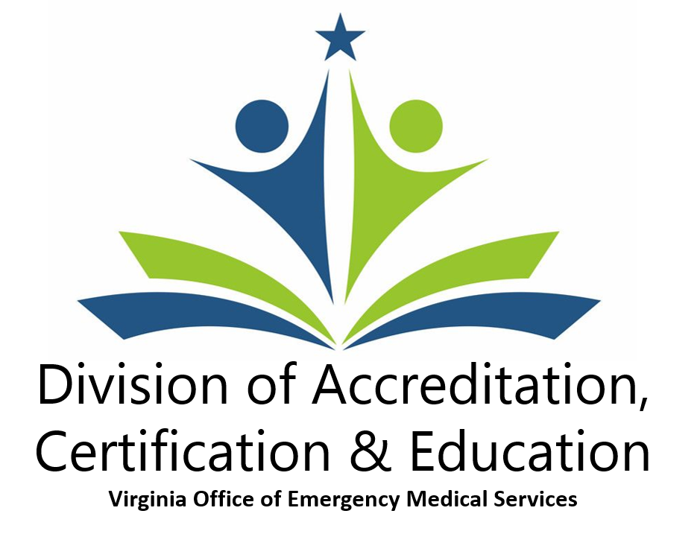

III. Accreditation, Certification and Education

Committees

- The Training and Certification Committee (TCC): The July 2022 Training and Certification Committee meeting was cancelled due to a lack of business..

Copies of past minutes are available on the Office of EMS Web page here:
http://www.vdh.virginia.gov/emergency-medical-services/education-certification/training-certification-committee-standing/.

- The Medical Direction Committee (MDC): The Medical Direction Committee meeting scheduled for July 7, 2022 was held at the Embassy Suites in Richmond, VA. There is one action item attached as appendix XXX.
Copies of past minutes are available from the Office of EMS web page at: http://www.vdh.virginia.gov/emergency-medical-services/education-certification/medical-direction-committee-standing/

Accreditation

All EMS programs that are in need of a site visit having gained accreditation either through Letter of Review or through full accreditation have been granted an extension of expiration until December 31, 2022 due to Omicron wave of COVID-19. No accreditation visits will be scheduled until such time as it is deemed safe due to COVID-19.

  - EMS accreditation program.

    - Emergency Medical Technician (EMT)

      - The following EMT programs are under Letter of Review:
        - Arlington County Fire Department
        - Fauquier County
        - Hampton Roads Regional EMS Academy
        - Augusta County
        - Rockingham County Dept. of Fire and Rescue
        - Gloucester Volunteer Fire and Rescue
        - Fairfax County Fire and Rescue

    - Advanced Emergency Medical Technician (AEMT)

      - The following AEMT programs are under Letter of Review:
        - Newport News Fire Training
        - Fauquier County
        - Hampton Roads Regional EMS Academy
        - Augusta County
        - Rockingham County Dept. of Fire and Rescue
        - King George Fire, Rescue and Emergency Services
        - City of Virginia Beach Division of EMS
        - Germanna Community College

    - Paramedic – Initial

Brightpoint Community College (formerly known as John Tyler Community College) has a program director vacancy and all scheduled classes for the spring semester have been cancelled. Students enrolled in current programs were offered the option to transfer to either J. Sargeant Reynolds Community College or VCU. John Tyler has request inactive status with CoAEMSP until they are able to fill the program director position.

Tidewater Community College has named Carlos Cajeres as the interim Program Director.

Thomas Nelson Community College has been renamed to Virginia Peninsula Community College.

Patrick Henry Community College has been renamed to Patrick and Henry Community College.

Lord Fairfax has been renamed to Laurel Ridge Community College.

National accreditation occurs through the Committee on Accreditation of Educational Programs for the EMS Professions (CoAEMSP – www.coaemsp.org).

      - Blue Ridge Community College has completed their first cohort. They are now working on submission of their initial report to CoAEMSP.

      - Virginia Peninsula Community College has completed their first cohort class and are working on submission of their initial report to CoAEMSP.

      - Henrico County Division of Fire has completed their first cohort class and are working on submission of their initial report to CoAEMSP.

      - Chesterfield Fire and EMS has completed their first cohort class. Based on the date the Letter of Review was issued for Chesterfield Fire, the next class will be considered their first cohort by CoAEMSP. They have named Hunter Elliott as the new Program Director.

      - Hanover Fire/EMS is completing their first cohort class and the students will be testing in the next few weeks.

    - Paramedic – Reaccreditation

National accreditation occurs through the Committee on Accreditation of Educational Programs for the EMS Professions (CoAEMSP – www.coaemsp.org).

  - For more detailed information, please view the Accredited Site Directory found on the OEMS web site at:
https://vdhems.vdh.virginia.gov/emsapps/f?p=200:1

Virginia COVID-19 Actions

Clinical/field Site Requirements

The VEMSES requires that students have patient contacts in a field setting and they need to gain knowledge of how the Emergency Department works. To satisfy the ED requirement, you can have a representative from the hospital/s provide an overview via Zoom or visiting your class to let the students know what to expect when bringing a patient to their facility.

The Office of EMS is still allowing the use of attestation statements if you cannot place your students in a clinical or field site, however this needs to be an “all or none” situation per clinical or field site, not something that is directed to those who refuse to become vaccinated.

You also have the ability to place them in alternative locations such as nursing homes, doctor’s offices, etc., but will likely encounter some of the same issues that you are experiencing with the hospitals.

Continuing Education

All CE is available through online resources and providers are encouraged to use those resources. https://www.vdh.virginia.gov/emergency-medical-services/education-certification/provider-resources/web-based-continuing-education/

Free Continuing Education for Virginia EMS Providers

Available in partnership with VectorSolutions

The Virginia Office of EMS is pleased to announce that Virginia EMS providers now have free exclusive access to VectorSolutions Training, featuring robust courses delivered through an award-winning learning management system.

We have invested significant money and resources into developing this partnership which will allow Virginia EMS providers to choose from 100 different continuing education courses in Vector’s catalog in order to meet their requirements for recertification of their Virginia and National Registry certifications.

Unlock the power of this partnership today! Sign into your account at: https://app.targetsolutions.com/auth/vacee

National Registry

National Registry Cognitive Examination Changes – Effective Date: April 15, 2022

The National Registry is transitioning to a new software platform for administering our examinations. This software upgrade comes with a few modifications to examination scheduling and delivery that candidates may notice. The exam scheduling system was taken offline for maintenance on April 12, 2022. The updated scheduling system went into effect on April 15, 2022. As a reminder, some of the updates to highlight are:

- Candidates will select their examination delivery method (testing center or online proctored) and schedule their examination on Pearson VUE’s website.
- Candidates logging in to schedule examinations will notice they cannot schedule any online proctored (OnVUE) examinations beyond April 11, 2022. This temporary inconvenience is necessary as part of our software upgrade.
- On April 15, 2022, candidates will be able to resume scheduling their online-proctored examinations via OnVUE.
- The EMR level cognitive examination will be available as an online proctored examination starting April 15, 2022.
- The AEMT level cognitive examination will no longer be available as an online proctored examination. AEMT will be administered at Pearson VUE testing centers only. Both EMR and EMT providers will be able to use OnVUE testing for recertification by examination beginning April 15, 2022.
- Our EMT online proctored examination (OnVUE) will be updated to use our computer adaptive format (CAT) and reflect the same experience as at testing centers. This will change the length of the online proctored examination from a fixed set of 110 questions to a variable length between 70-120 questions.

Beginning on April 15, 2022, all Basic Life Support (BLS) examinations will have an online proctored (OnVUE) option in addition to the testing center option, and all Advanced Life Support (ALS) examinations will only be administered at testing centers.

If you have any questions about these updates, please contact support@nremt.org and we will be happy to help. We are excited to continue our commitment to providing the best testing experiences for our candidates.

General Updates

2021 National EMS Education Standards Rollout

The Office of EMS has worked closely with Training & Certification (TCC) and Medical Direction Committees (MDC) to plan for the statewide rollout of the new 2021 National EMS Education Standards (NEMSES). These state Committees and a number of your fellow educators have worked tirelessly over the past 6 months to develop policies, procedures and guidance documents to help ensure this transition is a smooth one. Registration is required to attend.

The State EMS Advisory Board approved TCC’s recommendations for how to move forward at its meeting on May 6, 2022. With this approval, ACE Division staff are working on the final policies and procedures and prepping for a Commonwealth wide rollout this fall.

All educators conducting initial certification courses in Virginia will continue to teach to the Virginia EMS Education Standards (VEMSES) until further notice. The VEMSES is the basis for EMS education at all levels in Virginia. * NEMSES Rollouts will not count as an Education Coordinator Update; CAT 2 CE will be awarded for attendance.

More information on the rollout of the 2021 National EMS Education Standards can be found at the link below:

- https://www.vdh.virginia.gov/emergency-medical-services/education-certification/educator-resources/2021-national-ems-education-standards-rollout/

* NEMSES Rollouts will not count as an Education Coordinator Update; CAT 2 CE will be awarded for attendance.

Training Program Administration Manual (TPAM)

The TPAM has been updated to reflect our recent adoption of the 2021 National EMS Education Standards (NEMSES) as supported by the Training & Certification and Medical Direction Committees and as approved by the EMS Advisory Board. The effective date for most changes is July 1, 2022.

If you are curious about what policies were updated, please do a keyword search on “2022” to see those policies that were affected by these changes. The TPAM can be found on the OEMS website at:

- https://www.vdh.virginia.gov/emergency-medical-services/education-certification/documents-forms-downloads/ems-training-program-administration-manual/
Eligibility of EMS Students for (pre-hospital) Field Rotations in Virginia
The Division of Regulation & Compliance released the following guidance document for all educators in Virginia regarding eligibility of EMS students for field rotations in Virginia. This full memo can be found at: https://www.vdh.virginia.gov/emergency-medical-services/education-certification/educator-resources/ems-student-eligibility-for-clinical-rotations/
Virginia Administrative Code - EMS Regulations §12VACS-31-1170 - Provision of care by students, requires the student to be enrolled in a Virginia Office of Emergency Medical Services (OEMS) approved EMS certification training program.

Compliance with this regulation requires the student(s) completing clinical rotations to be enrolled in an EMS education course that has been announced to, and approved by the Virginia Office of EMS; as demonstrated by the issuance of a Virginia OEMS course approval.

EMS Regulations §12VAC5-31-1423 require all EMS Educational programs (courses) in Virginia to be announced by the Program Director; who must hold a valid Virginia OEMS Education Coordinator (EC) Certification.

The individual must be easily identifiable as a student with appropriate clothing and/or badging indicating they are a student. They must be assigned an approved preceptor who is certified at or above the level of training the student is enrolled. Student may ONLY serve as the 3'd member of an EMS crew. EMS students do not fulfill any EMS agency regulatory staffing requirements.

EMS Educational Programs that are conducted outside of Virginia do not meet these regulatory
requirements; therefore, students enrolled in an out of state program are NOT eligible to complete EMS clinical and field rotations in Virginia, or with a Virginia OEMS licensed EMS agency.

Should an EMS agency be identified as allowing rotations of students enrolled in EMS education programs from outside of Virginia, the agency will be in violation of 12VACS-31-1170 and subject to enforcement action(s). While the Virginia OEMS cannot regulate clinical rotations in the hospital setting, all Virginia hospitals will be notified of these regulatory requirements.

Education Program

Education Coordinator Certification Program

As of July 28, 2022, there are 208 candidates in the pipeline to become Education Coordinators in Virginia. Of these 208 candidates, there are:

- 19 candidates (9% of all applicants) fully eligible to attend the next EC Institute.
- 57 candidates (27% of all candidates) who have not completed any of the requirements of the program
- 152 candidates (73% of all candidates) who have not completed their required NREMT testing.

Education Coordinator Institutes

All EC institutes for the next year have been scheduled and are published on the OEMS website.

https://www.vdh.virginia.gov/emergency-medical-services/education-certification/educator-resources/ems-instructor-resources/ems-education-coordinator-requirements/

Education Coordinator Updates

All EC Updates for 2022 have been scheduled and are published on the OEMS website. As we indicated last year, ACE Division staff will not be traveling as much in 2022 as we did in 2021.

Registration is required to attend all EC/ALS-Coordinator updates and can be found online at: https://www.vdh.virginia.gov/emergency-medical-services/ems-educator-update-schedule/

EMS Training Funds

Table. 1 – Virginia EMS Scholarship Program – FY22
Certification Level | Q1 | Q2 (cum) | Q3 (cum) | Q4 (cum) | Amount Awarded (cum)
EMR | 0 | 0 | 0 | 0 | $0.00
EMT | 188 | 231 | 419 | 498 | $ 416,218.00
AEMT | 18 | 20 | 68 | 71 | $ 86,365.00
Paramedic | 107 | 139 | 223 | 257 | $ 1,275,744.00
Grand Total | 313 | 390 | 710 | 826 | $ 1,778,327.00

Psychomotor Test Site Activity

- BLS Psychomotor Testing has been suspended indefinitely. A proposal to replace BLS psychomotor testing with Competency based verification by the Program Director and Medical Director has been approved by the Medical Direction Committee and will be an action item at the May Governor’s Advisory Board meeting.

Other Activities

- Debbie Akers continues to serve on the Competency Based Education workgroup and the Competency Based Education Steering Committee with the National Registry.

- Debbie Akers has been appointed to serve on the Advanced EMT Psychomotor Competency workgroup with the National Registry.

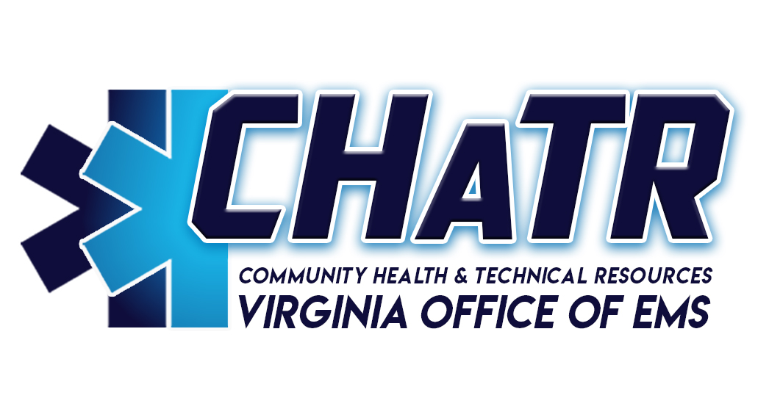

IV. Community Health and Technical Resources

Planning and Regional Coordination

CHaTR Website and Division Information

The CHaTR division has its own section on the Virginia OEMS website at the link below:

http://www.vdh.virginia.gov/emergency-medical-services/chatr/

There have been changes in structure of the CHaTR Division, as Hannah Lyons left OEMS employment on June 3, 2022.

Regional EMS Councils

The OEMS continues to maintain a Memorandum of Understanding (MOU) with the Regional EMS Councils for the 2022 Fiscal Year. The Regional Councils submitted their FY22 Fourth Quarter reports throughout the month of July, and are under review. OEMS utilizes a web based reporting application for the Regional EMS Councils to submit quarterly deliverables.

OEMS staff and the Regional Council Executive Directors held a retreat on March 7-9, 2022, to discuss various aspects of the regional council programs including council updates, discussion of the current MOUs in place and the next round of Regional EMS Council designation. Follow up work sessions were held on May 4 and June 2, 2022 to continue the work started in March. Council directors are submitting their work plans for OEMS review as part of the process for developing the 5 year MOU period beginning October 1, 2022.

OEMS staff have been holding COVID-19 updates via webinar with regional council staff and board members on a routine basis since March 13, 2020. These webinars transitioned to monthly basis on July 16, 2021 through the rest of 2021. In addition, CHaTR staff continue to assist in the coordination of Personal Protective Equipment (PPE), distribution of COVID test kits, and associated COVID activities with the Regional EMS Councils.

CHaTR staff have attended Board meetings and committee meetings for the Old Dominion, Northern Virginia, Peninsulas, Thomas Jefferson, and Western Virginia EMS councils throughout the quarter.

The Regional Council re-designation process is in the final stages. In October 2021, the councils submitted their applications and supporting documents to the Regional Council Portal for review. Site reviews have been conducted from March 16 through April 20, 2022. Following the site reviews, the review teams reported their findings, OEMS compiled those findings into a final report recommending the re-designation of all eleven Regional EMS Councils. The final report was presented and unanimously approved by the EMS Advisory Board at the May 6, 2022 meeting. The State Board of Health unanimously approved the re-designation at their meeting on June 23, 2022. The letters of designation recognition from Health Commissioner Greene are forthcoming.

Medevac Program

The Medevac Committee met on August 4, 2022. The minutes of previous Medevac Committee meetings are available on the OEMS website linked below:
http://www.vdh.virginia.gov/emergency-medical-services/advisory-board-committees/medevac-committee/

The amount of data submitted to the Medevac Helicopter EMS application (formerly known as WeatherSafe) continues to be robust. In terms of weather turndowns, there were 396 entries into the Helicopter EMS system in Q2 of the 2022 calendar year. 65% of those entries (259 entries) were for interfacility transports, which is consistent with information from previous quarters. The total number of turndowns is an increase from 173 entries in Q2 of 2021. This data continues to demonstrate a commitment to the program and to maintaining the safety of medevac personnel and equipment.

The Committee continues to evaluate the increased use of unmanned aircraft (drones), and the increased presence in the airspace of Virginia. A workgroup continues work to raise awareness among landing zone (LZ) commanders and helipad security personnel.

The Office of EMS has developed a form intended for a health care provider to notify a patient or his/her authorized representative that the health care provider is requesting air medical transport for the patient who may not have an emergency medical condition.

The form can be found via the link below:
http://www.vdh.virginia.gov/content/uploads/sites/23/2019/03/Air-Medical-Transport-Authorization-Form.pdf

A workgroup has been created to look at better communications integration - especially across state lines - in a similar fashion to the VIPER system that exists in North Carolina, and involves all air medical entities in that state.

The medevac committee met on July 3, 2022 to review the Virginia Office of EMS Strategic and Operational Plan. It was decided that components of the plan would be regular discussion topics at future State Medevac Committee meetings.

The CHaTR Division Director participates on the NASEMSO Air Medical Committee, and attended the meeting held during the NASEMSO Annual Meeting on June 22, 2022. OEMS and Medevac stakeholders continue to monitor many developments regarding federal legislation and other documents related to Medevac safety, regulation, and the cost of providing air medical services.

State EMS Plan

The Virginia Office of EMS Strategic and Operational Plan (The Plan) is mandated through The Code of Virginia to be reviewed and revised on a triennial basis. The Plan is currently underway for revision in 2022.

Review and revision of the State EMS Plan began in spring of 2022. Committee chairs, OEMS staff, and Regional EMS Council staff received the plan and guidance documents for the review and revision of the plan.

Reports from committees for edits will be compiled into a draft of the 2023-2025 State EMS Plan. The draft State EMS Plan will be presented to the State EMS Advisory Board for approval at the November 2022 meeting. The State Board of Health will be presented with the Plan for approval in December of 2022 or March of 2023.

The current version (2020-2022) of the State EMS Plan is available for download via the OEMS website at the link below:
http://www.vdh.virginia.gov/emergency-medical-services/state-strategic-and-operational-ems-plan/

State Telehealth Plan

During the 2020 session, the Virginia General Assembly passed House Bill 1332, which directs the Board of Health to complete a State Telehealth Plan by January 1, 2021.

The Virginia Department of Health (VDH) created several workgroups to address the specific provisions of the bill language. The Office of EMS (OEMS) worked with the Office of Health Equity (OHE) and leadership from the Injury and Violence Prevention Program to coordinate stakeholders to participate in the development of the State Telehealth Plan. Stakeholder workgroup meetings were held virtually in August and September.

The VDH workgroup delivered the plan to VDH leadership in early February 2021, and was submitted to the General Assembly in March of 2021.

At the direction of the Health Commissioner, the internal VDH Telehealth Plan Workgroup has begun preparations to create the Telehealth Advisory Workgroup.

During the 2022 Virginia General Assembly Session, House Bill 81, and it’s Senate companion, Senate Bill 436 were entered for consideration. The language of both bills “Requires the Board of Health to consult with the Virginia Telehealth Network in amending and maintaining the Statewide Telehealth Plan. The bill requires the Board of Health to contract with the Virginia Telehealth Network, or another Virginia-based nongovernmental organization focused on telehealth if the Virginia Telehealth Network is no longer in existence, to (i) provide direct consultation to any advisory groups and groups tasked by the Board with implementation and data collection, (ii) track implementation of the Statewide Telehealth Plan, and (iii) facilitate changes to the Statewide Telehealth Plan as accepted medical practices and technologies evolve.”

The language for both bills can be found below:
https://lis.virginia.gov/cgi-bin/legp604.exe?ses=221&typ=bil&val=HB81
https://lis.virginia.gov/cgi-bin/legp604.exe?221+sum+SB436

State Rural Health Plan

For several months, the Office of Rural Health worked to develop the first State Rural Health Plan released since 2013. Members from the Office of Rural Health, the Office of Health Equity, and the Office of Emergency Medical Services collaborated on the document on a weekly basis since early May of 2020.

In early 2022, the Office of Health Equity received the final version of the plan. The plan is posted to the Office of Health Equity’s webpage and was mailed to selected stakeholders. It is available for the public to view and can be found at the following weblink:

https://www.vdh.virginia.gov/content/uploads/sites/76/2022/01/Virginia-Rural-Health-Plan_Book_POST_1-24-22_LR.pdf

IV. Technical Assistance

EMS Workforce Development Committee

The EMS Workforce Development Committee (WDC) met on August 4, 2022. Previous WDC minutes are available on the OEMS website, at the link below:
http://www.vdh.virginia.gov/emergency-medical-services/advisory-board-committees/workforce-development-committee/

The goals of the WDC include: the EMS Officer program, the Standards of Excellence (SoE) program, the introduction of military personnel and veterans into the Virginia EMS workforce, and supporting the recruitment and retention of the EMS workforce in Virginia.

EMS Officer Program:

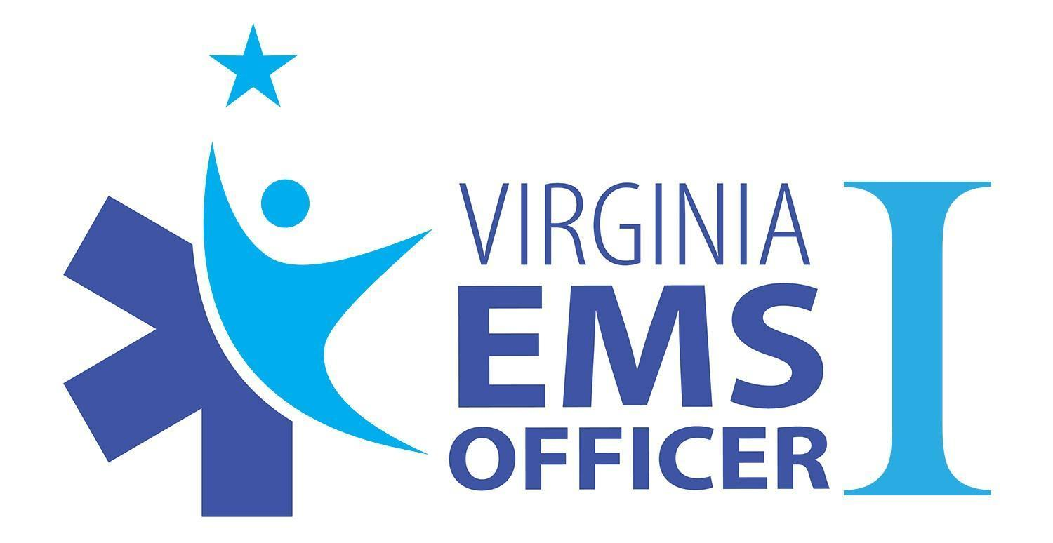

Due to the COVID-19 pandemic, all course offerings after March 13, 2020 were canceled. CHaTR staff resumed instruction of EMSO1 at the 2021 Virginia EMS Symposium. An EMSO1 course was held at the 2022 VAVRS Rescue College with 10 students completing the course, as well as an additional instructor being on boarded to the program’s instructor cache. Additional course offerings are being planned for the remainder of 2022, including the 2022 Virginia EMS Symposium.

The EMSO workgroup continues development of a Train-the-Trainer program, as well as the development of the EMS Officer II program.

The EMSO1 online education modules were formatted to a Learning Management System (LMS). The input from the students and instructors was extremely positive and is being utilized to make changes to future course offerings.

The EMS Officer section of the VDH/OEMS webpage has been updated to reflect the recent progress with the program, at the link below:

http://www.vdh.virginia.gov/emergency-medical-services/agency-leadership-resources/ems-officer-i/

Standards of Excellence (SoE) Program:
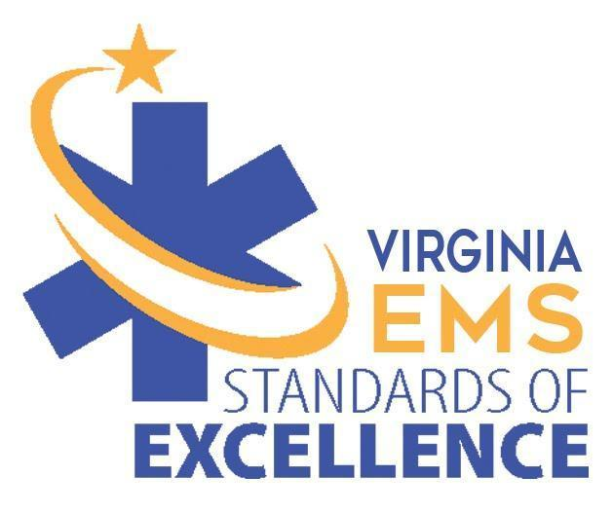
The SoE Assessment program is a voluntary self-evaluation process for EMS agencies in Virginia based on eight areas of excellence - areas of critical importance to successful EMS agency management, above the requirements of the Virginia EMS Regulations.

Each area is reviewed using an assessment document that details optimal tasks, procedures, guidelines and best practices necessary to maintain the business of managing a strong, viable and resilient EMS agency.

CHaTR staff is providing technical assistance to agencies wishing to become Agencies of Excellence, and is working with applicant agencies to schedule site visits in the remainder of 2022.

All documents related to the SoE program can be found on the OEMS website at the link below:
http://www.vdh.virginia.gov/emergency-medical-services/virginia-standards-of-excellence-program/

EMS Recruitment and Retention

CHaTR continues to be a statewide resource to assist with recruitment and retention throughout the Virginia EMS system.

The Virginia Fire & EMS Recruitment Network (https://www.varecruitretain.com/) is composed of membership from Virginia, Maryland and West Virginia with over 300 members. The mission of the Virginia Recruitment and Retention Network is “to foster an open and unselfish exchange of information and ideas aimed at improving staffing” for volunteer and career fire and EMS agencies and organizations.

The Virginia Recruitment and Retention Network met on June 8, 2022 at the Spotsylvania Public Safety Building. The network revamped their website, which offers resources for agencies as well as contact points for individuals interested in Fire and EMS. The network is continuing to add additional content including obtaining member information.

The link to the website can be found on the CHaTR Recruitment and Retention page at the link below:
https://www.vdh.virginia.gov/emergency-medical-services/chatr/recruitment-retention/

Several changes have been made to the Recruitment and Retention page on the OEMS website to give it a more streamlined appearance. The network continues to be strongly encouraged to work with OEMS to provide updated information and resources through the website and social media for recruitment and retention across Virginia. In addition, CHaTR staff have been working with staff from WVEMS to restore the VAEMSJobs website.

EMS Needs Assessment

OEMS partnered with Virginia Commonwealth University’s Performance Management Group (PMG) to conduct an updated needs assessment in 2021. EMS agencies across the commonwealth were notified to expect correspondence from PMG and encouraged to submit a response to the assessment.

The online survey was deployed from early August until late September 2021, with some agencies opting to complete a hard copy of the assessment. All responses have been collected and the data has been analyzed.

The final report was generated and the results of the needs assessment was presented to the EMS Advisory Board on March 11, 2022.

A Tableau dashboard is being created from the responses to the 2012 and 2021 assessments and will be updated with data from subsequent assessments. Users will be able to identify trends in the EMS system and utilize regional data. The sizable dataset must undergo a data cleansing process before it can be visualized for the public.

System Assessments/Miscellaneous Technical Assistance

CHaTR staff assists the Virginia Department of Fire Programs (VDFP) with evaluations of the Fire and EMS systems in localities in Virginia.

The most recent studies were held in Montgomery County on November 15-16, 2021, Northumberland County on August 17, 2021, Nottoway County on April 19, 2021. The final reports of the Montgomery and Nottoway studies have not been released by the VDFP.

Evaluation reports from previously conducted studies can be found via the link below:
https://www.vafire.com/about-virginia-department-of-fire-programs/virginia-fire-services-board/virginia-fire-services-board-studies/

On March 30, 2020, Center for Medicare and Medicaid Services (CMS) released notification to allow for an expansion of the list of allowable destinations for ambulance transports, including any destination that is able to provide treatment to the patient in a manner consistent with state and local Emergency Medical Services (EMS) protocols in use where the services are being furnished.

On April 9, 2020, the Virginia Office of Emergency Medical Services (OEMS) distributed guidance in the form of a white paper to both EMS agencies and facilities considered to be allowable destinations for ambulance transports under the CMS guidance.

The white paper includes guidelines for agencies transporting patients to alternative sites, the protocols that outline the transportation options, funding for transportation to an alternate site, as well as further considerations for transportation to an alternate site.

The white paper can be found at the link below:
http://www.vdh.virginia.gov/content/uploads/sites/23/2020/04/EMS-Transport-to-Alternate-Sites-White-Paper.FINAL_.pdf

Mobile Integrated Healthcare/Community Paramedicine (MIH/CP) and Rural EMS

The MIH/CP workgroup that was created in 2015 reconvened on September 19, 2018, with Dr. Allen Yee again serving as chair.

Previous meeting minutes may be viewed at the link below:
http://www.vdh.virginia.gov/emergency-medical-services/community-paramedicine-mobile-integrated-healthcare/

The workgroup has created a MIH-CP white paper and a letter of intent for agencies that are performing system evaluations to determine the feasibility of providing MIH-CP service. These documents were unanimously approved by the Medical Direction Committee at their meeting on January 16, 2020.

The white paper and letter of intent were approved by the State EMS Advisory Board at their meeting on February 7, 2020. The process for agencies to begin advertising to the public that they are providing MIH or CP service to the public will begin August 1, 2022.

CHaTR staff is also working with the VDH Office of Health Equity (OHE) to perform assessments of EMS systems that have Critical Access Hospitals (CAH) in their service areas. Due to the pandemic, those visits have been postponed.

The CHaTR Division Director participates with the CAMTS MIH Program Standards Workgroup, the NASEMSO CP-MIH workgroup, the Joint Committee on Rural Emergency Care (JCREC), and is a member of the Virginia Rural Health Association (VRHA) Board of Directors.

EMS For Children (EMSC) Program

Fifty EMSC Registration Awards Planned for Symposium

The Virginia EMSC Program plans to award at least fifty EMSC Registration Awards for the 2022 Virginia EMS Symposium being held November 9-13, 2022 in Norfolk. To be eligible for a registration award (basic registration) one must sign up for at least three pediatric-related classes. Those interested should contact David Edwards, EMSC Coordinator, at david.edwards@vdh.virginia.gov for information on how to apply.

“Homeland Security for Children Act,” Reinforces Need for Pediatric Inclusion

This newly-signed bill directs the Federal Emergency Management Agency (FEMA) to identify and integrate the needs of children into all emergency preparation, protection, response and recovery activities dealing with natural and man-made disasters as well as terrorist actions. It will create a new position of Children’s Technical Expert within FEMA to guarantee that the needs of children are addressed and considered during these agency activities. It also directors the Department of Homeland Security (DHS) to report to the Congress annually for five years on implementation of the act.

Emergency Child Restraints Ready for Placement

OEMS-EMSC still has an inventory of grant-funded Emergency Child Restraints (patient range 4-110 lbs.). EMS agency leaders with a legitimate need for these should contact the EMS for Children program (via email) with their requests. Only one or two of these devices can be given to qualified agencies. For greater numbers of restraints we can recommend grant alternatives (RSAF) and note that appropriate restraint of children being transported by ground ambulance in Virginia is a priority issue. EMS agencies are strongly encouraged to adopt safety policies and procedures requiring the use of child restraints by their providers, and the Virginia EMSC program is available to assist in this.

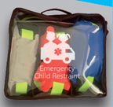

(Funding for the child restraint systems was through the EMSC State Partnership Grant [H33MC07871] via the Health Resources & Services Administration [HRSA] and administered by the Maternal and Child Health Bureau [MCHB] Division of Child, Adolescent and Family Health.)

Pediatric Emergency Care (PEC) Council Active Once Again

The Pediatric Emergency Care Council met in June during the 2022 NASEMSO Annual Meetings held in Charleston, South Carolina. EMSC managers from fifty states and several US territories comprise the Council, which advises the National Association of State EMS Officials (NASEMSO) on pediatric issues and collaborates with various federal agencies interested in pediatric emergency care. Highlights of the two-day meeting agenda included:

- Results of PEC Council Workgroups:
  - PECC Welcome Packet
  - Pediatric EMS Skills

- “NEMSIS Cube – Data Visualization”
- State & U.S. Territory Updates (2 sessions)
- Tour: Medical University of South Carolina Children’s Health Hospital
- “State of NASEMSO”
- “Midwest EMSC Education”
- Chair Elect & Secretary Elections
- Regional Breakout Sessions:
- “National Roadway Safety Strategy – How it will change future of EMS”
- “New Pediatric Trauma Standards & National Pediatric Readiness Project” (with Trauma Council)
- Handtevy Spotlight Presentation
- 2022 PEC Council Meeting – Lessons Learned & Takeaways

National Training for Pediatric Champions Wraps Up

The Pediatric Emergency Care Coordinator (PECC) Workforce Development Collaborative (PWDC) began in September and ran through June 2022. The mission of this national collaborative, led by the Emergency Medical Services for Children Innovation and Improvement Center (EIIC), was to support healthcare professionals working in prehospital and emergency department systems to become effective pediatric champions (also known as PECCs—Pediatric Emergency Care Coordinators). Twenty-six Virginians, both hospital and prehospital, participated in the collaborative.

Coming Soon: EMSC Pediatric Suicide Care Collaborative (National):

In late 2021, the American Academy of Pediatrics, the American Academy of Child and Adolescent Psychiatry, and the Children’s Hospital Association collectively declared a National State of Emergency in Children’s Mental Health and called out the need to “address the ongoing challenges of the acute care needs of children and adolescents, including shortage of beds and emergency room boarding.” In recognition that emergency departments (EDs) across the nation are overwhelmed by the rate that children and adolescents are presenting mental health emergencies, the EMSC program is gearing up to launch the EMSC Pediatric Suicide Care Collaborative to bring ED-based teams from across the nation together with nationally recognized experts in pediatric mental health to implement best practices to optimize the care of children and adolescents presenting to the ED with acute suicidality.

The collaborative will begin in January of 2023 and is open to any hospital or freestanding emergency department that is interested in improving care processes for children and adolescents presenting with acute suicidality. Teams should consist of individuals who regularly interact with children and adolescents presenting to their ED with mental/behavioral health emergencies. This might include physicians, advanced practice providers, nurses, social workers, internal mental health providers, child life specialists, sitters/medical watch, patient/family advisory board representatives or community-based partners such as mental health professionals, pediatricians, or school officials.

As mental health resources are often shared within a region, sites will be grouped into state/territory or region-based teams to encourage collaboration and efficient use of these often-limited resources. Sites are encouraged to promote participation in the collaborative across their hospital system and/or amongst neighboring hospitals and freestanding emergency departments. EMSC program managers who participate in the collaborative will have an opportunity to work with and support participating teams. Participation will include monthly, one-hour virtual learning sessions as well as optional office hours for further assistance. These sessions will be recorded for those that cannot make the live events.
In addition to attending the virtual sessions, teams will work with their internal team and regional or network partners, to ensure high quality care for children presenting with acute suicidality. Using quality improvement methodology as an underpinning of this work, teams will select an improvement idea, implement change strategies, and monitor improvement in the care process.

Continuing nursing education (CNE) hours will be available for participants that attend the live, virtual learning sessions and complete post-session evaluations. Maintenance of Certification Part 4 (MOC Part 4) credit will be provided to physicians who complete an improvement project.
Pediatric suicide screening tools and mental health care resources for prehospital professionals, ED-based teams, and patients and families can be found by visiting PEAK: Suicide and the New England Regional Behavioral Health Toolkit.

Interesting Pediatric Resources
- ASPR TRACIE - Healthcare Pediatric Surge Annex: Leveraging Templates For Operational Impact webinar slides & link to recording
- ASPR-TRACIE - Healthcare Coalition Pediatric Surge Annex template
- American College of Surgeons Committee on Trauma - The Revised National Guidelines for the Field Triage of Injured Patients
- Minnesota Department of Health - Pediatric Surge Plan

EMSC 2022 Annual EMS Agency Survey RESULTS

The survey collected data on specific EMSC performance measures related to EMS agency Pediatric Champions and skills checking of provider pediatric skills. EMS agencies across 58 US states and territories responded to the EMS for Children Survey, which measures progress toward national EMSC performance measures. Collated results will soon be issued to the EMSC Committee and forwarded to EMS agencies.

Continued EMSC Recommendations to Hospital Emergency Departments:

- Weigh AND record children in kilograms (to help prevent medication errors).
- Include children specifically in hospital disaster/emergency plans.
- Designate a Pediatric Champion (Pediatric Emergency Care Coordinator--PECC). (This is the single most important item a hospital can implement to ensure pediatric readiness, including patient safety.)
- Ensure pediatric patients are included in the quality improvement process.
- Review and adopt pediatric safety policies (radiation dosing, medication dosages, abnormal VS).

Suggestions/Questions

Please submit suggestions or questions related to the Virginia EMSC Program to David P. Edwards via email (david.edwards@vdh.virginia.gov), or by calling 804-888-9144 (direct line). The EMS for Children (EMSC) Program is a part of the Division of Community Health and Technical Resources (CHaTR), within the Virginia Office of Emergency Medical Services (OEMS). If you have any difficulty connecting with David Edwards, please contact Tim Perkins via email (tim.perkins@vdh.virginia.gov) or by phone (804-888-9100).

The Virginia EMSC Program receives significant funding for programmatic support through the EMSC State Partnership Grant (H33MC07871) awarded by the U.S. Department of Health and Human Services (HHS) via the Health Resources & Services Administration (HRSA), and administered by the Maternal and Child Health Bureau (MCHB) Division of Child, Adolescent and Family Health.

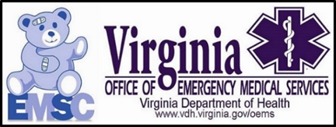

Division of EMS Emergency Operations

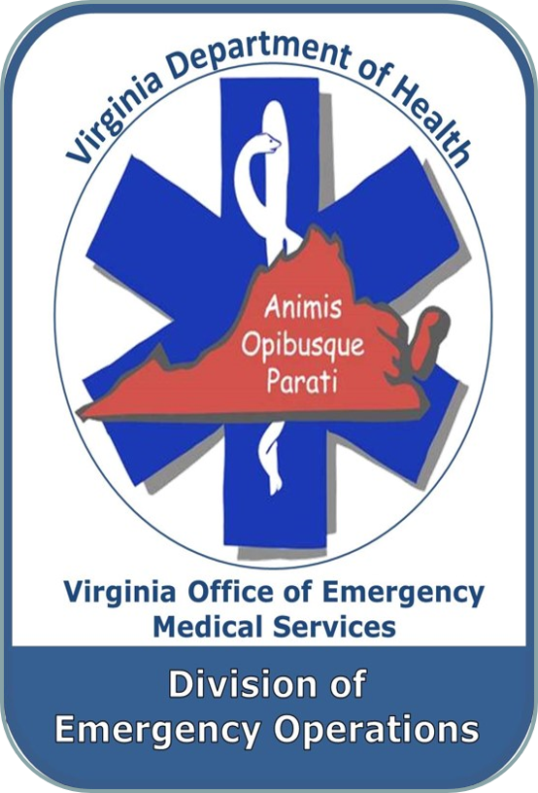

V. Division of Emergency Operations

Division of Emergency Operations Staff Members
Office Number for Staff Members 804-888-9100

Karen Owens Division Director
Staff Support – Provider Health and Safety Committee
karen.owens@vdh.virginia.gov

Sam Burnette Emergency Services Coordinator
Staff Support – Communications Committee samuel.burnette@vdh.virginia.gov

Kari Magner Emergency Services Planner
Staff Support – Emergency Management Committee
kari.magner@vdh.virginia.gov

Vincent Valeriano Epidemiologist
vincent.valeriano@vdh.virginia.gov

Operations

- New Staff Member – Kari Magner

Kari Magner joined the Virginia Office of EMS Division of Emergency Operations as the new Emergency Services Planner. She comes to OEMS with experience in 911 dispatching in Chesterfield and Hanover counties as well as serving in the Virginia Department of Emergency Management (VDEM) Situational Awareness Unit. She has two bachelor degrees from Virginia Commonwealth University – one in forensic science and the other in criminal justice. Kari will be overseeing the development and testing of the office Continuity of Operations Plan (COOP), review of regional plans such as surge and MCI, and development of resources related to emergency preparedness and emergency planning.

- National Association of State EMS Officials

On July 19-24 Karen Owens attended the National Association of State EMS Officials (NASEMSO) annual conference in Charleston, South Carolina. The conference is an opportunity for officials from all 50 date EMS offices to come together to discuss ongoing issues, hot topics, and exchange ideas on how to better effectively operate. As the Health and Medical Preparedness Council Chair, Karen conducted a council meeting, receiving updates from FirstNet on their resources and FEMA on the federal ambulance contract. Additionally, council attendees discussed lessons learned as a result of COVID response activities.

- Emerging Disease Updates

Throughout the quarter, Kari Magner participated in several conference calls related to Monkeypox and COVID-19. She continues to update the emerging infectious disease website with information relevant to the ongoing response to these events. The website can be found here: https://www.vdh.virginia.gov/emergency-medical-services/emergency-operations/emerging-infectious-diseases-information/

- 9-8-8 Suicide and Crisis Lifeline

In 2020, Congress designated the new 988 dialing code to operate through the existing National Suicide Prevention Lifeline’s (1-800-273-8255) network of over 200 locally operated and funded crisis centers across the country. On July 16, 2022, the U.S. transitioned to using the 988-dialing code. 988 is a 24/7, free and confidential direct connection to compassionate, accessible care and support for anyone experiencing mental health-related distress. More information can be found here: https://www.samhsa.gov/find-help/988

- Missions of Mercy Support

Members of Thomas Jefferson Task Force 2 deployed July 22-23 to support the Missions of Mercy program in Wise County. The event provides dental support to the rural areas of far Southwest Virginia. The team provided medical support to attendees and medical staff.

- Hanover Tomato Festival

The Division of Emergency Operations provided support to Hanover County Fire & EMS and Hanover County Parks and Recreation for the annual Hanover Tomato Festival. The Division provided tents, misters, and generators to provide respite locations throughout the event for heat related incidents.

Training and Exercises

- 2022 Hurrevac Webinar

On June 6-10, 2022, Kari Magner attended a virtual training webinar on the HURREVAC software system. This system provides vital information on preparing for and responding to hurricanes, or similar wind and weather related events, during hurricane season.

- Personal Mental Health

On June 9, 2022, Chris Jett presented on personal mental health to the 2022 Virginia Chief Officer Academy. This course discusses public safety related mental health topics specific to leadership, why they are prevalent and ways to improve one's personal mental health. It also highlights how far the effects (positive and negative) can spread throughout their work life, but more importantly, their home life.

- Twiage Tracking System

On May 9, 2022 Sam Burnette and Karen Owens participated in an online demonstration of the Twiage patient tracking system. The system provides daily and special event tracking capabilities for EMS agencies and hospitals.

On June 1, 2022 Sam Burnette traveled to northern Virginia to attend a tabletop exercise that provided an opportunity for the demonstration of Twiage in an exercise setting.

- Saving Our Own with Mental Fitness

On July 5, 2022 Chris Jett presented on health and wellness/resilience to the Spotsylvania VFD firefighter 1 class. This course discusses public safety related mental topics for entry level personnel to make them more informed and better equipped to handle their new adventure. My course has been reviewed and approved by Virginia DBHDS.

On July 28, 2022 Chris Jett presented on health and wellness/resilience to Stafford County Recruit Academy 16. This course discusses public safety related mental topics for entry level personnel to make them more informed and better equipped to handle their new adventure. My course has been reviewed and approved by Virginia DBHDS.

- International Critical Incident Stress Foundation (ICISF) Training

During this quarter, Patricia Copeland has taught (July 14) July Awareness: An Introduction for Crisis Responders, which teaches participants the ability to recognize and effectively intervene with suicidal individuals, (May 10-12) (June 10-12) (July 15-17) Assisting Individuals in Crisis & Group Crisis Intervention, which gives participants the knowledge and tools to provide individual and group crisis interventions.

For information on conducting these and other mental health training classes contact Karen Owens.

- VDEM Region I Complex Coordinated Attack Tabletop Exercise

On May 9, 2022, Sam Burnette served as an evaluator for the VDEM Region I Complex Coordinated Attack Tabletop Exercise.

- Mass Casualty Incident Management Training
On May 10, 2022, Sam Burnette and Wayne Berry delivered an MCIM I/II training course at the 2022 Tidewater EMS Expo in Chesapeake, Virginia. Sixteen EMS providers from the Tidewater area were in attendance.
On Friday June 24, 2022, Sam Burnette traveled to Danville, Virginia for multiple mass casualty training events. On Friday morning he delivered a Mass Casualty Incident Management Train-the-Trainer class at the Danville Life Saving Crew. The course was attended by participants from the City of Danville and Pittsylvania County. That evening, Mr. Burnette returned to observe a rescue task force review and exercise at the Danville Life Saving Crew. This training and exercise demonstrated the importance of properly triaging patients in a hostile environment.
On Saturday, June 25, 2022, Mr. Burnette assisted with a Mass Casualty Incident Management I and II course at the Blairs Volunteer Fire Department in Pittsylvania County. The fifteen students in the class were from various departments in Pittsylvania, Henry, and Campbell counties.
On July 22, Sam Burnette and Wayne Berry delivered an MCIM I/II class for Virginia Beach EMS. The class delivery was part of the Virginia Beach EMS Paramedic training program.
- Vehicle Extrication Training
The Virginia Office of EMS has temporarily halted delivery of their vehicle extrication programs. OEMS will be coordinating with the Virginia Department of Fire Programs (VDFP) to evaluate the programs in an effort to continue our cooperative agreement between the two agencies concerning the delivery of these programs.

Communications / 911 Centers

- 9-1-1 Services Board Regional Advisory Committee (RAC)

During this quarter, Sam Burnette continued to participate in monthly meetings of the 9-1-1 Services Board Regional Advisory Committee. The meetings provide an opportunity for public safety representatives to discuss pertinent communications issues or actions related to public safety communications in the Commonwealth.

- Southwest Virginia LMR Radio Assistance Workgroup

On May 5, 2022, Sam Burnette traveled to Abingdon, Virginia to participate in a Southwest Virginia Radio Assistance Workgroup coordinated by the Statewide Interoperability Coordinator – Gabe Elias. The workgroup consisted of representatives from fire, EMS, law enforcement and 911 centers in Southwest Virginia and discussed challenges and issues with land mobile radio and cellular service coverage and their impact on public safety response.

- 9-1-1 Stakeholders Summit

On May 11, 2022, Sam Burnette participated in the second 9-1-1 Stakeholders Summit hosted by VDEM in North Chesterfield, Virginia. Participants included members of the 9-1-1 Services Board Regional Advisory Committee.

- Public Safety Communications Testing Project

The Virginia Office of EMS received it PCTel Public Safety Network Testing Solution that can conduct both in-building and drive tests for public safety land mobile radios and cellular systems. Once policies and procedures for its use are finalized, the equipment will be used to explore land mobile radio and cellular coverage concerns for EMS agencies in the state.

Planning

- Hurricane Evacuation Planning Committee

On June 12, 2022, Kari Magner virtually participated in the Hurricane Evacuation Planning Committee meeting.

- Central Virginia Healthcare Coalition

Kari Magner, Emergency Services Planner, has transitioned to the role of representing the Office of EMS on the Central Virginia Healthcare Coalition monthly meetings. These monthly meetings provide an opportunity for healthcare agencies across the central Virginia area to discuss ongoing concerns, training opportunities, and needs of the area.

- VEST – ESF-8 Training day

On June 7, 20-22 Karen Owens and Kari Magner participated in a Virginia Emergency Support Team – Emergency Support Function 8 (VEST ESF-8) training opportunity. The online presentation provided an overview of the expectations and functions of staff serving in the state emergency operations center in the ESF-8 role.

- Shelter Training

During this quarter division staff attended an online training on the topic of shelter operations. The course, hosted by the Office of Emergency Preparedness, provided information on the role of VDH staff in shelter operations during emergency events.

- Rappahannock EMS Council Community Outreach Patient Engagement (COPE)

On July 20, 2022 Karen Owens participated in the REMS COPE monthly meeting. The focus of the meeting was on preparedness and how participants might best prepare for emergency events. As part of a panel of presenters Karen answered questions related to continuity and preparedness.

Health and Safety

- 2022 Virginia EMS Provider Mental Health Survey Data Collection

In April and May, OEMS emailed every provider in Virginia and invited them to participate in the 2022 Virginia EMS Provider Mental Health Survey. The goal of the survey is to evaluate the mental health status of Virginia’s EMS providers and assess the perceived mental health cultures, services, and barriers to seeking help within the providers’ agencies. This is a new survey and a follow-up to the 2019 Virginia EMS Provider Mental Health Survey (results here). The survey results will provide valuable data and insight for raising awareness and improving the health and resiliency of EMS providers in the Commonwealth. Results will be publically available later this year.
- Health and Safety Infographics
During this quarter, Vincent Valeriano released two new infographics surrounding provider health and safety that were shared on the OEMS webpage and social media:

- May – “Hold Up and Buckle Up”
https://www.vdh.virginia.gov/content/uploads/sites/23/2022/05/May-Hold-Up-Buckle-
Up.pdf
- June – “Illicit Drug Exposure Prevention”
https://www.vdh.virginia.gov/content/uploads/sites/23/2022/06/Illicit-Drug-Exposure-
prevention-1.pdf

Kari Magner produced the following infographics

Hurricane awareness. This is shared on the OEMS webpage and social media:
www.vdh.virginia.gov/content/uploads/sites/23/2022/06/2022-Hurricane-Infographic-1.pdf

- Health and Safety Webinars

Vincent Valeriano attended multiple webinars related to provider health and safety. They include:

- IPSA: How Full Is Your CART? – An evidence-based assessment of mental health applications

The portability of mobile devices, their ease of use, cost and connectivity make them ideal for providing mental health services. The webinar presented the results of the A-CART assessment tool for mental health applications content quality, security, usability, availability, performance, appearance, adaptability, and accuracy. Additionally, the training reviewed recommendations for their adoption by public safety organizations.

  - Lexipol: 4-Legged Therapy: Getting Started with First Responder Therapy Dogs

Dogs have long been recognized for their unique ability to relate to humans. Therapy dogs are proving to be a key ingredient in agency wellness programs, helping first responders process the trauma they experience, reduce anxiety, cope with grief—and sometimes, just reset between calls. This webinar discussed how a therapy dog program benefits personnel, the agency and the community, key program considerations from funding and handler compensation to dog selection and training, different therapy dog program models, and how to build executive-level support.

  - VHHA Workplace Violence Program

Violence against EMS providers and hospital personnel is an ongoing issue. This webinar featured presentations from representatives at two Virginia health systems (UVA Health and VCU Health) about the structure of the workplace violence reduction program they have implemented to support and protect their employees. The presentation also shared best practices and lessons learned

Division of Public Information and Education

VI. Division of Public Information and Education

Public Relations

Beginning in January 2020, Public Relations staff, along with VDH/OEMS staff began assisting with COVID-19 pandemic response efforts. This emergency response effort is ongoing and is now occurring in tandem with events planned for 2022.
Public Outreach via Marketing Mediums

Via Virginia EMS Blog

The OEMS continues to share important updates and information via the Virginia EMS Blog. This blog replaces the EMS Bulletin, which was an online newsletter that went out twice a year. This blog allows OEMS shares information in a more timely, concise and in a web-friendly format. It also offers more interactive features so readers can comment or ask questions through the blog.
Via Virginia EMS Listserv (April - June)

- 4/15/2022 - Research Survey: Prehospital Point of Care Ultrasound (POCUS) Use and Clinical Decision Making
- 4/26/2022 - EMS Training Opportunity Late Registration - TIDEWATER HEALTHCARE EDUCATION EXPO, May 10-15, 2022
- 5/16/2022 – EMS Week in Virginia press release (sent to statewide media press contacts)
- 5/17/2022 – Emergency Medical Services Week 2022

Via Social Media Outlets
We continue to keep OEMS’ Twitter and Facebook pages active, educational and relevant by posting daily and/or weekly updates that provide important announcements and health-related topics to increase awareness and promote the mission of OEMS and VDH. Some of the subjects that were featured from April - June are as follows:

- April – National Public Safety Telecommunicators Week, Fiber: The Forgotten Hero of Human Health - health and safety monthly infographic, Virginia EMS Portal system maintenance.
- May – Hurricane preparedness, National Nurses Week, Virginia Office of EMS' Guidance Document - Physio-Control LifePak 15 in AED Mode NOT INTENDED for Pediatric Patient <8 Years Old, ambulance safety - health and safety monthly infographic, National EMS Week daily shareables, EMS Week news release, EMS Week Governor’s proclamation, EMS Week presidential proclamation, Extreme heat safety tips, VDH Collaboration with ESO to launch first-ever Virginia Stroke Registry – press release, Virginia EMS Portal system maintenance, holiday office closure, Virginia Fire + EMS Memorial Service save the date.
- June – Hurricane preparedness season Governor’s press release, 2022 Virginia Fallen Firefighters & EMS Memorial Service live broadcast link, U.S. Fire Administration EMS Safety manual, hurricane preparedness health and safety monthly infographic, VDOT #moveover, Virginia EMS Portal system maintenance, Fentanyl and illicit drug exposure prevention and mitigation - Health and Safety monthly infographic, Virginia EMS Symposium 2022 registration reduction, Virginia EMS Symposium sponsorship.

Customer Service Feedback Form (Ongoing)

- PR Assistant provides monthly reports to EMS management regarding OEMS Customer Service Feedback Form.
- PR Assistant also provides biweekly attention notices (when necessary) to OEMS Director and Assistant Director concerning responses that may require immediate attention.
Training

- May 24, 2022 - Public Relations Coordinator completed the DHRM-MVP-HR Policy & Law management training series
- June 7, 2022 - Public Relations Assistant completed the VEST-ESF 8 Training – virtual session

Social Media and Website Statistics

As of July 20, 2022, the OEMS Facebook page had 8,825 likes, which is an increase of 83 new likes since April 27, 2022. As of July 20, 2022, the OEMS Twitter page had 5,324 followers, which is an increase of 7 followers since April 27, 2022.
Figure 1: This graph shows the total organic reach* of users who saw content from the OEMS Facebook page, April - June. Each point represents the total reach of organic users in the 7-day period ending with that day. Our most popular Facebook post was posted on June 17, 2022. This post garnered 12, 449 people reached and 850 engagements (including post likes, reactions, comments, shares and post clicks.)
*Total Reach activity is the number of people who had any content from our Facebook Page or about our Facebook Page enter their screen. Organic reach is the number of unique people who saw our post in the newsfeed or on our page, including people who saw it from a story shared by a friend when they liked it, commented on it, shared our post, answered a question or responded to an event. Also includes page mentions and check-ins. Viral reach is counted as part of organic reach. Organic reach is not paid for advertising.

Figure 2: This graph shows the total organic impressions* over a 91-day period on the OEMS Twitter page, April - June. During this 91-day period, we earned 370 impressions per day and 33.7k impressions. The most popular tweet received 1,104 organic impressions.
*Impressions are defined as the number of times a user saw a tweet on Twitter. Organic impressions refer to impressions that are not promoted through paid advertising.

Figure 3: This table represents the top five most downloaded items on the OEMS website from
April - June.

April | - Authorized Durable Do Not Resuscitate Form (291)  - Scope of Practice Procedures (275)  - TR-06 Course Roster (143)  - TR-57 Virginia Recertification Requirements (120)  - How to affiliate as Non-EMS Certified Personnel (109)
May | - Authorized Durable Do Not Resuscitate Form (245)  - EMS Training Program Administration Manual (TPAM) (198)  - TR-57 Virginia Recertification Requirements (184)  - EMS Scholarship Quick Guide (129)  - TR-06 Course Roster (123)
June | - EMS Training Program Administration Manual (TPAM) (440)  - Scope of Practice Procedures (354)  - Authorized Durable Do Not Resuscitate Form (231)  - TR-06 Course Roster (149)  - EMS Scholarship Quick Guide (131)

Figure 4: This table identifies the total number of unique pageviews, the average time on the homepage and the average bounce rate for the OEMS website from April - June.

 | Unique Pageviews | Average Time on Page (minutes: seconds) | Bounce Rate  (Average for view)
April | 10,198 | 00:46 | 29.19%
May | 8,059 | 00:51 | 26.91%
June | 8,038 | 00:47 | 25.50%

Google Analytics Terms:

A unique pageview aggregates pageviews that are generated by the same user during the same session. A unique pageview represents the number of sessions during which that page was viewed one or more times.

The average time on page is a type of visitor report that provides data on the average amount of time that visitors spend on a webpage. This analytic pertains to the OEMS homepage.

A bounce rate is the percentage/number of visitors or single page web sessions. It is the number of visits in which a person leaves the website from the landing page without browsing any further. This data gives better insight into how visitors are interacting with a website.

If the success of a site depends on users viewing more than one page, then a high bounce rate is undesirable. For example, if your homepage is the gateway to the rest of your site (e.g., news articles, additional information, etc.) and a high percentage of users are viewing only your home page, then a high bounce rate is undesirable.

The OEMS website is setup in this way; our homepage is a gateway to the rest of our information, so ideally users should spend a short amount of time on the homepage before bouncing to other OEMS webpages for additional information. Generally speaking, a bounce rate in the range of 26 to 40 percent is excellent and anything under 60 percent is good.

Events

EMS Week

- On May 17, 2022, the Public Relations Assistant sent the EMS Week in Virginia email to all statewide EMS agencies.

- On May 16, 2022, the Public Relations Coordinator sent statewide press release announcing EMS Week in Virginia.

- Public Relations Coordinator updated the EMS Week webpage and webpage information that was posted on the main VDH homepage under highlights.

- PR Coordinator posted EMS Week shareables on the website and shared them to social media. These EMS Week shareables coordinated with each day’s theme. We had several EMS Week related posts that received a large organic reach, which included five posts that reached 3.2k, 1.7k (two posts), 4.4k and 2.1k people.

Governor’s EMS Awards Program
- Public Relations Assistant provided assistance presenting the Governor’s EMS Award guideline and tips to the Regional EMS Council Directors – May 4, 2022.

Media Coverage

The PR Coordinator and PR Assistant are responsible for fielding the following OEMS media inquiries April - June, and submitting media alerts for the following requests:

- 5/3/22 – Story regarding women in the EMS Field – The Roanoke Times
- 6/3/22 – Petersburg FD inquiry – WTVR, WRIC, Progress Index

OEMS Communications

The PR Coordinator and PR Assistant are responsible for the following internal and external communications at OEMS:

  - On a daily basis, the PR Assistant monitors and provides assistance to the emails received through the EMS Tech Assist account and forwards messages to their respective divisions.

  - The PR Assistant is the CommonHealth Coordinator at OEMS, and as such, she sends out weekly CommonHealth Wellnotes to the OEMS staff and coordinates events within the office.
- The PR Coordinator and PR Assistant design certificates of recognition and resolutions for designated EMS personnel on behalf of the Office of EMS and State EMS Advisory Board.

- Upon request, the PR Coordinator and PR Assistant create certificates for free Symposium registrations to be used at designated events.

- Upon request, the PR Coordinator and PR Assistant provide assistance for the preparation of responses to constituent requests.

- The PR Coordinator and PR Assistant respond to community requests by sending out letters, additional information, EMS items, etc.

- The PR Coordinator and PR Assistant provide reviews and edits of internal/external documents as requested.

- The PR Coordinator and PR Assistant update OEMS website with content and documents upon request from office Division Directors and Program Managers.

- The PR Coordinator is responsible for monitoring social media activity and requests received from the public. She forwards questions to respective OEMS division managers and provides responses to the inquiries through social media. The PR Assistant provides back-up to all social media for OEMS and VDH.

- The PR Coordinator is responsible for coordinating and submitting weekly OEMS reports to be used in the report to the Secretary of Health and Human Resources. The PR Assistant provides back-up assistance.

- When applicable, the PR Assistant submits new OEMS hire bios and pictures to be included on the New Employees webpage on the VDH intranet.

- The PR Assistant is the designated FOIA Officer for the OEMS and the PR Coordinator provides back-up assistance as needed.

VDH Communications Office

VDH Communications Tasks – The PR Coordinator and PR Assistant are responsible for covering the following VDH Communications Office tasks:

- April - June – The PR Coordinator is responsible for working with the Communications Office to assist with coverage for media alerts, VDH in the News, weekly Commissioner’s message, media assistance, team editor, VDH social media and other duties upon request.

- The PR Assistant is responsible for sending VDH media alerts, updating the VDH new employees’ photos for the VDH intranet, replying to website feedback via the VDH website, coordinating and sending the Commissioner’s clinician letters and assisting the Communications Director with entering Media Alerts. The following Clinician Letters were sent from April - June:
  - COVID-19 Update for Virginia - May 20

- PR Assistant coordinated sending the VDH COVID-19 Monoclonal Antibody and Therapeutics Bi-Weekly Update.

- PR Assistant conducted training VDH staff on using the GovDelivery platform.

Ongoing communications duties:

  - The PR Coordinator assists with sending statewide press releases and posting on the VDH website, serves as a backup for VDH social media posts (and primary for OEMS) social media and website, submits RAPs, assists marketing contractors with access to VDH social media advertising sites, uploads videos to VDH YouTube page.

  - The PR Assistant logs media inquiries into the VDH Media Alert Generator, serves as back to monitoring the VDH web feedback submissions, assists with posting and sharing OEMS information and updates and sends statewide press releases and posts them on the VDH website. The PR Assistant also serves as secondary backup for VDH social media, listserv emails.

- VDH Communications Conference Calls (Ongoing) - The PR Coordinator participates in conference calls and polycoms for the VDH Communications team.

  - PR Coordinator and PR Assistant attend the bi-monthly communications check-in meetings.
  - PR Coordinator and PR Assistant participate in bi-monthly Agencywide Communications Workgroup.

- Commissioner’s Dear Colleague Email
PR Coordinator submitted the following info for the State Health Commissioner’s weekly/monthly staff update email.

  - June 7 - The Virginia Department of Health, Office of Emergency Medical Services' Associate Director Adam Harrell was recently appointed as co-chair of The Sequoia Project's Interoperability Matters Emergency Preparedness Information Workgroup. The OEMS is excited for this collaborative opportunity with a nationally recognized organization, to have Adam share his expertise and innovation in Information Technology (IT) as it pertains to the Virginia EMS System.
The Sequoia Project is a non-profit, 501c3, public-private collaborative chartered to advance implementation of secure, interoperable nationwide health information exchange. The Sequoia Project focuses on solving real-world interoperability challenges, and brings together public and private stakeholders in forums like the Interoperability Matters cooperative to overcome barriers. The Sequoia Project is also the Recognized Coordinating Entity (RCE) for the Office of the National Coordinator for Health IT’s Trusted Exchange Framework and Common Agreement (TEFCA), for which it will develop, implement, and maintain the Common Agreement component of TEFCA and operationalize the Qualified Health Information Network (QHIN) designation and monitoring process. The Sequoia Project leads in cross-industry collaboration to develop implementation strategies that enable secure, interoperable nationwide exchange of health information. For more information about The Sequoia Project, visit www.sequoiaproject.org.

Division of Regulation
& Compliance

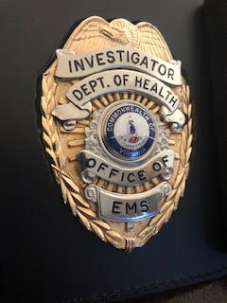

VII. Regulation and Compliance112 | Page

The Division of Regulation and Compliance Enforcement performs the following tasks:
- Licensure & Permitting
  - EMS Agencies and vehicles
- Regulatory Compliance Enforcement of:
  - EMS Agencies
  - EMS Vehicles
  - EMS Personnel
  - EMS Physicians
  - RSAF Grant Verification
  - Regional EMS Councils
  - Virginia EMS Education
  - Complaint\Compliance Investigations
  - Drug Diversion Investigations
  - LCR Database Portal Management
- Endorsement of EMS Physician (Operational Medical Director)
- Background Investigations (review finger-print based criminal histories)
  - Determine eligibility for EMS certification and/or affiliation in Virginia
- Litigate on behalf of the OEMS in appeal hearings to defend enforcement actions
- EMS Regulation Variance/Exemption application determinations
- EMS Psychomotor Examination Accommodation Request determinations
- Creation and/or Revision of EMS Regulation(s)
  - Utilizing the Virginia Division of Legislative Services, Regulatory Information System, and Department of Planning and Budget as required
- Provide Virginia General Assembly legislative session OEMS representation
  - Provide written and verbal consultation regarding proposed legislation being debated or considered, that involves or impacts the delivery of EMS in the Commonwealth of Virginia
- Virginia EMS Regulation & Compliance Enforcement Educational Resource
  - Educational programs provided on request and during most EMS conferences throughout the Commonwealth of Virginia
- Provide support to all Committees of and for the State EMS Advisory Board
- Provide EMS regulatory and compliance consultation services for EMS agencies and localities within the Commonwealth of Virginia
- Represent the Virginia Office of EMS, Regulation & Compliance Enforcement Division on national boards and/or committees
We perform these tasks to protect the health, safety, and welfare of the public when accessing or utilizing the EMS System in the Commonwealth of Virginia.
The following (next page) is a summary of the Division’s activities for the second quarter, 2022:

EMS Agency/Provider Compliance Enforcement Activity

Enforcement | 2022  1st Quarter | 2022  2nd Quarter | 2022  3rd Quarter | 2022  4th Quarter | 2022 YTD Totals | 2021 Totals | 2020 Totals
Citations | 6 | 3 |  |  | 9 | 19 | 29
EMS Agency | 1 | 3 |  |  | 4 | 5 | 10
EMS Provider | 5 | 0 |  |  | 5 | 14 | 19
Verbal Warning | 1 | 0 |  |  | 1 | 7 | 7
EMS Agency | 0 | 0 |  |  | 0 | 2 | 1
EMS Provider | 1 | 0 |  |  | 1 | 5 | 6
Correction Order | 4 | 4 |  |  | 8 | 18 | 6
EMS Agency | 2 | 3 |  |  | 5 | 7 | 0
EMS Provider | 2 | 1 |  |  | 3 | 11 | 6
Suspension | 9 | 17 |  |  | 26 | 28 | 34
EMS Agency | 3 | 1 |  |  | 4 | 3 | 0
EMS Provider | 6 | 16 |  |  | 22 | 25 | 34
Revocation | 0 | 1 |  |  | 1 | 6 | 0
EMS Agency | 0 | 1 |  |  | 1 | 0 | 0
EMS Provider | 0 | 0 |  |  | 0 | 6 | 0
Compliance Cases
Investigations Opened | 63 | 76 |  |  | 139 | 196 | 180
Investigations Closed | 62 | 63 |  |  | 125 | 173 | 168
Drug Diversions | 6 | 2 |  |  | 8 | 11 | 10
Variances | 26 | 86 |  |  | 112 | 96 | 87
Approved | 5 | 54 |  |  | 59 | 50 | 49
Denied | 21 | 32 |  |  | 53 | 44 | 38
RSAF Grant Verifications | 61 | 34 |  |  | 95 | 195 | 258

Quarterly EMS Agency & Vehicle Inspection/Licensure Activity
Licensure | 2022  1st Quarter | 2022  2nd Quarter | 2022  3rd Quarter | 2022  4th Quarter | 2021 Total | 2020 Total
Total Agencies | 563 | 560 |  |  | 566 | 573
New Agency | 0 | 5 |  |  | 7 | 10
New Vehicles | 112 | 133 |  |  | 295 | 232
Inspections | 517 | 934 |  |  | 3121 | 3082
Agencies Inspected | 76 | 69 |  |  | 321 | 250
Vehicles Inspected | 270 | 702 |  |  | 2429 | 2683
Unscheduled “Spot” Inspections | 171 | 163 |  |  | 308 | 149

Quarterly IFFC = Informal Fact Finding Conferences (APA) appeal hearing update
There were 2 Administrative Processes Act (APA) - Informal Fact Finding Conferences (hearings) held during this quarter. 1 each in April and June.

Both Cam Crittenden, R.N., and Ron Passmore, NRP, have completed courses at the National Judicial College on a tract to obtain non-attorney, Administrative Law Judge (hearing officer) credentials. Ms. Crittenden will be the sole hearing officer for all Regulation & Compliance Enforcement Division cases.

Background Investigation Unit
Background Checks | 2022  1st Quarter | 2022  2nd Quarter | 2022  3rd Quarter | 2022  4th Quarter | 2021 Total | 2020 Total
OEMS Processed | 2,088 | 2340 |  |  | 9,813 | 6,410
Eligible | 1,986 | 2359 |  |  | 9,249 | 6,310
Non-Eligible | 6 | 22 |  |  | 34 | 54
Manual Review  Criminal history | 304 | 125 |  |  | 1,225 | 430
Pending  Review | 121 | 62 |  |  | Not Cumulative | Not Cumulative
Rejected  Fingerprint cards | 6 | 37 |  |  | 51 | 56
Jurisdictional Ordinance Processed | 96 | 78 |  |  | 530 | 1,119

EMS Physician Endorsement
Operational Medical Directors | 2022  1st Quarter | 2022  2nd Quarter | 2022  3rd Quarter | 2022  4th Quarter | 2021 Total | 2020 Total
Endorsed | 229 | 221 |  |  | 228 | 208
New OMD’s | 5 | 4 |  |  | 9 | 18
Re-Endorsed (5yr) | 8 | 12 |  |  | 44 | 20
Conditional (1yr) | 0 | 0 |  |  | 6 | 14
Expired Endorsement | 5 | 4 |  |  | 11 | 8

The OMD Workshop schedule for 2022 started at the EMS Symposium in Norfolk on November 4, 2021. OMD Workshops held this quarter were as follows: Thomas Jefferson EMS & Central Shenandoah EMS Councils in Staunton (April 12), Southwest Virginia EMS Council in Marion (May 3), Old Dominion EMS Council in Richmond (May 12), and Lord Fairfax EMS Council in Winchester (June 28).

This quarter completed the 2022 OMD Workshop schedule.

Once the 2023 OMD Workshop schedule is available it can be found on the OEMS website, under Regulation & Compliance Enforcement tab, then click EMS Medical Director sub-tab, then click the link titled EMS Medical Director Workshops 2022 – 2023.

Regulatory Process (Chapter 32) Update

OEMS Regulation & Compliance Enforcement Division continues to work with key EMS stakeholder groups to review suggested revisions to all sections of the current EMS Regulations (Chapter 31).
- Stage 1 - A Notice of Intended Regulatory Action (NOIRA) posted in the Virginia Register of Regulations (Vol. 33 Issue 19) on May 15, 2017. The deadline for public comment was June 14, 2017. No public comments were submitted. OEMS Staff is working to complete the required documentation for the next step for the “Proposed” EMS Regulations.

- The approved first draft of “Proposed” EMS Regulations (Chapter 32) is currently being manually entered into the RIS as project 5100.

- The required Town Hall (TH-02) form is also being completed which details all changes in regulatory language from Chapter 31 to 32 by comparison. This form will submitted to the Regulatory Town Hall following approval of the Final Draft of Chapter 32 by the Board of Health in 2023.

- Final Draft of Chapter 32 will be presented to the Rules & Regulations Committee during their next scheduled meeting on October 5, 2022, for their 90 day final review.

- Rules & Regulations Committee to approve final draft of Chapter 32 at the January 4, 2023 meeting. Ultimately submitting the final draft as an action item for approval by the State EMS Advisory Board meeting scheduled on February 3, 2023.

- Office of EMS will then submit the approved final draft of Chapter 32 to the State Board of Health for approval to enter into Stage 2 of Regulatory Process (Executive Branch Review and Public Comment period)

- Stage 2 - Submission of the completed TH-02 document for project 5100 (Chapter 32) will be submitted following the VDH – Board of Health approval of this final draft; this will initiate the Executive Branch Review process which requires the Office of Attorney General, Department of Planning and Budget including an Economic Impact Analysis, Cabinet Secretary, and Governor of Virginia to review; then posted for a 60 day public comment period on the Virginia Regulatory Town Hall *(Target Goal for this phase is Spring of 2023)

- Following the 60 day comment period, all comments will be considered (adopted) and final regulatory language will be revised

- Stage 3 – Submission of the completed (TH-03) document for project 5100 as the final regulatory package via the Town Hall to again receive a repeat Executive Branch review and final public comment period before adoption into law.

Additional Regulation & Compliance Enforcement Division Work Activity

- The Regulation and Compliance Enforcement Division bi-monthly staff meeting(s) were held on April 20th through 22nd & June 1st through 3rd at the Office of EMS in Glen Allen, VA.

- Division Task Team(s) met on April 18th & June 1st to work on Regulation & Compliance Enforcement Division specific work projects and templates.

- Division Leadership Team (Division Director & Field Supervisors) met April 20th and May 30th to review, plan, and monitor the 2022 Division deliverable goals.

- Coordinated monthly meetings at OEMS for Division Directors with Assistant Attorney General Krista Samuels Esq. who represents the Office of EMS.

- Attended the following 44 meetings this quarter:

  - April 6th – Rules & Regulation Committee Meeting
  - April 7th – Medical Direction Committee Meeting
  - April 8th – Regulatory Processes meeting with VDH
  - April 14th – Fairfax County Fire Rescue Meeting
  - April 14th – Virginia International Raceway Meeting
  - April 21st – OEMS Division Directors Meeting
  - April 25th – Colonial Beach Volunteer Rescue Squad Meeting
  - April 25th – Westmoreland County Administration Meeting
  - April 26th – NASEMSO Personnel Licensure Committee Meeting
  - April 28th – Colonial Beach Volunteer Rescue Squad Meeting
  - April 28th – Westmoreland County Administration Meeting
  - April 28th – Westmoreland County Board of Supervisors Meeting
  - May 2nd – Carilion Clinic Patient Transport Meeting
  - May 5th – State Medevac Committee Meeting
  - May 5th – State Workforce Development Meeting
  - May 5th – State Trauma Advisory Group Pre-hospital Committee Meeting
  - May 5th – Virginia Ambulance Association Meeting
  - May 5th – State EMS for Children Committee Meeting
  - May 5th – State EMS Advisory Board Executive Committee Meeting
  - May 6th – State Legislative and Planning Committee Meeting
  - May 6th – State EMS Advisory Board Meeting
  - May 6th – Virginia Governmental EMS Agency Meeting
  - May 9th – NASEMSO Code of Ethics Committee Meeting
  - May 10th – OEMS Symposium Program Committee Meeting
  - May 11th – NASEMSO Medical Directors Handbook & Needs Assessment Mtg.
  - May 17th – OEMS Division Directors Meeting
  - May 18th – RVEL (Required Vehicle Equipment List) Development Meeting with Division Staff
  - May 24th – NASEMSO Medical Directors Handbook Committee Meeting
  - May 25th – NASEMSO EMS Needs Assessment Committee Meeting
  - June 6th – VDH Regulatory Process Training
  - June 6th – NASEMSO Code of Ethics Committee Meeting
  - June 8th – Virginia Recruit and Retention Committee Meeting
  - June 9th – Combined MDC & Rules & Reg’s Committee Meeting
  - June 13th – Westmoreland County Compliance Training
  - June 16th – OEMS Division Directors Meeting
  - June 21st – Virginia Fire Chiefs Association Board Meeting
  - June 21st – Chesterfield Fire & EMS Meeting
  - June 23rd – Virginia Board of Health Meeting
  - June 27th – Rules & Regulations Committee Meeting
  - June 28th – Patient Transport Services (AMR) Meeting
  - June 29th – EMS Advisory Board Composition Workgroup Meeting
  - June 30th – Meeting with OMD and Dr. Lindbeck

- Meeting(s) with OIM on development of EMS portal updates (bug-fixes).

  - April 15th – Defects specific to OMD related issues
  - April 19th – Develop workaround with ACE Division – student background check

- DEA/BOP/OEMS Task Force continued meeting schedule to work collaboratively in developing manageable pathway for EMS agencies to comply with BOP regulations and upcoming new DEA rules (Protecting Patient Access to Emergency Medications Act of 2017) once they are posted. This act governs how EMS providers can administer controlled substances to individuals receiving emergency medical services. More on this to come in the future.

  - Virginia Board of Pharmacy Guidance Document for EMS Agency Drug Kits is posted to the Regulation and Compliance Enforcement section, Guidance Document sub-tab, on the OEMS website
  - No New updates as of the time of this report.

- Regulation & Compliance Enforcement Division website updates:

- Division Section of OEMS website has been updated and reorganized as follows:

  - Regulation & Compliance Enforcement Division Home page
    - Quick links for most common forms
      - NEW - Instructions how to create portal accounts for non-certified EMS agency members and apply for EMS agency affiliation, prior to submitting finger prints for background checks.

  - There are 10 division subtabs as follows:

    - Agency Licensure
    - Regulation
    - Guidance Documents and Memo’s
      - NEW – Scope of Practice explanation of Red Dots
      - EVOC Equivalents Listing – (UPDATED)
      - Who Must Submit Fingerprints – (UPDATED)
    - Criminal History Record
      - Who Must Submit Fingerprints – (UPDATED)
    - Fingerprint Submission
      - NEW - Instructions how to create portal accounts for non-certified EMS agency members and apply for affiliation, prior to submitting finger prints for background checks.
    - EMS Interstate Compact (REPLICA)
    - Data Compliance Report
    - Durable Do Not Resuscitate (DDNR)
    - EMS Medical Directors
      - Scope of Practice Documents (Formulary & Procedures) UPDATED
    - Sample Policies and Agreements
Regulation and Compliance Enforcement Division Structure Profile
Ronald D. Passmore, NRP, TS-C
Division Director, Regulation and Compliance Enforcement
Phone: (804) 888-9131

Oversees the Division of Regulation and Compliance Enforcement, focus is on the following broad areas:
  - EMS Physician initial and re-endorsement
  - EMS agency initial and re-licensure
  - EMS vehicles permitting and renewal
  - EMS regulations development and enforcement
  - Variances and Exemptions processing for provider, agencies and entities
  - OEMS policy advisor to Executive Management
  - Provide technical assistance & guidance to all committees of and the state EMS Advisory Board
  - OEMS Staff Liaison to the Rules and Regulations Committee
  - Manages Operations Education Track for Virginia EMS Symposium
  - Technical assistance to local governments, EMS agencies and providers
  - Background investigations on EMS certified personnel and EMS students
  - Regulatory enforcement, complaint processing
  - National issues involving licensure and regulations
Marybeth Mizell
Senior Administrative Assistant,
Physician Endorsement & Background Investigation Unit
Phone: (804) 888-9130

- Provides direct administrative support to the Division Director and staff while managing all Virginia endorsed EMS physicians, to include all applications for OMD endorsement and re-endorsement, and provides technical support assistance to field team administrative assistants.
- Update and maintain listing of all Virginia endorsed EMS Physicians
- Provides staff support to the Rules and Regulations and Transportation committees

Kathryn “Katie” Hodges
Administrative Assistant,
Background Investigations
Phone: (804) 888-9133

Provides support to field team and coordinates background investigation activities to include:

- Receiving and processing results of all fingerprint based background investigations
- Notification to agencies regarding member eligibility status per background investigations
- Assist Field Investigators (Program Representatives) with all administrative tasks
- Assist customers by navigating requests to the appropriate resource for resolution

OEMS Program Representatives (Field Investigators)

Provides field support to EMS agencies, local government, facilities and interested parties in the development of EMS to include the following:

- EMS agency initial and renewal licensure by inspections
- EMS vehicle initial and renewal permits and spot inspections
- EMS regulation development and compliance enforcement
- EMS complaint investigations
- Verify awarded EMS grants to eligible recipients from RSAF program
- Liaison and OEMS representative at various local and regional meetings with organizations to include but not limited to local governments (county, city, town), regional EMS Councils, VDEM, VDFP, OCME, federal/state/local law enforcement agencies, etc…
- Subject matter experts on the delivery of EMS within the Commonwealth
- Facilitator for matters related to OEMS through the various Office of EMS programs

Sr. Supervisor, Jimmy Burch, NRP (Jimmy.Burch@vdh.virginia.gov) – Virginia - East
Chad Gregg, EMT-I (Chad.Gregg@vdh.virginia.gov) – Coastal
Steve McNeer, EMT-I (Stephen.McNeer@vdh.virginia.gov) – Central
Doug Layton, EMT-P (Douglas.Layton@vdh.virignia.gov) – Shenandoah

Supervisor, Paul Fleenor, NRP (Paul.Fleenor@vdh.virginia.gov) – Virginia - West
Ron Kendrick, EMT-I (Ron.Kendrick@vdh.virginia.gov) – Appalachia
Scotty Williams, EMT-P (Scotty.Williams@vdh.virginia.gov) – Highlands
Len Mascaro, NRP (Leonard.Mascaro@vdh.virginia.gov) – Northern Virginia

The Regulation and Compliance Team of professionals provide the Commonwealth of Virginia with more than 142 years of combined experience specific to EMS regulations and compliance enforcement; in addition, this team of twelve has more than 292 years of combined experience with the delivery of Emergency Medical Services as clinical providers and EMS administrators.

Division of Trauma
and
Critical Care

VIII. Division of Trauma and Critical Care

Staffing/Recruitment:

- Trauma/Critical Care Manager
- Administrative Assistant
Trauma/Burn Center Reviews:

- 10 verification/designation reviews completed
- 1 consultative visit completed
- 5 currently scheduled for the remainder of 2022

- June 2022 NASEMSO Conference (National Association of State EMS Officials)

- Trauma/Critical Care Representative for VAOEMS

Central Shenandoah EMS Council

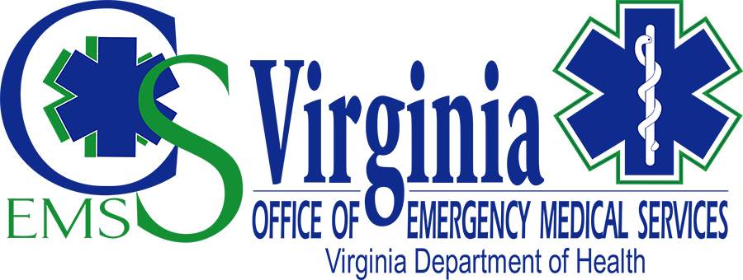

IX. Central Shenandoah EMS (CSEMSC) Regional Office

This document contains hyperlinks to supporting documentation publicly available and submitted for approval to the Central Shenandoah EMS Council (CSEMSC) Board of Directors. The items outlined are in accordance with the Regional Council MOU’s required deliverables.
- Regional Medical Protocols
  - Regional Medical protocols were recently updated at the June MCRC Meeting.
    - Regional Protocols
  - The regional protocol training is on Google Classroom. Agency Training Officers and Medical Directors are responsible for releasing new providers when they have completed the training and meet any further agency requirements, such as skills verification, etc. CSEMS staff are working with agencies to comply with the new “red dot'' scope of practice changes and have advised multiple agencies to apply for a variance as concerns arise about meeting the deadline. Technical support has also been provided through this process. CSEMS provided authorization to practice document templates, in collaboration with the Division of Regulation and Compliance Enforcement and made them available to all EMS agencies via the CSEMS website. Forms can be customized to meet agency-specific needs.
- Ambulance Restocking Program
  - The Regional Restocking Program remains unchanged during the previous reporting period. The Board of Directors reviewed the current policy and voted to withhold any changes until the UCapIT machines are installed at hospitals.
    - Ambulance Restocking Plan - Current.pdf
- Medication Kit Exchange Program
  - The Regional Restocking Program remains unchanged during the previous reporting period. The Board of Directors reviewed the current policy and voted to withhold any changes until the transition of drug boxes is complete, or new DEA rules are released.
    - Regional-Drug-Box-Best-Practices.pdf
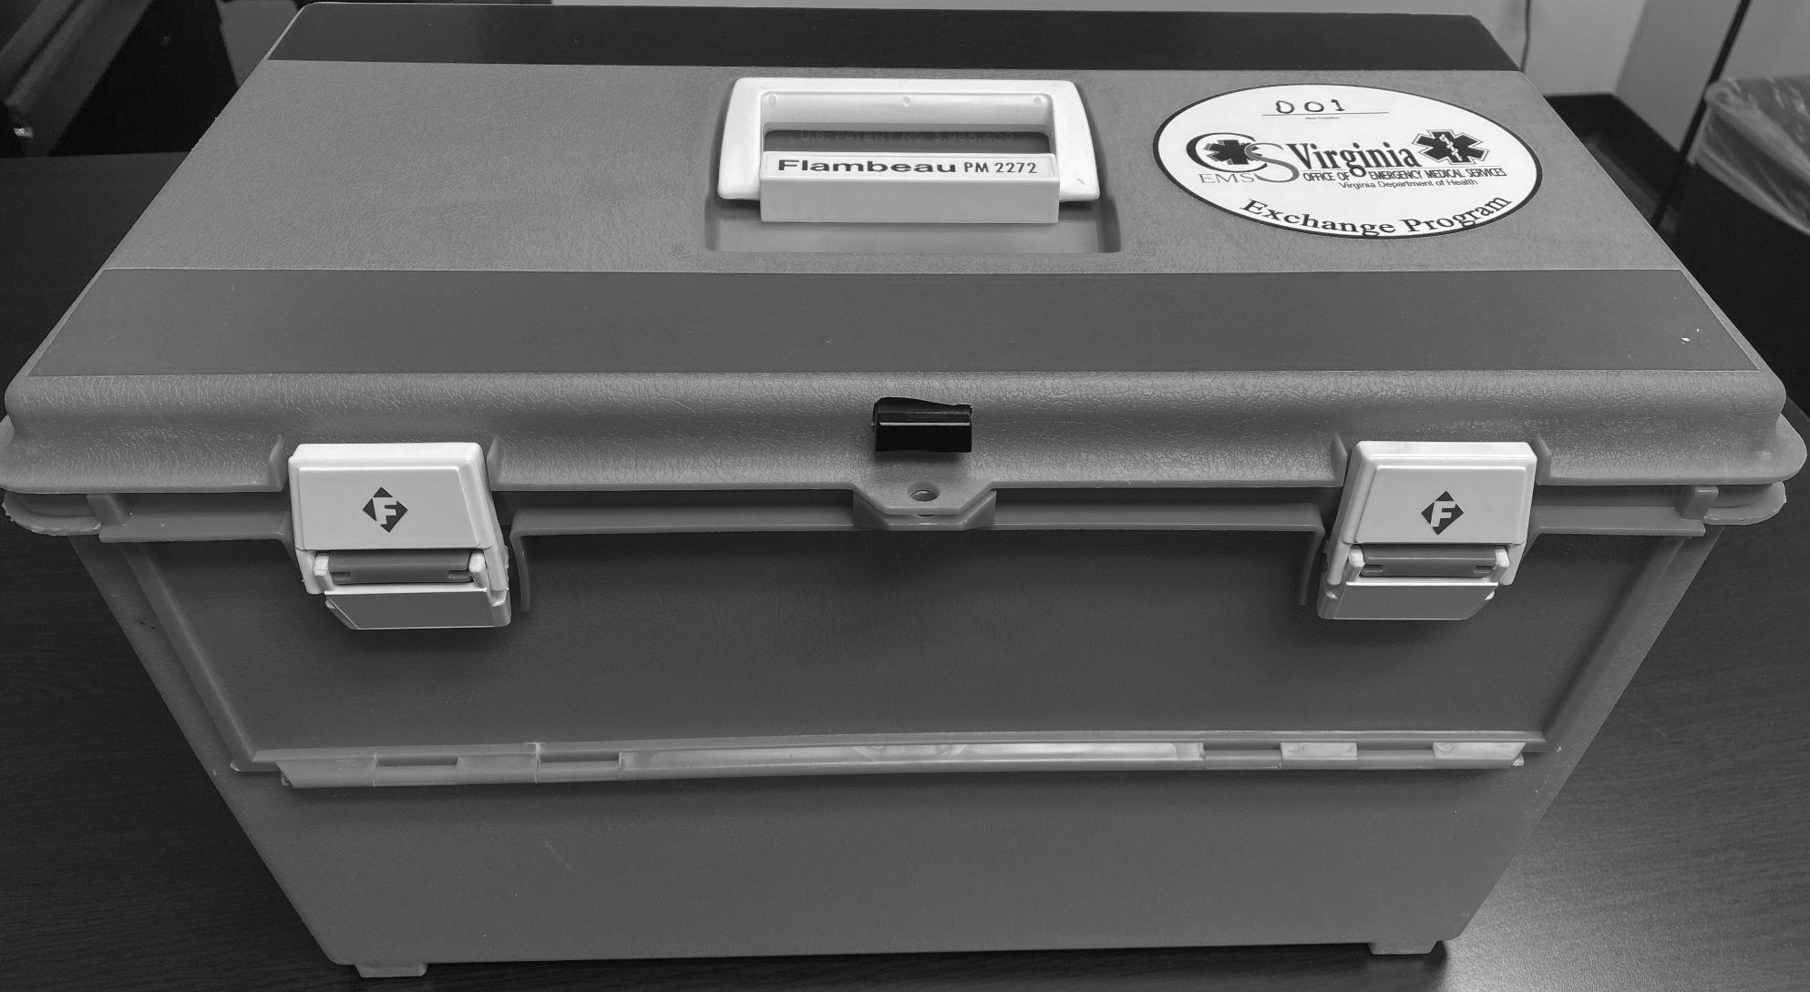
  - The transition to a single box solution is approximately 70% complete, with only a portion of Rockingham, all of Harrisonburg, and the Staunton, Augusta and Waynesboro areas remaining. EMS Agencies pending transition expressed concerns about the layout, and requested a meeting to review proposed changes. Two meetings were hosted with EMS agency stakeholders on the potential changes to the drug box layout and the physical containers. The stakeholders were commissioned at the MCRC meeting in June to form a working group and report back any consensus agreements for further discussion and stakeholder approvals. No action was taken on this recommendation. Both meetings were in person with the option to attend via a virtual meeting link. A meeting with EMS agency representatives in Rockbridge County and the City of Lexington prompted another meeting to be scheduled in July. At this time, no consensus has been reached on the future of the drug box system. Pending new final DEA rules, uncertainty remains on the future of regional medication exchange programs.
    - Meeting Dates that were held
      - June 1, 2022
      - June 15, 2022
      - An additional date is being scheduled prior to the next pharmacy meeting to include volunteer agencies in the southern part of the region.
- Hospital Diversion Planning
  - The Regional Diversion Plan was revised and has been reviewed by representatives from all of the hospitals in the region as listed below.
    - Reviewers:
      - Augusta Health :
Amanda Bennington - Administrative Director ED
      - Bath Community Hospital :
        - Lisa Craft - Director of Clinical Operations
        - Lucy Dunnagan - Hospital Nursing Director
      - Carilion Rockbridge Community Hospital:
        - Leonard Stewart
Emergency Management /Safety Consultant
        - Tracy Higgins - ED Director
      - Sentara RMH Medical Center -
        - Marcus B. Almarode - Director of ED & RT
      - Northwest Region Healthcare Coalition:
        - Ashley Waite Shifflett - Exercise and Training Specialist
    - The draft copy is linked below for the board's approval for implementation. This review was completed via collaborative document sharing (Google Docs). .
      - Regional Hospital Diversion Protocols - Spring 2022.docx
- Regional Instructor Network
  - Efforts over the last two years to engage EMS Educators in the region have had limited success. The last official meeting was in 2021, and had only two of the 53 Education Coordinators attend (not including those employed by CSEMS/OEMS). Staff have been working to develop opportunities that would bring value to the instructor network, but further meetings were postponed pending final decisions from the state EMS Advisory Board on the future of CTS testing. Since this decision was made earlier this year, new plans have been included in the proposed CSEMS Work Plan, which include a quarterly workshop format, which will include information sharing, instructor development, and potentially hosting external speakers. The goal is not simply to provide updates, but to equip instructors with resources to improve both the quality of education and the enjoyment of educators. Topics include moulage, simulation training (on equipment to be housed at CSEMS), item writing, exam analysis, and documentation management for accreditation. A poll has been distributed to the educators in the region to identify the best dates to begin this in October.
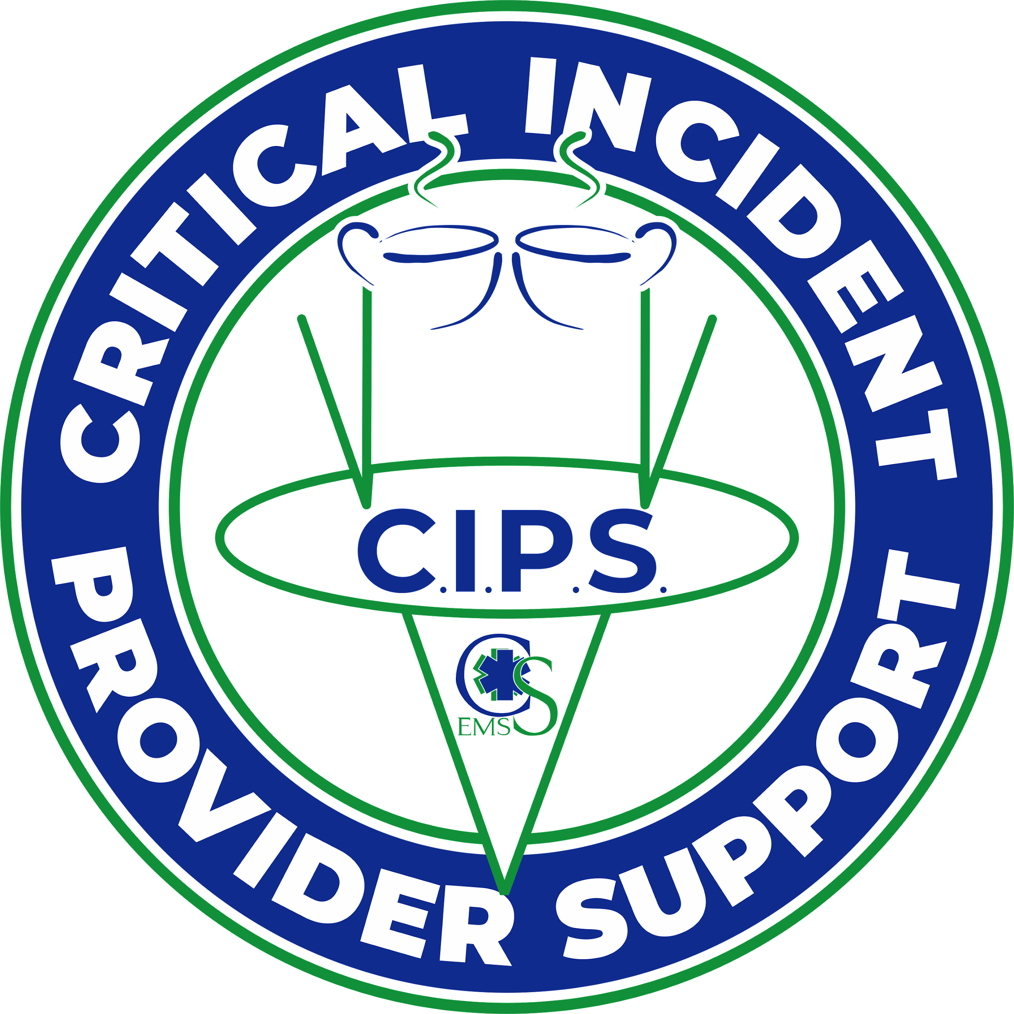
- CISM Semi-Annual Report
  - The Central Shenandoah EMS Council has an active CISM team available 24 hours 365 days per year. With the increase in agency Peer Support teams, CSEMS has continued to support EMS agencies when requested. CSEMS has rebranded the team so as to distinguish some of the stigma surrounding CISM, and to embrace a more comprehensive approach to provider care. The Critical Incident Support (CIPS) Team has responded to thirteen activations so far in 2022. The CIPS team has organized and participated in five training sessions for 2022, with one of these being the ICISF Assisting Individuals and Groups in Crisis class.
    - 2022 CISM Report
- Education Outreach
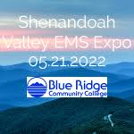
  - EMS Expo - CSEMS Partnered with Augusta Health, Blue Ridge Community College, Carilion Lifeguard 12, PHI Air Medical and Sentara RMH Medical Center, to host the first annual Shenandoah Valley EMS Expo. This event offered 22 continuing education sessions, three pre-conference classes, and incredible breakfast, lunch and ice cream from North Ridge Cafe and Coffee, Thomas House, and Smiley’s Ice Cream, respectively. The event was provided free to all participants. The event was hosted at Blue Ridge Community College on the last day of EMS Week, May 21, 2022. The Expo was also supported by more than a dozen vendors and the Central Shenandoah Health District. Quality education was provided to 61 registered attendees. 100% of respondents rated the overall experience a 4 or 5 on a 5-point scale, with over 95% of instructors requested back by survey respondents. The intent is to expand this event to a multi-regional rotation with increased support and partnerships to improve education access for EMS providers in the northwestern region of Virginia.
  - Continuing Education Opportunities Provided by CSEMS
    - April - EMS Documentation & Quality Assurance @ MSVFR - Amanda Loreti
    - May - BLS/ALS Skills Drill @ Highland County EMS - Becky Anhold & Asher Brand
    - May - EMS Expo Classes
      - BLS Airway Academy - Jeremy Wampler & Becky Anhold
      - PEPP - Jeremy Wampler & Becky Anhold
      - Sips with CIPS - Amanda Loreti
    - June - Sports Injuries for EMS 8 hour class @ VAVRS Rescue College - Becky Anhold & Jeremy Wampler
    - June - Healthy Minds, Healthy Lives: Increasing Awareness and Erasing Stigmas @ Highland County EMS - Amanda Loreti

- Quarterly Meeting Agendas and Minutes
2022.04.12 CIPS Meeting Agenda
2022.04.12 CIPS Meeting.docx
2022.04.14 Pharmacy Committee Meeting Agenda
2022.04.14 Pharmacy Meeting Minutes
2022.04.26 Board of Directors Meeting Agenda DRAFT.docx
2022.04.25 Virtual BOD Meeting Minutes.docx
2022.06.16 MCRC Meeting Agenda
2022.06.16 MCRC Meeting Minutes .docx
- Quarterly Financial Reports
FY22 Annual Budget vs Actual.pdf
FY22 4th Qtr P&L.pdf
- Regional Activities
  - CSEMS Staff regularly attend meetings as invited by EMS agencies and/or localities. In these meetings, staff generally provide a report from the region, and are able to answer questions regarding regional operations. Staff also participate in a weekly agency-wide forum with VDH, as a hybrid office of the VDH Office of EMS. Below is a list of meetings attended in the fourth quarter of FY22.
CSEMS External Meetings
Augusta County
Name | Person | Status | Meeting Date
ACESOA Meeting | Charles Feiring | Done | 2022-04-26 19:00
ACESOA Meeting | Charles Feiring | Done | 2022-05-24 19:00
ACESOA Meeting | Amanda Loreti | Done | 2022-06-28 19:00
Harrisonburg/Rockingham County
Name | Person | Status | Meeting Date
Sentara RMH EMS Taskforce Meeting | Charles Feiring | Done | 2022-04-21
Harrisonburg-Rockingham Emergency Management Task Force Meeting 5.12.2022 |  | unable to attend | 2022-05-12 08:30
Northwest Region Health Care Coalition
Name | Person | Status | Meeting Date
NWHCC HVA Group Interview | Daniel Linkins | Done | 2022-05-27 08:30
Rockbridge County
Name | Person | Status | Meeting Date
Rockbridge VFESA Meeting 4/19/2022 | Charles Feiring | Done | 2022-04-19
Rockbridge VFESA Meeting 5/17/22 | Daniel Linkins | Done | 2022-05-17
Rockbridge VFESA Meeting 6.21.22 | Daniel Linkins | Done | 2022-06-21

  - CSEMS Staff provide a local contact for questions and support with statewide and regional policies, protocols, and information distribution. Members of the EMS Community or the general public can submit helpdesk tickets via the CSEMS website. Staff attempt to also record requests via telephone in the helpdesk system, in order to track support and receive feedback from customers. Below is a summary of recorded assistance activities in the fourth quarter of FY22.
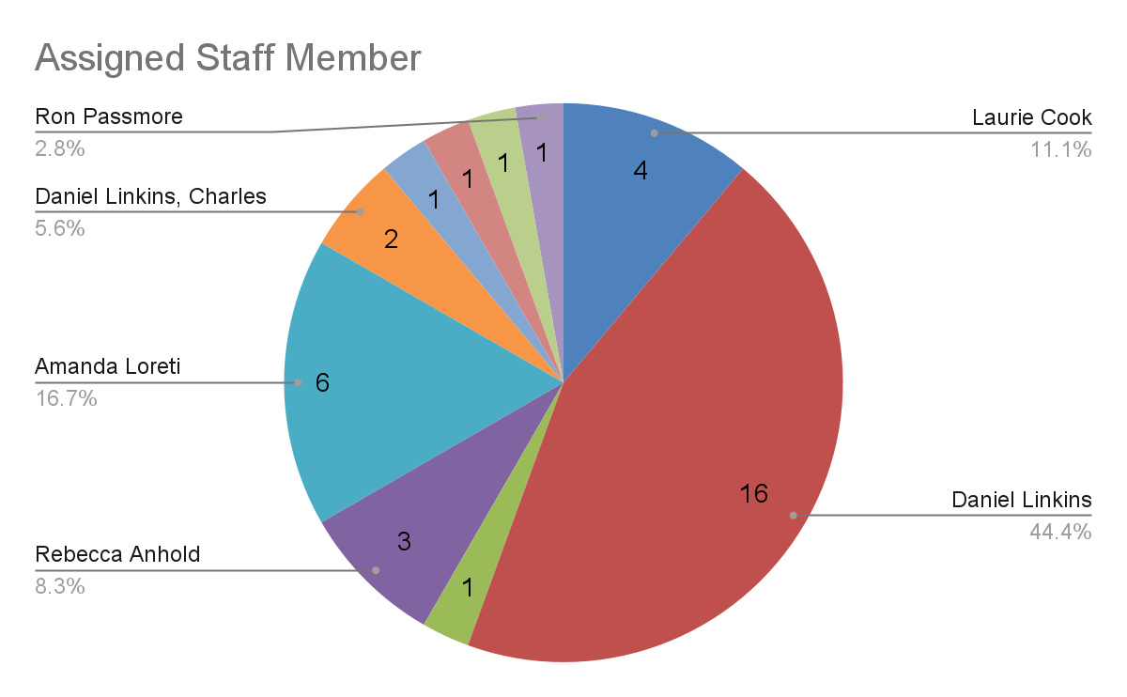
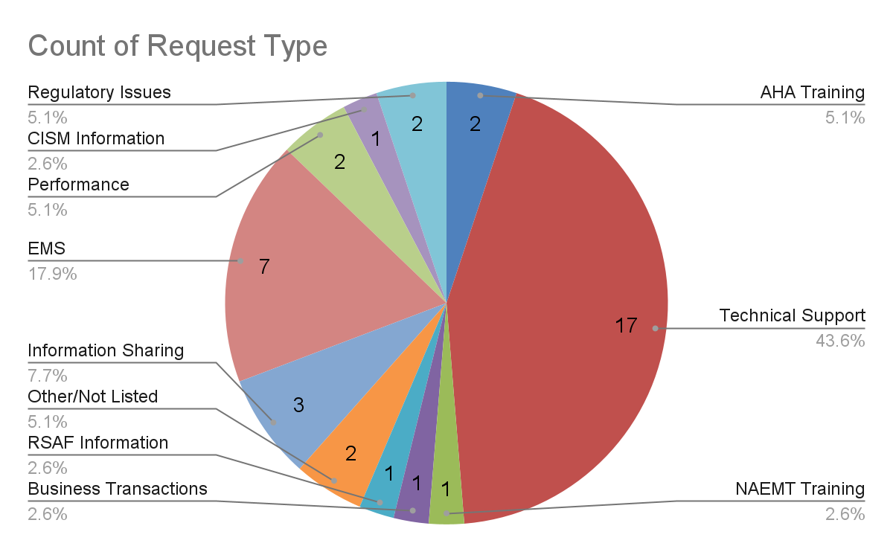
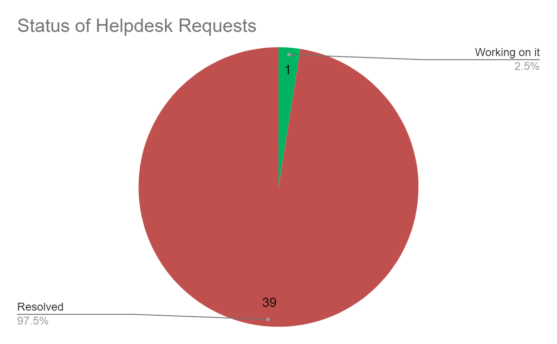
  - Additional Activities by CSEMS Staff:
    - Daniel Linkins continues to represent the Staunton West End Business Association, hosting monthly meetings at CSEMS and volunteering for street clean ups each quarter.
    - Charles Feiring and Laurie Cook attended the 3 day course to become qualified members of the CIPS team.
    - Daniel Linkins, Asher Brand, and Amanda Loreti met with INOVA Blood Services to discuss potential for hosting blood drives and accessing blood for prehospital use on 4.8.2022.
    - Daniel Linkins, Charles Feiring and Amanda Loreti continued meeting weekly with the ESO transition team to ensure all EMS agencies migrating are supported and up to date.
    - CSEMS and TJEMS hosted an OEMS Medical Director Workshop at the CSEMS Office, coordinated by Ron Passmore and Dr. George Lindbeck on 4.12.2022.
    - Charles Feiring met monthly with the Northwest Region Healthcare Coalition to discuss regional emergency preparedness and hospital system status.
    - CSEMS regional stakeholders hosted a site visit team from OEMS for the Council redesignation on 4.18.2022.
    - Charles Feiring attended a webinar on a new Junctional Tourniquet just entering the marketplace.
    - Daniel Linkins and Charles Feiring met with representatives from PulsePoint to discuss regional access to the software on 4.20.2022.
    - Daniel Linkins attended monthly Division Director meetings at the Central Office in Richmond.
    - Charles Feiring taught/coordinated the NAEMT AMLS course in Stuarts Draft Rescue Squad.
    - Regional Directors of the Hybrid offices continue to meet with Scott Winston on a weekly basis to exchange ideas and information for system improvements.
    - CSEMS and REMS staff coordinated monthly exchange visits to improve collaboration and joint support, and to share ideas for continuity of operations.
    - Daniel Linkins met with a small workgroup, including Heidi Hooker from ODEMSA and Steve Simon from WVEMS to design the template for the Regional EMS Council Work Plan document on 4.21.2022, 4.26.2022, and 4.29.2022.
    - As a member of the Staunton West End Business Association, CSEMS hosted a presentation on Opportunity Zones to support growth in the surrounding region.
    - Daniel Linkins represents CSEMSC as a member of the Virginia Association of Governmental EMS Agencies at quarterly meetings.
    - Daniel Linkins met with TJEMS staff to provide an in-service on the use of Google Forms and Sheets to automate registration processes and communications for VILT Education.
    - Daniel Linkins and Charles Feiring attended a portion of an EMT class in Millboro to meet new instructors in the region and provide support from CSEMS for future education initiatives.
    - All CSEMS staff join a weekly VDH Agency forum to receive updates from the Health Commissioner, other VDH offices, and Local Health Districts.
    - Daniel Linkins served as the guest speaker for the Blue Ridge Community College Paramedic Pinning Ceremony for 2022 graduates on 5.13.2022.
    - CSEMS received the Simulation Trailer from OEMS on 5.16.2022 for display at the EMS Expo. Equipment is still pending.
    - May 16-20, CSEMS Staff celebrated the work of EMS providers through daily social media posts and ice cream socials at hospital emergency departments throughout the region.
    - Charles Feiring attended the ODEMSA Training Committee meeting 6.9.22.
    - Charles Feiring attended a webinar “Establishing a Prehospital Whole Blood Program” sponsored by the NAEMT on 6.24.2022
    - Daniel Linkins attended the REMS Open House on 5.25.2022 to support new initiatives and assist with the event setup.
    - Daniel Linkins and Charles Feiring met with a local Marketing Writer to discuss professional writing of nominations for Governor’s EMS Awards on 5.27.2022
    - Daniel Linkins, Charles Feiring, and Amanda Loreti joined ESO for a State Insights Phase II Demonstration on 5.26.2022.
    - Daniel Linkins supported the NWHCC in a Hazard Vulnerability Analysis interview on 5.27.2022.
    - Charles Feiring taught PALS Skills session on 6.9.2022
    - Charles Feiring upgraded teaching certification for the NAEMT 3rd Edition of EMS Safety course 6.17.2022.
    - Daniel Linkins and Charles Feiring met with representatives from Unite Us Virginia to discuss the RUSH program and other opportunities to increase utilization of the platform throughout the region on 6.7.2022, 6.14.2022, and 6.21.2022.
    - Daniel Linkins attended a virtual meeting with the Staunton Augusta Waynesboro Metropolitan Planning Organization meeting with the Central Shenandoah Planning District Commission on 6.15.2022.
    - Daniel Linkins, Amanda Loreti and Charles Feiring joined Regional Council staff for a rollout training of ESO Insights at the OEMS Office in Glen Allen on 6.30.2022.
    - Amanda Loreti attended Mental Health Wellness and the Rippling Effects of COVID-19 on 4.6.2022.
    - Amanda Loreti participated and presented at the ESO Wave conference in Texas during the week of April 18th.
    - Amanda Loreti participated in NAEMSP Q&S Course Sessions monthly.
    - Amanda Loreti worked with Rele Crowe from ESO on gathering TXA data on 6.1.22.
    - Amanda Loreti participated in Augusta Health’s advisory board meeting on 6.2.22.
    - Amanda Loreti met with officers from Mount Solon Fire Rescue to assist them in developing a quality management program on 5.26.22 and a follow up on 6.6.22.
    - Amanda Loreti participated in the ICISF quarterly Team Coordinator Virtual Meeting on 6.13.22.
    - Amanda Loreti had a quality improvement progress meeting with Stephanie Ashford on 6.21.22 and 6.28.22.
- State Committee Participation
  - Regional EMS Council Executive Directors’ Group - Daniel Linkins represents CSEMSC at the Regional EMS Council Director’s Group. The regional directors have been meeting on a bi-weekly basis to share information, train on common systems, and collaborate on statewide initiatives that impact Virginia’s EMS System. Additionally, two retreats were held with the Regional EMS Council Directors in April and June to discuss the new work plan format.
  - State EMS Advisory Board - CSEMSC is represented on the state EMS Advisory Board by Matt Lawler, EMS Chief for Augusta County Fire - Rescue. Matt was reappointed for an additional term.
  - Assigned State Committees, Workgroups and Task Forces
    - Matt Lawler represents the state EMS Advisory Board at the Training and Certification Committee.
    - Gary Critzer represents EMS at the Virginia Board of Health, and represents the Board of Health at the state EMS Advisory Board, the Executive Committee and the Rules and Regulations Committee.
    - Donna Hurts represents CSEMSC at the Financial Assistance Review Committee (FARC) and Medevac Committees.
    - Dr. Asher Brand represents CSEMSC at the Medical Direction Committee (MDC).
  - CSEMS Staff attended state committee meetings in the fourth quarter, as outlined in the summary below:
State EMS Advisory Board Meetings
Emergency Management Committee
Name | Person | Status | Meeting Date | Location
Emergency Management Committee - 5.5.2022 | Charles Feiring | Attended | 2022-05-05 09:30 | Embassy Suites by Hilton Richmond, 2925 Emerywood Parkway, Richmond, VA, USA
EMS for Children
Name | Person | Status | Meeting Date | Location
EMS for Children Committee 05.05.2022 @ 15:00 | Daniel Linkins, Charles Feiring | Attended | 2022-05-05 15:00 | Embassy Suites by Hilton Richmond, Emerywood Parkway, Richmond, VA, USA
EMS Advisory Board Meetings
Name | Person | Status | Meeting Date | Location
Executive Committee Meeting - Composition Workgroup & Bylaws Workgroup Combined meeting 05.05.2022 | Daniel Linkins | Attended | 2022-05-05 17:00
State EMS Advisory Board Meeting 05.06.2022 @ 10:00 | Daniel Linkins, Charles Feiring, Amanda Loreti | Done | 2022-05-06 10:00 | Embassy Suites by Hilton Richmond, Emerywood Parkway, Richmond, VA, USA
Legislative and Planning Committee
Name | Person | Status | Meeting Date | Location
L&P Meeting 5.6.22 | Daniel Linkins | Done | 2022-05-06 08:30 | Embassy Suites by Hilton Richmond, Emerywood Parkway, Richmond, VA, USA
Medical Direction Committee Meetings
Name | Person | Status | Meeting Date | Location
Medical Direction Committee Meeting 4.7.22 | Daniel Linkins, Amanda Loreti | Done | 2022-04-07 | Embassy Suites by Hilton Richmond, Emerywood Parkway, Richmond, VA, USA
EMS Provider Health and Safety
Name | Person | Status | Meeting Date | Location
EMS Provider Health and Safety Committee 5.6.2022 08:30 | Amanda Loreti | Done | 2022-05-06 08:30 | 2025 Emerywood Parkway, Henrico, VA, USA
Rules and Regulations Committee
Name | Person | Status | Meeting Date | Location
Rules and Regulations Committee 4.6.22 | Daniel Linkins | Done | 2022-04-06
Rules and Regulations Committee 6.27.22 | Daniel Linkins | Unable to Attend | 2022-06-27
R&R/MDC Meeting 6/9/22 | Daniel Linkins | Done | 2022-06-09
Rules and Regulations Committee
Name | Person | Status | Meeting Date | Location
R&RC - 04.06.2022 @ 13:00 | Daniel Linkins | Done | 2022-04-06 13:00 | 1041 Technology Park Drive, Glen Allen, VA, USA
State Medevac Committee Meetings
Name | Person | Status | Meeting Date | Location
State Medevac Committee 5.5.2022 @ 09:00 | Daniel Linkins | Done | 2022-05-05 09:00 | Embassy Suites by Hilton Richmond, Emerywood Parkway, Richmond, VA, USA
Transportation Committee
Name | Person | Status | Meeting Date | Location
Transportation Committee 4.4.22 | Charles Feiring | Done | 2022-04-04
Trauma Administrative and Governance (TAG) Committee Meetings
Name | Person | Status | Meeting Date | Location
SIC 05.05.22 @ 10:00 | Amanda Loreti | Done | 2022-05-05 10:00 | Embassy Suites by Hilton Richmond, Emerywood Parkway, Richmond, VA, USA
PACC - 05.05.2022 @ 13:00 | Amanda Loreti | Done | 2022-05-05 13:00 | Embassy Suites by Hilton Richmond, Emerywood Parkway, Richmond, VA, USA
Acute Care Committee 5.05.2022 @ 15:00 | Amanda Loreti | Done | 2022-05-05 15:00 | Embassy Suites by Hilton Richmond, Emerywood Parkway, Richmond, VA, USA
Trauma Program Managers Workgroup 05.05.2022 @ 16:30 | Amanda Loreti | Done | 2022-05-05 16:30 | Embassy Suites by Hilton Richmond, Emerywood Parkway, Richmond, VA, USA
TAG 05.06.2022 @ 08:00 | Charles Feiring | Done | 2022-05-06 08:00 | Embassy Suites by Hilton Richmond, Emerywood Parkway, Richmond, VA, USA
Workforce Development Committee Meetings
Name | Person | Status | Meeting Date | Location
Workforce Development Committee 5.5.2022 10:30am | Daniel Linkins | Done | 2022-05-05 10:30 | 2925 Emerywood Parkway, Richmond, VA, USA
Association Meetings
Name | Person | Status | Meeting Date | Location
VAGEMSA 5.6.22 | Daniel Linkins | Done | 2022-05-06 13:00 | 2925 Emerywood Parkway, Richmond, VA, USA
VAA 5.5.22 | Charles Feiring | Done | 2022-05-05 13:00 | 2925 Emerywood Parkway, Richmond, VA, USA

- Community Training Center
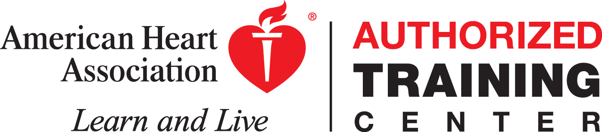
  - The AHA Training Center has continued to offer classes with reduced capacity, social distancing, enhanced disinfecting, and 1:1 student-to-manikin ratios due to COVID-19. Off-site classes were limited to familiar sites, where COVID-19 precautions exceeding minimum CDC guidelines could be exercised. FY22 Fourth Quarter showed an decrease in classes compared to the previous quarter. In May the Training Center offered a BLS Instructor Course.
FY22 4th Quarter AHA Training Center
    - CSEMS Training Center 4th Quarter Activity Report

  - The NAEMT Training Center continued focus on instructor development, hosting an Advanced Medical Life Support class in April at Stuarts Draft Rescue Squad, and an Advanced Medical Life Support Hybrid Provider class in June at Rockbridge County Fire-Rescue. Additionally, courses have been held at the Rappahannock EMS Council as a site of the CSEMS NAEMT Training Center. A Prehospital Trauma Life Support class has been scheduled for July, 2022 at Stuarts Draft Rescue Squad. Unfortunately, the cost of running NAEMT classes is sometimes prohibitive for many EMS providers, leading to many canceled classes. The new proposed CSEMS Work Plan includes a request for funding for auxiliary courses approved by OEMS, making quality standardized education attainable by all providers, if approved.
    - 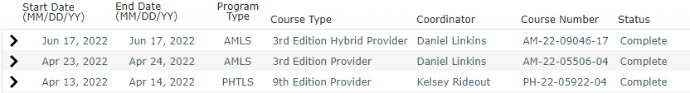
- Collaboration with the Central Shenandoah Health District
  - The Interim Director of the Central Shenandoah Health District, Dr. Elaine Perry has participated in the discussions on the Rare and Under-Served Healthcare for Children (RUSH) initiative, and has been an active advocate for the program.
  - Hilary Cronin has been actively involved in the development of the Region’s MCI/EID/WMD plan revision.
  - In June, discussions at VDH indicated that the Governor’s mandate for all state employees to return to in-person work on July 5 may create some challenges for staff who were hired during the pandemic under telework expectations. The CSEMS director initiated conversations through OEMS and the Commissioner’s Leadership team to offer space at CSEMS to support overflow staffing. In effort to enhance collaboration, the former Pearson Vue Testing Center has been converted to “LiquidSpace” flexible workstations. This opportunity was also shared with the local health district to enable staff to use either the private offices or workstations by simply scheduling through the VDH gmail calendar. Work stations provide access to the state network, along with docking stations, office supplies, telephones, and secure storage for personal belongings.
  - Additionally, two breakout rooms in the Classroom were cleaned out to allow the Health District to house and distribute PPE and other supplies to health care agencies. The Waynesboro Health Department is transitioning to a new facility, and will have to close operations before the new facility is available. CSEMS was able to partner to enable the district to reopen clinical services in the Staunton Health Department through this process. CSEMS staff continue to seek opportunities to support partnerships to improve the health of the community.

Blue Ridge EMS Council

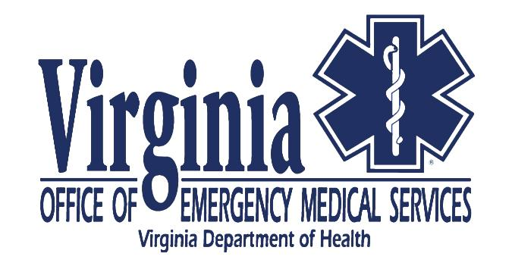. 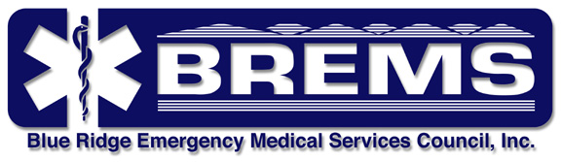

  - Blue Ridge EMS (BREMS) Regional Office

- Participation in Local, Regional and State EMS Activities

  - BREMS/OEMS Staff participate in local/regional activities in support of agency operations as a regional system. Our regular monthly and quarterly meetings have been conducted as conference calls. BREMS coordinated efforts with the Centra hospital system to continue emergency management conference calls. Our Regional Medical Director, Dr. Wendy Wilcoxson, provided information updates for EMS. The bi-weekly, monthly, and quarterly calls help to identify goals and objectives necessary to meet regional needs. The BREMS region encompasses a committed and engaged group of EMS Leadership, EMS providers, EMS agencies, and physician medical directors.

    - The following activities were attended by BREMS leadership:
      - Numerous local and regional in-person and virtual conference calls during the 4th quarter FY 2022:
        - BREMS Regional EMS Director’s meetings and conference calls during the quarter
        - Virginia Heart Attack Coalition (VHAC)
        - Medical Direction
        - BREMS Staff Meetings
        - RSAF Grant Review (April 12th, 2022)
        - Continuous Quality and Performance Improvement (CQI)
        - Accelerated Paramedic Program (APP)
        - Centra Trauma Team Conference
        - Centra Chest Pain and VHAC Meetings
        - VDH Stroke Coverdell
        - ASTHO Stroke Grant

    - BREMS Board of Directors meetings and grant review session. Board of Directors met on Tuesday, March 8th and the Grant review was held on Tuesday, April 12th.

    - Hospital System (Centra) and BREMS meetings and conference calls during the quarter:
        - Centra A-Fib Meeting
        - Chest Pain Council Meeting
        - Virginia Heart Attack Coalition
        - Stroke Committee
        - Trauma Committee

  - State in-person and virtual conference calls during the 4th quarter:

    - OEMS Division Director Meetings
    - OEMS & Regional EMS Council Update conference calls
    - Regional EMS Council Director conference calls
Regional Director & OEMS Retreat
    - Regional EMS Office Director Information Sharing conference calls (between the state hybrid offices).

- Regional EMS Council Meetings, Operations and State Regional Office Transition Progress

  - To fulfill regional responsibilities of the BREMS Council, the following meetings were conducted in the 4th quarter of FY 22:
    - Board of Director’s meeting- March 8th, June 14th, and Grant Review on April 12th.
    - Multiple meetings between BREMS staff, Provider Workgroup, and Regional Medical Director on protocol review for CQI benchmarks and the Advanced Paramedic Program. These meetings included communication on strategic planning for CQI and training for the BREMS region.

  - BREMS/OEMS State Regional Office Transition Update:
    - BREMS has an executed lease from the landlord for their new office space. Building permits for interior renovations have been granted, measurements for office furniture have been completed, and the building office space is expected to be ready for occupancy in October/November 2022.
    - As of July 2022, OEMS is steadily pursing the approval of the Recruitment of the BREMS full time EMS Education Coordinator position.
    - Currently during the 4th quarter, our efforts have been largely spent on strategic planning, OEMS work plans, FY 23 budget, updating our files in the office, and reviewing old files for scanning and shredding. We will continue this effort through the 1st quarter of FY 23.

  - Professional Development
    - BREMS staff continue to work on any VDH trainings offered during the 3rd and 4th quarter of FY 22.

  - BREMS Office
    - As of July 2022, BREMS has a lease for our new office location at 2412 Langhorne Road, Lynchburg, VA. BREMS and OEMS staff met July 7th to review the office space for a needs assessment.
    - As of July 5, 2022, BREMS staff is back in the office full time with one telework day a week. Staff is able to provide a schedule which allows the office to be open to our customers every day.
    - BREMS staff continue to coordinate day to day operations, while working to grow our organization and continue to build and foster partnerships with stakeholders.
    - Many of the regional EMS council meetings/quarterly meetings are still currently being offered in a virtual format to meet the needs of the Board members, providers, and all stakeholders. Most regional committees are meeting in person.

- Education & Projects

  - BREMS coordinates regional education training and is a resource for other EMS programs and educators in the region. Over the last quarter or two we have begun VILT trainings and we look forward to providing more CE opportunities for all BREMS agencies and providers.

  - DART & STEMI
We worked with DART (Data to Action Resource Team) and the Centra STEMI team on data review,
    - We worked with this team to include EMS data in our region to report overdoses emergencies, including overdoses and naloxone administration. We are able to review data per locality for overdose incidents, how the trends in primary impression recorded by EMS changed over time, how does naloxone usage compare to the total number of opioid emergencies, what was the demographic breakdown of EMS incidents, and what were the most common substances involved in overdoses.
STEMI review- We have worked with the STEMI team to see what data to include in the monthly Chest Pain/VHAC meetings. The STEMI team will review data for 12 lead obtain, obtain to transmission, and 12 lead obtain per STEMI patient. We are working through ESO and as the platform continues to grow and data is restored data reliability will improve. We are waiting to determine if EMS agencies will have to make any of the data points required fields for data accuracy.

  - Lifeline
We have received funds for the Farmville Extension with the Regional Communication System- Lifeline. The total cost of the project is $171,600. OEMS provided the funds for the project, resulting in cost savings to the localities. 50% of the funds have been distributed. BREMS is working with OEMS and the Dept. of General Services to review leases for this project on Leigh Mountain in Farmville and Long Mountain in Campbell County.

  - Strategic Plan
The DRAFT Strategic plan presented during the December 14, 2022 meeting was formally approved during the Board of Director’s meeting on June 14th.

  - Protocols
BREMS has provided the protocols and the training videos/materials for the website. BREMS has completed training for train-the-trainer and for EMS agencies that need more protocol review training.

  - Regional Wellness Committee

BREMS is working with providers across our region to help develop a Regional Wellness Program. During the fourth quarter, the committee met on April 28th and June 23rd. Current tasks include:
- BREMS is also working on suggestions for a BREMS CISM Team to support our providers across the region.
- BREMS has met with each locality in order to comprise a list of regional resources and this was shared with the committee during the June 23rd meeting.
- BREMS is working on our website to include information for peer support, education, trainings, and mental health resources.
The end goal of the committee is to help develop a regional support system for overall wellness in the BREMS region. We are waiting on the OEMS to share the information from their survey sent out in April.

  - Stroke Grants

- CDC Coverdell Stroke Grant
BREMS is almost at the end of our first year of the Coverdell Stroke Grant. Saylor Hardin, Analyst with Lynchburg Fire Department, has been assisting BREMS with the data review of our stroke patients. We have made great strides in the FY 22 fourth quarter with Unite Us platform for patient referral. We are excited about ESO insights coming out and we feel this will really help with our stroke data. Upcoming actions steps include:
  - Virginia Stroke Registry: The registry is live. OEMS is working internally on figuring out how staff can have access. There is a plan to invite the regional EMS council offices to join our stroke registry planning calls. Anticipated involvement: August 2022.
  - EMS Survey: The EMS stroke inventory survey has been completed by the state. We are waiting on Mindy Carter at OEMS to give the final green light for Vince Valeriano to release the survey to the 623 Agency superusers. BREMS will work to get 100% participation from our regional EMS agencies. Anticipated involvement: June 2022.

  - Unite Us Platform and Insights Licenses: There are 2 Insights Licenses available to us via the Coverdell grant. However, as we are a state office, under VDH, BREMS is working with Unite Us to get us set up under the state contract so we can maintain our licenses after the grant has been completed. Mary Kathryn and Saylor have both attended the training for the platform. Anticipated involvement: May-June 2022. BREMS is involved in gathering information for the individuals who will use the Unite Us and Insights license.
  - Year 2: BREMS will have a heavier involvement in the stroke registry, Unite Us insights, and using the EMS survey data to build our PI/QI reports. BREMS will work with our Stroke partners at Centra on Stroke Prehospital Education, and data analysis.
    - ASTHO (Association of State and Territorial Health Officials)/CDC Grant
      - The ASTHO (Association of State and Territorial Health Officials) grant gives BREMS the opportunity to work with many community partners. BREMS will work closely with the Centra Community Paramedicine Program, VDH, Unite Us, BEATStroke, Virginia Cooperative Extension, Lynchburg Social Services, and the Lynchburg Community Market. The grant deadline has been extended to December 31, 2022.

      - BREMS has completed the Sam.gov Registration activation for our federal grant account. We have identified 50 patients through the Centra Paramedicine group and the blood pressure monitors and BEATStroke information brochures have been purchased and delivered to the Community Paramedicine office. The Centra Paramedicine group has completed the assessment tool and has begun meeting with the 54 patients identified. BREMS, Centra Stroke Staff, and the Centra Paramedicine group have attended all ASTHO group calls to give updates and attended training for the Unite Us insights licenses. We have a great group working together. BREMS, Centra Stroke staff, and the Centra Paramedicine program are working together to ensure this grant is a success for the patients, in hopes of continuing this outreach and support in the future. BREMS will provide updates from the Centra Paramedicine group as it is received.

      - The Centra Marketing team put together an article about this initiative. “The Virginia Hypertension Improvement Project” is between BREMS and Centra Lynchburg General Hospital’s stroke discharge clinic to community paramedics who will monitor patient blood pressure and refer patients to lifestyle change programs over six months.

  - BREMS EMS Day & Regional Award Winners
On Friday, May 21, 2022 from 11A-2P, BREMS held our first EMS Day. It was well received and EMS providers genuinely seemed to enjoy themselves. There were a large assortment of activities- Music by DJ Smoove, 2 Food Trucks (Upper Crust Pizza), Beer Truck with Blue Ridge Beverage, Corn hole, Gaming Trailer, Nerf war, Ax Throwing, Kiddie rides, great door prizes, and fun had by all. Thank you to those able to attend and a huge thanks to Lori Meadows. Lori went above and beyond to make this a memorable event for all EMS providers across the BREMS region! We hope to continue this offering annually.
    - BREMS Regional Award Winners:
      - Outstanding EMS Telecommunications Dispatcher- Michael Miller, II with Bedford Co. Emergency Communication Office.
      - Outstanding Contribution to a High School Senior- Emma Board- Concord Volunteer Rescue Squad.
      - Outstanding EMS Prehospital Provider- Patrick Dukes- Lynchburg Fire Department
      - Outstanding EMS Leadership- John Singer- Moneta Rescue Squad
      - Outstanding EMS Health and Safety- Jennifer Collins- Lynchburg Fire Department
      - Outstanding Prehospital Educator- Benjamin Kirkland- Central Virginia Community College.
      - Outstanding EMS Physician- Dr. Kayla Long- Campbell County Public Safety and Centra Health.
    - Congratulations to the BREMS 2022 Regional EMS Award Winners

- ACTIVITIES:
  - BREMS held bi-weekly staff meetings in April, May, and June 2022.
  - Staff continues to participate in monthly STEMI, Stroke, and Trauma meeting and our quarterly CQI meeting.
  - The Regional Director attended the state monthly and quarterly meetings and the Regional Medical Director attended the State Medical Direction Committee (MDC) meeting in Richmond.
  - BREMS held a STEMI VILT in May and our next VILT offering is STEMI case reviews on August 9th.

- Upcoming Events:
  - August 9th- STEMI- EMS Case Reviews webcast with Dr. O’Brien. This will be a Virtual offering and the flyer will be out soon for registration.
  - September 9th – 11th- Save the date for the BREMS CEU Weekend. There will be lots of CEU offerings. If you are interested and willing to help in the planning of this weekend, please let BREMS know.
  - BREMS is currently working on a monthly training schedule for FY 23 for Regional CE. These trainings will consist of hands-on and virtual trainings during the year.

- Regional Medical Director’s Report
  - OEMS
    - Participated in quarterly MDC meetings, held in Richmond and facilitated by OEMS.
    - Participated in ongoing discussions with other OMDs/Regional MDs related to patient care and system improvement!
  - BREMS/ Agencies

- Continued work with BREMS staﬀ to develop a CQI dashboard based on protocol benchmarks, including rebuilding new program requirements related to ESO.
- Worked with individual EMS agencies to develop agency-level CQI programs.
- Worked with both Region and agency level projects to initiate ESO programs.
- Continued work on protocol development and revision with substantial formatting and educational changes for rollout Winter 2022
- Participated in BREMS Board of Directors meetings.
- Participated in BREMS Council Staﬀ Meetings
- Served as an SME for development of BREMS simulation resources.
- Worked to develop equipment/supply list for regional simulation trailer.
- Served as an SME for development of BREMS/LFD partnership to support recent Stroke Grant.
- Provided personal oversight and CQI review of the Advanced Practice Paramedic (APP) program.
- Worked with Centra Pharmacy to develop new medication options for the Region, improving both patient care and cost eﬀectiveness.
- Provided agency operational medical direction to two career departments, an educational program, a student-based first response program, an industrial program and two PSAPS in the absence of other physician availability.
- Provided subject matter expertise to local law enforcement reviewing situational risk for positional asphyxia and ways to improve safety for detained subjects.
- Worked with EMS agencies and APP program to expand regional ultrasound access.
- Developed multiple agency-level educational initiatives to ensure adequate CME and hands-on competence.
- Continued development of a Region-wide Competency project.
- Partnered with Centra Simulation Center on development of Winter 2022 educational programs.
    - Participated in planning for EMS Week 2022 activities.
    - Supported EMS agencies’ transition to new scope of practice documents, including new “Red Dot” designation of some procedures and medications.
    - Worked with BREMS staff to develop a CQI dashboard based on protocol benchmarks, including rebuilding new program requirements related to ESO.

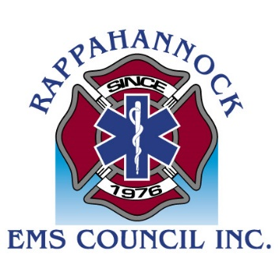
Rappahannock EMS Council
.

  - Rappahannock EMS (REMS) Regional Office

Submitted by: Wayne Perry, REMS Regional Director
Virginia Office of EMS

Kelsey Rideout, Performance Improvement Specialist
Virginia Office of EMS

Margot Moser, Office Manager
Rappahannock EMS Council

Linda Harris, Regional Education Coordinator
Rappahannock EMS Council

Vivian Delts, Regional Field Coordinator
Rappahannock EMS Council

Nana Noi, Regional Systems Coordinator
Rappahannock EMS Council

Participation in Regional Activities

REMS/OEMS staff participates in various regional meetings and activities in support of EMS agency operations as a regional system. Participation in jurisdictional and/or hospital and system meetings enables the regional office to stay informed about issues experienced by EMS agencies, in order to better align regional goals and objectives with the needs of the agencies. These meetings also provide an opportunity for REMS/OEMS staff to provide important informational updates to agency leadership and other healthcare providers. The REMS region, which includes Planning Districts 9 and 16, comprises an engaged community of both EMS providers and agency leaders. REMS/OEMS has ongoing meetings for the EMS Advisory Committee at Germanna Community College’s new EMS program and the Citizens Advisory Committee for the EMS Degree Program at the Rappahannock Community College

The following regional meetings/activities were supported by REMS/OEMS staff (Regional Training and Simulation Center use annotated with *) during this reporting period:

■ 04/04/2022 * PHI Air Medical Training Center Use
■ 04/05/2022 * Stafford County: Third Party Provider Evaluation
■ 04/07/2022 * Mary Washington Hospital Trauma Nurse Core Curriculum Class
■ 04/09/2022 * Bob Page BLS Arena Simulation Class
■ 04/13/2022 * NAEMT Pre-Hospital Trauma Life Support Class (two days)
■ 04/23/2022 * NAEMT Advanced Medical Life Support Class (two days)
■ 04/28/2022 MWHC: EMS Night Out
■ 05/02/2022 Rappahannock County Emergency Manager Meeting
■ 05/04/2022 * Stop the Bleed Community Class
■ 05/05/2022 * Orange County Fire and Rescue annual airway/RSI training
■ 05/23/2022 * PHI Air Medical Training Center Use
■ 05/25/2022 * REMS Open House Celebration/Stroke Smart Ceremony
■ 05/26/2022 * Bob Page 12-Lead Class
■ 06/03/2022 * LifeCare EMT Class - Practical Skills / Scenarios
■ 06/06/2022 * Enhanced Scope of Practice “Red Dot” Skills Training
■ 06/07/2022 * Enhanced Scope of Practice “Red Dot” Skills Training
■ 06/10/2022 * ICISF Group and Individual (GRIN) Class (three days)
■ 06/16/2022 King George Blood Product Training for Pilot Program
■ 06/23/2022 MWHC: EMS Night Out
■ 06/25/2022 * Enhanced Scope of Practice “Red Dot” Skills Training
■ 06/26/2022 * Enhanced Scope of Practice “Red Dot” Skills Training (two sessions)
■ 06/28/2022 *Mass Casualty Incident Management I/II Training
■ 06/28/2022 *Fredericksburg Fire Department Training (two days)

The REMS Council is integrated with the Northern Virginia Healthcare Coalition (NVHCC) as well as the Northwest Regional Healthcare Coalition (NWRHC) and attended several meetings during this reporting period. The REMS Council also attended several planning meetings with the Rappahannock Area Health District regarding the Community Health Improvement Plan (CHIP).

The REMS Council continues to provide updates and information from other meetings to ensure timely and accurate distribution of information to the end-user agency-level operations.

Regional EMS Council Meetings and EMS Operations

The REMS Council continues to hold bi-weekly staff meetings to promote prompt sharing of staff projects and needs.

In addition, in order to fulfill contract and regional EMS Plan responsibilities of the REMS Council, the following meetings were conducted in this reporting period:

■ 04/06/2022 Regional Grants Committee Meeting
■ 04/11/2022 Redesignation Site Visit
■ 04/11/2022 Regional CISM Team Meeting
■ 04/14/2022 Regional Pharmacy Committee Meeting
■ 04/20/2022 Regional Heart and Stroke Committee Meeting
■ 04/22/2022 Regional Incident and Threat Mitigation Committee Meeting
■ 04/26/2022 Regional Guidelines and Training Committee Meeting
■ 04/28/2022 Regional Protocol Subcommittee Meeting
■ 04/29/2022 Cultural Diversity Workgroup Meeting
■ 05/03/2022 Regional Medical Direction Committee Meeting
■ 05/12/2022 Regional Performance Improvement Committee Meeting
■ 05/18/2022 REMS Board of Directors Meeting
■ 05/31/2022 Regional Protocol Subcommittee Meeting
■ 06/03/2022 Cultural Diversity Workgroup Meeting
■ 06/16/2022 Regional Protocol Subcommittee Meeting

The REMS/OEMS staff remains available to respond to requests for PPE from area EMS providers and has small amounts of items from the SNS and OEMS PPE deliveries. The requests have dwindled down to a virtual stop, but supplies still remain available at the council office.

The REMS Council continues to participate in a discussion with the regional director’s group (RDG) after the March retreat to discuss the upcoming MOU and contract with OEMS. The REMS Council was a host, provided loaner training equipment, and intended host for patient care simulations. This annual event, PACES, is a regional critical care seminar through a partnership between PHI Air Medical and Mary Washington Healthcare’s Regional Level II Trauma Center.

The Regional Guidelines and Training Committee has initiated a cultural diversity workgroup, with a goal to identify and address gaps in cultural understanding and the interaction with the EMS system. They are working on a cultural diversity roundtable with several ethnic, religious and cultural leaders participating. The goal is to bring awareness and education to the local first responders. It will focus on what is permitted/not permitted and appropriate/not appropriate when dealing with certain populations on the topics of death, communication, patient interaction and treatment modalities. The roundtable is scheduled for September 24, 2022 at the Tompkins Martin Building at MWH in Fredericksburg, VA.

King George County was selected to pilot a program for prehospital whole blood administration. The pilot program was approved by the BOD in February 2021 and the council staff assisted with obtaining funding and all necessary equipment. Due to a national shortage of O negative blood, the protocol was rewritten with guidance from the Medical Direction Committee to allow O positive blood to be used for the pilot. Training for King George field providers occurred on June 16, 27, 28, 29, and 30, and the pilot was set to go live on July 1.

The REMS Council staff provides regular assistance to EMS providers in the region answering questions on recertification requirements and providing instructor resources, affiliation troubleshooting, information on EMS recertification, and educational offerings. Additional specific assistance was provided by scanning and submitting validated CEU for providers. The REMS/OEMS staff fielded requests for technical support from the City of Fredericksburg, Caroline County, and Orange County for assistance.

The REMS Council is tasked with reviewing and processing the release documentation for ALS providers seeking to practice in the region. Once the documentation packet is approved, the Regional Education Coordinator (REC) schedules an in-person meeting with the candidate to administer a written test, provide an ID badge, obtain EMS Physician validation, and finalize the documentation. The REC conducted the following ALS release meetings:

■ 04/14/2022 for Caroline County
■ 05/04/2022 for Caroline County

Critical Incident Stress Management

The Rappahannock EMS Council has an active state-accredited public safety peer support team (multidisciplinary 39-member team). It is available 24-hours per day, 365-days per year to provide on-going support of the region’s EMS operations through pre-incident education, on-scene support, defusing, one-on-one services, crisis management briefings, and referral services. For the fourth quarter of FY2022, the CISM team was activated 29 times to provide both individual and group interventions, station outreach, community service, support for funeral services, and education for regional providers.

The REMS Council was also proactive in providing mental health awareness, chronic fatigue management, and other educational offerings through social media. Awareness level training is offered to recruit schools and initial certification courses. Quarterly Team training/meetings have returned to in-person after being virtual during the pandemic.

The REMS Council hosted an ICISF Group and Individual (GRIN) - 3-day course on June 10-12, 2022, and will also host an ICISF Advanced Group - 2-day course on October 21-22, 2022.

Community Outreach and Patient Engagement

The mission of the Community Outreach Patient Engagement (COPE) program is to collaborate with community partners to support appropriate and accessible care focused on individual needs, improving health literacy through education, clarifying navigation of the healthcare system, and promoting innovative approaches to fill healthcare gaps. The REMS Council staff are executing this mission by increasing the participation among community partners. There are currently 66 community partners who participate in monthly meetings to discuss various health topics and gaps in the regional healthcare system. The meetings provide an environment for extremely informative, enlightening and engaging panel discussions based on the issues and needs identified in the community. In April 2022, COPE highlighted the issues of public health. Allison Balmes-John, Population Health Manager for the Rappahannock Area Health District, Eleni McNeil, Substance Abuse Coordinator for the Rappahannock Area Community Services Board, Aidan Quirke, Deputy Director of Fredericksburg Regional Public Transit, and Barb Barlow, Executive Director of Mental Health America / Fredericksburg composed the panel for the Q&A.

Mental Health and Stroke Awareness was the focus of the May 2022 monthly stakeholder session. The main speaker was Alan Stillman, CEO of Stroke Smart Virginia and Margaret Probst, Stroke Smart Coordinator and Data Analyst with Northern Virginia EMS Council presented during the stakeholder meeting.

The June 15 discussion focused on healthy aging. Panelists who participated included Bonita Hogue, LCSW with VCU Health and Virginia Geriatric Education Center, Sheryl Finucane, Graduate Program Director, VCU Department of Physical Therapy, Schericka Twyner, Executive Director of the Caroline County YMCA, and Kathy Miller, Director of Aging Programs and Services with Virginia Department of Aging and Rehabilitative Services.

REMS Council staff resumed COPE events at The Table in Market Square on Tuesday, March 29. This event operates from noon to 2:00 pm every Tuesday with COPE participating twice per month March through December. The Table features a farmer's market offering free fresh produce for all who come. COPE engages with and encourages community partners to attend and participate with patient engagement. One community partner that regularly attends is the Lloyd Moss Clinic, who offers free blood pressure and glucose checks, field Medicare and Medicaid questions, and are available for general health and wellness advice. A physician is also available onsite; Moss Clinic provided 118 health checks. For a 12-month period, ending November 2021 there were 532 health and social wellness checks provided by the more than 60 different community partners. Moss Clinic also provided 25 COVID-19 vaccines and 23 Flu shots to community members. RACSB also provided Narcan training.

Community members that visit our COPE table are provided with emergency preparedness information, child and health literacy information, and also have the opportunity to learn how to use AccessMeCare™. This free healthcare access tool serves as a virtual social worker and one-stop-shop for locally relevant healthcare providers, social service organizations, and educational programs. This joint partnership between the REMS Council and Heudia launched several years ago with a goal of helping vulnerable individuals find the most convenient and appropriate points of care. Visit https://rappahannock.accessmecare.com to learn more.

Other participating community partners include Stafford County Fire and Rescue, Capital Caring Health, Encompass Health, Healthy Generations, Mental Health America - Fredericksburg, Virginia Department of Health RAHD, the Central Rappahannock Regional Library, and Loisann’s Hope House.

During this reporting cycle the Regional Systems Coordinator (RSC), who leads the COPE program, continued to align the program’s structure with identified statewide initiatives from the Governor’s office as well as elements from the VDH Strategic Plan to promote public health initiatives in Virginia.

Regional EMS Council Operations

The REMS Council was selected as a scientific sample of business across the United States and submits monthly payroll and performance data to the US Department of Labor Bureau of Labor Statistics. This reporting continues.

The REMS Council staff participated in various training and professional development events for streamlining operations, such as Anatomage Table training, ESO training, HTML training, and LinkedIn Learning. The Regional Council Staff continues to collaborate with the other regional councils and hybrid OEMS offices through regular meetings. Staff also attended the Wave 2022 Data Conference sponsored by ESO in Austin, Texas. Two staff members became NAEMT AMLS instructors in order to support the new NAEMT training center at the REMS Council Regional Training and Simulation Center.

The REMS Council continues to work on a project for validating the regional medication boxes that are provided by the hospitals.

REMS Council Board of Director meetings occur quarterly. During this reporting period the BOD met on May 18 at the Warrenton Fire Company in Fauquier County. The BOD was provided with updated reports of opioid use data, PI data such as run dispositions and advanced procedures performed in the field, ASPR TRACIE updates and reports, as well as the latest National Report on Violence against EMS Practitioners. Some additional topics on the agenda for discussion included a brief summary of the legislative actions that had occurred during the latest Virginia General Assembly sessions.

Four action items were on the agenda as well: the BOD approved the Regional Heart and Stroke Committee and Regional Guidelines and Training Committee Charters, updates to the Regional Patient Care Protocols, updates to the ALS Release Handbook, and the IRS 990 filing.

There were also several operational topics which were presented including:
■ The increase in synthetic cannabinoids
■ VDH Agency Forum Slides from weekly meetings
■ Upcoming changes to the NREMT Cognitive Exam
■ CMS Guidance for Healthcare Staff COVID-19 Vaccination
■ Stroke Awareness Training program for middle school children
■ Regional EMS Council Designation Application / Site Visit
■ Off-duty EMS provider response and participation in patient care
■ Prehospital Pain Management Evidence-Based Guidelines
■ Release of the new National EMS Education Standards (NEMSES)
■ CISM Training Plan for ICISF classes
■ Close-out of Hunter Street property arrangement

The REMS Council is continuing the transition to a cloud environment and had been utilizing Google-suite for digital file management. The regional director’s group IT has provided NextCloud as an option for a transition from a physical server on the ground to the cloud environment. The office also continues to use the GoToMeeting platform for virtual meetings.

The REMS Council attends weekly meetings of the VDH Agency Forum.

The REMS Council has moved into their new site and recovered from the COOP that was initiated in April of 2020. The REMS Council staff is covering the office throughout the week, but we continue to suggest appointments for in-person meetings and events as not all of the staff are working in the office each day of the week.

The Regional EMS Council has successfully earned the designation of American Heart Association Training Site and National Association of EMT’s Training Site, under the auspices of the Central Shenandoah EMS Council Training Center. This designation will allow the council to offer the below classes on a quarterly basis to our regional EMS providers for free and any costs associated with the classes will be covered by locality funding; out-of-region providers will also be welcome to attend the classes, but for a fee.

■ AHA Basic Life Support (BLS)
■ AHA Advanced Cardiac Life Support (ACLS)
■ AHA Pediatric Advanced Life Support (PALS)
■ NAEMT Pre-Hospital Trauma Life Support (PHTLS)
■ NAEMT Advanced Medical Life Support (AMLS)
■ NAEMT EMS Safety
■ NAEMT Geriatric Education for EMS (GEMS)
■ NAEMT All Hazards Disaster Response (AHDR)
■ NAEMT Psychological Trauma in the EMS Patient (PTEP)

REMS/OEMS Hybrid Office Restructuring Update

The REMS Regional EMS Director position was filled at the end of May 2020. The REMS Council submitted two different employee work profiles for additional positions through the regional office of EMS. They have been approved and are titled “Performance Improvement Specialist” and “Technical Resource Specialist”. The Performance Improvement Position was hired and on boarded on January 25, 2022. The two Technical Resource Specialist positions are pending additional information in order to advertise and fill these positions. The remaining staff at the council remain council employees and continue to be supervised by the Regional EMS Office Director.

Fiscal and general operations continue with the Regional EMS Office Director administering the budget, processing bills and invoices, and performing payroll and HR duties for the REMS Council staff. Updates and meetings are held with the BOD President and Treasurer as needed.

The REMS Council formally moved to their new location November 29, 2021 and the previous location was turned back over to MWH in February 2022. Staff has sent out change of address notifications to localities, suppliers, agencies, vendors, local governments and hospitals. An open house commemorating the new site occurred on May 25th.

The OEMS staff from the Blue Ridge, Central Shenandoah, Southwest, and Rappahannock Regional Offices participate in a monthly exchange where staff visit other offices to understand procedures and identify best practices.

State, National, and International Activity

REMS/OEMS staff participated in the following statewide events:

■ 04/07/2022 OEMS Medical Direction Meeting
■ 05/05/2022 OEMS Medevac Committee Meeting
■ 05/05/2022 OEMS Workforce Development Committee Meeting
■ 05/06/2022 OEMS Trauma Administrative and Governance Committee Meeting
■ 05/06/2022 OEMS Provider Health and Safety Committee Meeting
■ 05/06/2022 State Advisory Board Meeting
■ 06/09/2022 OEMS Medical Direction and Rules and Regulation Meeting
■ 06/23/2022 State Board of Health Meeting
■ 06/30/2022 OEMS ESO Training

REMS Leadership joined regular division director meetings with OEMS staff to provide updates on progress and share information between the regional office and central office operations. REMS Leadership also shared bi-weekly updates on programs and services in meetings with the regional director’s group; conversations were had on various topics related to regional EMS operations occurring in the other ten council regions. As a regional Office of EMS entity, the REMS Leadership also connected with the Regional EMS Directors from the other two regional offices in weekly meetings to identify strategic planning needs, establish operational goals, and review best practices. Two of the hybrid regional EMS office directors met with the OEMS Attorney General representative for a Q&A on operations.

Participation by REMS/OEMS Staff also occurred in the following National and International Meetings:

■ 04/19/2022 NREMT Instructor Webinar
■ 05/11/2022 National EMS Advisory Council (NEMSAC) Meeting
■ 05/12/2022 National EMS Advisory Council (NEMSAC) Meeting
■ 05/10/2022 Heartsafe Community Webinar
■ 06/14/2022 Heartsafe Community Webinar
■ 06/17/2022 Diversity and Equity in the workplace webinar

Southwest Virginia EMS Council

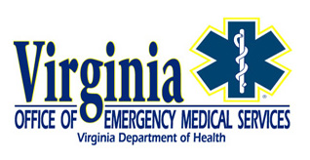
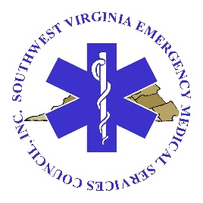
  - Southwest Virginia Regional EMS Office

- Participation in Local, Regional, State EMS Activities

SWEMS staff members attend and participate in local and regional activities related to the delivery of emergency medical services in the southwest region as well as related state meetings. Meetings primarily relate to EMS agency operations, emergency planning and preparedness, and education; however, council staff participate in a wide range of meetings that might not directly fall into one of these categories. The following list outlines meetings supported by Council staff:

- Local
  - Johnston Memorial Hospital EMS Appreciation Picnic—May 14
  - Twin County Regional Healthcare EMS Celebration—May 17
  - Ballad Health Pharmacy Meeting—June 7
  - Smyth County Active Threat Workshop—June 15
  - Norton Rescue Squad EMS Funding Meeting—July 21
  - Dedication of Green Cove Station, Washington County—July 21

- Regional
  - CISM Team Planning Meetings—May 13 and May 17
  - CISM Team Meeting—May 24
  - VDEM bi-annual stakeholder meeting—June 14
  - VDH Western Region Meeting—July 12
  - Aircraft Utilization Webinar—July 12
  - Southwest Virginia Paramedic Program Advisory Committee—June 22

- State and Other Meetings
  - OMD Workshop (Marion)—May 3
  - State EMS Advisory Board—May 6
  - First Responder Resiliency (Project Echo) Webinar—May 16
  - MDC/Rules and Regulations Joint Meeting—June 9
  - Regional EMS Directors Group (RDG) Work Meetings—May 4 and June 2
  - Hybrid Regional EMS Office Director Meetings—May 6, June 2, June 8
  - ESO Regional Meeting—June 30
  - Coverdell Stroke Grant Wrap Up—June 30
  - First Responder Resiliency (Project Echo) Webinar—July 11
  - Bi-weekly web meetings of the regional EMS council directors group
  - Weekly information sharing meetings with the Virginia Office of EMS hybrid regional EMS office directors

- Council Meetings (to fulfill regional contract responsibilities) *
  - Executive Committee—June 13
  - Board of Directors—June 16
  - Stroke Triage Committee—June 16
  - Emergency Planning & Preparedness Committee—June 22
  - Medical Direction Committee—June 22
  - Trauma/PI Committee—June 27

* Meeting minutes are maintained on the Council’s website for these meetings.

- Regional EMS Council Operations

State Regional EMS Office Transition

The Southwest Virginia EMS Council signed a memorandum of understanding with the Virginia Department of Health Office of Emergency Medical Services in March 2022 to provide services as a regional office of emergency medical services (ROEMS). The council is working with OEMS on the hybrid regional EMS office transition. OEMS is in the process of creating the regional director job description to move forward with recruitment and hiring. At present, a position number has been assigned; however, recruitment has not begun for this position. Upon completion of this hiring process, additional hybrid regional EMS office positions will be identified and moved through the hiring process. The Executive Director participates in weekly information sharing meetings with the other hybrid regional EMS office directors and other OEMS division meetings as requested. A strategic planning committee has been formed to guide the nonprofit during the transition process and has met multiple times. A regional work plan for the upcoming year was completed and submitted to OEMS in June 2022. The Executive Director continues managing all operational, fiscal, and human resources functions for the nonprofit.

Professional Development

The Council supports ongoing professional development. Staff members are encouraged to participate in related educational programs both in person and virtually. Staff members attended various virtual webinars including: NAEMT (whole blood) Virginia Healthcare Emergency Management Program (hurricane preparedness for healthcare workers), CDC (Monkeypox), Ballad Health (air medical utilization), and Project ECHO (First Responder Resilience). In addition, staff members attended ESO training in-person and remotely. Two staff members are currently completing graduate coursework.

Regional Planning

The Code of Virginia (32.1-111.3) mandates regional EMS council involvement in EMS system planning activities. SWEMS facilitates regional EMS planning activities and promotes collaborative approaches to support EMS system planning and preparedness efforts. Plan review and development is accomplished through representative committees who review plans annually. The Board of Directors reviews regional plans annually and takes action on proposed changes. Planning activities this quarter included:

Medication Kit/Supplies Restocking Plan

Ambulance Diversion Plan

Plan updates are posted to the Council’s website and mobile app. In addition, staff participated in regional planning and preparedness meetings. The Executive Director attended the regional VA Dept. of Emergency Management (VDEM) stakeholders meeting on June 14 and the VDH Western Region Meeting on July 12. In addition, the Executive Director participated in an Active Threat planning workshop in Smyth County on June 15, with additional work on this project continuing.

Vacancies

A field coordinator position was vacated during the reporting period. The Council presented a hiring plan to OEMS for this position. In light of the regional EMS Council’s transition to the hybrid model, several alternatives are being explored.

- Education & Projects

Community Training Center

SWEMS operates a community training center to support emergency cardiovascular care within southwest Virginia and adjoining areas. The center supports approximately 200 instructors. During the fourth quarter, the center conducted nearly 200 courses and issued nearly 1,000 completion cards. In addition to supporting members of the EMS community, our training center supports two hospitals, three colleges, numerous law enforcement agencies, and numerous primary care clinics and dental offices. SWEMS has applied for and received approval as an Advanced Stroke Life Support training center. This will facilitate the provision of ASLS training for EMS agencies and healthcare facilities throughout our region. SWEMS also serves as an NAEMT straining site and offers courses in Prehospital Trauma Life Support (PHTLS), Community Paramedic (CP), Emergency Pediatric Care (EPC), and Tactical Causality Combat Care (TCCC) throughout the year in various areas of our service region. In addition, SWEMS maintains a regional lending library of CPR videos and equipment for use by educators and agencies throughout the region.

EMS Certification Training

SWEMS operates an accredited training program for EMT and EMT-Advanced. An EMT Course and an Advanced EMT course finished in May 2022. An EMT course is scheduled to begin in August and will be completed by the end of 2022. An AEMT course is set to begin in January 2023. SWEMS is exploring the possibility of establishing an alternative site to support EMS educational needs in the Carroll/Grayson area. The Executive Director also serves on the Southwest Virginia Paramedic Program Advisory Committee to support other certification training initiatives in the region. An instructor network meeting was held at the SWEMS office on June 28 to provide a forum for information exchange and to identify and address issues/needs of other educators in the region.

Medication Restocking and Exchange Program

The regional Medical Direction Committee (MDC) recommended changes to regional protocols that necessitate changes to the regional medication kit exchange program. Staff met with hospital representatives to discuss proposed changes on May 3. A follow-up meeting was held on June 7. Current regional medication restocking and exchange policies were reviewed by the Board of Directors at their June 2022 meeting with no major changes.

Ambulance Diversion Plan

The regional ambulance diversion plan provides guidance to EMS providers and agencies for patient transport decision-making resulting from hospital diversion declarations. The plan was reviewed during the fourth quarter. Minor updates to the plan were approved by the Board of Directors at their June 2022 meeting. It was noted during the review period that the Virginia Healthcare Alerting & Status System (VHASS) hospital “Diversion Status” tab is being evaluated for possible changes to definitions. If such changes are implemented, additional updates to the regional plan will be evaluated in future quarters.

Protocols

The regional Medical Direction Committee (MDC) approved the addition of new protocols. These were forwarded to the Board of Directors for acknowledgement at their June 2022 meeting. Protocol documents and the mobile app have been updated to reflect these changes. The Council posts protocol changes on the organizational website in PDF format; however, changes are also reflected on the Council’s mobile app.

CDC Coverdell Stroke Grant

SWEMS completed first year deliverables under the CDC Paul Coverdell National Acute Stroke Program. This multi-year grant program focuses on improving stroke care in Virginia. Funding was allocated to develop promotional materials for use statewide. In addition, funding was provided to expand prehospital stroke education in the region.

CISM

SWEMS provides administrative support the Southwest Virginia CISM Team. Team leadership met on May 13 and May 17 to review operational guidelines. Recommendations were presented to the team for review and approval at their May 24 meeting. The SWEMS Board of Directors approved these policies at their June 2022 meeting. The CISM team has also established a workgroup to oversee CISM team accreditation.

Regional EMS Awards

SWEMS coordinates a regional EMS awards program to recognize the outstanding contributions of individual and/or agencies to the local, regional, and state EMS system. Applications are screened, and nominations were submitted for consideration in the Governor’s EMS Awards program in eight categories.

Appendix A

Virginia Office of Emergency Medical Services
Motion by MDC and
Scope of Practice - Procedures and Formulary for EMS Personnel

(Attached as two separate documents to this August 5, 2022 OEMS Quarterly Report to the State EMS Advisory Board)

Respectfully Submitted

By

OEMS Staff

