Safe Disposal Sites for Unused Medication

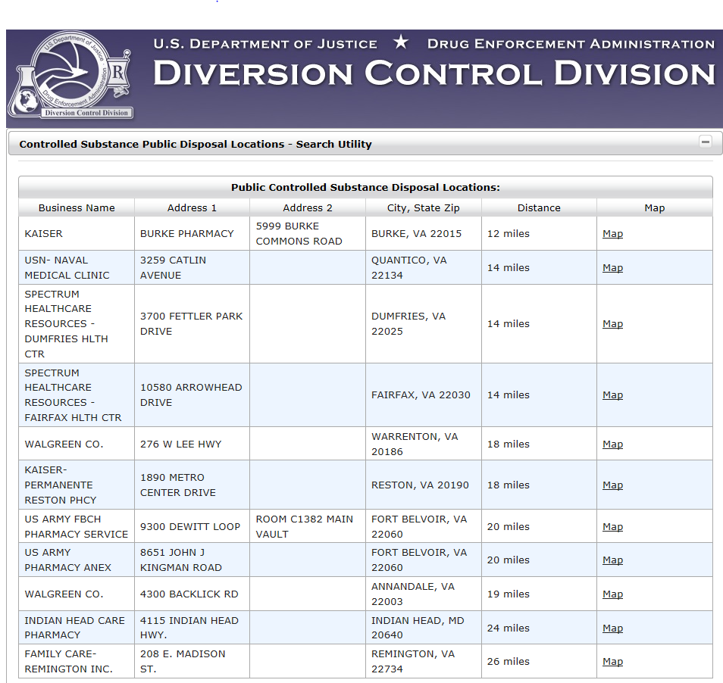

Safe Disposal of Medications Helps Prevent Drug Abuse and Overdose Deaths

