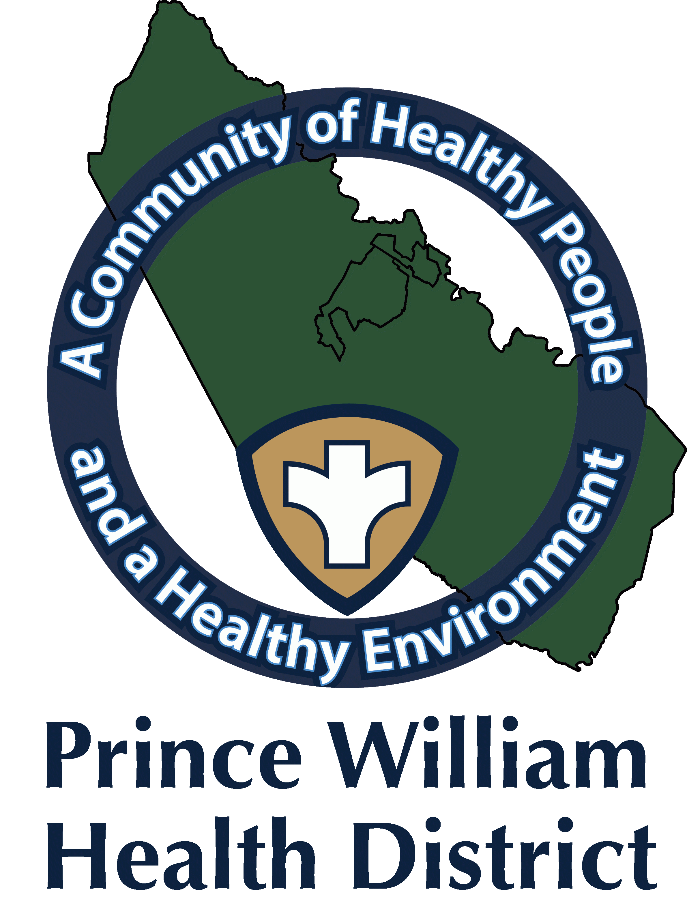

Information Update

Community Outreach Director
Sean Johnson
Sean.Johnson@vdh.virginia.gov
September 22, 2021

Prince William Health District Warns of Rabies Concerns
Woodbridge, VA.

In order to protect the health of residents and visitors, the Prince William Health District (PWHD) is issuing a notice about a fox that has been found with rabies in the 22192 area of Woodbridge.

Rabies is a deadly disease caused by a virus that attacks the nervous system. Rabies can be prevented in cats, dogs, ferrets and some livestock with a rabies vaccination. Rabies kills almost any mammal or human that gets sick from it. The rabies virus is mainly in the saliva and brain tissue of rabid animals. It can be transmitted through a bite or by getting saliva or brain tissue in a wound or in the eye or mouth.

A fox found on September 19, 2021 near the intersection of Bethel Church Drive and Smoketown Road has tested positive for Rabies. Over the course of several days, multiple reports of fox bites and encounters have occurred within the Minnieville Road and Smoketown Road area. While a rabid fox tested through Virginia Department of Health cannot be confirmed to be associated with the various events, caution should be taken with wildlife in the area. PWHD asks anyone who may have come in contact with wildlife acting strangely in or around this area, call the health district at 703-792-5363, or the Prince William Animal Control Division at 703-792-6500.

Steps to prevent the spread of Rabies:

To protect pets and their owners from rabies, Virginia law requires that all dogs and cats four months of age and older be vaccinated for rabies by a licensed veterinarian, and that vaccinations be kept current.

The Prince William Health District is reminding the public to avoid contact with bats, feral cats, stray dogs and wild animals, particularly in the area where the sick fox was found. See additional precautions below.

Additional Steps to Protect Against Rabies Exposure:

- Do not feed stray animals. Avoid wild animals, especially raccoons, bats, foxes and skunks. Feed your pets indoors and do not let them wander.
- Make sure your pets are vaccinated against rabies and their shots are up-to-date. By law, all dogs, cats and ferrets must be vaccinated against rabies.
- Teach children to avoid contact with wild animals and pets they are not familiar with.
- Do not handle sick, injured or dead animals.
- Keep wild animals out of homes by capping chimneys with screens and blocking openings in attics, cellars and porches. Ensure trash cans have tight fitting lids.
- If you observe any stray animals in the area, please contact the Prince William County Animal Control Division for assistance at 703-792-6500. Please do not try to trap or handle stray and wild animals.
- If a bat is found indoors and may have had contact with someone, do not release it. Please call the Prince William County Animal Control Division at 703-792-6500, to determine if the animal should be picked up and tested for rabies.
- If you are bitten by a wild or stray animal, do not panic. Wash the wound(s) thoroughly with warm soapy water and contact animal control, your doctor, or the Prince William Health District for further recommendations.

For additional information, visit www.vdh.virginia.gov/Epidemiology/DEE/Rabies/ or call the Prince William Health District at 703-792-5363 or the Animal Control Division at 703-792-6500. You can also follow the Health District on Twitter @PrinceWilliamHD or on Facebook at www.facebook.com/PrinceWilliamHD.

