Is Your Child in the RIGHT Seat?
Know for Sure!

Free Child Safety Seat Check Event

When: [date and time]

Where: [location]

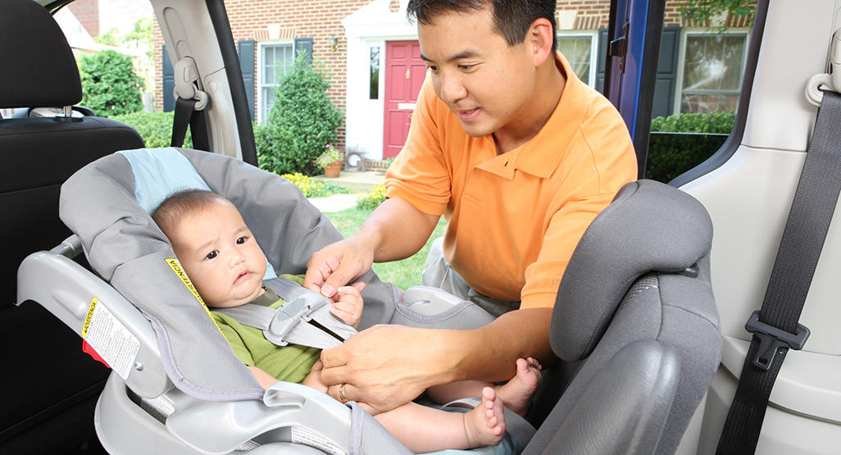
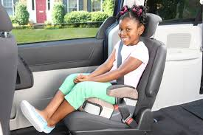
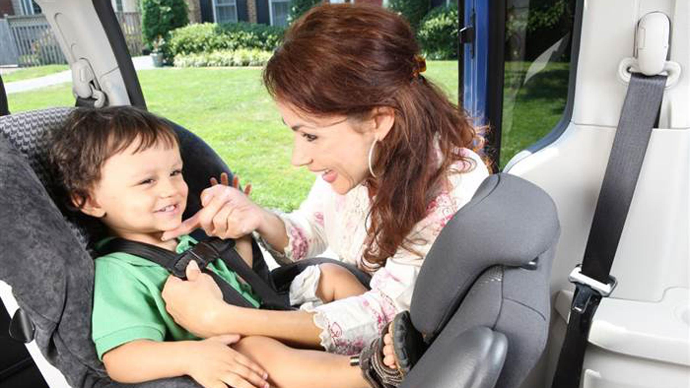

For more information or to schedule your appointment:
[co-host contact information]

Sponsored by [co-host name] and [SSCS Site name],
a Virginia Department of Health Safety Seat Check Station

[co-host logo] [SSCS logo]

