Child Passenger Safety
Facebook | Twitter
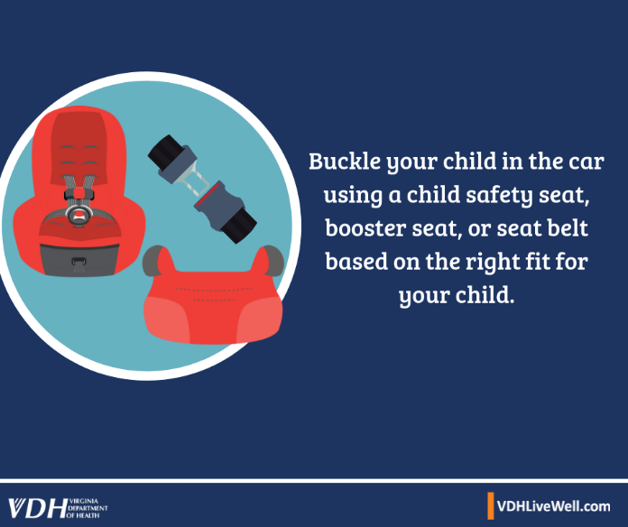  Buckle your child in the car using a child safety seat, booster seat, or seat belt based on the right fir for your child.  Make sure your child is in a car safety seat every time. https://bit.ly/2lrzR06 | 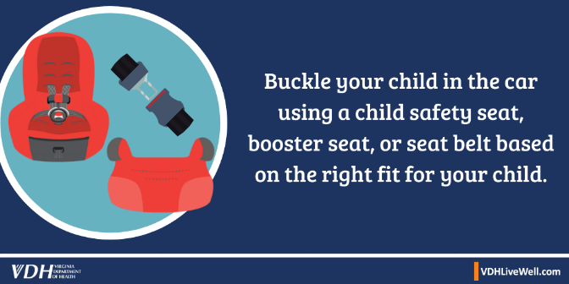  Buckle your child in the car using a child safety seat, booster seat, or seat belt based on the right fir for your child.  Make sure your child is in a car safety seat every time.  https://bit.ly/2lrzR06
Children under the age of eight who have outgrown their safety seats are usually too small for seat belts. Even older children should continue to ride in a booster seat until they are able to fit a vehicle seat belt correctly. https://bit.ly/2oO8m0F | Older children should ride in a booster until they fit correctly in a seat belt. https://bit.ly/2oO8m0F
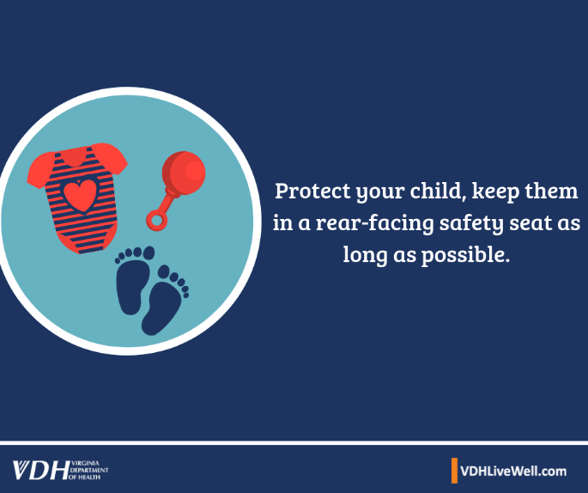  Protect your child, keep them in a rear-facing safety seat as long as possible. Rear-facing child safety seats provide the most protection. Keep your child safe by staying rear-facing as long as possible. #TheRightSeat https://bit.ly/2OQRmBN | 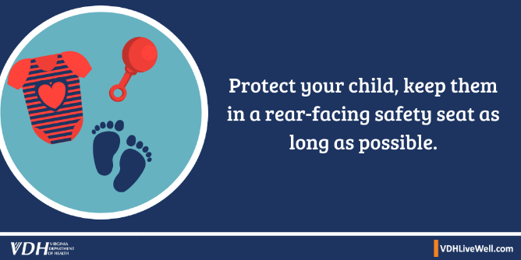  Protect your child, keep them in a rear-facing safety seat as long as possible. Rear-facing child safety seats provide the most protection. Keep your child safe by staying rear-facing as long as possible. #TheRightSeat https://bit.ly/2OQRmBN
Parents should always buckle up for their safety and to be a good role model for their children. Do you always buckle up? #TheRightSeat | Parents should always #buckleup and show their kids the importance of riding safely! #TheRightSeat
Children under 13 should always be in the back seat, buckled up, every time. #TheRightSeat | All children under 13 belong in the back seat, buckled up, every time. #TheRightSeat
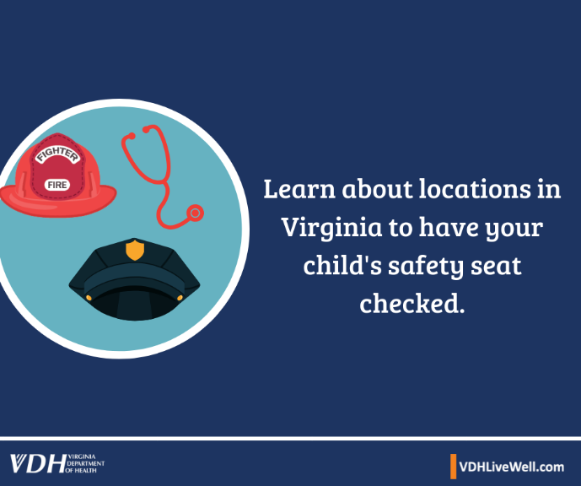  Learn about locations in Virginia to have your child’s safety seat checked. Did you know that nearly 8 out of 10 car seats are installed incorrectly? Get help at a child passenger safety seat check station in your area for all of your child’s safety seat needs: https://bit.ly/2ovEbIL #TheRightSeat | 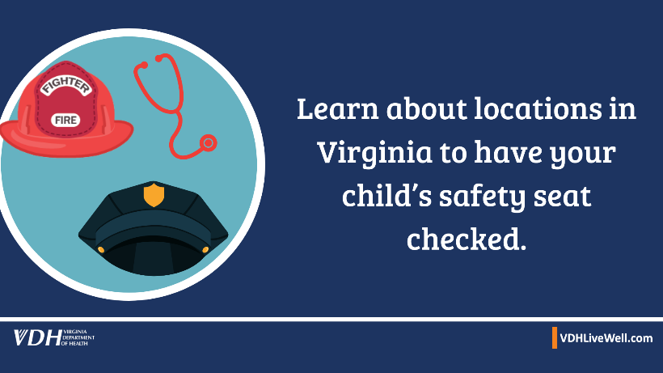  Learn about locations in Virginia to have your child’s safety seat checked. 8 out of 10 car seats are installed incorrectly. Go to a child passenger safety seat check station in your area and get help with all your safety seat needs: https://bit.ly/2ovEbIL #Virginia  #TheRightSeat
Not all 8 year olds fit the seat belt and should remain in a booster seat. https://bit.ly/2lrzR06 | In #Virginia, all children age 7 years & younger must be properly secured in a child safety seat or booster seat regardless of the child’s weight or height. However, not all 8 year olds fit seat belts & should remain in a booster seat. https://bit.ly/2lrzR06
Make sure to get your child’s safety seat checked: https://bit.ly/2ovEbIL #TheRightSeat | Make sure you get your child’s safety seat checked: https://bit.ly/2ovEbIL #TheRightSeat #Virginia

Children and Toy Safety
Facebook | Twitter
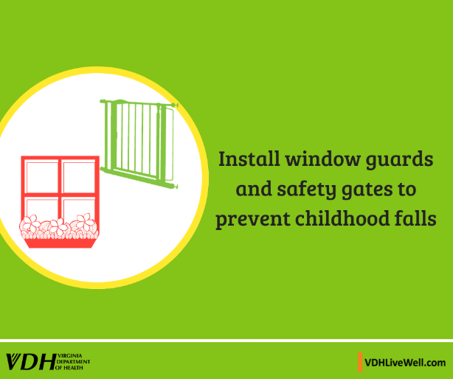  Install window guards and safety gates to prevent childhood falls. Keep young kids safe in your home and help prevent head injuries. https://www.safekids.org/fall-prevention | 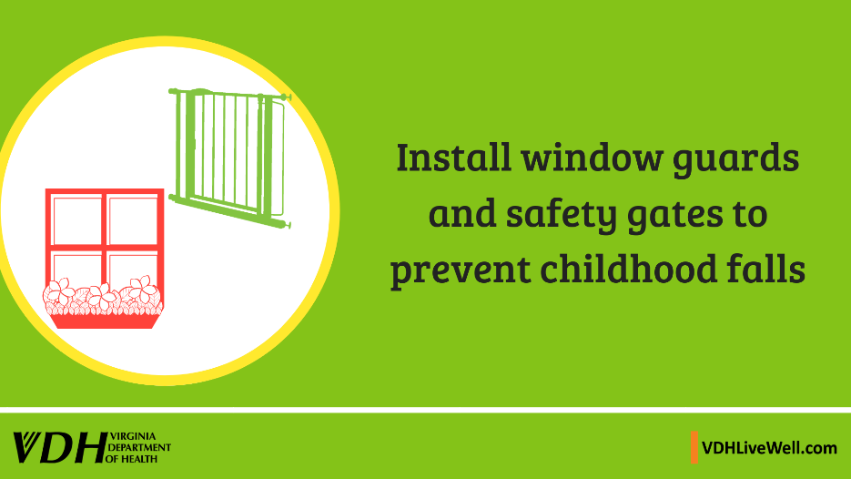  Install window guards and safety gates to prevent childhood falls. Keep young kids safe in your home and help prevent head injuries. https://www.safekids.org/fall-prevention
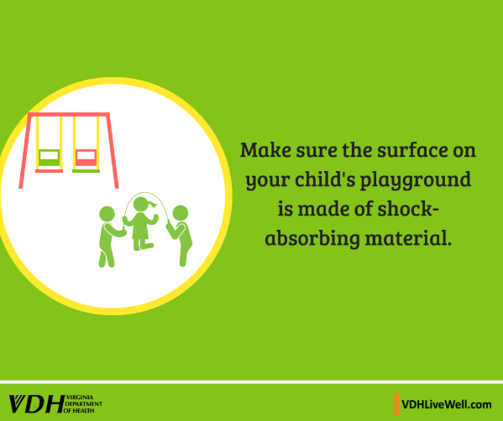  Make sure the surface on your child’s playground is made of shock-absorbing material. Learn about safe surfaces under and around playground equipment https://bit.ly/1hSKBGP | 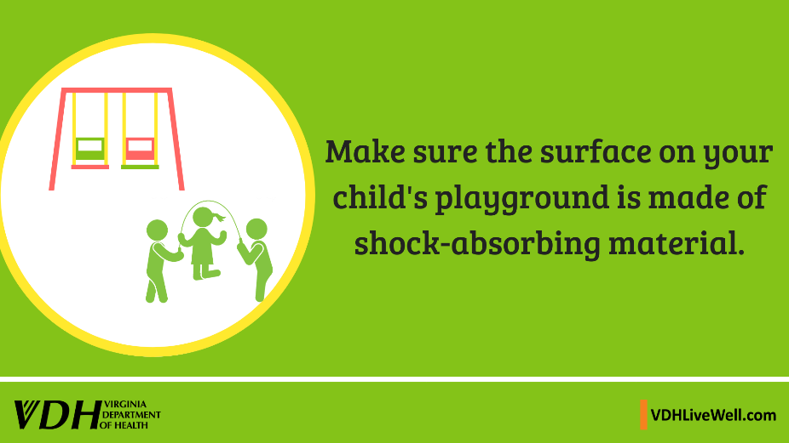  Make sure the surface on your child’s playground is made of shock-absorbing material. Learn about safe surfaces under and around playground equipment. https://bit.ly/1hSKBGP
Prevent accidental injuries at home by removing clutter and monitoring for slip areas. https://www.safekids.org/fall-prevention | Remove clutter and monitor for slip areas in the home to help prevent accidental injuries. https://www.safekids.org/fall-prevention
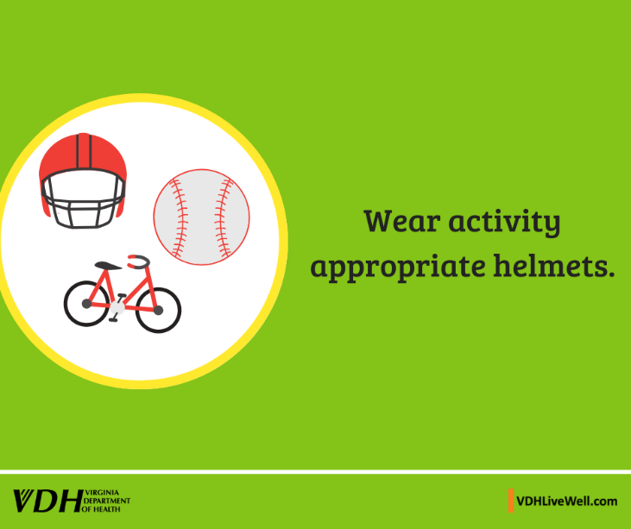  Wear activity appropriate helmets. Learn about the right helmet for the right activity.  https://bit.ly/2OjMIwn | 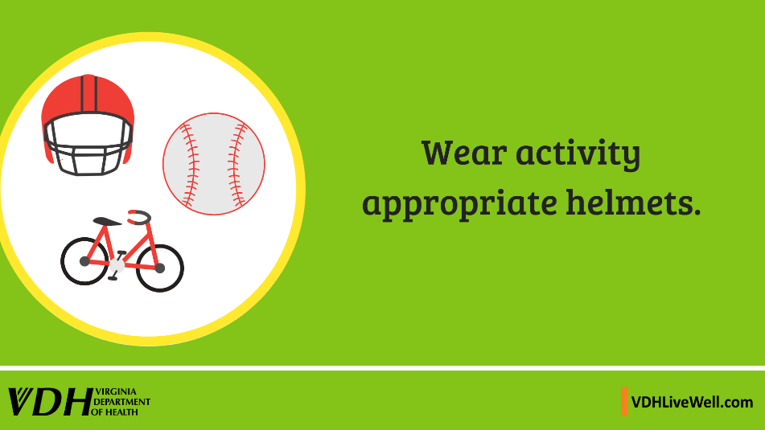  Wear activity appropriate helmets. Learn about the right helmet for the right activity.  https://bit.ly/2OjMIwn
Learn about safe playground equipment. Check to make sure playground equipment is safe for your child’s age. Visit https://bit.ly/2FlVF4M | Learn about safe playground equipment. Check to make sure playground equipment is safe for your child’s age. Visit https://bit.ly/2FlVF4M
Never leave a child unsupervised near a pool/spa, standing body of water, pond, bathtub, toilet, or water-filled bucket. Visit  https://bit.ly/2t9vlUm | Never leave a child unsupervised near a pool/spa, standing body of water, pond, bathtub, toilet, or water-filled bucket. #WaterSafety #CDC  Visit https://bit.ly/2t9vlUm
If you see a child alone in a car, call 911. Emergency personnel are trained to respond to these situations. For more information, visit https://bit.ly/2ais7oi | #Reminder: If you see a child alone in a car, call 911. For more information, visit https://bit.ly/2ais7oi
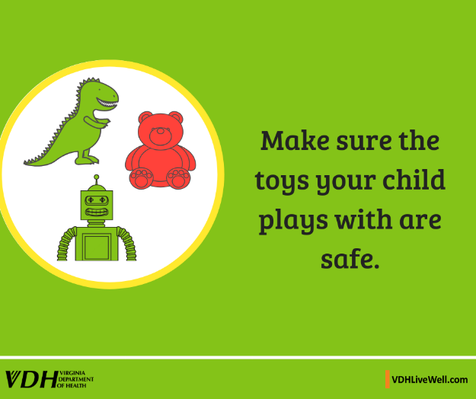  Make sure the toys your child plays with are safe. To learn more visit https://bit.ly/2BXLPFU | 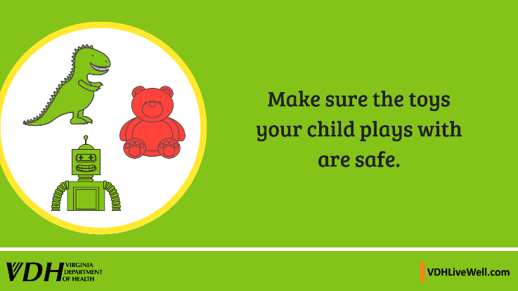  Make sure the toys your child plays with are safe. To learn more visit https://bit.ly/2BXLPFU
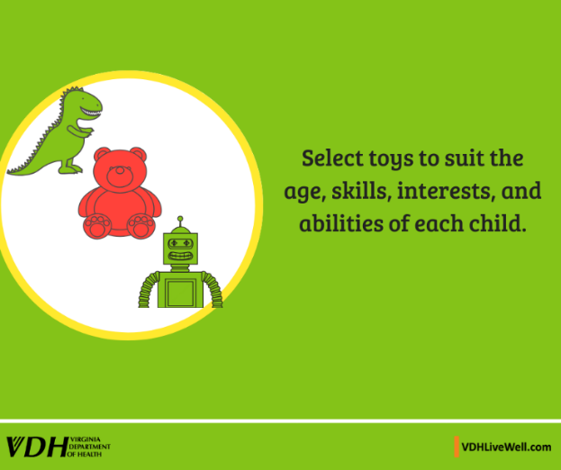  Select toys to suit the age, skills, interests, and abilities of each child. Toys intended for Children under 8 years cannot have sharp points or edges. To learn more visit https://bit.ly/2BXLPFU | 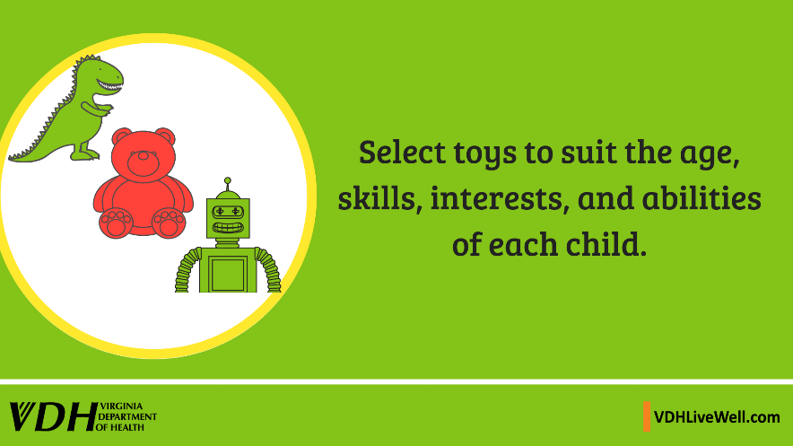  Select toys to suit the age, skills, interests, and abilities of each child. Toys intended for children under age 3 cannot have small parts that could cause a choking hazard. #SafetyAlerts  Visit https://bit.ly/2BXLPFU
For a list of toy detentions and recalls in the U.S. call 301-504-7908. Recall website www.cpsc.gov/Recalls | For a list of toy detentions and recalls in the U.S. call 301-504-7908. #KidSafety  Recall website www.cpsc.gov/Recalls

Poison Prevention
Facebook | Twitter
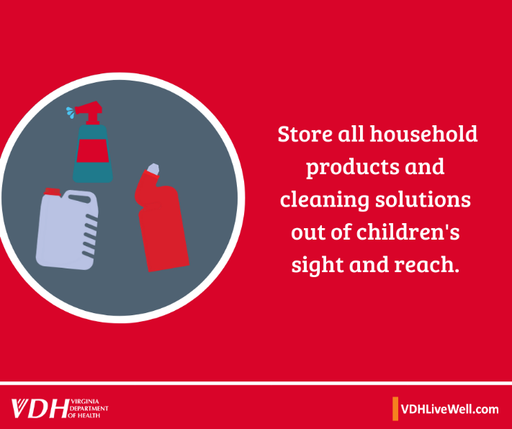  Store all household products and cleaning solutions out of children’s sight and reach. Store These items include cleaning products, liquid packets for the laundry and dishwasher, make-up, soaps, etc. To Learn more call 1-800- 222-1222 or visit www.poison.org/ | 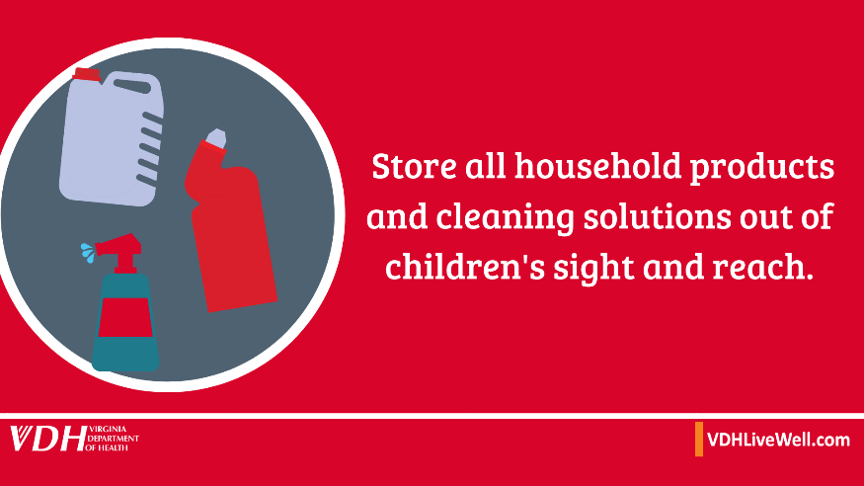  Store all household products and cleaning solutions out of children’s sight and reach. Keep household items from children. It only takes a few minutes, and it gives you one less thing to worry about. To learn more call 1-800- 222-1222 or visit www.poison.org/
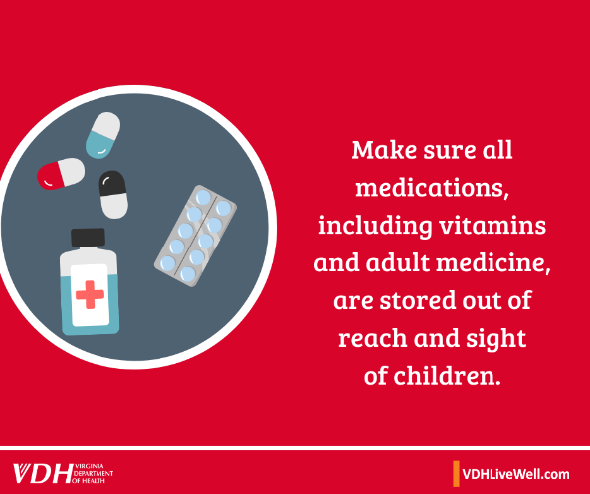  Make sure all medications, including vitamins and adult medicine, are stored out of reach and sight of children. Kids can mistake medicine for candy. Help keep them safe by locking your medicine. Call 1-800-222-1222 to learn more or visit: www.poison.org/ | 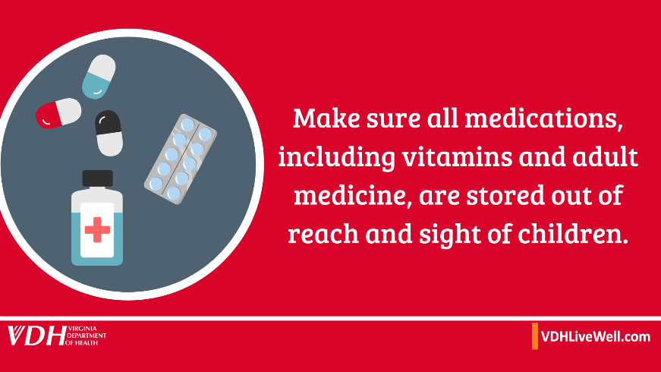  Make sure all medications, including vitamins and adult medicine, are stored out of reach and sight of children. Kids can mistake medicine for candy. Call 1-800-222-1222 to learn more or visit: www.poison.org/
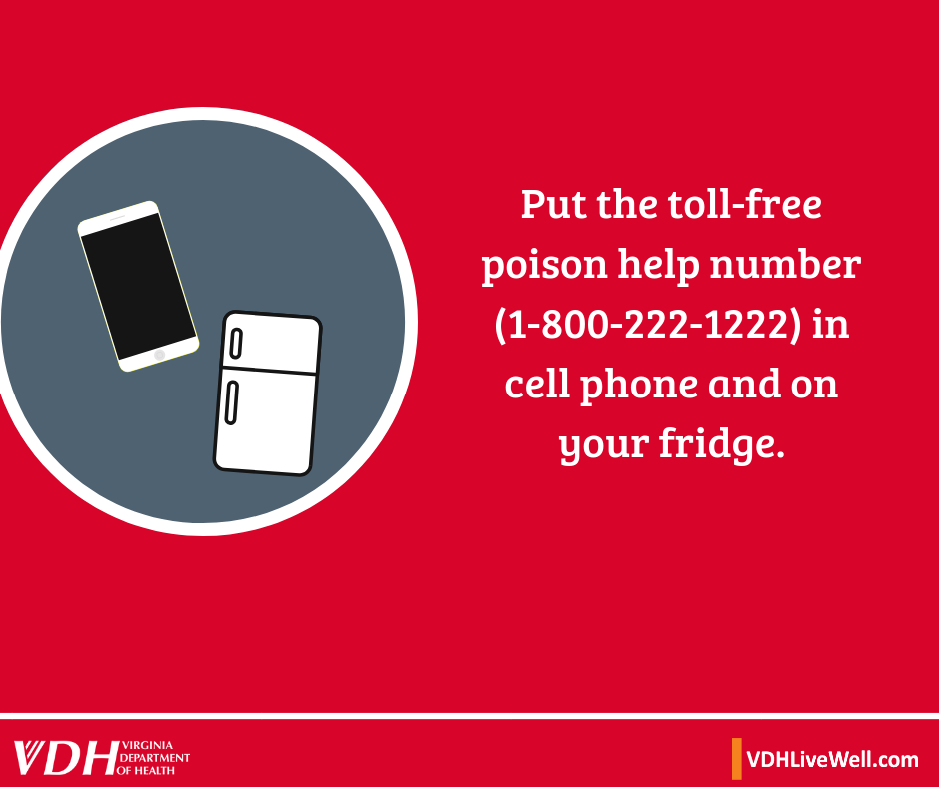  Put the toll-free poison help number 1800-222-1222 in cell phone and on your fridge. Keep the Poison Control number in a place that is easy to access for babysitters or others who may need to call. www.poison.org/ | 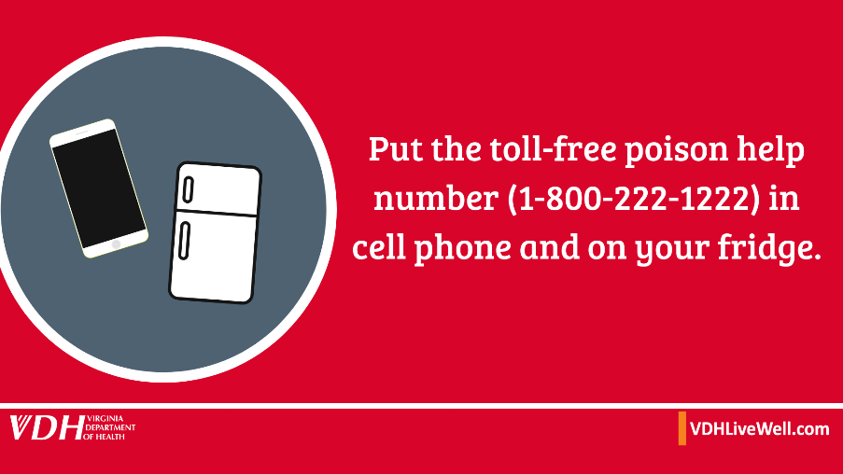  Put the toll-free poison help number 1800-222-1222 in cell phone and on your fridge. Keep the Poison Control number in a place that is easy to access! www.poison.org/
Read product labels to find out what can be hazardous to kids. Dangerous household items include makeup, personal care products, plants, pesticides, lead, art supplies, alcohol and carbon monoxide. www.poison.org/ | Read product labels to find out what can be hazardous to kids. Dangerous household items include makeup, personal care products, plants, pesticides, lead, art supplies, alcohol and carbon monoxide. www.poison.org/

Human Trafficking
Facebook | Twitter
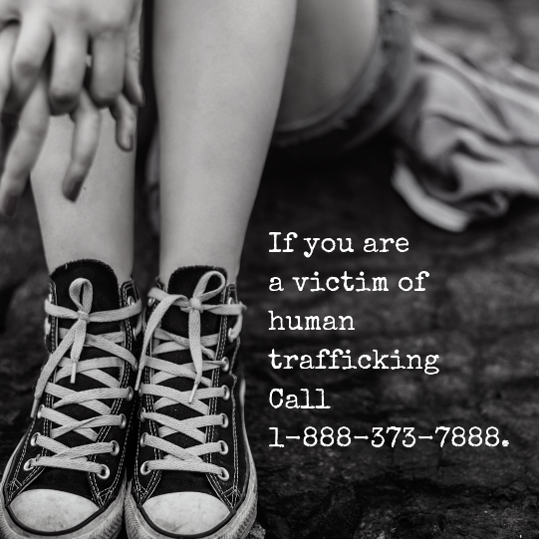  If you are a victim of human trafficking call 1-888-373-7888. If you or someone you know is a victim of human trafficking Call now. | 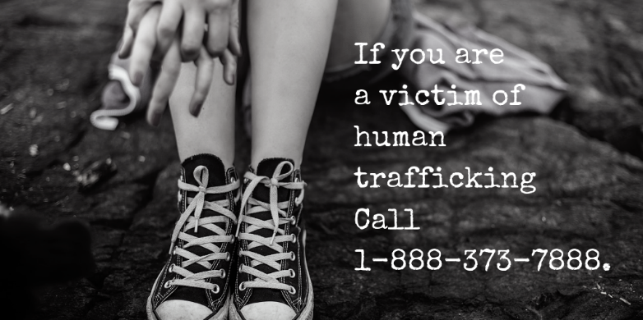  If you are a victim of human trafficking call 1-888-373-7888.  If you or someone you know is a victim of human trafficking Call now. 1-888-373-7888.
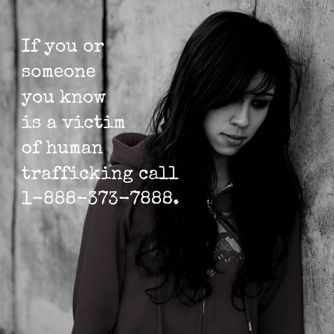  If you know someone is a victim of human trafficking, call 1-888-373-7888. | 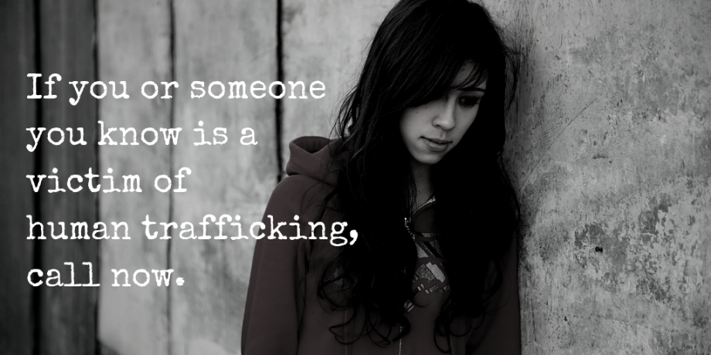  If you know someone is a victim of human trafficking, call  1-888-373-7888. #DidYouKnow? #HumanTrafficking
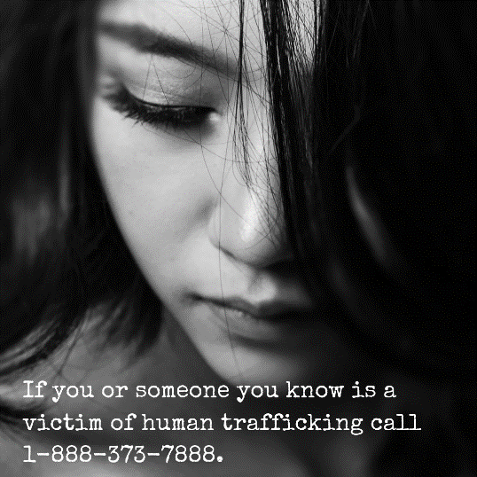  If you or someone you know is a victim of human trafficking call 1-888-373-7888. If you believe you are a victim of human trafficking or may have information about a potential trafficking situation, please contact the National Human Trafficking Hotline 1-888-373-7888. | 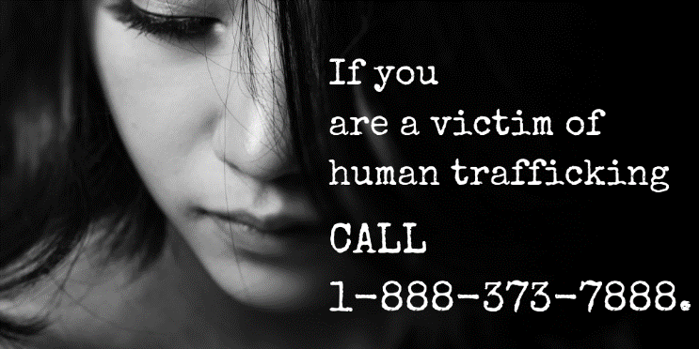  If you are a victim of human trafficking CALL 1-888-373-7888. If you or someone you know is a victim of human trafficking, call now. #humantrafficking
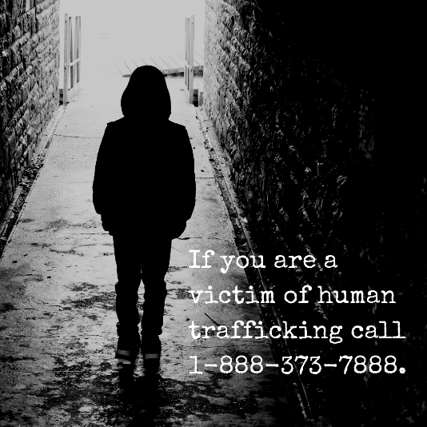  If you are a victim of human trafficking CALL 1-888-373-7888. If you or someone you know is a victim of human trafficking, call now. | 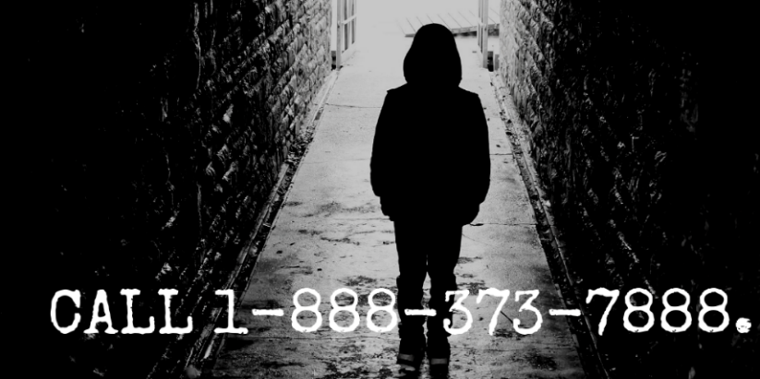  CALL 1-888-373-7888. If you or someone you know is a victim of human trafficking, call now. #humantrafficking.
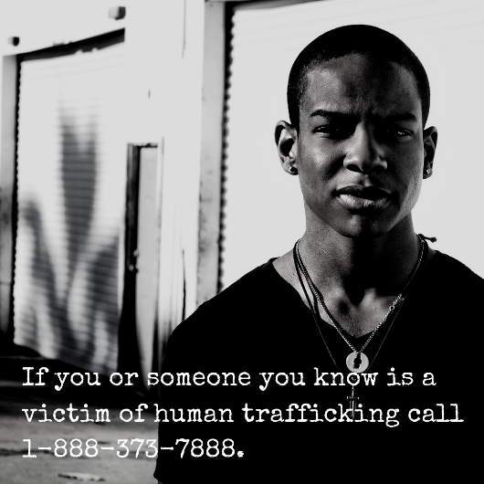  If you or someone you know is a victim of human trafficking call 1-888-373-7888. Take the step today. https://bit.ly/2Sxfj2U | 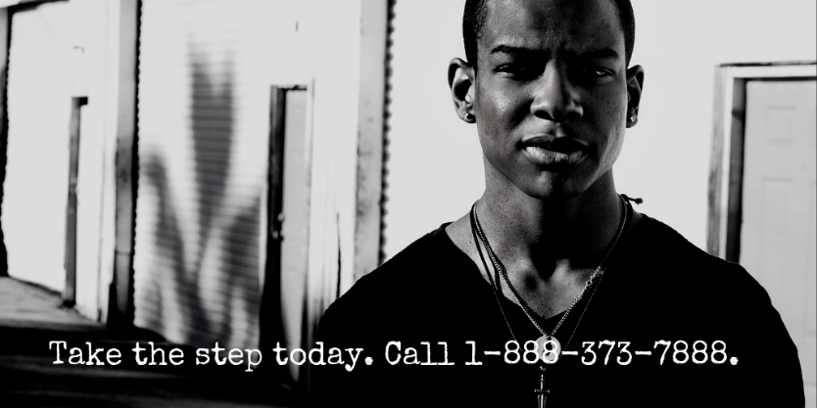  Take the step today. Call 1-888-373-7888. If you or someone you know is a victim of human trafficking, call now. https://bit.ly/2Sxfj2U

Suicide Prevention
Facebook | Twitter
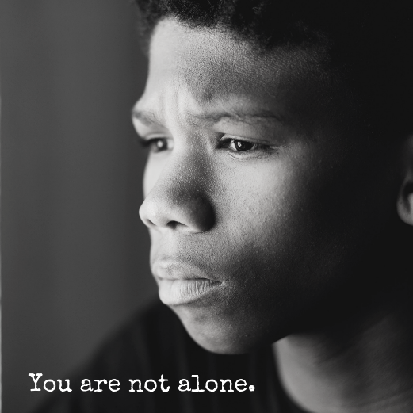  If you or someone you know is in emotional distress or suicidal crisis, call 1-800-273-TALK (8255). https://bit.ly/2qXLAGQ | 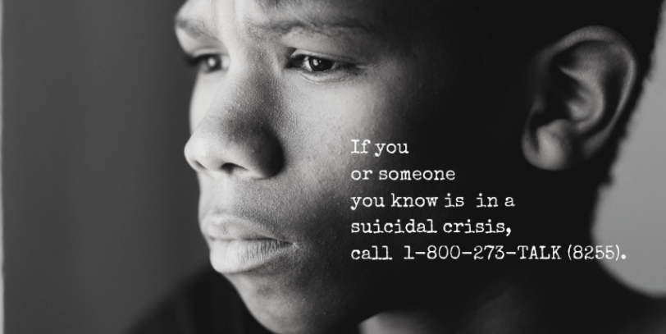  If you or someone you know is in emotional distress or suicidal crisis, call 1-800-273-TALK (8255). https://bit.ly/2qXLAGQ #YouAreNotAlone
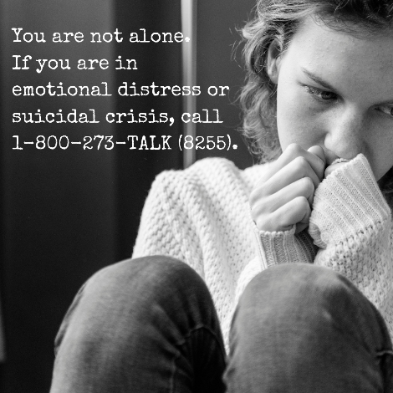  Risk factors are long standing conditions, stressful events, or situations that may increase the likelihood of a suicide attempt or death. https://bit.ly/2tM6Q2Y | 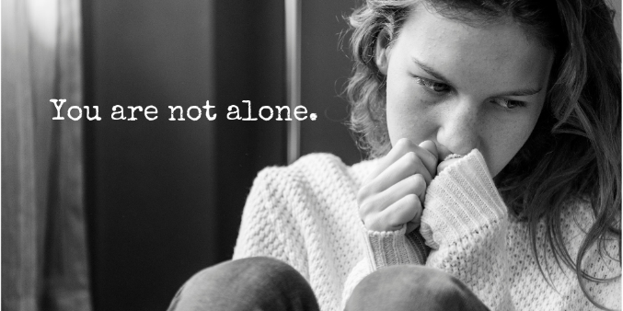  If you or someone you know is in emotional distress or suicidal crisis, call 1-800-273-TALK (8255). #YouAreNotAlone https://bit.ly/2tM6Q2Y
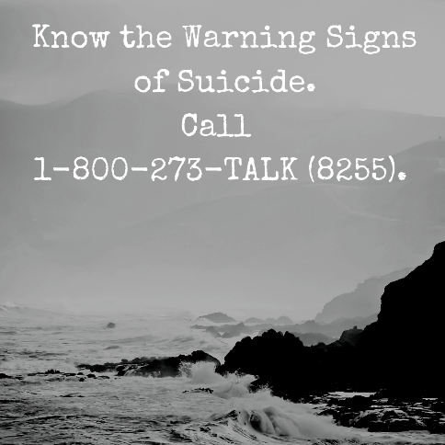  Suicide can be prevented. While some suicides occur without any outward warning, most people who are suicidal give warnings.  https://bit.ly/2tM6Q2Y | 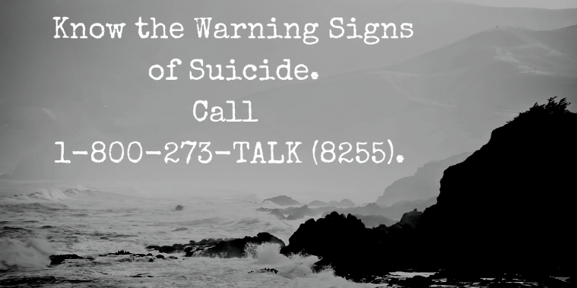  While some suicides occur without any outward warning, most people who are suicidal give warnings. https://bit.ly/2tM6Q2Y #YouAreNotAlone
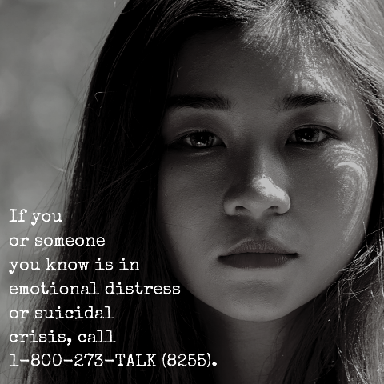  Any person exhibiting these behaviors should get care immediately. If you or someone you know is in emotional distress or suicidal crisis, call 1-800-273-TALK (8255). https://bit.ly/2QHbGdn | 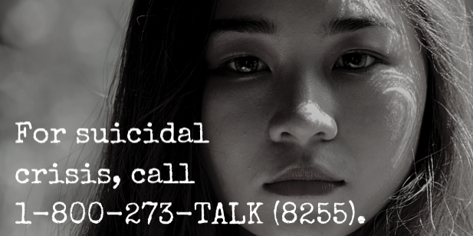  If you or someone you know is in emotional distress or suicidal crisis, call 1-800-273-TALK (8255). https://bit.ly/2QHbGdn

