Youth Violence Prevention Week | April 8th-12th
Social Media Toolkit
Facebook | Twitter | Instagram
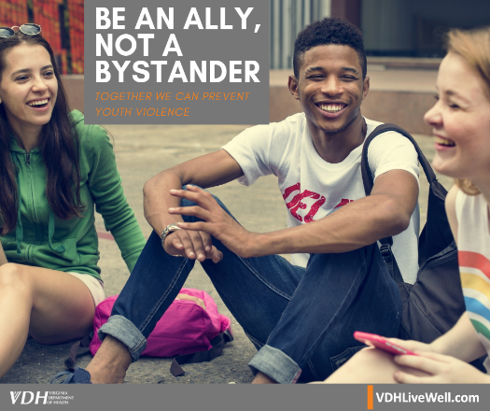  Be an ally, not a bystander. If you see someone being bullied, DO SOMETHING!  Learn how you can help prevent youth violence: VDHLiveWell.com/YVBP | 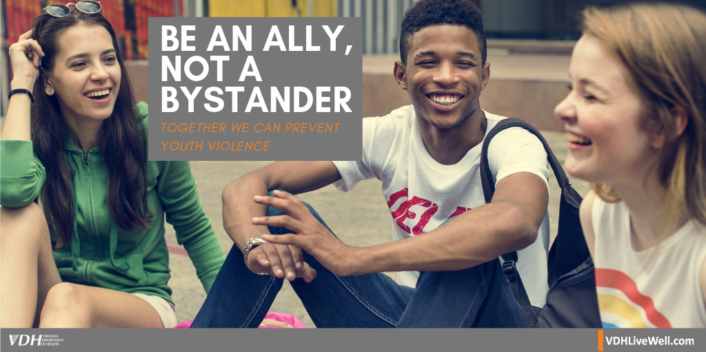  Be an ally, not a bystander. If you witness bullying, DO SOMETHING! VDHLiveWell.com/YVBP #NYVPM #StopBullying #BeAnUpstander #SpeakUp | Be an ally, not a bystander. If you witness bullying, DO SOMETHING!  #NYVPM #StopBullying #BeAnUpstander #SpeakUp
Learn the warning signs for violent behavior and reach out when you see them: VDHLivewell.com/YVBP | 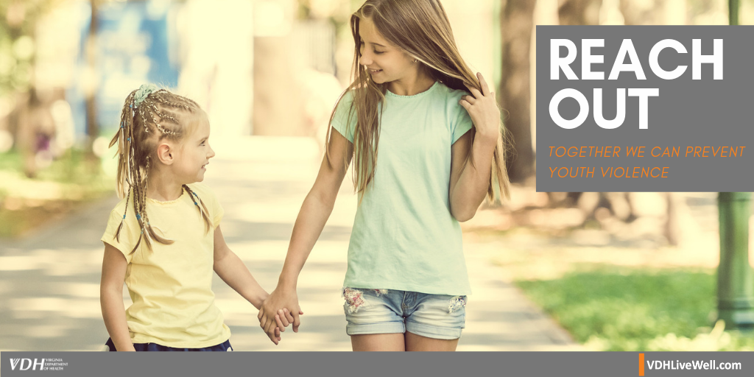  Learn the warning signs for violent behavior and reach out when you see them: VDHLivewell.com/YVBP #NYVPM #ReachOut #ViolencePrevention #SpeakUp #BeAnUpstander | Learn the warning signs for violent behavior and reach out when you see them.  #NYVPM #ReachOut #ViolencePrevention #SpeakUp #BeAnUpstander
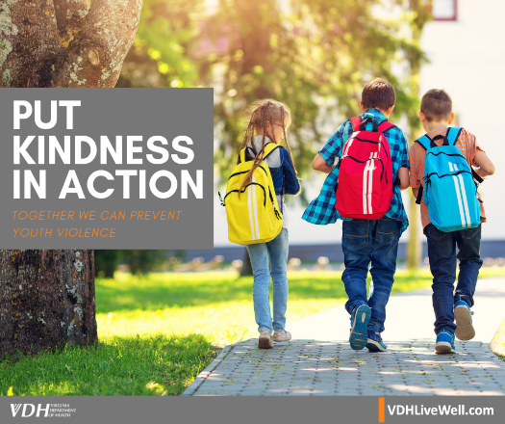  Put kindness in action. Leave an anonymous note, say hello to the new kid, reach out! Small actions can have a big impact.  Learn more about how to prevent youth violence: VDHLivewell.com/YVBP | 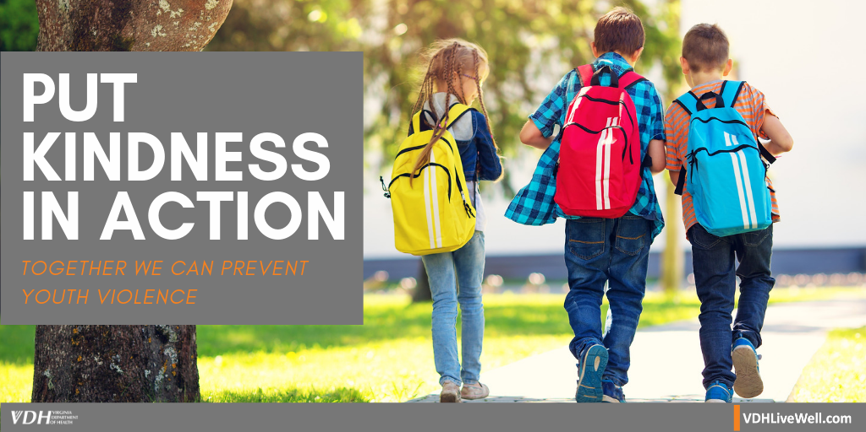  Put #KindnessInAction. Small actions can have a big impact! Learn more: VDHLivewell.com/YVBP #NYVPM #ReachOut #BeAnUpstander #SmallSteps | 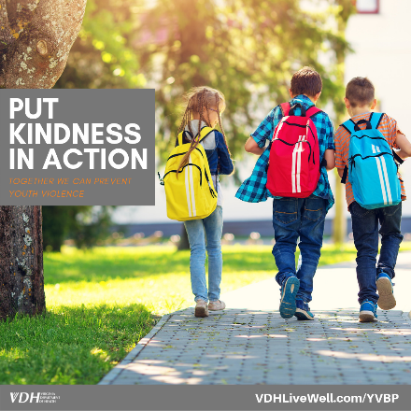  Put kindness in action. Leave an anonymous note, say hello to the new kid, reach out! Small actions can have a big impact.  #NYVPM #ReachOut #BeAnUpstander #SmallSteps
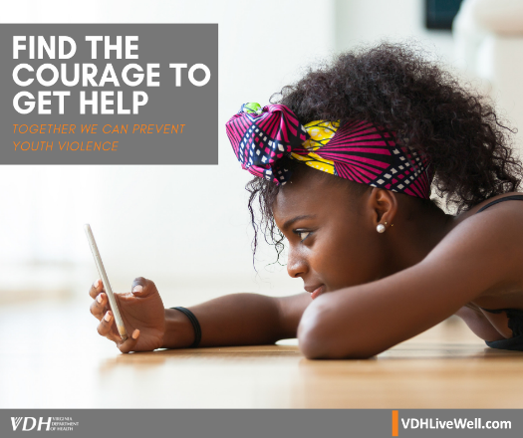  It takes more courage to walk away than to fight.  Learn how you can prevent youth violence: VDHLiveWell.com/YVBP | 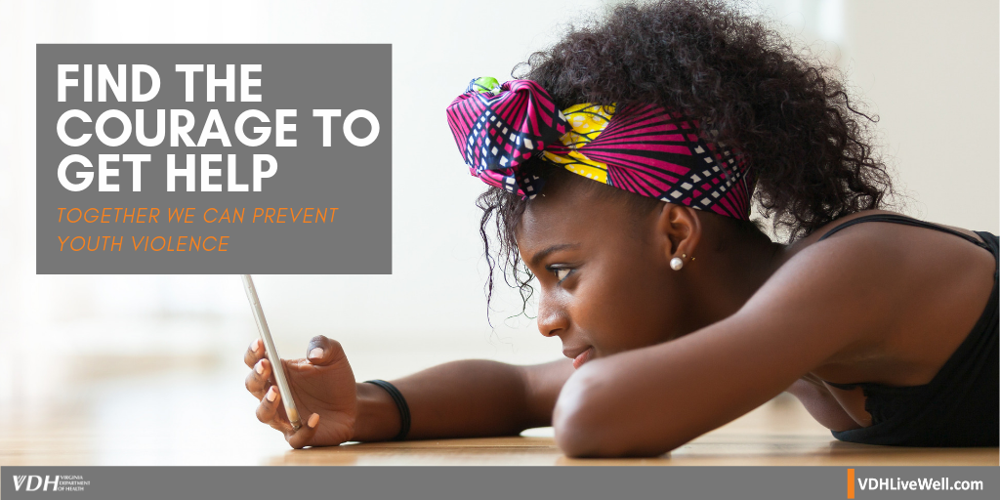  It takes more #courage to walk away than to fight. VDHLiveWell.com/YVBP #NYVPM #WalkAway #SpeakUp #ViolencePrevention | It takes more #courage to walk away than to fight.  #NYVPM #WalkAway #SpeakUp #ViolencePrevention
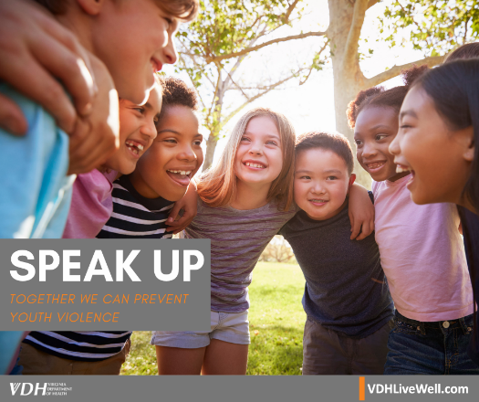  Be an upstander! Speak up if you see someone in trouble.  Learn how you can prevent youth violence: VDHLiveWell.com/YVBP | 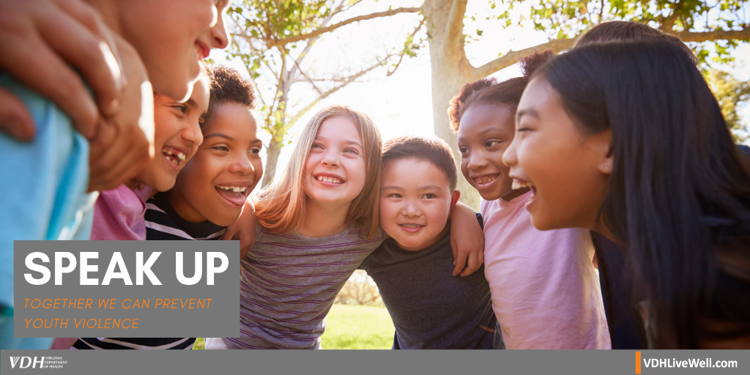  Be an #Upstander! #SpeakUp if you see someone in trouble. VDHLiveWell.com/YVBP #NYVPM #StopBullying | 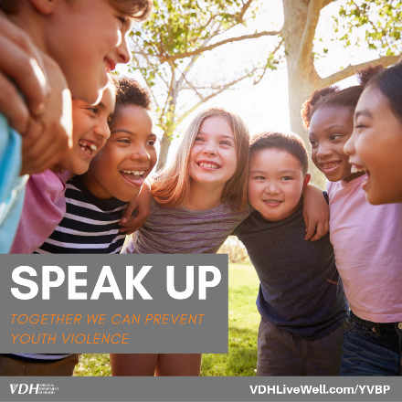  Be an #Upstander! #SpeakUp if you see someone in trouble.  #NYVPM #StopBullying

