Staff Sign-In & Badge Guide – <Indicate Health District here> Health District
NOTE: This guide can be modified/edited to suit the district’s needs. What follows are instructions should a district vest and badge are issued for the specific testing event. A district should choose to have testing team personnel to wear an item that would differentiate them from the public, e.g., a district vest, shirt or hat. Another decision point is whether to use employees’/MRC badges or develop something that can be inserted in a vest.
All personnel operating at a site MUST first sign-in upon arrival to the site and sign-out once their assignment is complete or if they depart the site. In addition, all testing staff are required to wear a testing event site vest and must display a testing event badge vest Insert (Exceptions to the vest requirement may include uniformed law enforcement personnel). Even if staff has a valid work or agency identification card, they still need to be issued a Testing Site Specific Badge. Badges and vests will be collected by the Sign-In Officer at the completion of POD assignment.

- The District COVID Site Planner will designate a worker to serve as the “Staff Sign-In Officer”.
- Provide the Sign-In Officer with a list of staff names expected to arrive at the site (from Testing Site Action Plan).

The Sign-In Officer will oversee the Sign-In/badge process and is responsible for the sign-in sheets, badges & vests.

Sign-In Officer Action Steps:

- Assemble/prepare:
Staff Sign-in Sheets Pens Yellow Vests (indicate where located) Badges (Role Specific & Basic) Rear Vest Role Title Inserts.
- The Sign-In Officer will don a yellow vest with a “Staff Sign-In Officer” insert displayed on the back panel. A “Sign-In Officer” front panel badge should be signed by the District COVID Site Planner and inserted in the front of the vest display panel.
- Obtain list (if available) from the District COVID Site Planner of staff names expected to arrive & their roles if known.
- Ensure that all staff currently at site has signed-in on the Sign-In Roster (including the Sign-In Officer). The # column (far left) should be filled out chronologically and these numbers will be entered on each staff badge in the “Sign-In #” block (the badge sign-in # should correspond with the staff sign-in number from the roster). Avoid having separate sign-in log sheets available for staff as this will interfere with the ability to maintain chronological order.
- Ensure that all staff currently at site has been issued a signed badge (see attached section on “Badges”)
- Ensure that staff currently at site are issued/wearing a yellow vest with front badge displayed.
- Ensure that all staff with leadership or supervisory role has an appropriate rear vest insert.
- Establish a single check-in station (site/table) that is clearly visible to arriving testing event staff.
- Clearly identify the check-in area with signage – all signage should be in English, Spanish and a third language is most common in district. All signage should be created prior to the event and brought with other testing supplies.
- Ensure that signage is placed at entrance doors that advise arriving staff they must sign-in.
- Signage should also be placed at the exits to remind staff to “Sign-Out” - all signage should be in English, Spanish and a third language is most common in district.
- The Sign-In Officer will confer with the District COVID Clinical Site Leader or District COVID Site Planner and advise them of the “Staff Sign-In” area location and that the Sign-In station is operational with signage. The Sign-In Officer will also determine any special instructions or procedures for the check-in process.
- The Sign-In Officer will check/verify identifications (i.e., driver’s license, work or MRC IDs) and any credentials of arriving staff as needed (based on the testing role of the incoming staff).
- If significant back-ups occur or assistance is needed at Sign-In table, request additional staff.
- Log the departure time of staff on the roster and collect all badges and vests.

Badges(2 types):
- Role Badges – with pre-printed role & distinguishing colors for easier identification of site leadership or supervisory personnel.
- Basic Badges (for non-supervisory/general staff) role and assigned station can be filled-out. No colors.

Role Badge Example:
Name of school, building, etc.
Sign-In Officer Signature
Clearly Printed Name
Enter the number from the sign-in sheet
Sign-In #
Site Name/Location
Approved By (signature):
NAME:_____________________________
ACCESS LEVEL: FULL
CLERICAL
SUPERVISOR
There are (12) pre-made role specific badges (and rear vest inserts):
Site Leader | Safety | Administrative Officer | Triage
Sign-In Officer | Site Training Coordinator | Clerical Supervisor | Greeter
Security | Logistics | Clinical Supervisor | Screener

Basic Badge Example:
Enter the number from the sign-in sheet
VDH Staff will have “Full” access unless otherwise indicated.

Other staff (i.e MRC) should be “Assigned Station/Area. If so, fill in the station/area.
(Registration, vaccination, exit, etc.)
Clearly Print Name
Indicate the assigned role or duties
Name of school, building, etc.
Sign-In Officer Signature
NAME:_____________________________
ROLE:______________________________________
ACCESS LEVEL: FULL ASSIGNED STATION/AREA
ASSIGNED STATION__________________________
Sign-In #
Site Name/Location
Approved By (signature):

Badge inserted into front vest display window:
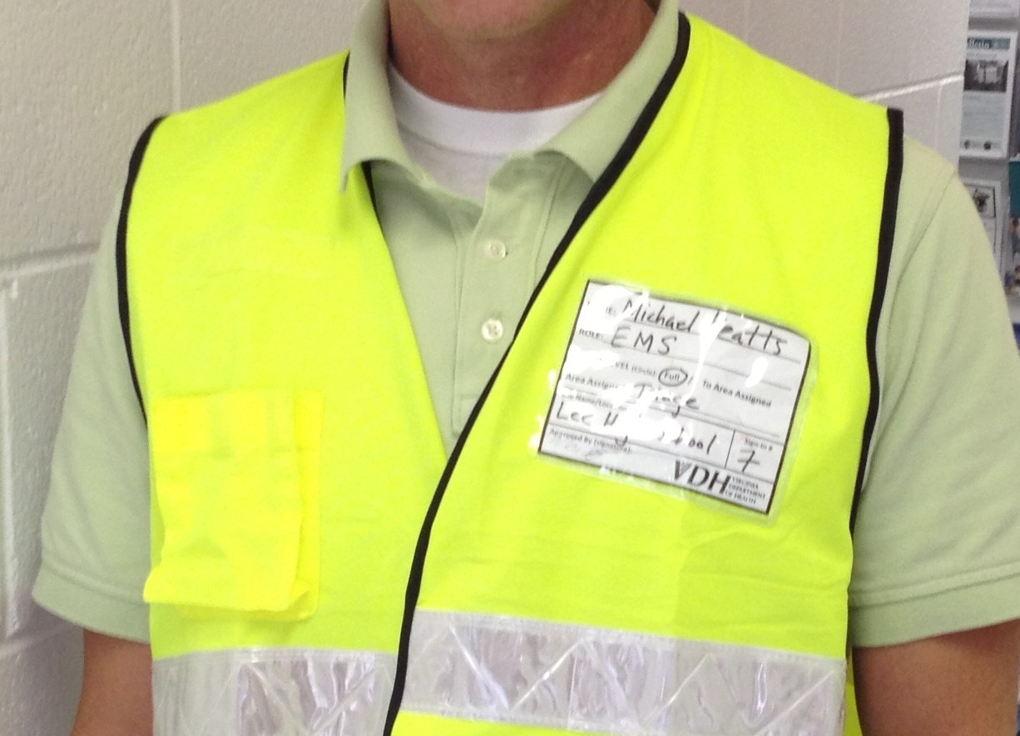

Rear Vest Display Window with Role Title Insert:
