Skills check off for collection of a Nasopharyngeal Swab (NP) and Oropharyngeal Swab (OP) for COVID-19 testing
Name of PHN/MRC Volunteer: ______________________________ Date: ______________
Nasopharyngeal testing procedure
No. | Task Steps | Pass
1. | Assemble supplies. Nasopharyngeal Swab and Viral Transport Medium (VTM), specimen label and biohazard bag.
2. | Encourage client to blow his or her nose to clear nasal passage. If the client is unable to perform this task wipe the nares with a cotton tip swab or tissue.
3. | Label the vial with the client’s name, date of birth and time collected.
4. | Perform hand hygiene. Use PPE as directed for contact with COVID-19 infected individuals.
5. | Open swab package and remove swab, taking care not to touch the tip on any surface of lay it down. (see accepted swabs and medium for Lab Corp and DCLS Samples)
6. | With person seated. If possible, tilt head back to 70 degrees, support back of their heard with your non dominant hand
 | a. Insert the dry swab through one nostril straight back (NOT upwards), along the floor of the nasal passage until you reach the posterior wall of the nasopharynx - generally one half the distance from the corner of the nose to the front of the ear (about 4 to 6 cm or 1.6 - 2.5 inches)
 | b. Rotate the swab several times while the swab is in contact with nasopharyngeal wall.
 | c. Carefully remove the swab without touching the sides of the nostril
7. | Place NP swab into the VTM (viral transport medium) and break (snap) off at the indicator line on the swab.
8. | Replace cap and screw cap and screw cap on securely.
9. | Label sample and place in biohazard bag.
10. | Remove your gloves and perform hand hygiene
11. | Guidance for Lab Corp Samples 4/10/2020: Samples should be shipped frozen at -20 C (preferred); refrigerated specimens acceptable (if received for testing within 72 hours of collection); room temperature swabs are acceptable (if received within 24 hours of collection). DCLS Samples: Store and ship specimens refrigerated at 4˚C within 72 hours. Store specimens at -70 ˚C or colder if the sample cannot be delivered to the DCLS within 72 hours.
12. | Submit sample on one requisition, with test code 139900-COVID-19.
13. | Perform hand hygiene
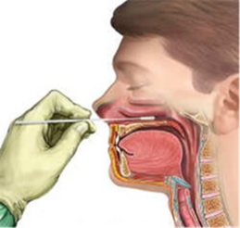

______________________________________________________________________________
Evaluator Date

Oropharyngeal Swab Procedure
Name of PHN/MRC Volunteer: ______________________________ Date: ________________
No. | Task Steps | Pass
1. | Assemble supplies. Nasopharyngeal Swab and Viral Transport Medium (VTM), specimen label and biohazard bag.
2. | Label the vial with the client’s name, date of birth and time collected.
3. | Perform hand hygiene
4. | Open the VTM package and remove one swab, taking care not to touch the tip to any surface or lay it down. See guidance under NP swabs for acceptable swabs/medium.
5. | Use PPE as directed for contact with COVID-19 infected individuals.
6. | With the person's head in a neutral position
 | - Holding swab, gently insert into back of the throat and tonsillar area.
 | - Rub the swab over both tonsillar pillars and the posterior oropharynx and avoid touching the tongue, teeth, or gums.
 | - Carefully remove the swab without touching the sides of the mouth
7. | Place swab into the VTM and break (snap) off at the indicator line on the swab.
8. | Replace cap and screw cap on securely.
9. | Place specimen into biohazard bag
10. | See specimen submission guidelines above for NP swabs
11. | Submit sample on one requisition, with test code 139900—COVID-19.
12. | Perform hand hygiene.

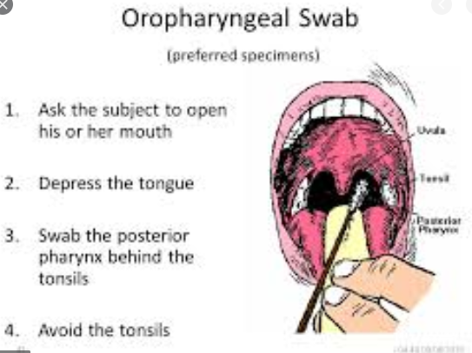

Evaluator Date

