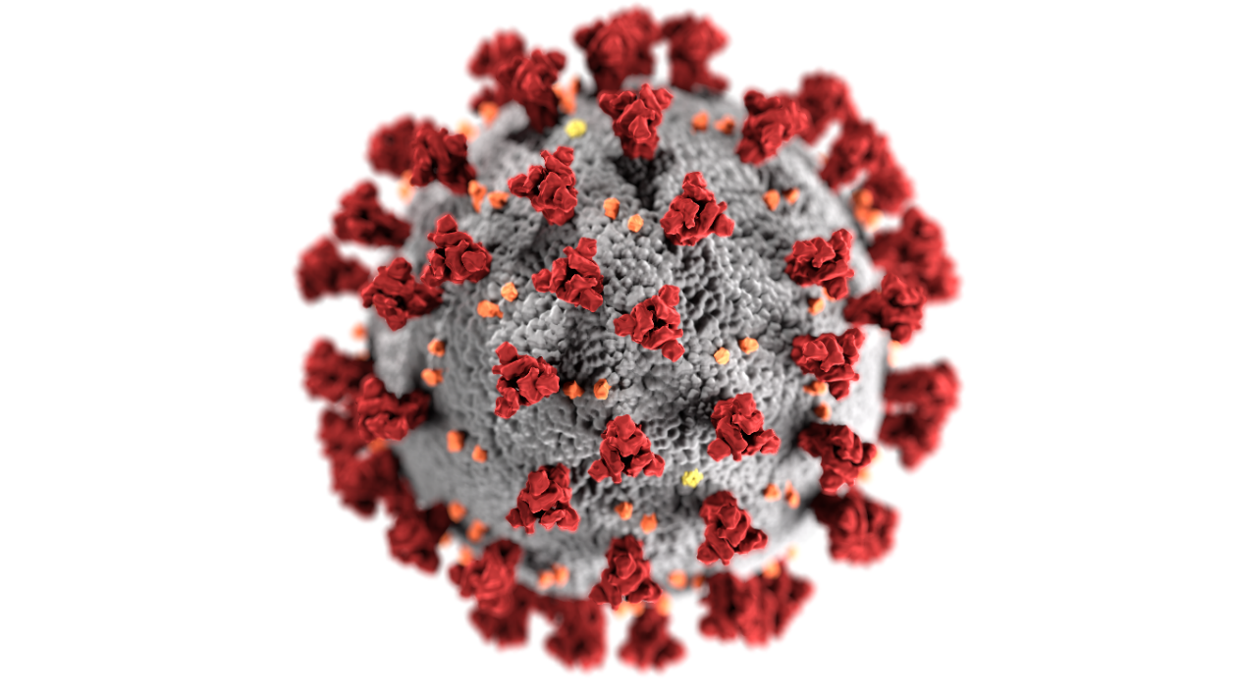
Local COVID 19 Vaccination Tabletop Exercise
  - After-Action Report/Improvement Plan
  - [Date]
The After-Action Report/Improvement Plan (AAR/IP) aligns exercise objectives with preparedness doctrine and related frameworks and guidance. Exercise information required for preparedness reporting and trend analysis is included; users are encouraged to add additional sections as needed to support their own organizational needs.

Exercise Overview
Exercise Name | [Insert the formal name of exercise, which should match the name in the document header]
Exercise Dates | [Indicate the start and end dates of the exercise]
Scope | This exercise is a [exercise type], planned for [exercise duration] at [exercise location]. Exercise play is limited to [exercise parameters].
Focus Area(s) | Response
Capabilities | - Public Health Preparedness Capability - Healthcare Preparedness Capability - DHS Core Capability  - Community Preparedness - Medical Countermeasure Dispensing and Administration - Foundation for Healthcare and Medical Readiness - Healthcare and Medical Response Coordination - Planning - Operational Coordination - Emergency Public Information and Warning - Logistics and Supply Chain Management
Objectives | - Increase stakeholder knowledge of the local COVID 19 Vaccination Campaign Plan and their roles to support execution of the plan upon arrival of COVID vaccines in the Commonwealth.  - Validate support needed to counter Preparedness Gap Analysis estimates in accordance with the COVID 19 Vaccination Campaign Plan.  - Assess the partners Support requirements for the phases of the Vaccination Campaign Strategy in accordance with the Vaccination Campaign Plan.  - Evaluate the ability of locality Logistics Section to provide facilities, services and support in support of vaccination distribution in accordance with established plans, policies and procedures.  - Demonstrate the ability of the Public Information Officer to deliver coordinated, prompt and actionable incident information in response to the distribution of vaccine in locality in accordance with existing plans, policies and procedures.  - Demonstrate the ability of the locality to coordinate the management of vaccination distribution operations within locality in accordance with existing plans, policies and procedures.
Threat or Hazard | [List the threat or hazard (e.g. natural/hurricane, technological/radiological release)]
Scenario | [Insert a brief overview of the exercise scenario, including scenario impacts (2-3 sentences)]
Sponsor | [Insert the name of the sponsor organization, as well as any grant programs being utilized, if applicable]
Participating Organizations | [Insert a brief summary of the total number of participants and participation level (i.e., Federal, State, local, Tribal, non-governmental organizations (NGOs), and/or international agencies). Consider including the full list of participating agencies in Appendix B. Delete Appendix B if not required.]
Point of Contact | [Insert the name, title, agency, address, phone number, and email address of the primary exercise POC (e.g., exercise director or exercise sponsor)]

Analysis of Capabilities
Aligning exercise objectives and capabilities provides a consistent taxonomy for evaluation that transcends individual exercises to support preparedness reporting and trend analysis. Table 1 includes the exercise objectives, aligned capabilities, and performance ratings for each capability as observed during the exercise and determined by the evaluation team.
Objective | Capability | Performed without Challenges (P) | Performed with Some Challenges (S) | Performed with Major Challenges (M) | Unable to be Performed (U)
Increase stakeholder knowledge of the local COVID 19 Vaccination Campaign Plan and their roles to support execution of the plan upon arrival of COVID vaccines in the Commonwealth. | - Community Preparedness  - Foundation for Healthcare and Medical Readiness  - Planning
Validate support needed to counter Preparedness Gap Analysis estimates in accordance with the COVID 19 Vaccination Campaign Plan | - Medical Countermeasure Dispensing and Administration  - Foundation for Healthcare and Medical Readiness  - Planning
Assess the partners Support requirements for the phases of the Vaccination Campaign Strategy in accordance with the Vaccination Campaign Plan. | - Medical Countermeasure Dispensing and Administration  - Foundation for Healthcare and Medical Readiness  - Operational Coordination
Evaluate the ability of locality Logistics Section to provide facilities, services and support in support of vaccination distribution in accordance with established plans, policies and procedures. | - Medical Countermeasure Dispensing and Administration  - Foundation for Healthcare and Medical Readiness  - Logistics and Supply Chain Management
Demonstrate the ability of the Public Information Officer to deliver coordinated, prompt and actionable incident information in response to the distribution of vaccine in locality in accordance with existing plans, policies and procedures. | - Emergency Public Information  - Healthcare and Medical Response Coordination  - Operational Coordination
Demonstrate the ability of the locality to coordinate the management of vaccination distribution operations within locality in accordance with existing plans, policies and procedures. | - Medical Countermeasure Dispensing and Administration  - Healthcare and Medical Response Coordination  - Operational Coordination

Table 1. Summary of Core Capability Performance
Ratings Definitions:
Performed without Challenges (P): The targets and critical tasks associated with the capability were completed in a manner that achieved the objective(s) and did not negatively impact the performance of other activities. Performance of this activity did not contribute to additional health and/or safety risks for the public or for emergency workers, and it was conducted in accordance with applicable plans, policies, procedures, regulations, and laws.
Performed with Some Challenges (S): The targets and critical tasks associated with the capability were completed in a manner that achieved the objective(s) and did not negatively impact the performance of other activities. Performance of this activity did not contribute to additional health and/or safety risks for the public or for emergency workers, and it was conducted in accordance with applicable plans, policies, procedures, regulations, and laws. However, opportunities to enhance effectiveness and/or efficiency were identified.
Performed with Major Challenges (M): The targets and critical tasks associated with the capability were completed in a manner that achieved the objective(s), but some or all of the following were observed: demonstrated performance had a negative impact on the performance of other activities; contributed to additional health and/or safety risks for the public or for emergency workers; and/or was not conducted in accordance with applicable plans, policies, procedures, regulations, and laws.
Unable to be Performed (U): The targets and critical tasks associated with the capability were not performed in a manner that achieved the objective(s).
The following sections provide an overview of the performance related to each exercise objective and associated capability, highlighting strengths and areas for improvement.

[Objective 1]
The strengths and areas for improvement for each capability aligned to this objective are described in this section.

[Capability 1]

Strengths
The [full or partial] capability level can be attributed to the following strengths:
Strength 1: [Observation statement]
Strength 2: [Observation statement]
Strength 3: [Observation statement]

Areas for Improvement
The following areas require improvement to achieve the full capability level:
Area for Improvement 1: [Observation statement. This should clearly state the problem or gap; it should not include a recommendation or corrective action, as those will be documented in the Improvement Plan.]
Reference: [List any relevant plans, policies, procedures, regulations, or laws.]
Analysis: [Provide a root cause analysis or summary of why the full capability level was not achieved.]
Area for Improvement 2: [Observation statement]
Reference: [List any relevant plans, policies, procedures, regulations, or laws.]
Analysis: [Provide a root cause analysis or summary of why the full capability level was not achieved.]

[Capability 2]

Strengths
The [full or partial] capability level can be attributed to the following strengths:
Strength 1: [Observation statement]
Strength 2: [Observation statement]
Strength 3: [Observation statement]

Areas for Improvement
The following areas require improvement to achieve the full capability level:
Area for Improvement 1: [Observation statement. This should clearly state the problem or gap; it should not include a recommendation or corrective action, as those will be documented in the Improvement Plan.]
Reference: [List any relevant plans, policies, procedures, regulations, or laws.]
Analysis: [Provide a root cause analysis or summary of why the full capability level was not achieved.]
- Improvement Plan
Capability | Issue/Area for Improvement | Corrective Action | Capability Element | Primary Responsible Organization | Organization POC | Start Date | Completion Date
Capability 1: [Capability Name] | 1. [Area for Improvement] | [Corrective Action 1]
Capability 1: [Capability Name] | 1. [Area for Improvement] | [Corrective Action 2]
Capability 1: [Capability Name] | 2. [Area for Improvement] | [Corrective Action 1]
Capability 1: [Capability Name] | 2. [Area for Improvement] | [Corrective Action 2]
Capability 2: [Capability Name] | 1. [Area for Improvement] | [Corrective Action 1]
Capability 2: [Capability Name] | 1. [Area for Improvement] | [Corrective Action 2]
Capability 2: [Capability Name] | 2. [Area for Improvement] | [Corrective Action 1]
Capability 2: [Capability Name] | 2. [Area for Improvement] | [Corrective Action 2]
This IP is developed specifically for [Organization or Jurisdiction] as a result of [Exercise Name] conducted on [date of exercise].

Appendix B: Exercise Participants
Participating Organizations
Federal
[Federal Participant]
[Federal Participant]
[Federal Participant]
State
[State Participant]
[State Participant]
[State Participant]
[Jurisdiction A]
[Jurisdiction A Participant]
[Jurisdiction A Participant]
[Jurisdiction A Participant]
[Jurisdiction B]
[Jurisdiction B Participant]
[Jurisdiction B Participant]
[Jurisdiction B Participant]

