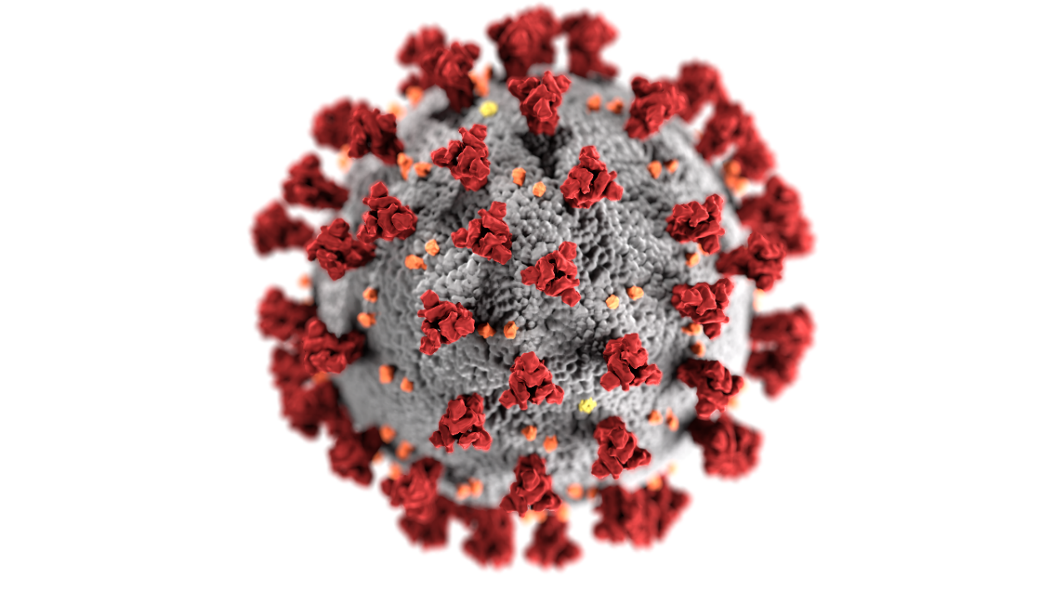
Local COVID 19 Vaccination Tabletop Exercise
  - Situation Manual
  - [Date]
This Situation Manual (SitMan) provides exercise participants with all the necessary tools for their roles in the exercise. Some exercise material is intended for the exclusive use of exercise planners, facilitators, and evaluators, but players may view other materials that are necessary to their performance. All exercise participants may view the SitMan.

Exercise Overview
Exercise Name | [Insert the formal name of exercise, which should match the name in the document header]
Exercise Dates | [Indicate the start and end dates of the exercise]
Scope | This exercise is a [exercise type], planned for [exercise duration] at [exercise location]. Exercise play is limited to [exercise parameters].
Mission Area(s) | Response
Capabilities | Public Health Preparedness Capability Healthcare Preparedness Capability DHS Core Capability  - Community Preparedness - Medical Countermeasure Dispensing and Administration - Foundation for Healthcare and Medical Readiness - Healthcare and Medical Response Coordination - Planning - Operational Coordination - Emergency Public Information and Warning - Logistics and Supply Chain Management
Objectives | Increase stakeholder knowledge of the local COVID 19 Vaccination Campaign Plan and their roles to support execution of the plan upon arrival of COVID vaccines in the Commonwealth.  Validate support needed to counter Preparedness Gap Analysis estimates in accordance with the COVID 19 Vaccination Campaign Plan.  Assess the partners Support requirements for the phases of the Vaccination Campaign Strategy in accordance with the Vaccination Campaign Plan.  Evaluate the ability of locality Logistics Section to provide facilities, services and support in support of vaccination distribution in accordance with established plans, policies and procedures.  Demonstrate the ability of the Public Information Officer to deliver coordinated, prompt and actionable incident information in response to the distribution of vaccine in locality in accordance with existing plans, policies and procedures.  Demonstrate the ability of the locality to coordinate the management of vaccination distribution operations within locality in accordance with existing plans, policies and procedures.
Threat or Hazard | Pandemic
Scenario | Notification of shipment and delivery of COVID 19 vaccine and imminent need to activate medical countermeasure operations in accordance with the appropriate vaccine phase.
Sponsor | [Insert the name of the sponsor organization, as well as any grant programs being utilized, if applicable]
Participating Organizations | [Insert a brief summary of the total number of participants and participation level (i.e., Federal, State, local, Tribal, non-governmental organizations (NGOs), and/or international agencies). Consider including the full list of participating agencies in Appendix B. Delete Appendix B if not required.]
Point of Contact | [Insert the name, title, agency, address, phone number, and email address of the primary exercise POC (e.g., exercise director or exercise sponsor)]

General Information

Exercise Objectives and Capabilities
The following exercise objectives in Table 1 describe the expected outcomes for the exercise. The objectives are linked to capabilities, which are distinct critical elements necessary to achieve the specific mission area(s).
Exercise Objectives | Public Health Preparedness Capability | Healthcare Preparedness Capability | DHS Core Capability
Increase stakeholder knowledge of the local COVID 19 Vaccination Campaign Plan and their roles to support execution of the plan upon arrival of COVID vaccines in the Commonwealth. | Community Preparedness | Foundation for Healthcare and Medical Readiness | Planning
Validate support needed to counter Preparedness Gap Analysis estimates in accordance with the COVID 19 Vaccination Campaign Plan. | Medical Countermeasure Dispensing and Administration | Foundation for Healthcare and Medical Readiness | Planning
Assess the partners Support requirements for the phases of the Vaccination Campaign Strategy in accordance with the Vaccination Campaign Plan. | Medical Countermeasure Dispensing and Administration | Healthcare and Medical Response Coordination | Operational Coordination
Evaluate the ability of locality Logistics Section to provide facilities, services and support in support of vaccination distribution in accordance with established plans, policies and procedures. | Medical Countermeasure Dispensing and Administration | Foundation for Healthcare and Medical Readiness | Logistics and Supply Chain Management
Demonstrate the ability of the Public Information Officer to deliver coordinated, prompt and actionable incident information in response to the distribution of vaccine in locality in accordance with existing plans, policies and procedures. | Emergency Public Information and Warning | Foundation for Healthcare and Medical Readiness | Emergency Public Information and Warning
Demonstrate the ability of the locality to coordinate the management of vaccination distribution operations within locality in accordance with existing plans, policies and procedures. | Medical Countermeasure Dispensing and Administration | Healthcare and Medical Response Coordination | Operational Coordination
Table 1. Exercise Objectives and Associated Capabilities

Participant Roles and Responsibilities
The term participant encompasses many groups of people, not just those playing in the exercise. Groups of participants involved in the exercise, and their respective roles and responsibilities, are as follows:
- Players: Players are personnel who have an active role in discussing or performing their regular roles and responsibilities during the exercise. Players discuss or initiate actions in response to the simulated emergency.
- Observers: Observers do not directly participate in the exercise. However, they may support the development of player responses to the situation during the discussion by asking relevant questions or providing subject matter expertise.
- Facilitators: Facilitators provide situation updates and moderate discussions. They also provide additional information or resolve questions as required. Key Exercise Planning Team members also may assist with facilitation as subject matter experts (SMEs) during the exercise.
- Evaluators: Evaluators are assigned to observe and document certain objectives during the exercise. Their primary role is to document player discussions, including how and if those discussions conform to plans, polices, and procedures.

Exercise Structure
This exercise will be a multimedia, facilitated exercise. Players will participate in the following [insert number of modules] modules:
- Module 1: Local Vaccination Campaign Plan Review Briefing
- Module 2: Phase I Vaccine Arrival
- Module 3: Phase II Vaccine Arrival
Each module begins with a multimedia update that summarizes key events occurring within that time period. After the updates, participants review the situation and engage in functional group discussions of appropriate response issues. For this exercise, the functional groups are as follows, determined by the locality/agency conducting the exercise:
- [Functional group]
- [Functional group]
- [Functional group]
- [Functional group]
After these functional group discussions, participants will engage in a moderated plenary discussion in which a spokesperson from each group will present a synopsis of the group’s actions, based on the scenario.

Exercise Guidelines
- This exercise will be held in an open, low-stress, no-fault environment. Varying viewpoints, even disagreements, are expected.
- Respond to the scenario using your knowledge of current plans and capabilities (i.e., you may use only existing assets) and insights derived from your training.
- Decisions are not precedent setting and may not reflect your organization’s final position on a given issue. This exercise is an opportunity to discuss and present multiple options and possible solutions.
- Issue identification is not as valuable as suggestions and recommended actions that could improve response efforts. Problem-solving efforts should be the focus.

Exercise Assumptions and Artificialities
In any exercise, assumptions and artificialities may be necessary to complete play in the time allotted and/or account for logistical limitations. Exercise participants should accept that assumptions and artificialities are inherent in any exercise, and should not allow these considerations to negatively impact their participation. During this exercise, the following apply:
- This TTX will involve discussions of Phase I and II of the vaccination strategy. Phase III-Widely available vaccines will not be part of this exercise.
- Exercise content is based on currently available data and may need to be revised as the situation evolves.
- The exercise is conducted in a no-fault learning environment wherein capabilities, plans, systems, and processes will be evaluated.
- The exercise scenario is plausible, and events occur as they are presented.
- All players receive information at the same time.

Exercise Evaluation
Evaluation of the exercise is based on the exercise objectives and aligned capabilities, capability targets, and critical tasks, which are documented in Exercise Evaluation Guides (EEGs). Evaluators have EEGs for each of their assigned areas. Additionally, players will be asked to complete participant feedback forms. These documents, coupled with facilitator observations and notes, will be used to evaluate the exercise and compile the After-Action Report (AAR).

Module 1: Local Vaccination Campaign Plan Review Briefing

To be completed by district conducting the TTX.

Minimum information that should be included (derived from Annex 1: Local Health District Specific Guidance of the COVID 19 Vaccine Campaign Plan) :

- Key Planning Assumptions
- Organization / Assignment of Responsibilities
- Vaccine Priority Groups
- Campaign Strategy
- POD / Vaccination Clinic Guidance (site considerations, infection prevention, etc.)
- Provider Recruitment and Enrollment
- Vaccine Ordering and Distribution
- Vaccine Storage and Handling
- Second Dose Reminders

Module 2: Phase I Vaccine Arrival

Scenario

December 1, 2020:
You have received notification of an impending shipment of COVID vaccine for Phase I priority groups. The supply is not sufficient to vaccinate all of the people in your health district who fall into Phase 1. Deliveries are expected to begin arriving over the next five days.

Key Issues
- This phase will involve a highly targeted campaign to immunize healthcare personnel, non-healthcare essential workers, and adults with underlying medical conditions that are risk factors for severe COVID-19 illness.
- Most vaccination events in this phase will be Closed Point of Dispensing (CPOD) events for specific groups.
- Public communications during this phase will emphasize the need to prioritize limited supplies for critical populations while assuring the general public that additional supplies of the vaccine will be on the way soon.

Questions
Based on the information provided, participate in the discussion concerning the issues raised in Module 2. Identify any critical issues, decisions, requirements, or questions that should be addressed at this time.
The following questions are provided as suggested subjects that you may wish to address as the discussion progresses. These questions are not meant to constitute a definitive list of concerns to be addressed, nor is there a requirement to address every question.
General Questions:
- What plans are in place with critical infrastructure partners in your health district to serve as Closed PODs? What cold storage capabilities do each have? Do they have a POD plan, has it been trained and exercised?
- What plans are in place for first responders to receive the vaccine?
- What are the requirements needed for the location of administration? Discuss locations in the area, building size, access needs, logistical needs, WiFi requirements, cold storage, etc.
- What internal information sharing and dissemination processes does your organization currently have in place?
- What information will you be disseminating to the public? What methods would you use? How would you coordinate the message with stakeholders?
- Who is responsible for ensuring the supplies are available beyond the vaccine?
- What plans have been developed to ensure the administration of the second dose of the COVID-19 vaccination?

Facility/POD Specific Questions and/or Injects:

- A month into the distribution, an individual comes in stating that they received the first dose at a different location and want their second dose. What is the procedure?
- The computer network goes down. Who is responsible for inputting the information once the system is back online?
- Have you considered altering or rotating administration of the vaccine to the various departments and offices within your facility?
- What policies and procedures does your facility have in place to vaccinate employees and how will you track?
- What is your current cold storage capability?
- Do you have temperature data loggers?
- Is the freezer or refrigerator connected to emergency power?

Module 3: Phase II Vaccine Arrival

Scenario

February 16, 2021
Phase I vaccinations have been occurring since December of 2020. You have received notification that vaccine supplies have reached the necessary production volume to begin phase II of the vaccination campaign. Bulk shipments are expected to commence in the next five days.

Key Issues
- This phase marks the transition from vaccinating critical populations to vaccinating the general public.
- Administration through commercial and private sector partners will occur during this phase.
- Large open/community PODs and mobile vaccination events will occur during this phase.
- Public Health focused events on underserved and hard to reach populations will also take place during this phase.
- Public Health messaging will encourage all Virginians to get vaccinated, counter anti-vaccine narratives, and include appropriate targeted messaging campaigns for specific demographics (i.e., race, ethnicity, age groups, etc.).

Questions
Based on the information provided, participate in the discussion concerning the issues raised in Module 3. Identify any critical issues, decisions, requirements, or questions that should be addressed at this time.
The following questions are provided as suggested subjects that you may wish to address as the discussion progresses. These questions are not meant to constitute a definitive list of concerns to be addressed, nor is there a requirement to address every question.
General Questions:

- What plans are in place with partners in your health district to serve as Closed PODs and/or Open PODs? Do they have a POD plan, has it been trained and exercised?
- What plans have been developed to ensure and administer the second dose of the COVID-19 vaccination? Who is in charge of this plan?
- What are the POD site requirements? Discuss locations in the area, building size, access needs, logistical needs, WiFi requirements, cold storage, etc.
- What internal information sharing and dissemination processes does your organization currently have in place?
- What information will you be putting out to the public? What methods would you use? How would you coordinate the message with stakeholders?
- What outreach are you working on with access to functional needs and health equity?
- Is there a priority for who will receive the vaccine during Phase II? Is it first come, first serve or will people have to sign up?
- Who is responsible for ensuring the supplies are available beyond the vaccine? Where will you store the items?
- Does the building have access issues? How do you deal with members who come in public transportation, especially if it is raining/snowing or too cold /hot to stay outside?

Facility/POD Specific Questions and/or Injects:

- A member of the community comes in whose first language is not English. How do you help this individual?
- A community member calls into the local dispatch center or local health department and advises they do not have a way to get to a vaccination site. How will you ensure the community member has access to the vaccine?
- A major snowstorm is coming into the area and will shut down the roads for at least a few days. Multiple calls are coming into the city with people who are panicked that they will not receive their second dose on time. What message are you going to send the public?
- There is an issue with the transportation distribution. What is the procedure and what message are you going to send to the public?
- A member of the public states their child has asthma and is in need of the vaccine. The mother has no medical paperwork. How do you handle this situation?
- A month into the distribution, an individual comes in stating they received the first dose at another location and want their second dose. What is the procedure?
- The computer network goes down. Who is responsible for inputting the information once the system is back online?

Appendix A: Exercise Schedule
Note: Because this information is updated throughout the exercise planning process, appendices may be developed as stand-alone documents rather than part of the SitMan.
Districts/agencies/facilities and localities should adapt the exercise schedule to fit their needs for the TTX.
Time | Activity
 | [Month Day, Year]
00:00 | Registration
00:00 | Welcome and Opening Remarks
00:00 | Module 1: Briefing, Caucus Discussion. and Brief-Back
00:00 | Break
00:00 | Module 2: Briefing, Caucus Discussion, and Brief-Back
00:00 | Lunch
00:00 | Module 3: Briefing, Caucus Discussion, and Brief-Back
00:00 | Break
00:00 | Hotwash
00:00 | Closing Comments

Appendix B: Exercise Participants
Participating Organizations
Federal
[Participating organization]
[Participating organization]
[Participating organization]
State
[Participating organization]
[Participating organization]
[Participating organization]
[Jurisdiction A]
[Participating organization]
[Participating organization]
[Participating organization]
[Jurisdiction B]
[Participating organization]
[Participating organization]
[Participating organization]

Appendix C: Relevant Plans
Districts conducting the exercise are encouraged to place the current version of their local plans and any other necessary plans, policies and procedures applicable to the successful execution of the vaccination campaign plan.
[Insert excerpts from relevant plans, policies, or procedures to be tested during the exercise.]

Appendix D: Acronyms
Acronym | Term
AAR | After Action Report
DHS | U.S. Department of Homeland Security
EEG | Exercise Evaluation Guide
HSEEP | Homeland Security Exercise and Evaluation Program
HPP | Healthcare Preparedness Program
PHEP | Public Health Emergency Preparedness
POD | Point of Dispensing
SitMan | Situation Manual
SME | Subject-Matter Expert
TTX | Tabletop Exercise
[Acronym] | [Term]
[Acronym] | [Term]
[Acronym] | [Term]
[Acronym] | [Term]
[Acronym] | [Term]

