SANITATION REQUIREMENTS FOR TEMPORARY FOOD ESTABLISHMENTS

Each temporary establishment shall have:

Three (3) dish pans or buckets for cleaning and sanitizing utensils and cooking implements.

CORRECT SANITIZATION SETUP

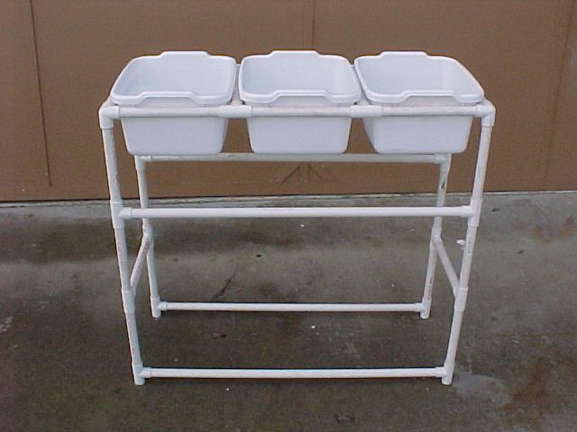
1. WASH
HOT WATER & DETERGENT

2. RINSE
HOT WATER

3. SANITIZE
WARM WATER
& BLEACH (SANITIZER NEEDS TO HAVE INSTRUCTIONS FOR SANITIZING FOOD CONTACT SURFACES)
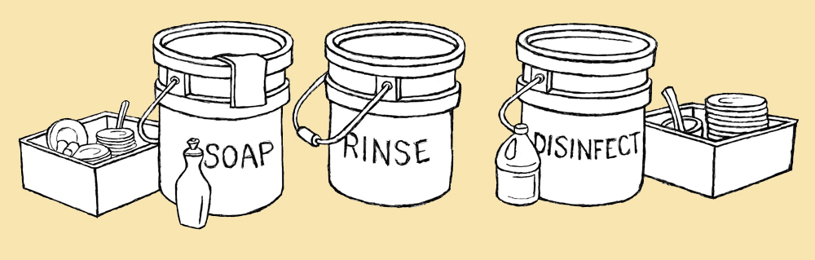

Sanitizing solution – It is recommended to use at least 50 ppm of chlorine, which is approximately one (1) tablespoon (capful) of regular chlorine bleach, per gallon of water (any brand is acceptable, no scented varieties). As it is not an exact science, vendors should purchase and use chlorine test trips to ensure the proper concentration levels. Do not add soap or detergent to the bleach water because soap makes the bleach ineffective as a sanitizing agent.

Paper towels – For drying hands after washing.

Large Bucket with tight-fitting lid – For holding used wash-water and transporting it to the designated disposal site. NEVER DISPOSE OF WASTE-WATER ONTO THE GROUND.

Insulated container with a dispensing spout for hot water to be used for hand and equipment washing.

CORRECT HANDWASHING SETUP
