FOOD PROTECTION MANAGER CERTIFICATION
An Important Way To Improve Restaurant Food Safety!
RESTAURANTS WITH MANAGERS CERTIFIED IN FOOD SAFETY...
As specified in 12VAC5-421-55 of the Virginia Food Regulations food establishments (including temporary food establishments) need to have at least one employee with supervisory and management responsibility and the authority to direct and control food preparation and service who is a Certified Food Protection Manager (CFPM).

- Are less likely to have foodborne illness outbreaks
- Have better food safety practices
- Have better ratings and fewer critical violations on their inspections

Each year, 800 outbreaks of foodborne illness occur in the United States and most of these are linked with restaurants. Government agencies and the restaurant industry can use kitchen manager certification to improve food safety in restaurants.
WHAT IS KITCHEN MANAGER CERTIFICATION?
Certified kitchen managers are restaurant employees with management responsibility who have passed a test to show knowledge of food safety.
TYPICALLY, THEY DO THIS BY:
- Taking a food safety course
- Passing a test given by one of the SIX accredited certification programs
- National Registry of Food Safety Professionals
- National Restaurant Association-ServSafe
- Prometric
- 360training.com
- Above Training/StateFoodSafety.com
- The Always Food Safe Company, LLC

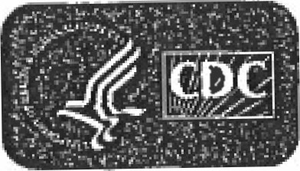
Centers for Disease
Control and Prevention
National Center for Disease Control
Environmental Health csasu.nu

