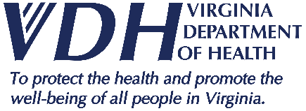 | Crater Health District  News Release
109 Governor Street, Richmond, VA 23219

FOR IMMEDIATE RELEASE August 27, 2020

Media Contact: Tara Rose, Tara.Rose@vdh.virginia.gov

Crater Health District Experiencing Increase in COVID-19 Community Transmission,

PRECAUTIONS PROVIDE THE BEST PROTECTION

(Petersburg, Virginia) – We have made progress in reducing the spread of COVID-19 in the Commonwealth; however, the Crater Health District (CHD) located within the Central Region is now experiencing an increase in COVID-19 community transmission. We have an increase in new community transmission cases as well as new cases linked to facility outbreaks. Residents should assume the risk of exposure is everywhere and should understand that staying safe depends on their individual behaviors and precautions.
"Now that fall is almost here, we need to maintain our vigilance in following effective prevention measures to slow the spread of COVID-19," said Crater Health District Director Alton Hart, Jr., MD, MPH. “In particular, we must continue to stay home as much as possible, wear face coverings, maintain social distancing, and practice hand hygiene to help manage transmission of the virus.”
We all can take steps to protect our health; the Virginia Department of Health encourages everyone to:
- Stay home as much as possible, especially if you are at higher risk of serious illness. If you must go out in public, wear a cloth face covering;
- Stay home when you are sick and avoid contact with people who are sick;
- Wash your hands often with soap and water for at least 20 seconds; use an alcohol-based hand sanitizer if soap and water are not available;
- Avoid touching your eyes, nose, and mouth;
- Clean and disinfect frequently touched surfaces;
- Practice social distancing by staying six feet or more away from others; and
- If you are experiencing symptoms, call your doctor;
“Individuals, communities, schools, businesses, healthcare organizations, and local governments all play an important role in slowing the spread of COVID-19, “ said Crater Health District Director Alton Hart, Jr., MD, MPH. “This is how we all work together to save lives. We all have a duty to protect ourselves and those around us.”
For the most accurate and up-to-date information online, visit, www.vdh.virginia.gov/coronavirus, and www.cdc.gov/coronavirus.
###

