Dear Restaurant Operator, April 20, 2020

We hope you are doing well. We know that times are tough and that we all are doing our best to keep health while trying to maintain normal daily routines.

Although routine inspections including food establishment inspections are postponed until further notice, the Hampton Health Department (HHD) will continue to respond to and investigate complaints, and respond to COVID-19 questions and concerns about the facilities we regulate, including the enforcement of food establishment seating and capacity mandates under the Commissioner’s Declaration of Public Health Emergency and Executive Order 53. HHD is focused on the safety and health of Virginians. The top priority for our Environmental Health (EH) staff is assisting in the agency’s efforts related to COVID-19, and answering your questions and concerns about EH programs as they relate to COVID-19. EH services are still open and available; however, we are only recommending that interaction with clients be transitioned to telephone, email, fax, mail, and other means that do not require clients to physically come into local health departments to the greatest extent possible.

Please call the Hampton Health Department at 757-727-2570 and let us know your current operational status. If you are open, we would like to briefly (10-15 minutes) discuss your food safety operations during the COVID-19 pandemic. If we are unable to answer, please leave a voice message with the phone number and the best time(s) we may contact you.

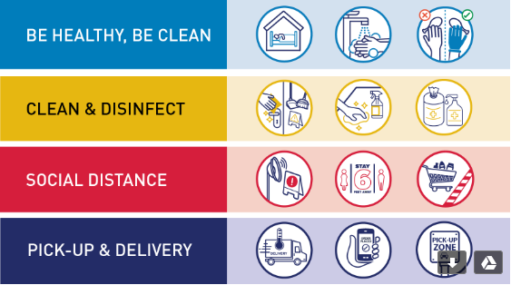

Please feel free to reference the following websites for additional food safety information related to COVID-19:

Serv Safe and National Restaurant Association: https://restaurant.org/covid19
EPA-registered disinfectants for SARS-CoV-2 (the virus that causes COVID-19): https://www.epa.gov/pesticide-registration/list-n-disinfectants-use-against-sars-cov-2
VDH: http://www.vdh.virginia.gov/surveillance-and-investigation/novel-coronavirus/
VDH Environmental Health:
http://www.vdh.virginia.gov/environmental-health/

CDC food safety and COVID-19:
https://www.cdc.gov/foodsafety/

